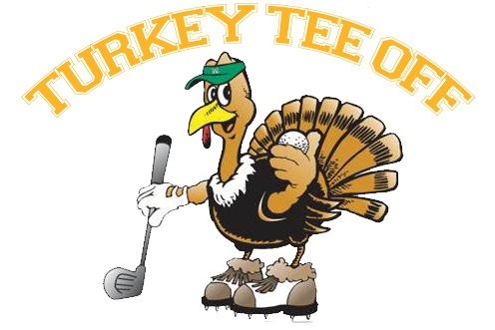**FOR IMMEDIATE RELEASE**

**Date:** November 9, 2020

**Contact**: Katie Enzor, Child Advocacy Center

[kenzor@childadvocacycenter.org](mailto:kenzor@childadvocacycenter.org) (615) 867-9000

**An Early Thanksgiving Tradition**

*10th Annual Turkey Tee Off*

**MURFREESBORO, TN –** "The 10th Annual Turkey Tee Off is an early Thanksgiving tradition,” said Child Advocacy Center director Sharon De Boer.  “This year we were blessed with 75 degree weather, a beautiful sunny day, and a great group of golfers.”

The golf tournament was held last Saturday with the support of loyal sponsors:  PATCO and the Patterson Family, Altimate Controls, Chick-Fil-A, CRF Properties, Come to Life Chiropractor Dr. Korey Sheridan, Farrer Bros. Hardware and Rental Service, District Attorney General Jennings H. Jones, Middle Tennessee Electric, Retired General David Puckett, Redstone Federal Credit Union, Michael and Barbara Sheppard, Smyrna Ready Mix, Topre America, US Community Credit Union, Waldron, Fann, and Parsley, Retired District Attorney General William C. Whitesell, and Wilson Bank and Trust.

“We are very grateful for our sponsors, tee box sponsors, and the Turkey Tee Off planning committee of Chase Patterson, Chase Fann, and TJ Patterson,” announced Development Coordinator Katie Enzor.  “Financially, the COVID-19 pandemic has been a tough time for non-profit agencies.  Local community support is helping us keep our doors open providing critically needed services to child abuse victims and their families.”

Tee box sponsors included:  Altimate Controls, Gabriel Besleaga with Bill Jakes Realty, Mike and Julie Cha, Coley and Coley Family Eye Care, Come to Life Chiropractic, CRF Properties, Farrer Brothers Hardware and Rental, Chuck and Carol Farrer, Jennings and Ayers Funeral Home, District Attorney General Jennings H. Jones, Jeremy Head Golf Shop and Academy, Middle Tennessee Electric, PATCO Fire Co., Pinnacle Financial Partners, Retired General David Puckett, Redstone Federal Credit Union, Season of Renewal Consignment Sale, Smyrna Ready Mix, Adam Tipton Farm Bureau, Topre America, Treasure Investments Corporation, Tri-Star Title Company, US Community Credit Union, Waldron Fann and Parsley, Retired District Attorney General William and Lucy Whitesell, and Wilson Bank and Trust.

Golfers enjoyed Chick-Fil-A chicken biscuits before teeing off at 9 a.m.  After the round of golf, the teams were treated to Slick Pig BBQ.  The silent auction concluded sharply at 1 p.m. and winners can claim their prizes by calling the Child Advocacy Center at (615) 867-9000.

**Turkey Tee Off Winners:**

The Smyrna Ready Mix team of Travis Lawrence, Zach White, TJ Whittaker, and Chris Yoder took home first place of $200 with a score of 52.  Smyrna Ready Mix won in the score card playoff.

The second place team with a prize of $160 was US Community Credit Union.  The golfers on the second place team were Nathan Brown, JR Jernigan, Ben Johnson, and Paul Johnson with a score of 52.

The third place team was Great Front Nine winning a prize of $100.  The third place team golfers were John Reynolds, Jordan Reynolds, Brian Seagraves, and Steve Stokes with a score of 55.

Smyrna Ready Mix and US Community Credit Union teams generously donated their winnings back to the Child Advocacy Center to support services for child abuse victims.

The following people won the following contests:

* The “Men’s Longest Drive” on Hole 5 was Trey Hunter
* The “Women’s Longest Drive” on Hole 5 was Molly Hisong.
* Jordan Reynolds won the “Closest to the Pin” on Hole 3.
* Taylor Wilson won the “Closet to the Pin” on Hole 14.
* David Puckett won the putting contest with 6.5 inches to the hole.

The winning ticket number in the 50/50 contest was 8926937 with a jackpot of $170.  The winner has not come forward yet.  If no one claims their prize the proceeds from the 50/50 contest will benefit child abuse victims.

"Congratulations to all of our winners!" concluded tournament chairman Chase Patterson.  "We appreciated everyone’s commitment and donations to support our cause, especially this year.  We look forward to seeing all of you again next year."  Any golfers who want to serve on the 2021 Turkey Tee Off Committee please contact Katie Enzor at (615) 867-9000 or [kenzor@cacrutherford.org](mailto:kenzor@cacrutherford.org).

###