STEVENS INSTITUTE OF TECHNOLOGY
MS – Computer Science
Spring 2025
BIA 500-B Business Analytics: Data, Models, and Decisions
Tuesday 6:30 – 9:00 PM
Instructor: Brian Mueller

Course Project

Course Project Title:
"Coffee Trade Analysis: A Comparative Study of Africa and Global Coffee Production"

By Group 4:
Amala Koppu
Harshitha Tankasala
Janvi Pravinkumar Lakhani
Sravya Goli

Objective Statement
The objective of this project is to conduct an in-depth, data-driven analysis of global coffee production with a special focus on Africa, examining its performance relative to other key coffee-producing continents—namely the Americas, Asia, and Oceania. This study utilizes longitudinal data from 1961 to 2022 to investigate the dynamics of coffee production across these regions, focusing on three critical agricultural indicators: total production volume (in tons), land area harvested (in hectares), and crop yield per hectare (in tons/hectare). By analyzing these indicators, the project aims to quantify Africa’s historical and current contribution to the global coffee trade and evaluate whether the continent has kept pace with global advancements in agricultural productivity.
A core component of this analysis involves identifying the leading and lagging African countries in terms of coffee output and yield and comparing their performance to top global producers such as Brazil, Colombia, and Vietnam. These comparisons are intended to reveal performance disparities and provide insight into the underlying causes—ranging from technological limitations and lack of mechanization to issues in infrastructure, farmer education, policy support, and environmental factors. The study further explores how much land is being utilized for coffee cultivation in Africa compared to other continents, and whether this land is being used efficiently in terms of output per hectare. Ultimately, the findings will support the development of data-driven insights and strategic recommendations to improve Africa’s competitiveness, productivity, and sustainability in the global coffee market.

Overview of the project
This project analyzes global coffee production trends from 1961 to 2022, with a focus on Africa’s performance compared to other major producing continents—Americas, Asia, and Oceania. Using historical data from FAOSTAT, the study explores key metrics such as production volume, harvested area, and yield per hectare. The objective is to assess Africa’s contribution to global coffee output, identify performance gaps, and highlight opportunities for improvement. The analysis includes data cleaning, comparative assessments, and visualizations such as pivot tables and donut charts to clearly present trends and insights. The findings aim to support data-driven recommendations that can help enhance productivity and competitiveness in Africa’s coffee sector.

Dataset Overview
The data used in this project is sourced from FAOSTAT and made available through a structured dataset on Kaggle, designed to capture long-term trends in global coffee production. The complete dataset comprises four main CSV files:
- Coffee_Production_1961-2022.csv – The primary file used in this project. It contains comprehensive data on coffee production, including total production volume (in tons), area harvested (in hectares), and yield per hectare. The data is organized by country and year and includes categorical attributes such as continent and region, which allow for effective grouping and comparison.
- Coffee_Production_Area_Harvested.csv – Provides detailed records of land area allocated to coffee cultivation.
- Coffee_Production_Volume.csv – Focuses on total annual production volume across countries.
- Coffee_Production_Yield.csv – Contains yield-related data, calculated as production per hectare.
For the purpose of this project, only the main file, Coffee_Production_1961-2022.csv, was used. This file alone provided all the necessary variables—production, area harvested, yield, country, continent, and year (with 7 columns and 4819 rows)—which were sufficient to conduct descriptive and comparative analysis. The data was first cleaned and structured to handle missing values and ensure consistency across all records, enabling effective visualization and interpretation of trends across time and regions.
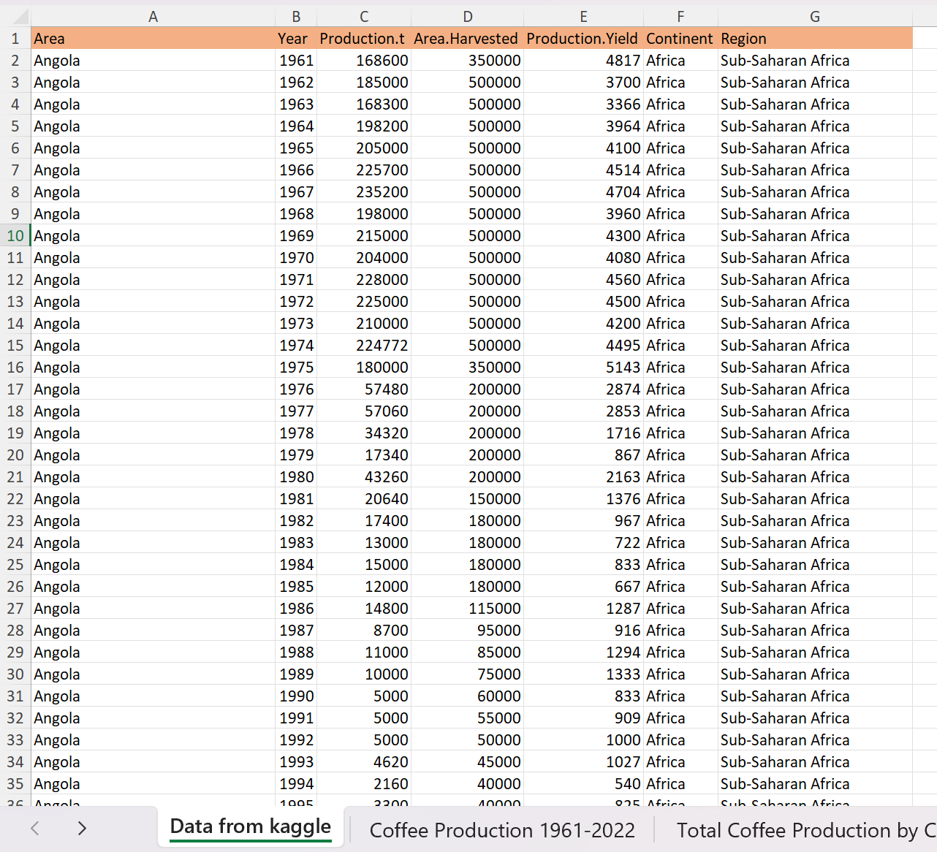
Data Analysis & Visualization
The coffee production data was analyzed using Microsoft Excel with a combination of pivot tables, feature engineering, and dynamic visualizations to explore production patterns across continents and over time. The goal of the analysis was to assess Africa’s performance in the global coffee market relative to the Americas, Asia, and Oceania. Six key pivot tables were created, each designed to extract specific insights regarding volume, yield, land efficiency, and regional performance. Visual tools such as slicers, conditional formatting, and charting were used to enhance interpretation and storytelling.
- Data Preparation and Feature Engineering
- The dataset was first transformed into a structured Excel Table to enable easier manipulation and dynamic referencing. Two new calculated fields were introduced which are Decade and Efficiency Level.
- Decade: Categorized each record into a ten-year interval to simplify time-based aggregation.
- Efficiency Level: conditional function was used to categorize the efficiency in high, medium and Low.
=IF([@[Production.t]]>4000,"High",IF([@[Production.t]]>2000,"Medium","Low"))
- These new features helped in segmenting the analysis across time and evaluating the yield performance of different regions.

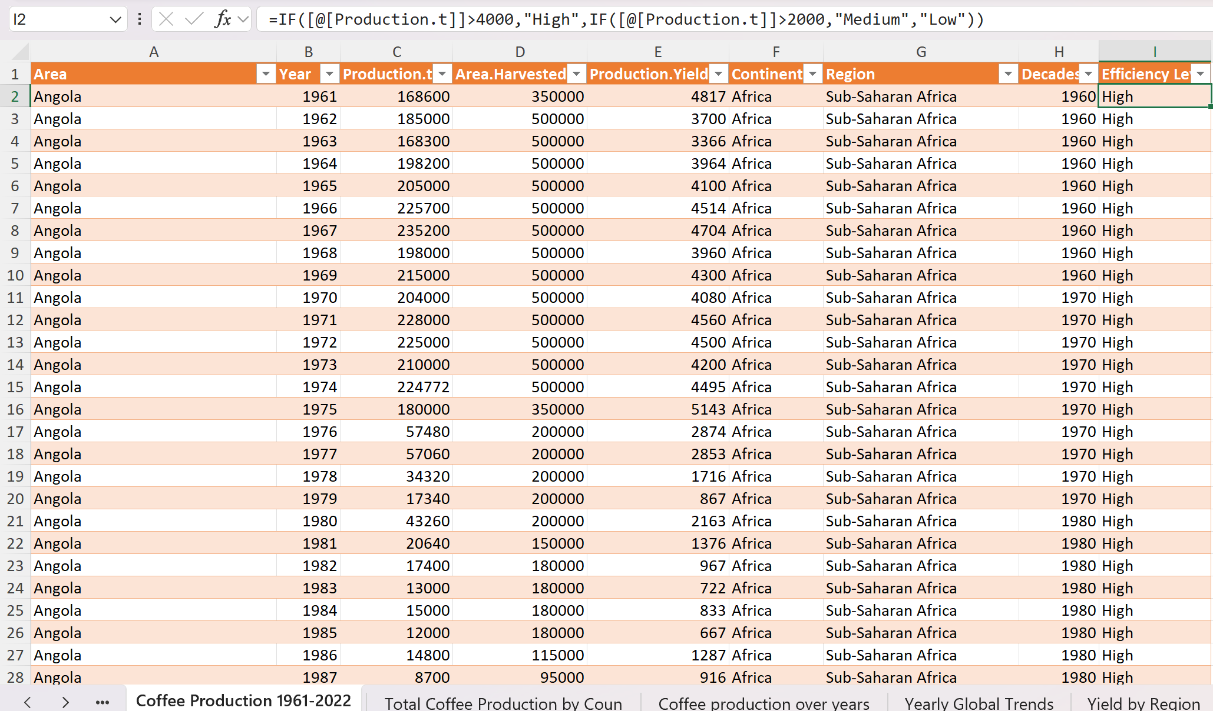

- Pivot Table 1: Total Coffee Production by Country
- A pivot table was created to display cumulative production by the country.
- Rows: Country names
- Values: Sum of Production.t
- Sorting: From largest to smallest
- A column chart was generated to visualize comparative output. This revealed Brazil, Vietnam, and Colombia as top producers globally, while Ethiopia and Uganda led in Africa.
- The insight from the column chart: we can observe from bars of column chat that, African nations, although regionally dominant, produce significantly less than top global exporters, suggesting capacity for expansion and efficiency improvements.
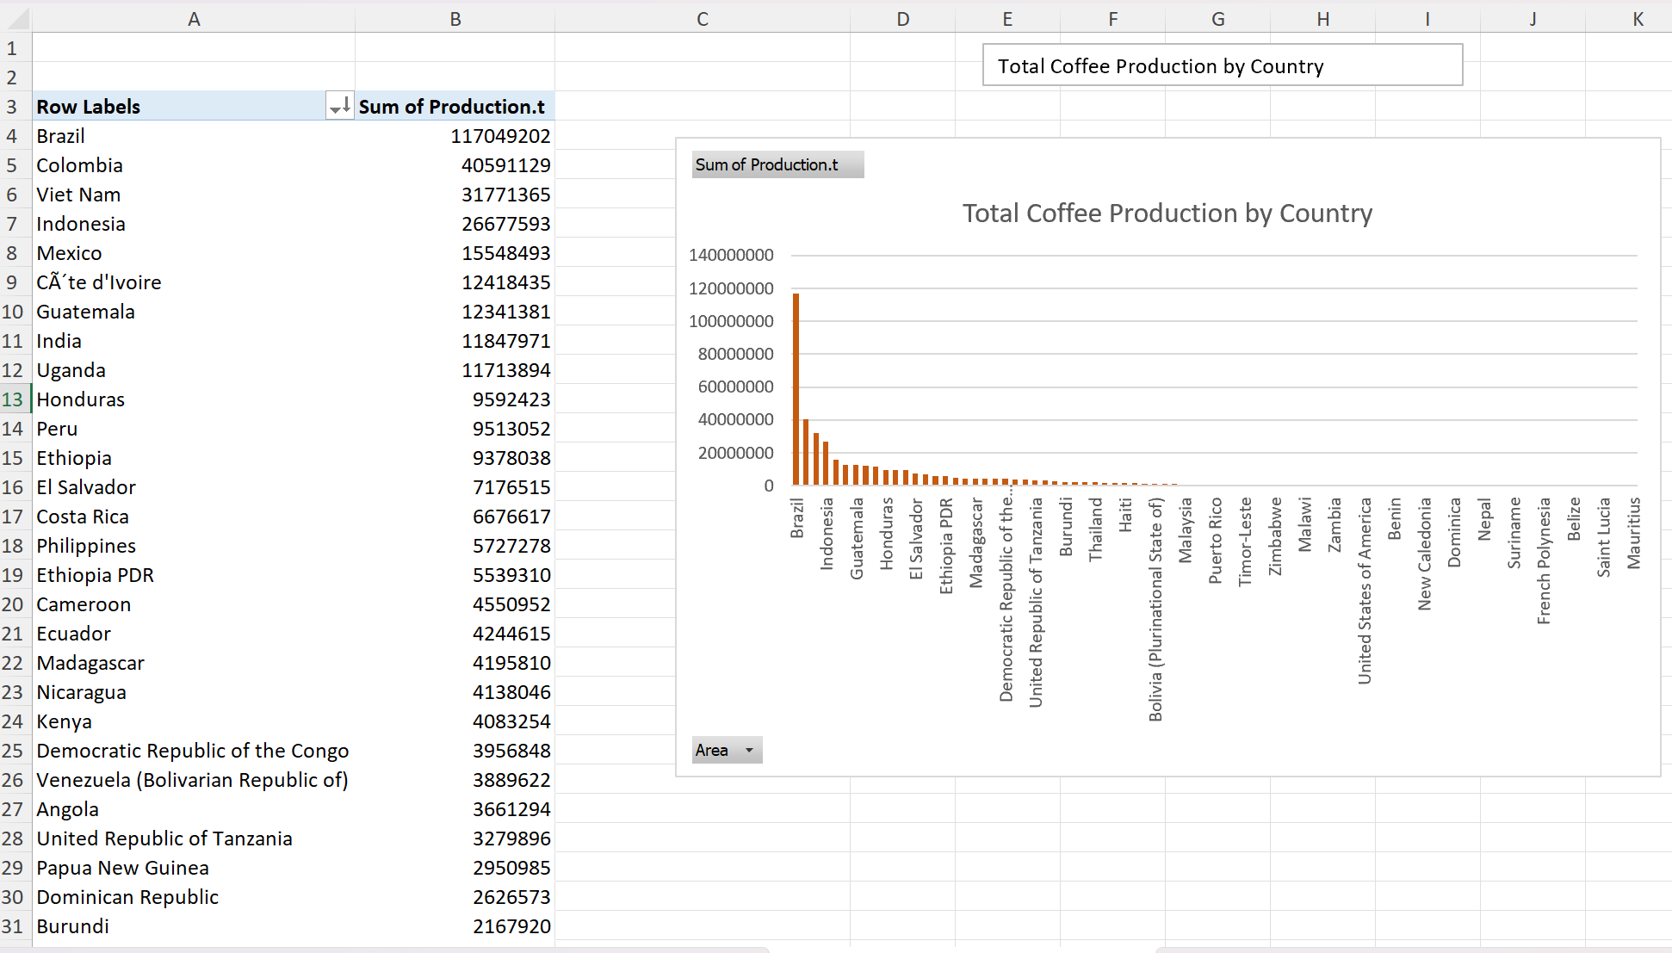

- Pivot Table 2: Global Production Trends Over Time (year)
- This pivot table summarizes yearly global productions.
- Rows: Year
- Values: Sum of Product.t
- Sorting: From smallest to Largest
- Conditional formatting was applied to identify key highs and lows, and a line chart was inserted to illustrate long-term trends.
- From line chart we can observe that Coffee production has steadily increased over the past 60 years, with notable dips likely tied to environmental, economic, or market disruptions.
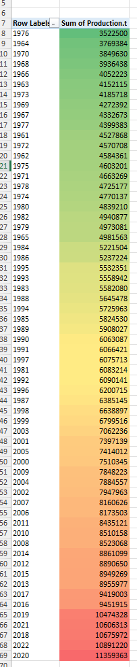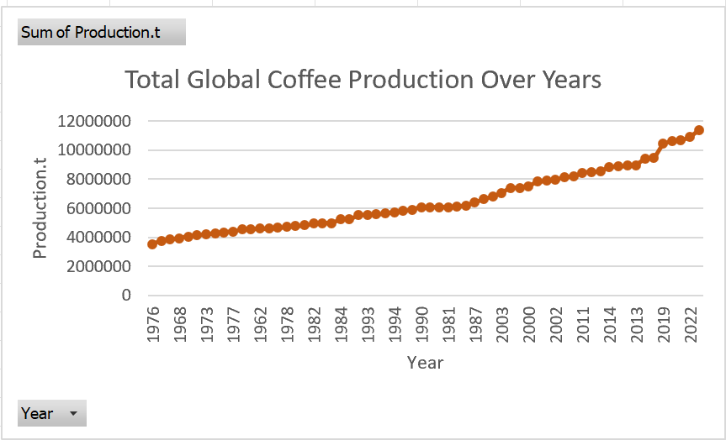

- Pivot Table 3: Yearly Global Trends Over Time (Average Time)
- In this pivot table it captured multi-metric yearly averages.
- Rows: Year
- Values: Average of Production.t, Area.Harvested, Production.Yield
- Slicer: Continent
- A line chart was used for visualization, and a continent slicer was added for interactivity of line chart.
- From line chart based on slicer activity we can observe that, Africa trails behind the Americas and Asia in both yield and production, despite increasing land use—highlighting inefficiencies in cultivation methods.
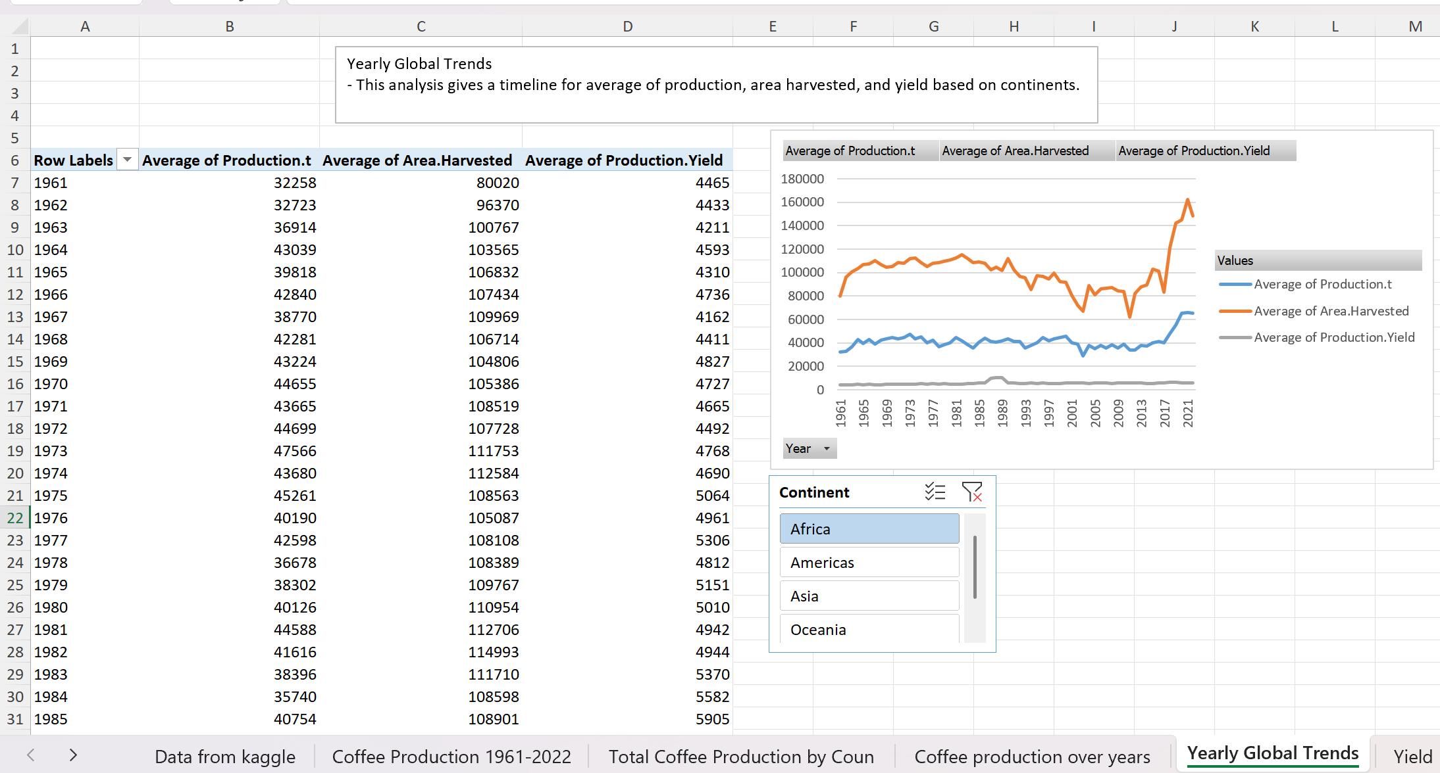

- Pivot Table 4: Yield By Continent
- In this pivot table we explored average production efficiency by continent over year.
- Rows: Continent
- Values: Average of Production.Yield
- A column chart displayed the comparison, and a year slicer allowed for year-specific insights.
- Africa consistently exhibits the lowest average yield per hectare, mostly compared to Americas and Asia, these points to a significant gap in productivity that can be addressed with better farming practices and access to modern agricultural tools.

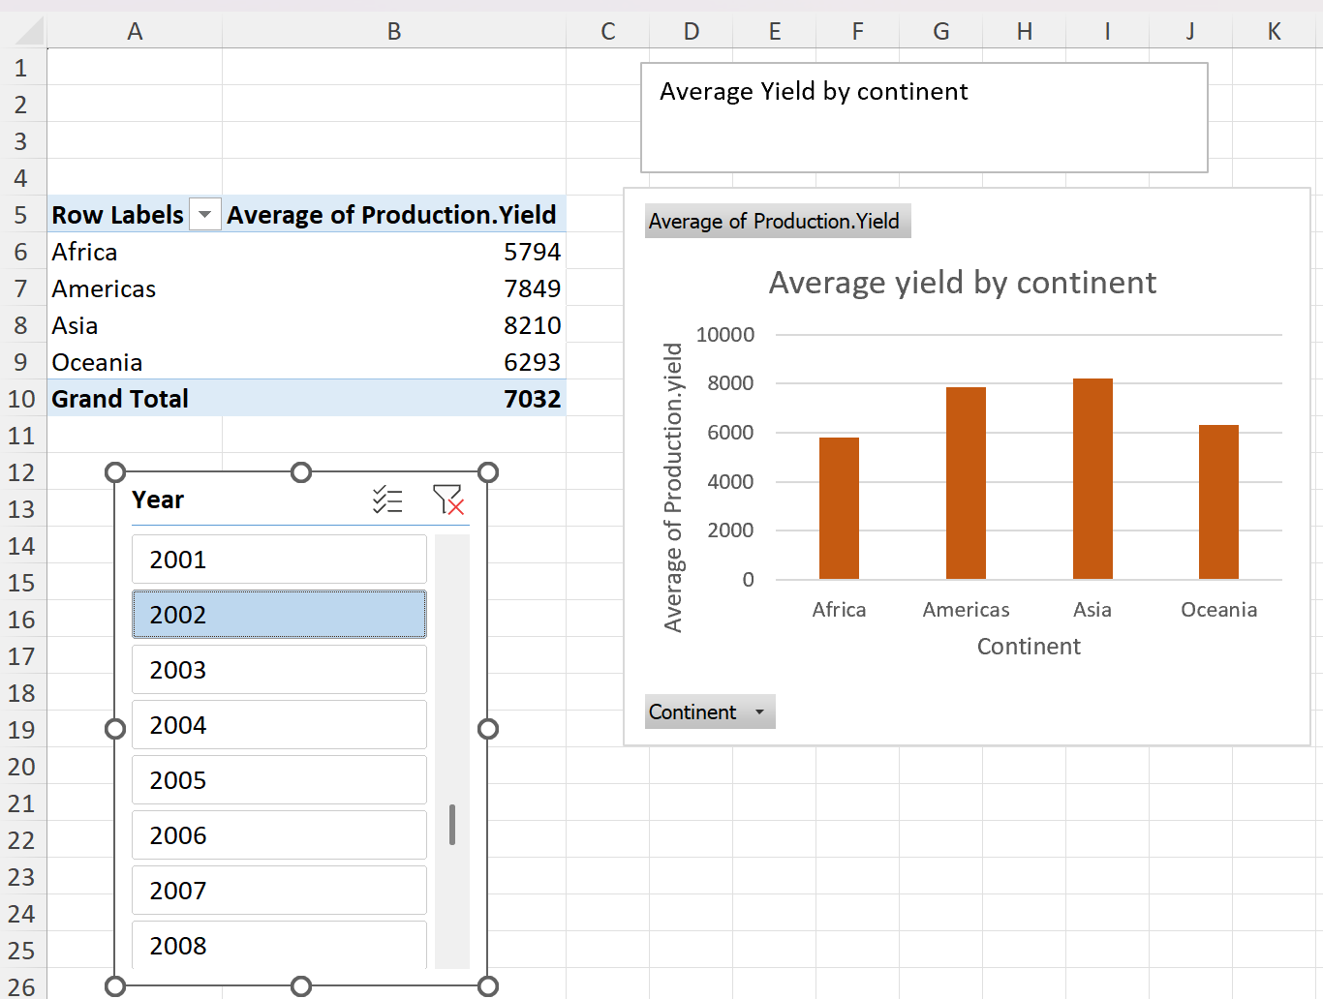
- Pivot Table 5: Production By Continent
- This pivot table calculates each continent’s share of total global production.
- Rows: Continent
- Values: Sum of Production.t
- A doughnut chart visualized the distribution, and a year slicer enabled dynamic comparisons over time.
- The Americas dominate the global coffee market, with Africa holding a modest share (~12%). This visualization highlights the imbalance in global production distribution.

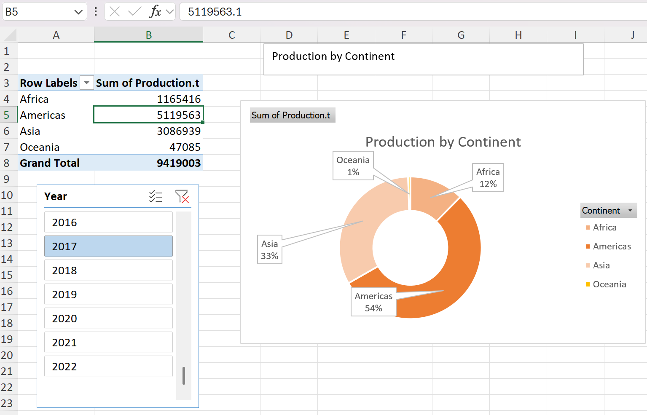

- Pivot Table 6: Comparative Analysis Area Harvested vs Production.t
- In this analysis we focused on the efficiency of land use.
- Rows: Continent
- Values: Average of Area.Harvested and Production.t
- A column chart showed each continent’s productivity relative to the land used, paired with a year slicer for timeline analysis.
- From the observation we can say that Africa cultivates substantial land but yields lower output compared to other continents—suggesting a critical need for yield-focused improvement rather than land expansion alone.
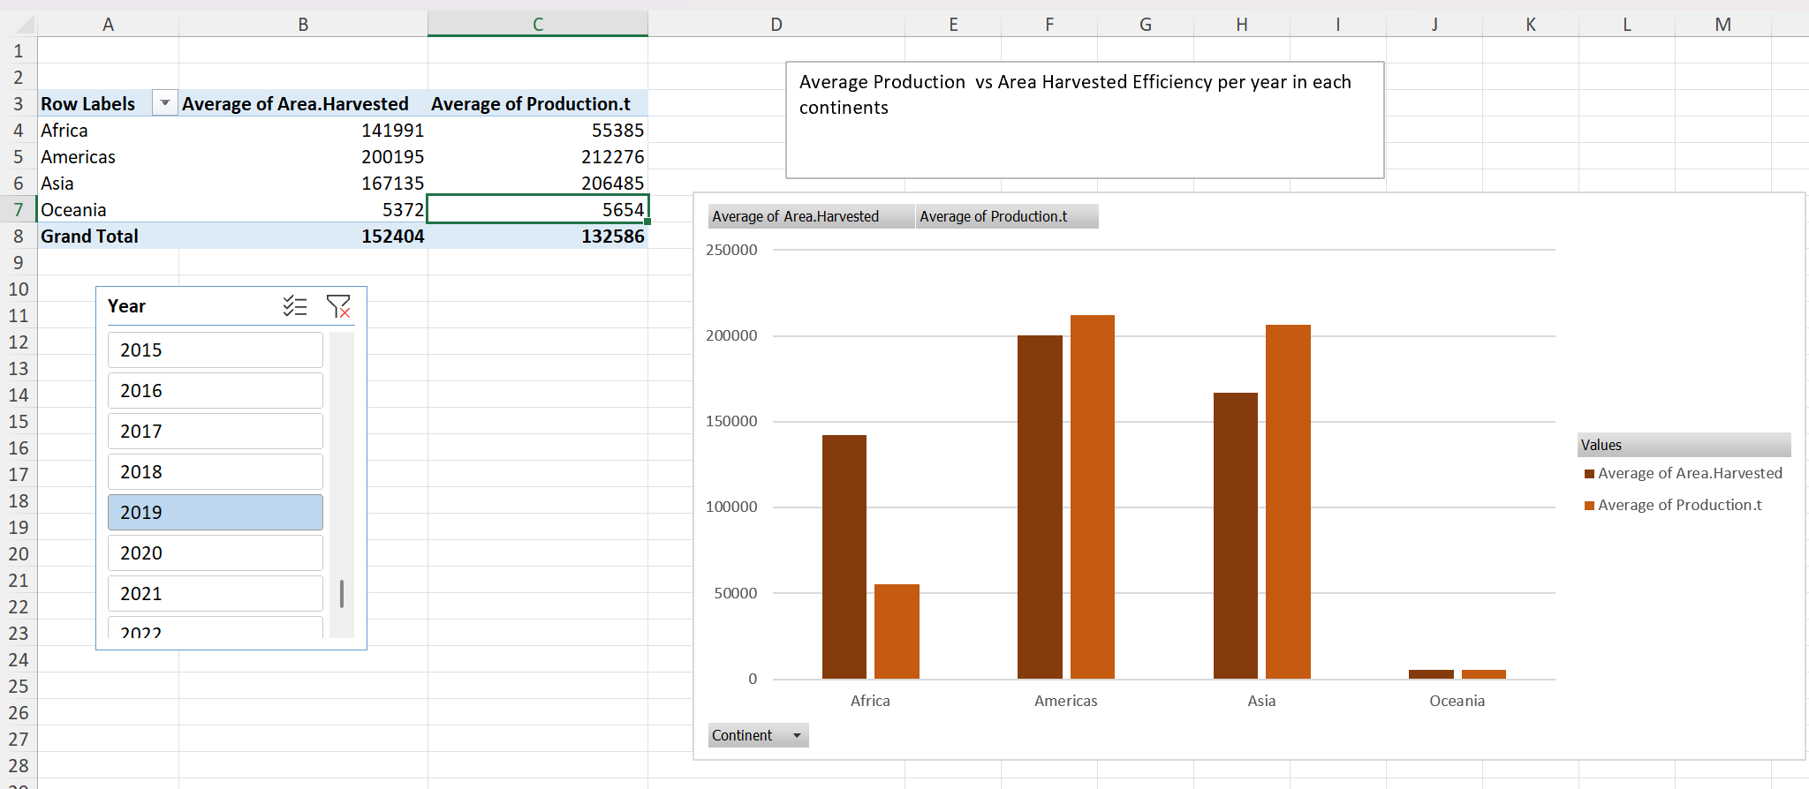

- Conclusion of Analysis and Visualization:
- Africa shows increasing land use but lags in yield and total production.
- Top African producers like Ethiopia and Uganda perform well within the continent but fall short on a global scale.
- Regions like South America and Asia achieve higher yields with less land, because of mechanization, R&D, and policy support.
- Interactive slicers and conditional formatting added interpretive depth to all visualizations.
- This combined analysis and visualization strategy effectively reveals Africa’s current limitations and future opportunities in the coffee sector.
- The findings serve as a foundation for data-driven recommendations focused on sustainable agricultural improvement, strategic investment, and policy reform.

Challenges & Solutions
One of the main challenges was dealing with missing or incomplete data, especially across different years and countries. Inconsistencies in units and formatting also made direct comparisons difficult. Additionally, the large size of the dataset—spanning over 60 years—made it complex to manage and analyze effectively. Comparing yield across diverse regions with different agricultural conditions also posed difficulties. Finally, presenting the results in a clear and engaging way while handling multiple metrics and time frames was challenging.
To address these issues, missing values were managed using interpolation or excluded when unreliable. Units were standardized to tons for production and hectares for area. The dataset was grouped by decade and continent, and pivot tables were used for efficient summarization. A calculated “Efficiency Level” column allowed fair productivity comparisons. Visual clarity was improved using slicers, conditional formatting, and varied chart types including line, column, and doughnut charts, ensuring the findings were accessible and easy to interpret.

Project Work Plan
Milestone | Task | Due Date
Week 1-2 | Data Collection & Cleaning | March 10, 2025
Week 3 | Data Analysis | March 20, 2025
Week 4-5 | Predictive Modeling & Machine Learning | April 3, 2025
Week 6-7 | Visualization & Dashboard Development | April 17, 2025
Week 8 | Final Report Compilation | April 24, 2025
Week 9 | Review & Presentation Preparation | May 1, 2025
Week 10 | Final Presentation & Submission | May 6, 2025

Conclusion
This project analyzed global coffee production trends with a focus on Africa’s performance compared to other continents from 1961 to 2022. The findings revealed that despite its vast agricultural potential, Africa contributes a relatively small share to global coffee output due to low yield efficiency and outdated practices. Countries like Ethiopia and Uganda lead within the continent but still lag global leaders such as Brazil and Vietnam. By using pivot tables, calculated metrics, and dynamic visualizations, the study identified key gaps and opportunities for improvement. These insights can support policymakers in shaping agricultural reforms, guide development organizations in targeting resources effectively, inform investors about growth markets, and help farmers and cooperatives enhance productivity. Overall, the project provides a valuable foundation for data-driven strategies aimed at boosting Africa’s competitiveness and sustainability in the global coffee trade.

References
- Kaggle: https://www.kaggle.com/
- FAOSTAT Coffee Production Data 1961-2022: https://www.kaggle.com/datasets/junkochida/faostat-coffee-production-data-1961-2022?select=Coffee_Production_1961-2022.csv
- Report for reference: Africa_s_Coffee_Sector_Status__Challenges_and_Opportunities_for_Growth

