University of Central Missouri

Department of Computer Science & Cybersecurity

CS5710 Machine Learning

Fall 2025

Home Assignment 4.

Student name: Sravya Mendem

Student ID: 700765926

Submission Requirements:
- Once finished your assignment push your source code to your repo (GitHub) and explain the work through the ReadMe file properly. Make sure you add your student info in the ReadMe file.
- Comment your code appropriately IMPORTANT.
- Any submission after provided deadline is considered as a late submission.

Part A: Calculation

Q1. Find the cluster using the Average and MIN technique. Use Euclidean distance to build the complete distance matrix, updated the distance matrix to the final step and draw the dendrogram for each.
 | X | Y
P1 | 0.4 | 0.5
P2 | 0.2 | 0.3
P3 | 0.1 | 0.08
P4 | 0.21 | 0.12
P5 | 0.6 | 0.16
P6 | 0.33 | 0.28
P7 | 0.11 | 0.15

Q2. We have the following 2D data points:
Points: (2,1), (3,1), (3, 3), (4, 1), (5, 1), (6,7), (1,3), (2,5)
for K =3:
Centroid1: (2,1)
Centroid 2: (4, 1)
Centroid 3: (5, 1)

Euclidean Distance:

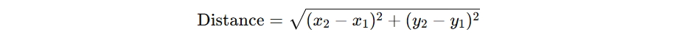

Part B — Short-Answer

Q1.

a) Describe agglomerative hierarchical clustering.
b) Describe divisive hierarchical clustering.
c) Which one is more commonly used and why?

Q2.

a) To improve clustering quality, should inter-cluster distance be maximized or minimized?
b) Same question for intra-cluster distance — explain the reasoning.

Q3.

a) Define single link, complete link, and average link.
b) Explain one strength and one weakness of single-link clustering.

Q4.

a) What is the role of tokenization and give one example.
b) Compare stemming vs. lemmatization in terms of speed and accuracy.

Q5.

a) Explain what word sense ambiguity is and provide an example.
b) Explain why pronoun reference ambiguity can confuse a model.

Q6.

a) Why can’t NLP tasks like POS tagging be solved by predicting each token independently?
b) Give one example where decisions are mutually dependent in a sentence.

Part C — Coding
Q1.
Write Python code to perform the following steps:
- Segment into tokens
- Remove stopwords
- Apply lemmatization (not stemming)
- Keep only verbs and nouns (use POS tags)
Input text:
"John enjoys playing football while Mary loves reading books in the library."
Code:
import nltk
from nltk.corpus import stopwords
from nltk.stem import WordNetLemmatizer
from nltk import word_tokenize, pos_tag

# ✅ Download all required NLTK resources
nltk.download('punkt')
nltk.download('punkt_tab') # new in NLTK ≥3.9
nltk.download('averaged_perceptron_tagger')
nltk.download('averaged_perceptron_tagger_eng') # new tagger model name
nltk.download('wordnet')
nltk.download('stopwords')
nltk.download('omw-1.4')

# Input text
text = "John enjoys playing football while Mary loves reading books in the library."

# Step 1: Tokenization
tokens = word_tokenize(text)

# Step 2: Remove stopwords and non-alphabetic tokens
stop_words = set(stopwords.words('english'))
filtered_tokens = [w for w in tokens if w.lower() not in stop_words and w.isalpha()]

# Step 3: Lemmatization
lemmatizer = WordNetLemmatizer()

# Helper function to map POS tags for lemmatization
def get_wordnet_pos(tag):
if tag.startswith('J'):
return 'a' # adjective
elif tag.startswith('V'):
return 'v' # verb
elif tag.startswith('N'):
return 'n' # noun
elif tag.startswith('R'):
return 'r' # adverb
else:
return None

# Step 4: POS tagging
pos_tags = pos_tag(filtered_tokens)

# Step 5: Lemmatize and keep only nouns & verbs
final_words = []
for word, tag in pos_tags:
wn_tag = get_wordnet_pos(tag)
if wn_tag in ('n', 'v'): # keep only nouns and verbs
lemma = lemmatizer.lemmatize(word.lower(), wn_tag)
final_words.append(lemma)

print("Final output tokens:", final_words)

Output:
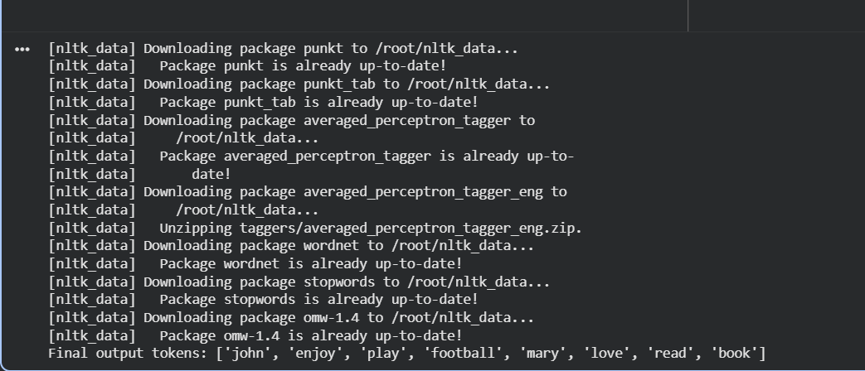

Q2.
Use Python and any NLP model to perform:
- Named Entity Recognition (NER)
- Disambiguation prompt:
If the text contains a pronoun ("he", "she", "they"), print:
"Warning: Possible pronoun ambiguity detected!"
Input text:
"Chris met Alex at Apple headquarters in California. He told him about the new iPhone launch."
Code:
import spacy

# Load English NLP model (small, fast, and pre-trained)
nlp = spacy.load("en_core_web_sm")

# Input text
text = "Chris met Alex at Apple headquarters in California. He told him about the new iPhone launch."

# Process text through spaCy pipeline
doc = nlp(text)

# 1️⃣ Named Entity Recognition (NER)
print("=== Named Entities ===")
for ent in doc.ents:
print(f"{ent.text} --> {ent.label_}")

# 2️⃣ Pronoun Disambiguation Warning
pronouns = {"he", "she", "they", "him", "her", "them"}
tokens_lower = [token.text.lower() for token in doc]

if any(p in tokens_lower for p in pronouns):
print("\n⚠️ Warning: Possible pronoun ambiguity detected!")
else:
print("\nNo pronoun ambiguity detected.")

Output:
