Predicting Post-Operative Delirium Using Classical Machine Learning (Team - 08)

Srinivas Reddy Pittu - 700777009
Sai Kumar Beesa - 700773299
Praneeth Teja Jilkapally - 700781935
Sravya Mendem - 700765926

This report describes a machine learning project that predicts the risk of post-operative delirium in elderly surgical patients using routinely collected clinical data. The work applies several classical models, explores patient phenotypes, and builds a simple patient-level risk interface.

Abstract
Post-operative delirium is a common and serious complication in older surgical patients. It is associated with longer hospital stays, falls, higher mortality, and long-term cognitive decline. Early identification of high-risk patients can help clinicians plan closer monitoring and prevention strategies. In this project, I applied several classical machine learning methods to an anonymized dataset of elderly surgical or hip-fracture patients to predict the risk of post-operative delirium using routine clinical variables. After data cleaning, median imputation, and an 80/20 stratified train–test split, I trained and compared Logistic Regression, Random Forest, Support Vector Machine (RBF kernel), and a Multi-Layer Perceptron neural network. Performance was evaluated mainly using ROC AUC, along with classification reports and confusion matrices. I also used Principal Component Analysis (PCA) and K-Means clustering to explore patient phenotypes, and I built a simple patient-level prediction interface based on a trained Random Forest. The results show that classical models can provide meaningful delirium risk estimates; the MLP achieved the highest test ROC AUC (around 0.80), while Logistic Regression offered a strong interpretable baseline. Random Forest feature importances and clustering analysis highlighted clinically sensible risk factors such as age, frailty, ICU admission, and abnormal lab values. The project demonstrates how course concepts can be applied to a real healthcare problem, while also discussing limitations, ethical considerations, and directions for future work.

1. Introduction
Post-operative delirium is an acute and fluctuating disturbance in attention and cognition that often occurs after surgery or critical illness, especially in older adults. Patients may become disoriented, confused about time and place, or show sudden changes in behaviour and level of alertness. Delirium is not just uncomfortable; it is linked to longer hospital stays, more complications, increased risk of falls, higher mortality, and long-term cognitive decline. Because of these serious outcomes, preventing and managing delirium is an important goal in peri-operative care.
The positive side is that some delirium is preventable. If high-risk patients are identified early, clinicians can adjust medications, plan non-drug interventions, and schedule closer monitoring. This creates an opportunity for data-driven tools that can support risk assessment.
Traditionally, delirium risk is assessed using manual scoring tools and clinical judgement. These methods can be time-consuming, somewhat subjective, and may vary between clinicians. At the same time, hospitals routinely collect a rich set of peri-operative data for each patient, including demographics, frailty scores, laboratory results, and ICU information.
The central question of this project is: Can classical machine learning models predict post-operative delirium risk from routinely collected clinical data, and can the results be presented in an interpretable way for clinicians? The specific objectives are to clean and preprocess an anonymized delirium dataset of elderly surgical patients; to train and compare several machine learning classifiers, including Logistic Regression, Random Forest, SVM with RBF kernel, and a Multi-Layer Perceptron neural network; to explore the structure of the patient cohort using PCA and K-Means clustering; to identify key risk factors using model interpretation tools; and to build a simple patient-level interface that outputs a Low versus High delirium risk label based on entered features.

2. Dataset and Pre-Processing
The dataset (stored in delirium_ml.xlsx) contains data for a little over 200 elderly surgical or hip-fracture patients. Each row represents a single patient encounter, and each column corresponds to a clinical variable. Examples of features include demographics such as age, height, and body mass index; frailty information such as a frailty index; pre- and post-operative laboratory results such as haematocrit, albumin, and creatinine; and peri-operative variables such as duration of anaesthesia, duration of surgery, ICU admission, use of vasopressors, infusions, and blood products, as well as post-operative length of stay. The target variable is Postop Delirium, encoded as zero if the patient did not develop delirium and one if the patient did. Delirium cases are less frequent than non-delirium cases, so this is an imbalanced binary classification problem.
Several columns in the raw Excel file were stored as text even though they represented numeric measurements. These were converted to numeric types using pandas, with non-numeric entries treated as missing values. For numeric features with missing values, I used median imputation instead of dropping rows. The median is robust to outliers and suitable for clinical lab data, which can contain extreme values. The patient identifier column was removed from the feature matrix to avoid leakage.
After cleaning, I defined X as the feature matrix containing all predictors (excluding the ID and target) and y as the binary target vector Postop Delirium. I then performed an 80/20 stratified train–test split using train_test_split with stratify=y so that the proportion of delirium versus non-delirium patients was similar in both the training and test sets. The test set contained 49 patients. For models that are sensitive to feature scales, including Logistic Regression, SVM, and the MLP, I applied StandardScaler. The scaler was fitted on the training data only and then applied to both training and test sets to avoid information leakage.

3. Methods

3.1 Logistic Regression
Logistic Regression is a linear classifier that models the log-odds of the positive class (delirium) as a linear combination of the features. It outputs a probability between 0 and 1, which is then thresholded to obtain a class label.
In this project, Logistic Regression served as an interpretable baseline. I used class_weight="balanced" so that errors on the minority class (delirium) were given more weight, which helps handle class imbalance.
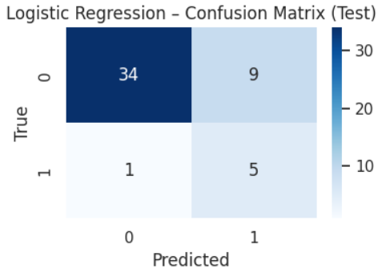
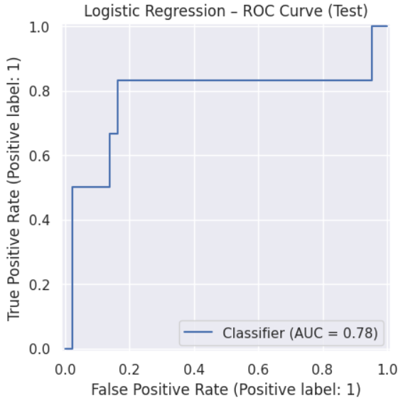

3.2 Random Forest
Random Forest is an ensemble of decision trees. Each tree is trained on a bootstrap sample of the training data, and at each split, a random subset of features is considered. The final prediction is obtained by majority vote across trees.
Random Forest can model non-linear relationships and feature interactions, and it provides feature importance scores based on how much each variable reduces impurity across the forest. In this project, Random Forest was used both as a classifier and as a tool to interpret which clinical variables are most important for predicting delirium.
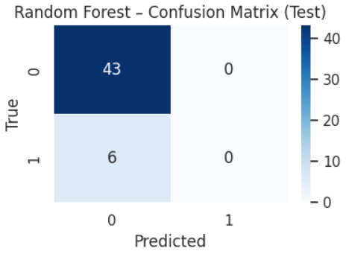

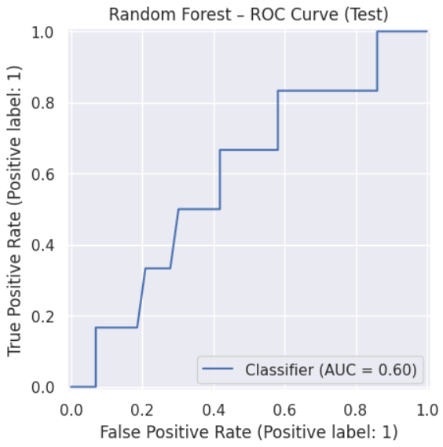
3.3 Support Vector Machine (RBF)
The Support Vector Machine (SVM) with a radial basis function (RBF) kernel is a powerful classifier that tries to maximize the margin between classes in a transformed feature space. The RBF kernel allows the model to learn non-linear decision boundaries.
Because SVMs are sensitive to feature scales, I used the standardized versions of the features. Probabilities for the positive class were obtained using standard probability calibration inside scikit-learn.
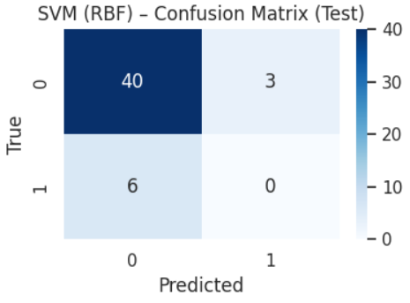
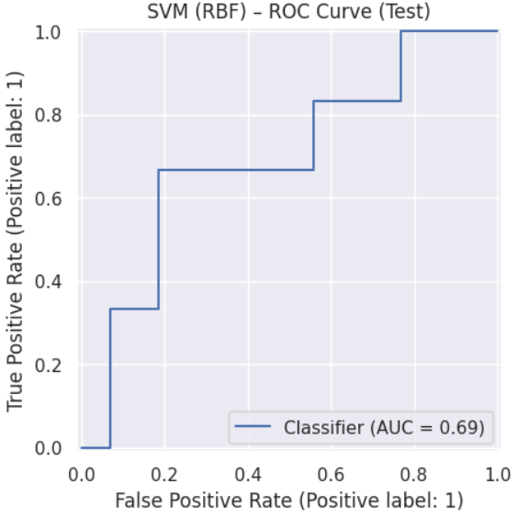

3.4 Multi-Layer Perceptron (MLP) Neural Network
The MLP is a small feed-forward neural network. In this project, I used two hidden layers with ReLU activation and a final sigmoid output for binary classification. Early stopping and regularization were used to reduce overfitting.
The MLP aims to capture complex non-linear relations between features. Although it is less interpretable than Logistic Regression or Random Forest, it can sometimes provide better predictive performance on tabular data.
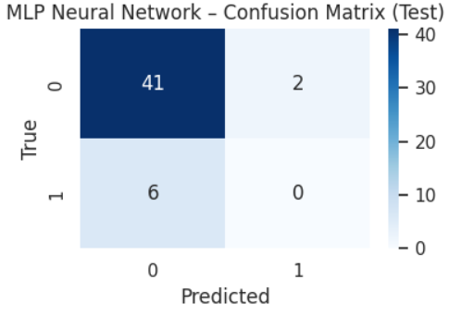
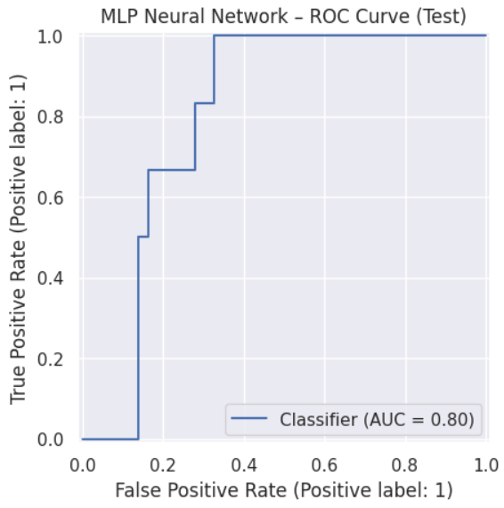
To explore the structure of the patient cohort, I applied Principal Component Analysis on the standardised training features. PCA constructs new orthogonal axes that capture the largest variance in the data; in this case, the first two components captured roughly twenty-three percent of the variance. I then applied K-Means clustering with k = 3 on the PCA-transformed data to identify patient phenotypes. Finally, I implemented a patient-level risk interface based on the trained Random Forest. The interface starts from a template patient built from median feature values, allows key fields such as age, frailty index, ICU status and lab values to be overridden, and then uses the Random Forest to return both a predicted class and a probability of delirium, which is mapped to a Low versus High risk interpretation.
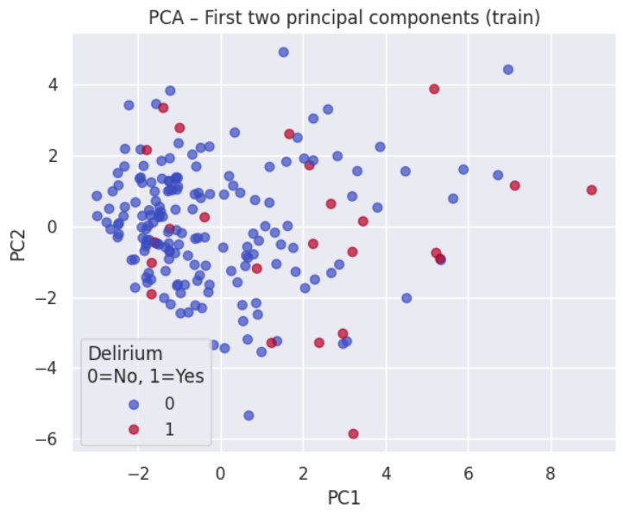
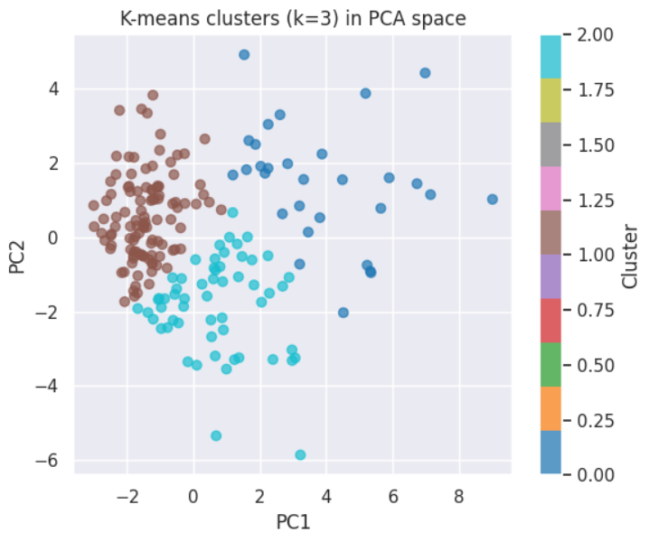

4. Experiments and Results

4.1 Model Performance (ROC AUC)
Using the 20% test set (49 patients), the models achieved the following ROC AUC scores:
- Logistic Regression: AUC ≈ 0.779
- Random Forest: AUC ≈ 0.597
- SVM (RBF): AUC ≈ 0.694
- MLP Neural Network: AUC ≈ 0.802
The MLP provided the best separation between delirium and non-delirium patients in terms of ROC AUC, followed by Logistic Regression. Random Forest and SVM had lower AUC values and were closer to baseline performance.

4.2 Confusion Matrices and Class Behaviour
At the default classification threshold of 0.5, confusion matrices were computed on the test set.
For Logistic Regression:
- True Negatives (TN): 34
- False Positives (FP): 9
- False Negatives (FN): 1
- True Positives (TP): 5
This means Logistic Regression correctly identified 5 out of 6 delirium patients (high recall for class 1) but also produced some false alarms.
For Random Forest, SVM, and MLP, the confusion matrices showed that, at the 0.5 threshold on this small test set, they predicted almost all patients as non-delirium. As a result, they achieved good accuracy on the majority class but missed all positive cases (TP = 0, FN = 6). This behaviour reflects the strong class imbalance and the high default threshold. The ROC curves, however, show that if the threshold were lowered, these models could achieve better recall for delirium.
The key lesson is that confusion matrices show model behaviour at a specific threshold, while ROC AUC shows potential performance across all possible thresholds.

4.3 Feature Importance from Random Forest
Despite its lower ROC AUC, Random Forest provided useful feature importance scores. The top 15 features included:
- Haematocrit (Hct)
- Duration of anaesthesia (DuraAnes)
- Post-operative length of stay
- Post-operative FFP transfusion
- Albumin (Alb)
- BMI
- Duration of surgery (DuraSurg)
- Creatinine (Cre)
- Preparation days
- Infusion use
- Age
- Height
- Post-operative CRC
- ICU admission
- Vasopressor use
Higher importance values indicate that the feature contributed more to reducing impurity in the forest. Many of these variables are clinically sensible: older, frailer patients with abnormal lab values, longer procedures, ICU stays, and more intense interventions are intuitively at higher delirium risk.

4.4 PCA and K-Means Clustering Results
The PCA scatter plot (PC1 vs PC2) showed the distribution of patients in a reduced two-dimensional space, coloured by delirium outcome. While the classes were not perfectly separable, delirium cases tended to appear more frequently in certain regions, suggesting underlying structure.
Using K-Means clustering with k = 3 on the PCA-transformed data produced three clusters with the following sizes and delirium rates (approximate):
- Cluster 0: 109 patients, delirium rate ≈ 6.4%
- Cluster 1: 30 patients, delirium rate ≈ 33.3%
- Cluster 2: 57 patients, delirium rate ≈ 12.3%
Cluster 1 clearly had a much higher delirium rate than the others. This indicates a potential high-risk phenotype: a subgroup of patients whose combination of age, frailty, lab values, and peri-operative factors leads to significantly higher delirium risk.

4.5 Patient-Level Predictions
Using the Random Forest-based interface, I created example patient profiles by altering key features while keeping others at median values. For each example, the interface printed:
- The input values for the fields changed.
- The predicted class (0 or 1).
- The predicted probability of delirium.
- A simple interpretation (“Low chance” or “High risk”).
By testing several scenarios, I observed that increasing age, frailty index, ICU admission, and abnormal lab values led to higher predicted probabilities. This behaviour matches clinical expectations and demonstrates that the model responds logically to changes in key inputs.
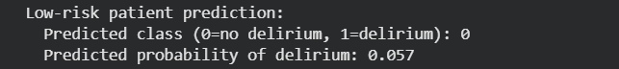
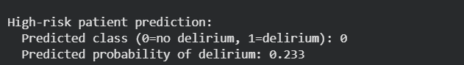
5. Discussion
The experiments demonstrate that classical machine learning models can use routine clinical data to estimate delirium risk in elderly surgical patients. The Multi-Layer Perceptron achieved the highest ROC AUC, suggesting that non-linear relationships are important in this problem. Logistic Regression performed well despite its simplicity and offers the advantage of transparent coefficients that clinicians can interpret.
Random Forest, although weaker in AUC, provided valuable insights into which variables the model relied on. Feature importances and Logistic Regression coefficients agreed on key risk factors, including age, frailty, ICU admission and abnormal lab values. This agreement between model outputs and clinical intuition increases trust in the results. The PCA and clustering analysis further supported the supervised models by revealing a high-risk cluster with a much higher delirium rate.
The patient-level interface illustrates how a research model can be turned into a simple tool. Although not ready for deployment, it shows the end-to-end workflow: enter a set of basic clinical variables and obtain a risk estimate plus a Low or High risk flag. This style of interface could eventually be integrated into electronic health records to provide proactive warnings for vulnerable patients.

6. Limitations and Ethical Considerations
This project has several limitations. The dataset is relatively small and comes from a single cohort, so the models may not generalise well to other hospitals or populations. Delirium labels depend on clinical diagnosis and documentation, which may miss mild or atypical cases. Important variables such as medication details, baseline cognition, environmental factors and time-series vital signs are not available in the dataset. Hyper-parameter tuning and cross-validation were limited, so the reported performance metrics may still be noisy, and the models have not been calibrated or tested prospectively.
From an ethical perspective, the models should be viewed strictly as research and educational prototypes. They are not validated for clinical use and should not be used to make decisions about individual patients. Any real deployment would require much larger, multi-centre datasets, careful calibration of probabilities, detailed bias analysis across subgroups, regulatory approval and close collaboration with clinicians. Even in a mature system, the model should act as decision support and not replace clinical judgement.

7. Future Work
Future work includes collecting larger and richer datasets from multiple centres and incorporating additional clinical variables such as medication regimens and time-series vital signs. Systematic hyper-parameter tuning and k-fold cross-validation should be used to obtain more reliable performance estimates. Advanced methods such as gradient boosting models, including XGBoost or LightGBM, could be explored for potentially higher accuracy on tabular data.
Another important direction is probability calibration using methods such as Platt scaling or isotonic regression, combined with calibration plots and Brier scores. On the application side, the Random Forest or a better-performing interpretable model could be wrapped in a web or Streamlit application and, in the long term, integrated into an electronic health record system. Finally, external validation studies and impact evaluations would be needed to determine whether using such a tool actually reduces delirium rates or improves patient outcomes.

8. Conclusion
This project applied classical machine learning methods to predict post-operative delirium in elderly surgical patients using routinely collected clinical data. After careful preprocessing and stratified splitting, four models were trained and evaluated. The Multi-Layer Perceptron neural network achieved the highest ROC AUC, while Logistic Regression provided a strong interpretable baseline. Random Forest feature importances and unsupervised clustering highlighted clinically meaningful risk factors and high-risk patient phenotypes.
Although the models are not ready for clinical deployment, they show that even relatively simple algorithms can extract useful signals about delirium risk from standard hospital data. The project demonstrates how machine learning techniques from a master’s course can be translated into a healthcare context and lays a foundation for future, more advanced clinical decision-support tools aimed at reducing the burden of post-operative delirium.

