**Sravya pidugu (50249282)**

**1.Stereo Vision**

**1.1 Disparity estimation using block matching**

Left disparity

3*3 windows----------leftDisparity_MSE_3_win=47.9622263732

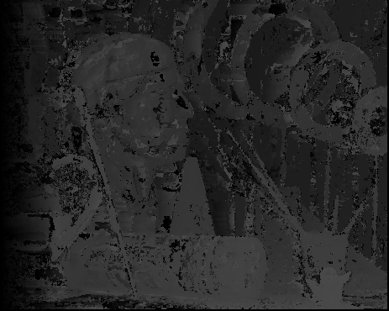

9*9 window-----leftDisparity_MSE_9_win=35.1475920845

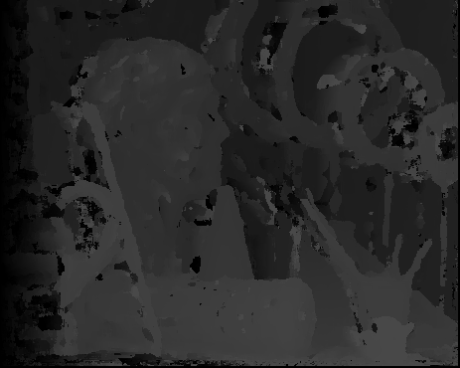

Right disparity

3*3 window----rightDisparity_MSE_3_win=46.7877765454

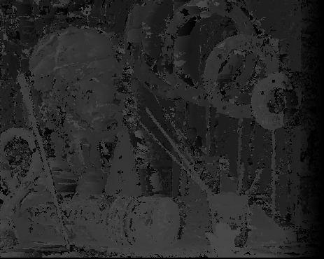

9*9 window---rightDisparity_MSE_9_win=35.7310431382

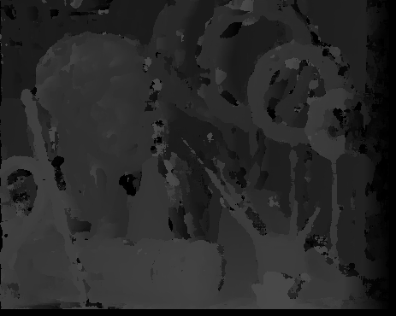

**1.2 Consistency check**

3*3 left----consistent_left_3_win_mse = 6.93845757438

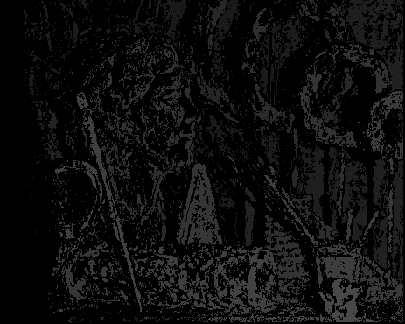

9*9 left----consistent_left_9_win_mse = 7.31207572055

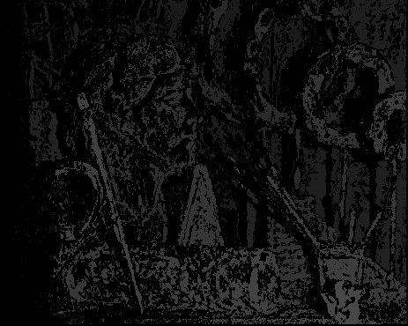

3*3 right---consistent_right_3_win_mse = 7.51090034524

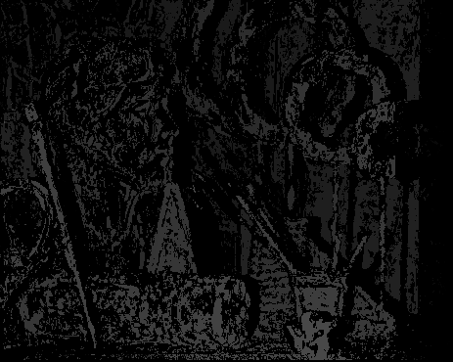

9*9 right--consistent_right_9_win_mse = 7.51090034524



**1.3 Disparity estimation using Dynamic Programming**

leftDisparity

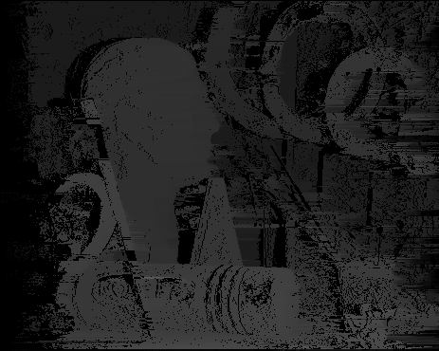

rightDisparity

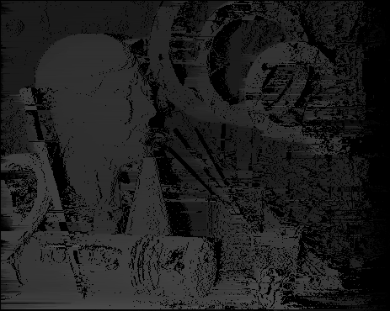

**1.4 View Synthesis-**

**View3_initial**

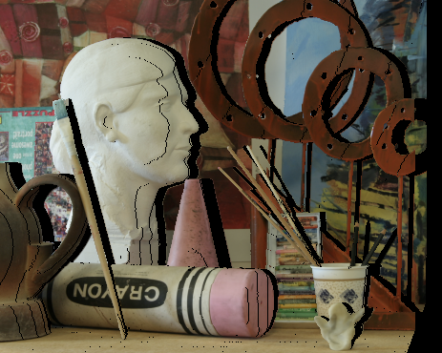

**View3_final**

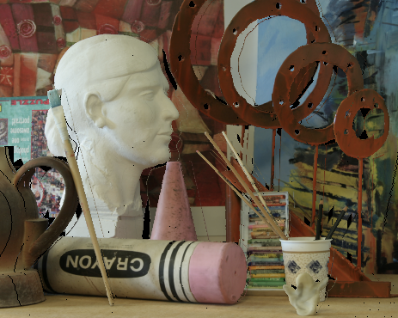

**2 Image Segmentation**

