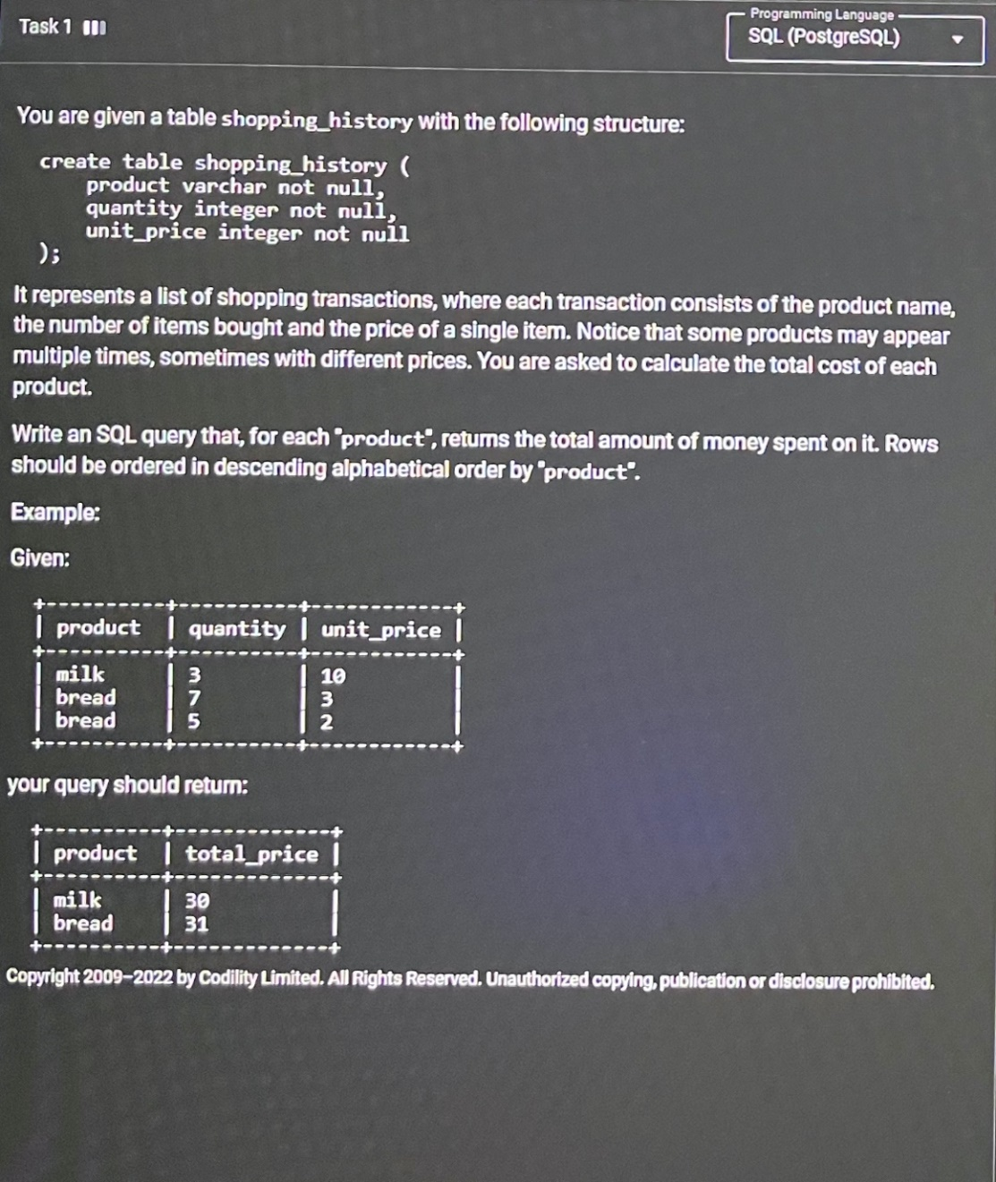

Solution : select product,sum(quantity*unit_price) as total_price from shopping_history group by product

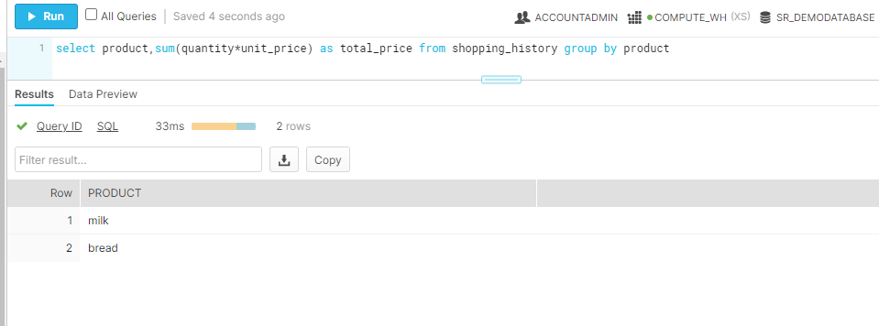

Task 2:

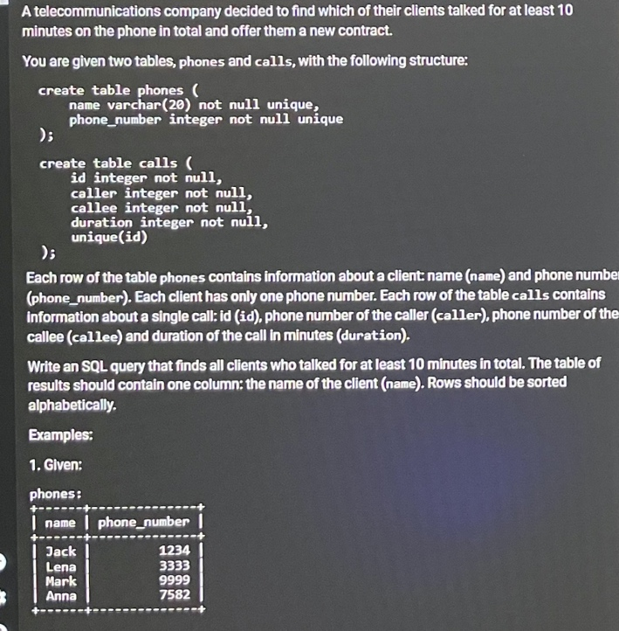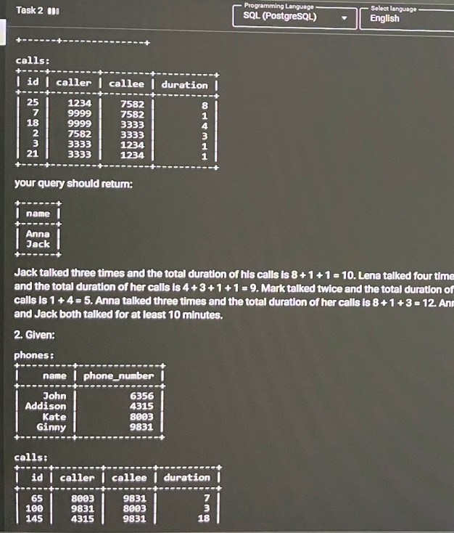

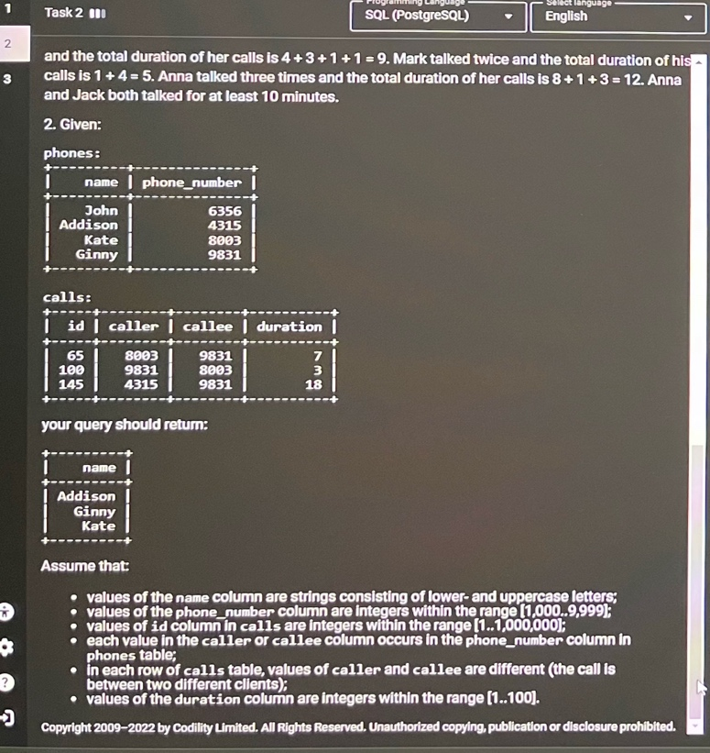

Solution :

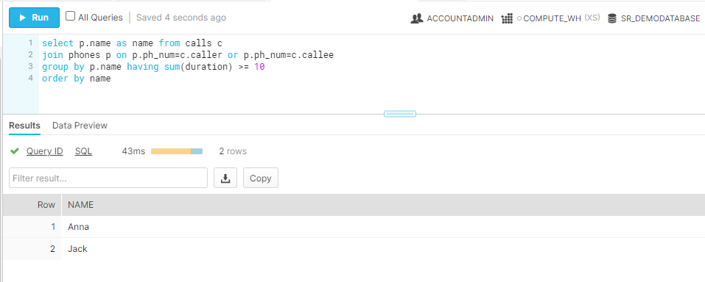

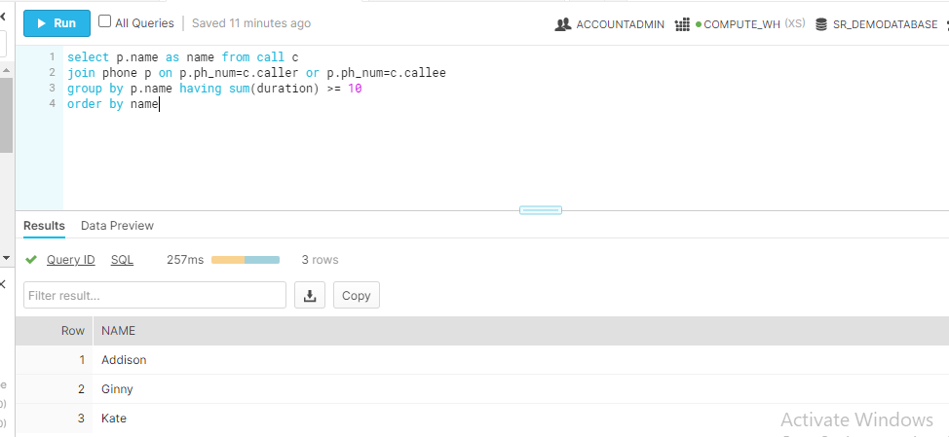

Solution :

select p.name as name from call c

join phone p on p.ph_num=c.caller or p.ph_num=c.callee

group by p.name having sum(duration) >= 10

order by name

Task 3:

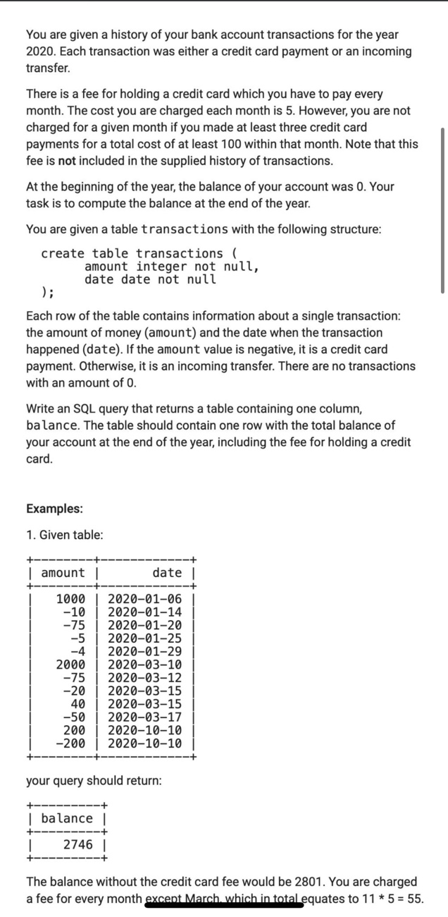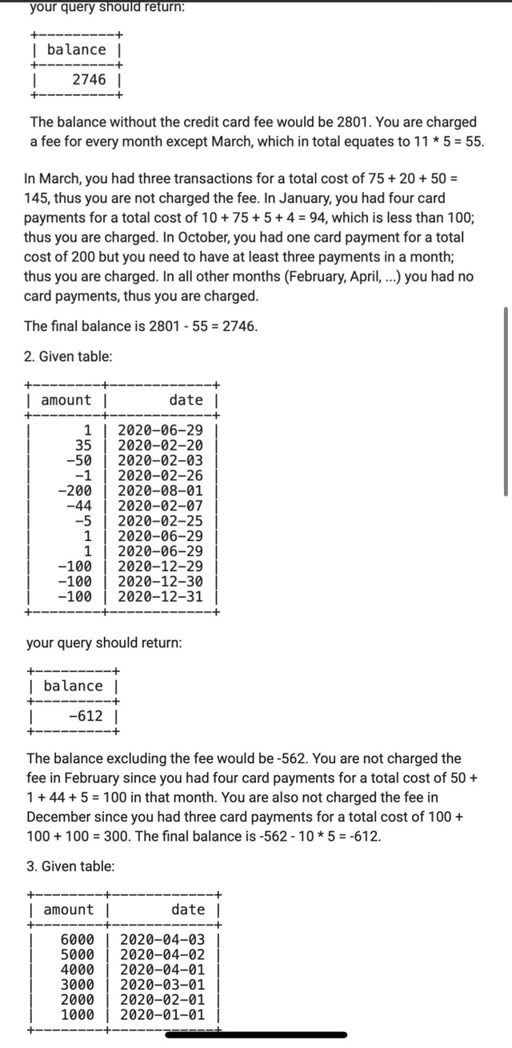

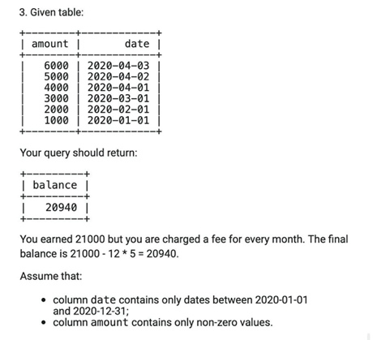

Solution :

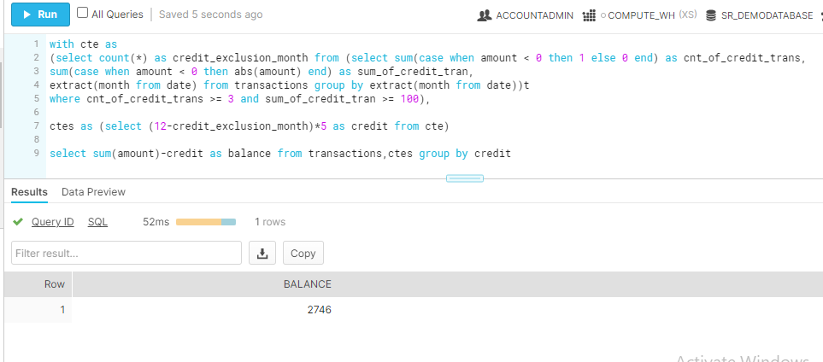

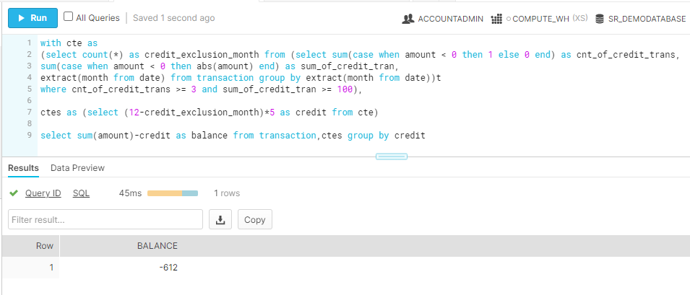

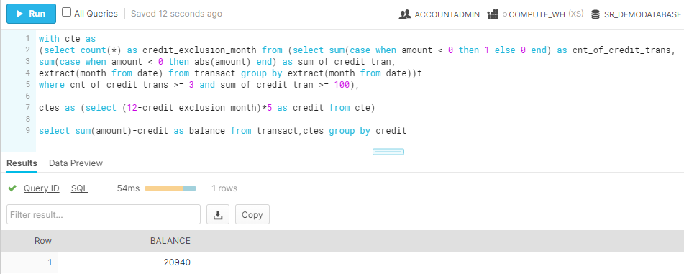

Solution :

with cte as

(select count(*) as credit_exclusion_month from (select sum(case when amount < 0 then 1 else 0 end) as cnt_of_credit_trans,

sum(case when amount < 0 then abs(amount) end) as sum_of_credit_tran,

extract(month from date) from transact group by extract(month from date))t

where cnt_of_credit_trans >= 3 and sum_of_credit_tran >= 100),

ctes as (select (12-credit_exclusion_month)*5 as credit from cte)

select sum(amount)-credit as balance from transact,ctes group by credit