

Sprint 2 Proposal – Team “APEX”
Project: Sustainable Grocery Tracker

Team members
1.Nandini kadiyala
2. Sravya Savirigam
3. Manju Uppe
4. Bala Manikanta Chowdary Musunuri

1.User stories

User Story | Description | Acceptance Criteria
As a Buyer, I want to log in to my account so that I can access my grocery tracker. | Authenticates user with email and password. | Login is successful with valid credentials; invalid attempts show an error.
As a Buyer, I want to select a grocery item so that I can keep track of my groceries. | Allows adding name, quantity, and category for an item. | Item appears in the grocery list after adding.
As a Buyer, I want to delete a grocery item so that I can remove unnecessary items. | Enables deletion of selected grocery item. | Selected item is removed from the list.
As an Admin, I want to log in to manage user and grocery data. | Provides secure admin authentication. | Admin login successful for valid credentials only.
As an Admin, I want to add grocery items to the master list. | Allows adding new grocery items for users to choose from. | New grocery items appear in the system list.
As an Admin, I want to delete grocery items from the master list. | Allows removal of outdated or incorrect grocery items. | Grocery item successfully removed from master list.

2.Persona as a buyer
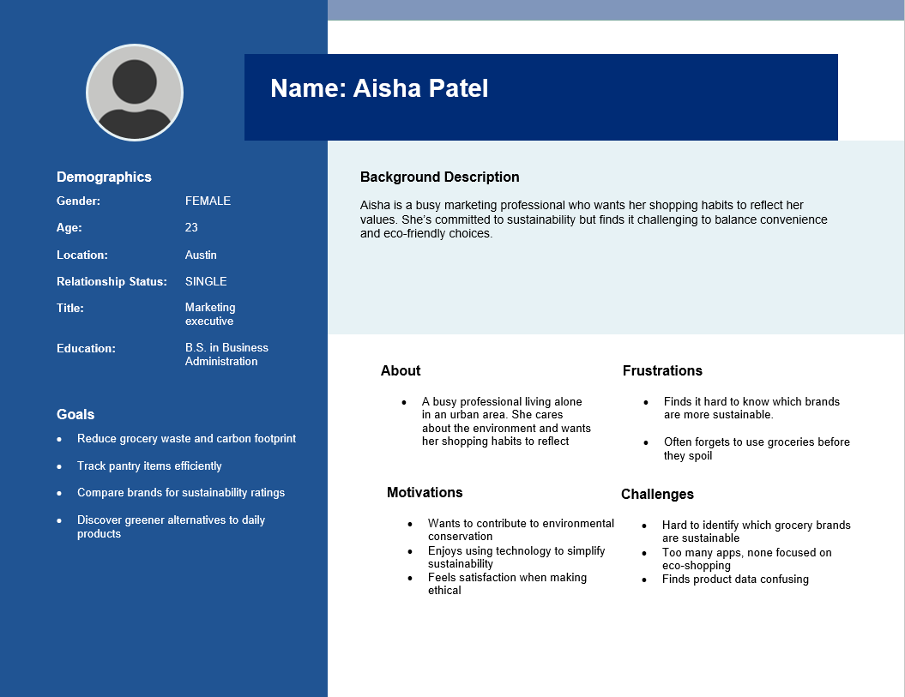
As an Admin
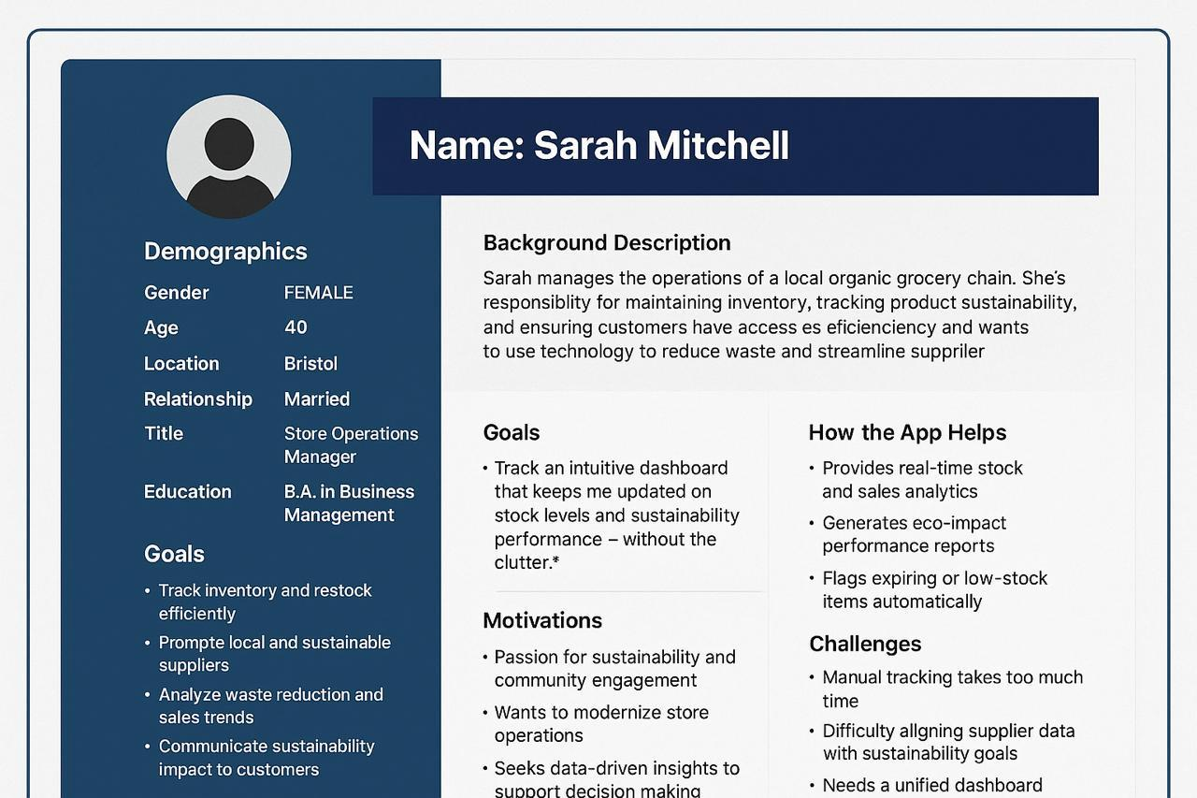

3.Wireframes
For buyer:
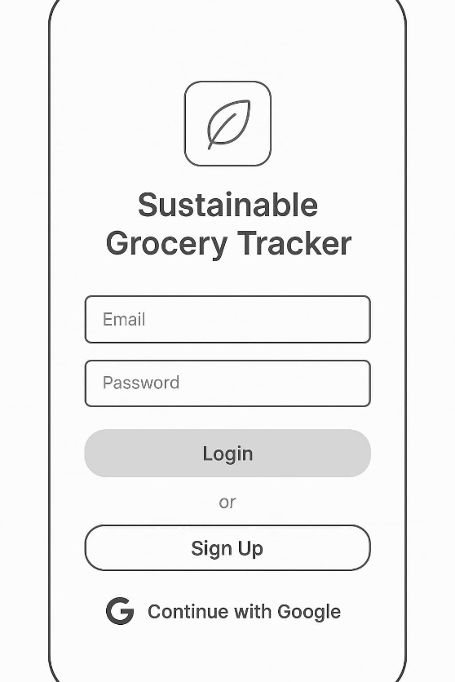

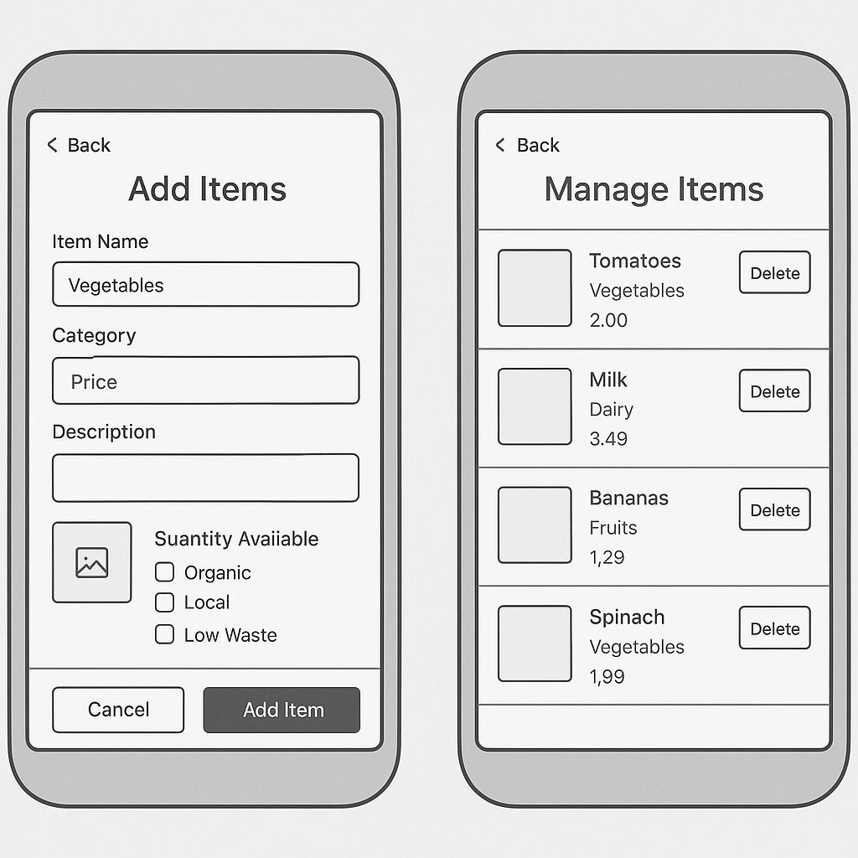

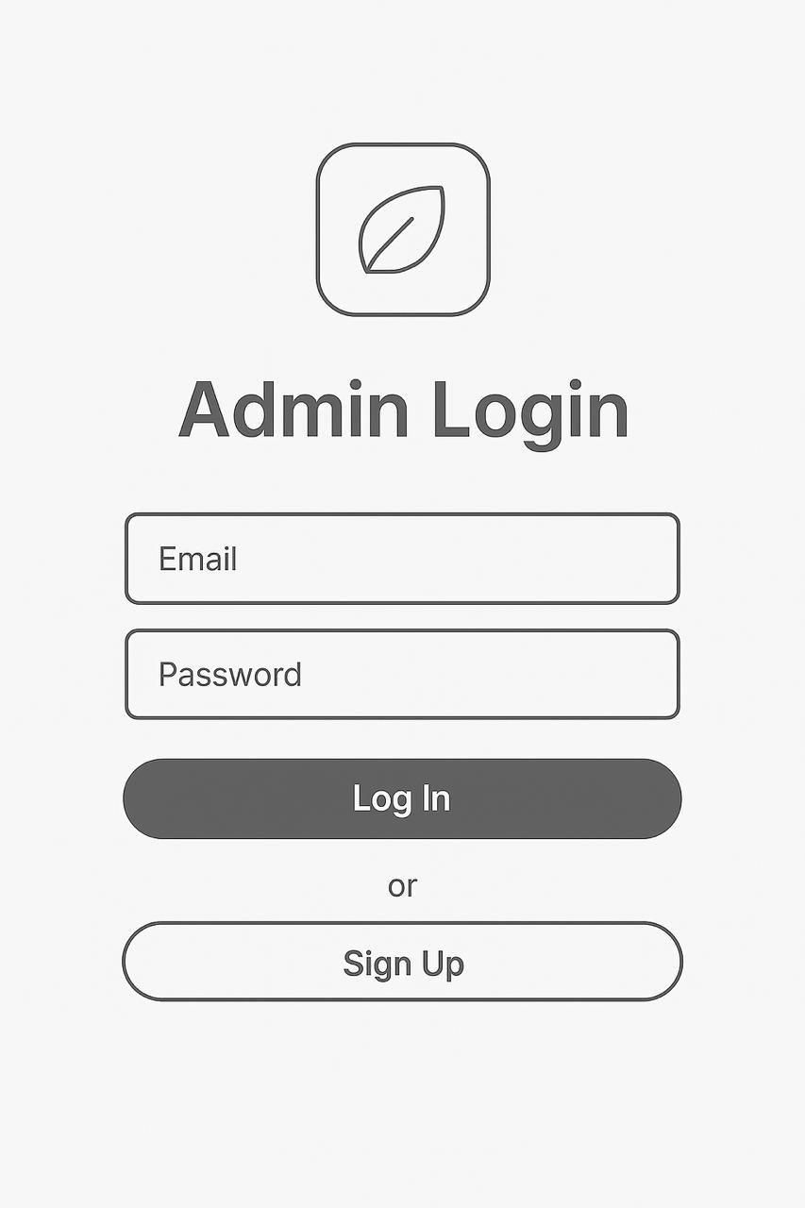

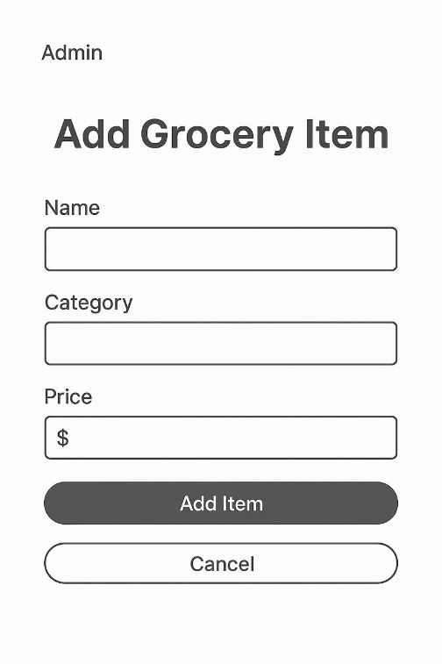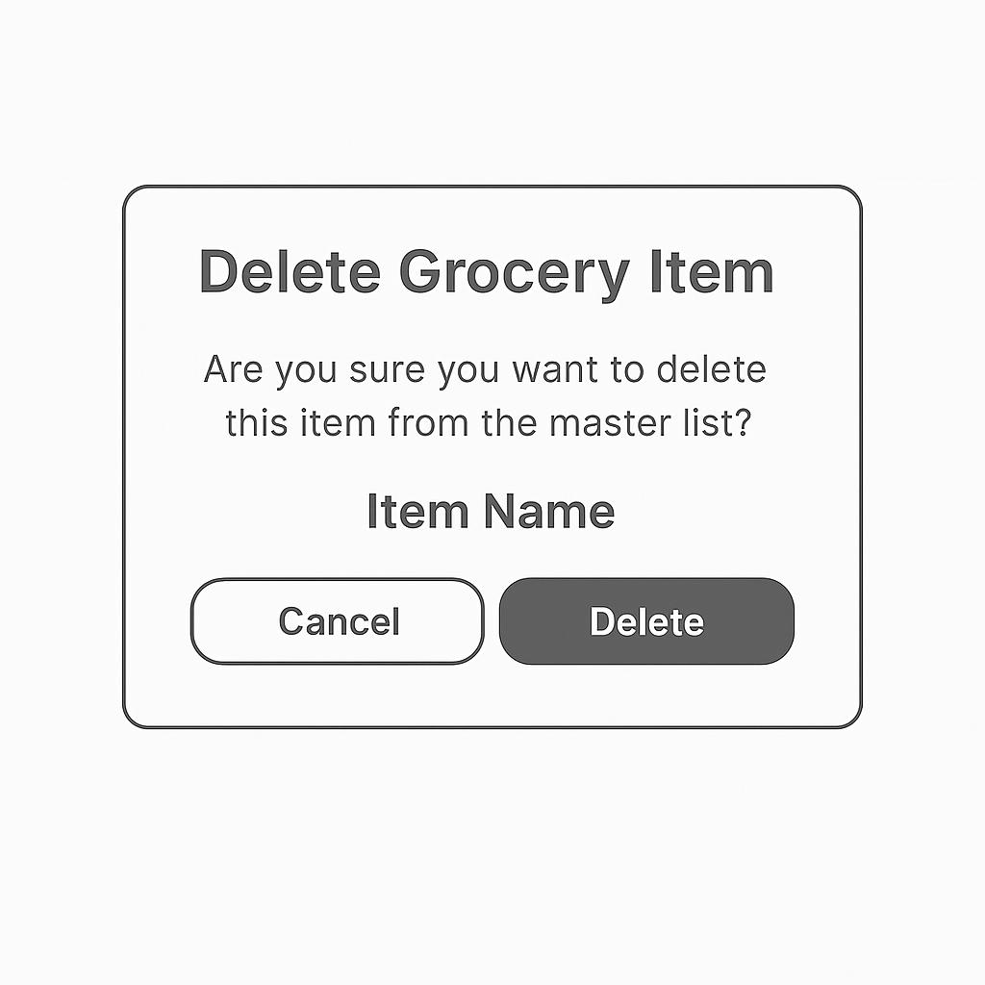

4.Use case diagrams

As a buyer:

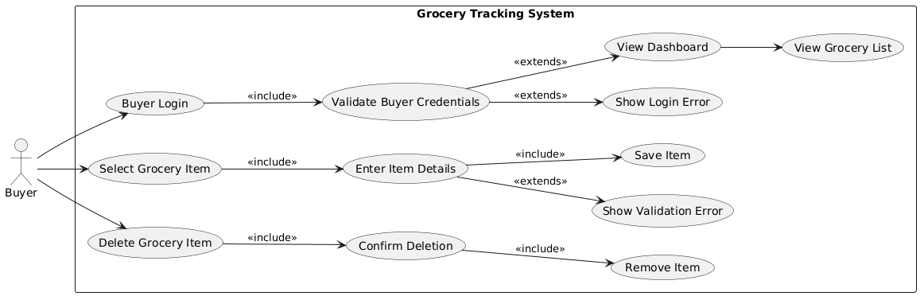

As a admin:
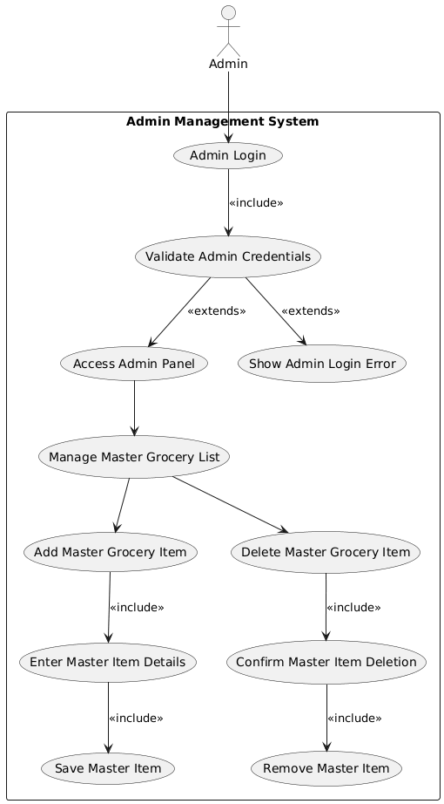

5.User flow diagrams
For buyer:

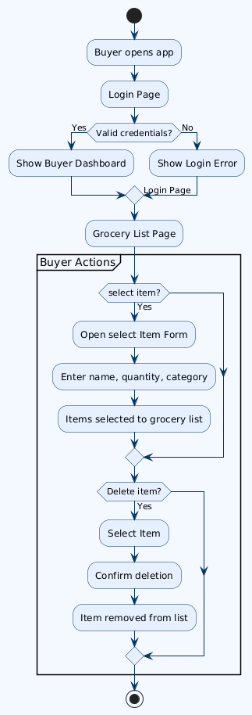

For admin:
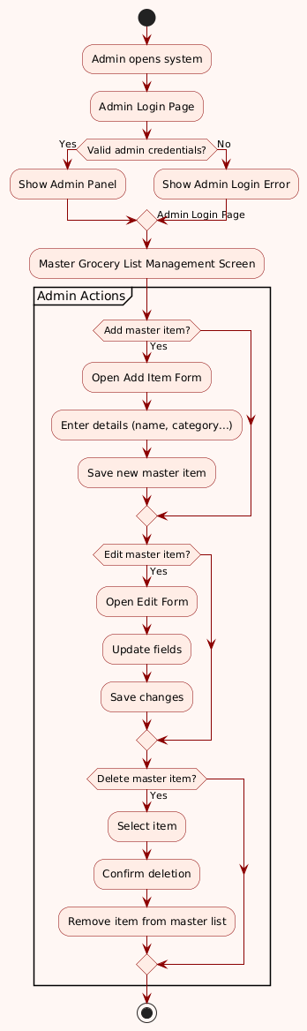

6. Sequence Diagrams

As a buyer:

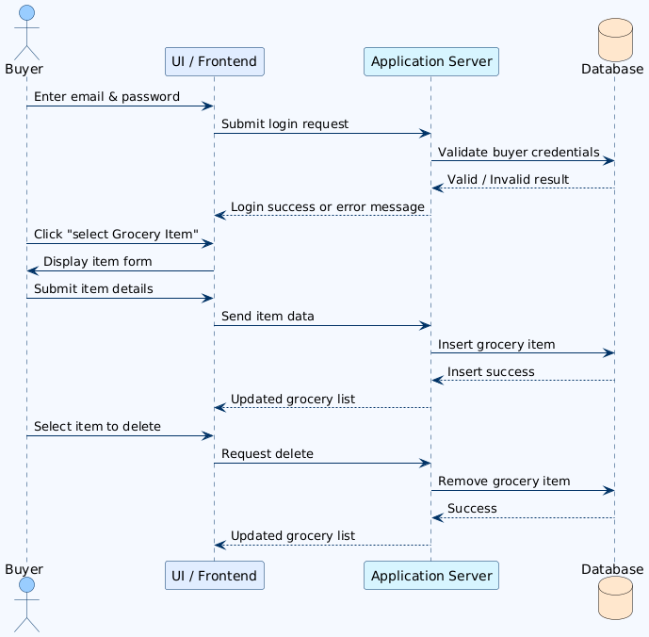

As an admin:

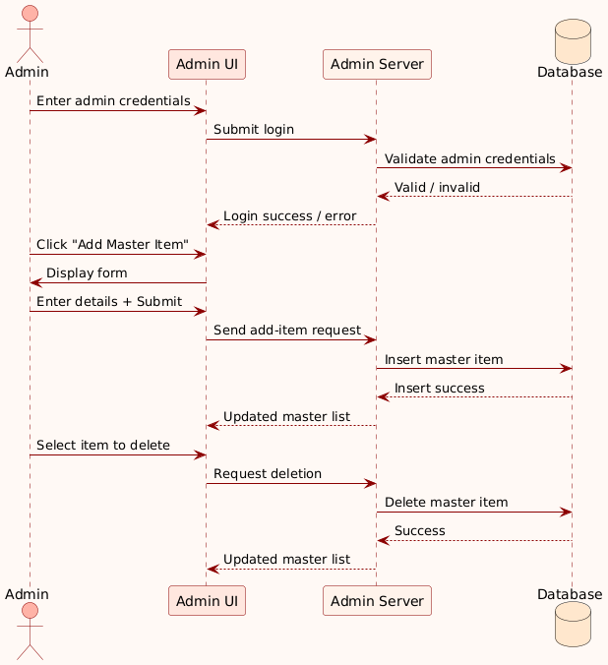

Trello Link: https://trello.com/b/nVz9qrDj/apex-sustainable-grocery-tracker

GitHub Repository URL:
These platforms are used to manage development tasks, track progress, and ensure consistent version control.

