**23CSE111**

**OBJECT ORIENTED PROGRAMMING**

**LAB REPORT**



**Department of Computer Science Engineering**

## **Amrita School of Computing**

## **Amrita Vishwa Vidyapeetham, Amaravati Campus**

## 

VERIFIED BY:  **NAME: T. SRAVYA**

**ROLL NO: AV.SC.U4CSE24331**

**WEEK-1**

**1) Explain the process of Installing JDK (Java Development Kit)**

**Installing of JDK (Java Development Kit):**

1. **Download JDK:**
   1. Go to the Oracle JDK download page in your web browser and click on JDK-21 version which is long term support (LTS) version.
   2. Click on the download link for your operating system (Windows, macOS, or Linux).
2. **Install JDK:**
   1. Once downloaded, run the installer.
   2. Follow the instructions and keep clicking "Next" until it's done.
3. **Set Environment Variables (Windows):**
   1. Open file explorer, then right click on This PC next select on properties then it will take you to the settings app then click on advanced system settings and then  
       click on **Environment Variables**.
   2. Click **New** under **System Variables**:
      1. **Set Variable name as:** java home
      2. **Variable value:** The folder address where JDK is installed (like C:\Program Files\Java\jdk-21\bin)

Find Path under **System Variables**, click **Edit**, and add the path of the jdk-21(C:\Program Files\Java\jdk-21\bin)

**Checking of JDK Version:**

1. **Open Command Prompt:**
   1. Press win+R, type cmd, and press Enter.
2. **Check Version:**
   1. Type java --version and press Enter.
   2. Type javac --version and press Enter.

**2.Simple Java Program for printing Name, Class, Roll No, of a Student**

**Write your code in Notepad and execute in cmd prompt**

**CODE:**

**class Main {**

**public static void main (String [] args ) {**

**System.out.println ("Name: T.Sravya");**

**System.out.println("Section: CSE-C");**

**System.out.println("Roll No: 24331");**

**}**

**}**

**OUTPUT:**

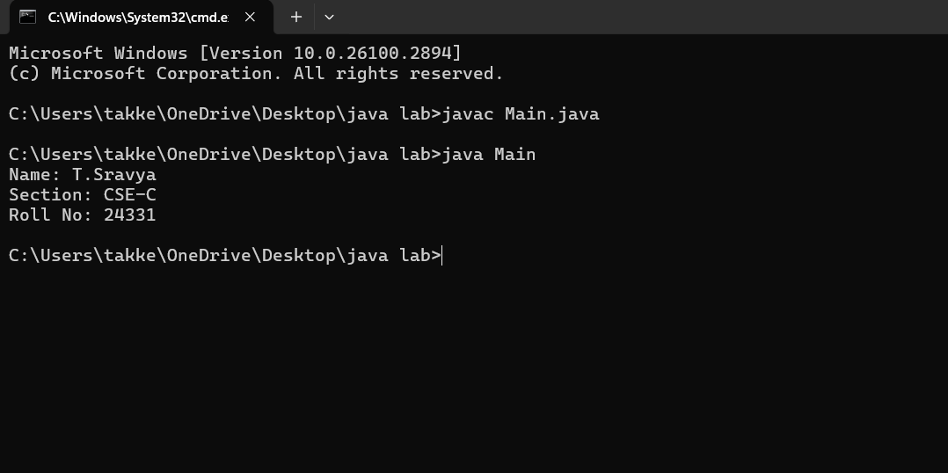

Week-2

**1.Write a Java program to Simple Interest where read values from users.**

**CODE:**

**import java.util.Scanner;**

**public class SimpleInterest {**

**public static void main(String[] args) {**

**Scanner scanner = new Scanner(System.in);**

**System.out.print("Enter the principal amount (P): ");**

**double principal = scanner.nextDouble();**

**System.out.print("Enter the rate of interest (R) in percentage: ");**

**double rate = scanner.nextDouble();**

**System.out.print("Enter the time period (T) in years: ");**

**double time = scanner.nextDouble();**

**double simpleInterest = (principal * rate * time) / 100;**

**System.out.println("The Simple Interest is: " + simpleInterest);**

**scanner.close();**

**}**

**}**

**OUTPUT:**

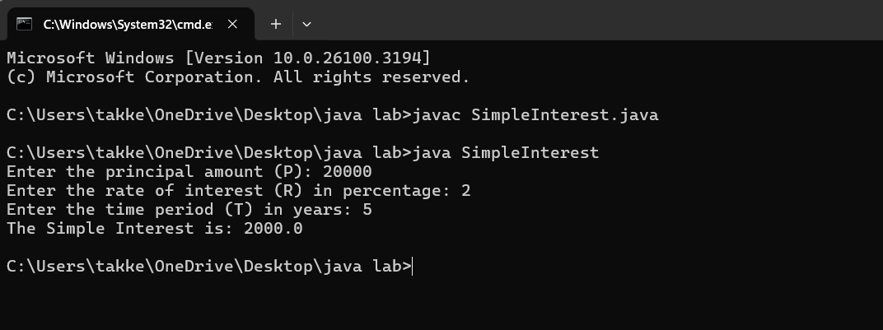

**ERROR:**

|  |  |  |
| --- | --- | --- |
| **SI.NO** | **ERROR MESSAGE** | **ERROR RECTIFICATION** |
| **1.** | error: ';' expected  System.out.print("Enter the rate of interest (R) in percentage: ") | **Insert: ‘;’**  **System.out.print("Enter the rate of interest (R) in percentage: ");** |
| **2.** | **error: cannot find symbol**  **Scanner scanner = new scanner(System.in);**  **symbol: class scanner**  **location: class SimpleInterest** | **Replace capital S in s: Scanner scanner = new Scanner(System.in);** |

**IMPORTANT POINTS:**

1.used Scanner library to get input from user in run time.

2.”import java.util.Scanner;”-step to import library.

3.”Scanner input= new Scanner(System.in);”-step to use the scanner.[case sensitive]

4. Should give ‘;’ symbol at the end of System.out.print("Enter the rate of interest (R) in percentage: ").

**2.Write a program on java on Factorial of a number with inputs taken.**

**CODE:**

import java.util.Scanner;

public class Factorialofanumber {

public static void main(String[] args) {

Scanner scanner = new Scanner(System.in);

System.out.print("Enter the number: ");

int number = scanner.nextInt();

long factorial = 1;

if (number < 0) {

System.out.println("No Factorial For Negative Numbers.");

} else {

for (int i = 1; i <= number; i++) {

factorial *=i;

}

System.out.println("The factorial of " + number + " is " + factorial);

}

scanner.close();

}

}

**OUTPUT:**

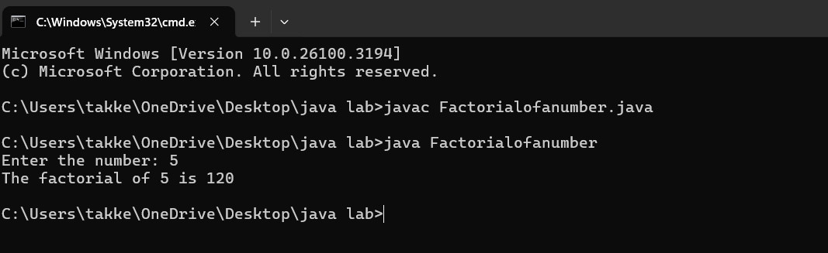

**ERRORS:**

|  |  |  |
| --- | --- | --- |
| **SI.NO** | **ERROR MESSAAGE** | **ERROR RECTIFICATION** |
| **1.** | Enter the number: 5  The factorial of 5 is 1  Error: factorial *=1; | Replace i in 1 place  Replace:factorial *=i; |
| **2.** | error: 'else' without 'if'  } else {  Reason: if (number < 0); | Solution:  if (number < 0) { |

**Important points:**

**1.** In the loop, the expression factorial*i; is incorrect because the result of the multiplication is not assigned back to factorial. It should be factorial*i; for proper multiplication and assignment.

2. **Using a colon** after if will cause a syntax error.

**3. Curly braces** {} are used to group the code inside the if block.

**3.Write a java program to convert the Temperature from Celsius to Fahrenheit & Fahrenheit to Celsius.**

**CODE FOR CELSIUS TO FAHRENHEIT:**

**import java.util.Scanner;**

**public class CelsiustoFahrenheit {**

**public static void main(String[] args) {**

**Scanner scanner = new Scanner(System.in);**

**System.out.print("Enter temperature in Celsius: ");**

**float celsius = scanner.nextFloat();**

**float fahrenheit = (celsius * 9 / 5) + 32;**

**System.out.println(celsius + "°C is equal to " + fahrenheit + "°F");**

**scanner.close();**

**}**

**}**

**OUTPUT:**

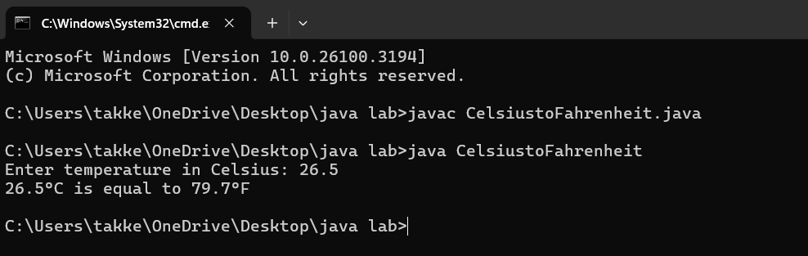

**ERRORS:**

|  |  |  |
| --- | --- | --- |
| **SI.NO** | **ERROR MESSAGE** | **ERROR RECTIFICATION** |
| **1.** | Error: float fahrenheit = celsius * 9 / 5 + 32;  Reason:Formula mistake. | It should be ((celsius * 9) / 5) + 32 |
| **2.** | Error: System.out.println(celsius + "°C is equal to " + fahrenheit "°F") | Print Missing semicolon here,  Print statement is missing a semicolon |

**Important Points:**

1. In the line float fahrenheit=celsius * 9 / 5 + 32;, the formula does not have proper parentheses for the multiplication and division. It should be float fahrenheit = (celsius * 9 / 5) + 32; for correct order of operations.

2. In the System.out.println() statement, there is a missing semicolon at the end of the line.

**CODE FOR FAHRENHEIT TO CELSIUS:**

**CODE:**

**import java.util.Scanner;**

**public class FahrenheittoCelsius {**

**public static void main(String[] args) {**

**Scanner scanner = new Scanner(System.in);**

**System.out.print("Enter Fahrenheit temp: ");**

**float f = scanner.nextFloat();**

**float celsius = (f - 32) * 5 / 9;**

**System.out.println(f + "°F is equal to " + celsius + "°C");**

**scanner.close();**

**}**

**}**

**OUTPUT:**

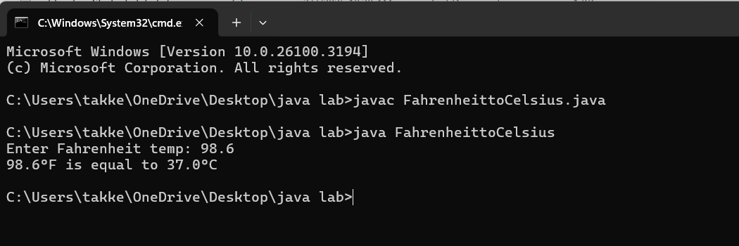

**ERRORS:**

|  |  |  |
| --- | --- | --- |
| **SI.NO** | **ERROR MESSAGE** | **ERROR RECTIFICATION** |
| **1.** | Error: Print statement with incorrect variable name System.out.println(fahrenheit + "°F is equal to " + Celsius + "°C") | 'Celsius' should be lowercase  It should be ‘celsius’. |
| **2.** | Duplicate close of scanner- scanner.close(); scanner.close() | Reason:  Use only one  scanner.close(); |

**Important points:**

1. The System.out.println statement is using Celsius with a capital "C" which doesn't exist as a variable. Java is case-sensitive, so this will cause a compilation error. It should be lowercase celsius.

2. The scanner.close() method is called twice, which is unnecessary and could cause issues. It should only be called once.

**4.Write a Program on Fibonacci Seqquence where input taken from user.**

**CODE:**

**public class FibonacciSeries {**

**public static void main(String[] args) {**

**int n = 10;**

**int firstTerm = 0, secondTerm = 1;**

**System.out.println("Fibonacci Series up to " + n + " terms:");**

**for (int i = 1; i <= n; ++i) {**

**System.out.print(firstTerm + ", ");**

**int nextTerm = firstTerm + secondTerm;**

**firstTerm = secondTerm;**

**secondTerm = nextTerm;**

**}**

**}**

**}**

**OUTPUT:**

ERRORS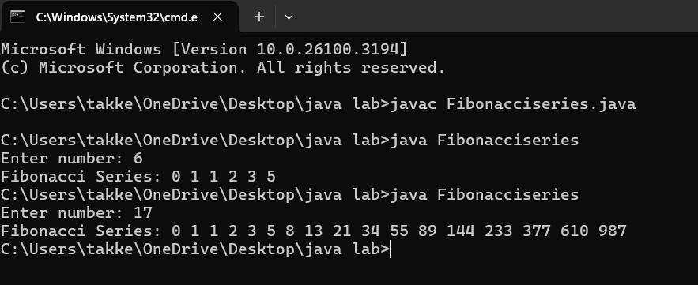**ERRORS:**

|  |  |  |
| --- | --- | --- |
| **SI.NO** | **ERROR MESSAGE** | **ERROR RECTIFICATION** |
| **1.** | int firstTerm;  Error: variables not initialized properly | should be initialized  int n = 10; |
| **2.** | int[] fibonacci = new int[n];  System.out.println(fibonacci[n + 1]); | invalid access  replace:  System.out.println("Fibonacci Series up to " + n + " terms:"); |

**IMPORTANT POINTS:**

1. Variables should be initialized properly
2. Accessing an array element outside its bounds.
3. Loop condition should be properly defined. No syntax error should be there.

**5.Write a program with java on How to calculate Area of Rectangle & Area of Triangle.**

**CODE FOR CALCULATING AREA OF RECTANGLE:**

**import java.util.Scanner;**

**public class Rectanglearea {**

**public static void main(String[] args) {**

**Scanner scanner = new Scanner(System.in);**

**System.out.print("Enter the length of the rectangle: ");**

**double length = scanner.nextDouble();**

**System.out.print("Enter the width of the rectangle: ");**

**double width = scanner.nextDouble();**

**double area = length * width;**

**System.out.println("The area of the rectangle is: " + area);**

**}**

**}**

**OUTPUT:**

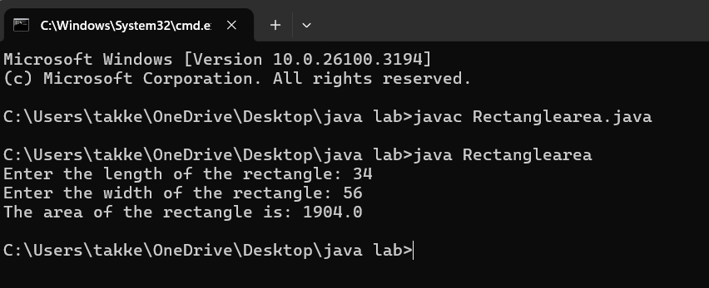

**ERRORS:**

|  |  |  |
| --- | --- | --- |
| **SI.NO** | **ERROR MESSAGE** | **ERROR RECTIFICATION** |
| **1.** | int length = 5.0; // Should be double | **Replace:** double length |
| **2.** | public class AreaOfRectangle {  public static void main(String[] args) | **Replace:**  Add flower braces at the end. |

**Important points:**

1. Trying to assign a double value to an int variable.

2. Incorrect placement of braces,should be placed correctly.

3.Should not give incorrect variables.

**CODE FOR CALCULATING AREA OF TRIANGLE:**

**import java.util.Scanner;**

**public class heronstriangle {**

**public static void main(String[] args) {**

**Scanner scanner = new Scanner(System.in);**

**// Taking input from the user**

**System.out.print("Enter the length of side a: ");**

**double a = scanner.nextDouble();**

**System.out.print("Enter the length of side b: ");**

**double b = scanner.nextDouble();**

**System.out.print("Enter the length of side c: ");**

**double c = scanner.nextDouble();**

**// Calculate the semi-perimeter**

**double s = (a + b + c) / 2;**

**// Calculate the area using Heron's Formula**

**double area = Math.sqrt(s * (s - a) * (s - b) * (s - c));**

**// Print the result**

**System.out.println("The area of the triangle is: " + area);**

**scanner.close();**

**}**

**}**

**OUTPUT:**

**ERRORS:**

|  |  |  |
| --- | --- | --- |
| **SI.NO** | **ERROR MESSAGE** | **ERROR RECTIFICARION** |
| **1.** | Main class name:triangle kept instead of herons | **Replace :**main class name by heronstriangle |
| **2.** | (),; closing tags forgot for  **double a = scanner.nextDouble** | **Replace:**  **double a = scanner.nextDouble();** |

**IMPORTANT POINTS:**

**1.**Verify that the input values can form a valid triangle (i.e., the sum of any two sides must be greater than the third side).

**2.**Calculate the semi-perimeter ss using the formula:

s=a+b+c/2.

Week-3

1. **To create java program with following :**
2. **Create a class with name car**
3. **Create four attributes named Car_colour,Car_brand,Fuel_type,mileage**
4. **Create three methods named Strat(),Stop(),Service()**
5. **Create three obj named Car1,Car2,Car3.**

**CODE FOR CREATING CAR CLASS**

**class car**

**{**

**public String car_color;**

**public String car_brand;**

**public String fuel_type;**

**public float mileage;**

**public void start()**

**{**

**System.out.println("Car starts");**

**}**

**public void stop()**

**{**

**System.out.println("Car stops");**

**}**

**public void service()**

**{**

**System.out.println("Car service");**

**}**

**public static void main(String [] args){**

**// object one creation**

**car car1= new car();**

**car1.car_color="Red";**

**car1.car_brand="Ferrari";**

**car1.fuel_type="Petrol";**

**car1.mileage=75.69F;**

**//calling methods for object 1**

**car1.start();**

**car1.stop();**

**car1.service();**

**System.out.println("color of the car1 is "+car1.car_color);**

**System.out.println("brand of the car1 is "+car1.car_brand);**

**System.out.println("fuel type of the car1 is"+car1.fuel_type);**

**System.out.println("mileage of the car1 is"+car1.mileage);**

**// object two creation**

**car car2= new car();**

**car2.car_color="Blue";**

**car2.car_brand="BMW";**

**car2.fuel_type="Petrol";**

**car2.mileage=11.96F;**

**// calling methods for object 2**

**car2.start();**

**car2.stop();**

**car2.service();**

**System.out.println("color of the car2 is "+car2.car_color);**

**System.out.println("brand of the car2 is "+car2.car_brand);**

**System.out.println("fuel type of the car2 is "+car2.fuel_type);**

**System.out.println("mileage of the car2 is"+car2.mileage);**

**//object three creation**

**car car3= new car();**

**car3.car_color="black";**

**car3.car_brand="Audi";**

**car3.fuel_type="Diesel";**

**car3.mileage=11.76F ;**

**// calling methods for object 3**

**car3.start();**

**car3.stop();**

**car3.service();**

**System.out.println("color of the car3 is "+car3.car_color);**

**System.out.println("brand of the car3 is "+car3.car_brand);**

**System.out.println("fuel type of the car3 is "+car3.fuel_type);**

**System.out.println("mileage of the car3 is"+car3.mileage);**

**}**

**}**

**OUTPUT:**

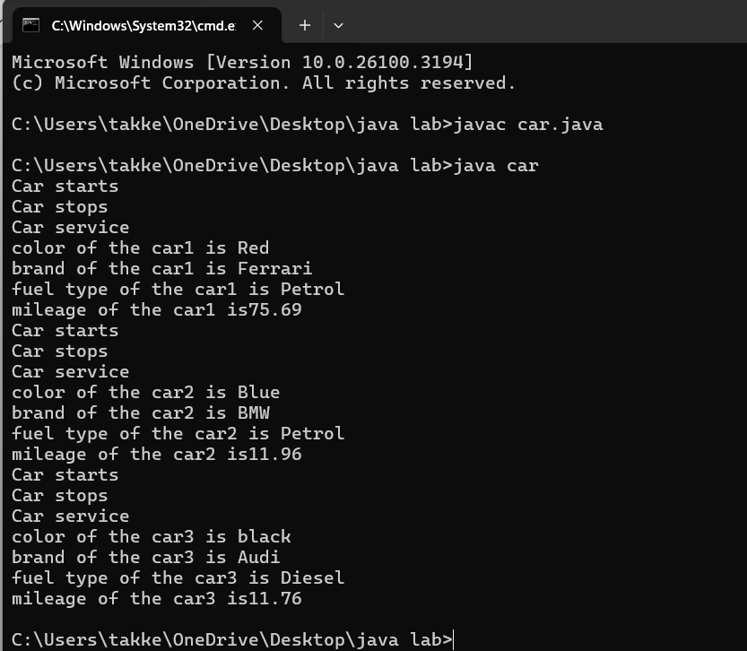**ERRORS:**

|  |  |  |
| --- | --- | --- |
| **SI.NO** | **ERROR MESSAGE** | **ERROR RECTIFICATION** |
| **1.** | Error: car_Color is undefined, should be car_color | **Replace:** car_Color with car_color |
| **2.** | Missing semicolon after 'car2.start()' will cause an error | **Replace:** add semi colon at the end |

**IMPORTANT POINTS:**

**1. Variable name mismatch**: The variable car_Color in the code should be car_color

2.**Incorrect variable name**: car1.car_color is used when the actual variable is car1.car_Color, which will cause an error due to case sensitivity.

3. **Missing Semicolon**: Forgetting to add a semicolon at the end of a statement will cause a compilation error.

**2.To create a class Bank Account with Methods deposit() and Withdrawal()**

**CODE:**

**import java.util.Scanner;**

**class BankAccount {**

**private float existing; // Class-level variable to store balance**

**private Scanner input; // Single Scanner instance for input**

**// Constructor**

**public BankAccount() {**

**input = new Scanner(System.in);**

**System.out.print("Enter existing amount in bank account: ");**

**this.existing = input.nextFloat();**

**}**

**// Deposit method**

**public void deposit() {**

**System.out.print("Enter amount to be deposited: ");**

**float deposit = input.nextFloat();**

**existing += deposit;**

**System.out.println("Existing amount now is: " + existing);**

**}**

**// Withdrawal method**

**public void withdrawal() {**

**System.out.print("Enter amount to be withdrawn: ");**

**float withdrawal = input.nextFloat();**

**if (existing < withdrawal) {**

**System.out.println("Not sufficient balance.");**

**} else {**

**existing -= withdrawal;**

**System.out.println("Remaining balance: " + existing);**

**}**

**}**

**// Main method**

**public static void main(String[] args) {**

**BankAccount customer1 = new BankAccount();**

**customer1.deposit();**

**customer1.withdrawal();**

**}**

**}**

**OUTPUT:**

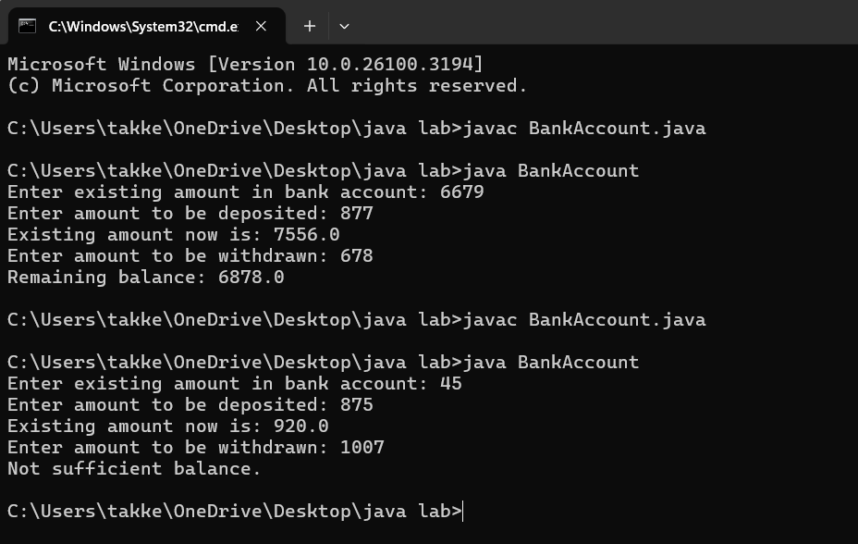**ERRORS:**

|  |  |  |
| --- | --- | --- |
| **SI.NO** | **ERROR MESSAGE** | **ERROR RECTIFICATION** |
| **1.** | this.existing = int.nextFloat(); | this.existing = input.nextFloat(); |
| **2.** | public int deposit() is incorrect return method | REPLACE:public VOID deposit() |

**IMPORTANT POINTS:**

1.The balance should be a float or double to handle decimal values correctly, but it's declared as an int.

2. **Incorrect deposit method signature**: The method DEPOSIT()has an incorrect return type int(), while it should be void since it doesn't need to return any value.

3. **Fixed the return type of deposit**: Changed from int to void, as the method does not need to return anything

**WEEK-4**

**AIM :: Write a java program with class named Book**

**a)a class should contain various attributes such as title,author,year of publication.**

**b)it should also contain a constructor with parameters which initializes title,author,year of publication.**

**c)create a method which displays the details of the book title ,author ,year of publication**

**Display the details of two books.**

**CODE:**

**class Book {**

**// Fields to hold book details**

**public String bookTitle;**

**public String bookAuthor;**

**public int bookYearOfPublication;**

**// Method to print book title**

**public void title() {**

**System.out.println("Book Title");**

**}**

**// Method to print book author**

**public void author() {**

**System.out.println("Book Year of Publishing");**

**}**

**// Main Method**

**public static void main(String[] args) {**

**// First book**

**Book book1 = new Book();**

**book1.bookTitle = "Atomic Habits";**

**book1.bookAuthor = "James Clear";**

**book1.bookYearOfPublication = 2018;**

**// Calling methods**

**book1.title();**

**book1.author();**

**// Printing book details**

**System.out.println("Book title is: " + book1.bookTitle);**

**System.out.println("Book author is: " + book1.bookAuthor);**

**System.out.println("Book year of publication is: " + book1.bookYearOfPublication);**

**// Second book**

**Book book2 = new Book();**

**book2.bookTitle = "South Pole Pig";**

**book2.bookAuthor = "James";**

**book2.bookYearOfPublication = 2014;**

**// Calling methods**

**book2.title();**

**book2.author();**

**// Printing book details**

**System.out.println("Book title is: " + book2.bookTitle);**

**System.out.println("Book author is: " + book2.bookAuthor);**

**System.out.println("Book year of publication is: " + book2.bookYearOfPublication);**

**}**

**}**

**OUTPUT:**

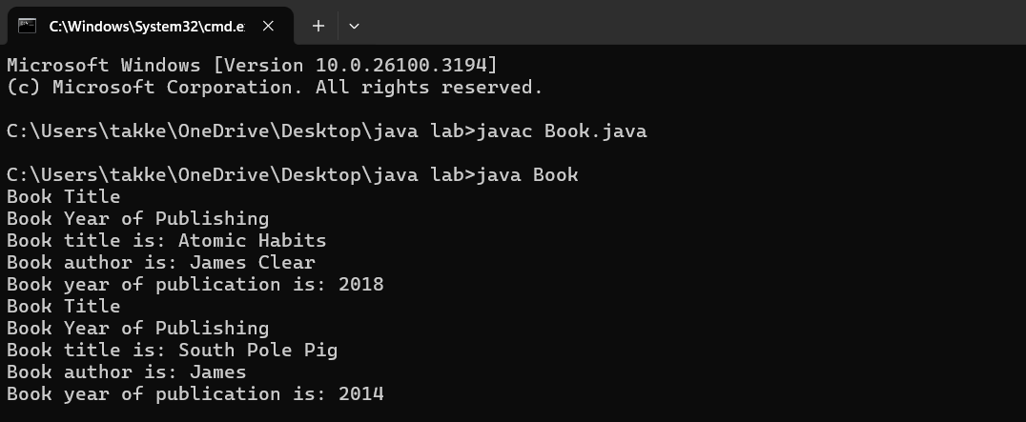**ERRORS:**

|  |  |  |
| --- | --- | --- |
| **SI.NO** | **ERROR MESSAGE** | **ERROR RECTIFICATION** |
| **1.** | Not defining the function in a file. | To call the method we must define a function in a file. |
| **2.** | Two public class files should not be saved in the same file. | Two public class files should be saved in different files. |

**IMPORTANT POINTS:**

1. While defining two classes for a code, we must be sure that we save both the classes in separate files.
2. While defining a method we should also define a function to call that method.

**CLASS DIAGRAM:**

|  |
| --- |
| **Book** |
| * Title: String * Author: String * Year of publication: int |
| + Book(title: String,  Author: String;  Year of publication: int  + displayDetails( ): void |

**AIM :: Create a java program with class named ‘MyClass’ with static variable count of int type,initaialized to zero and a constant variable ‘pi’ or type double initialized to 3.14 as attributes of the class. Now define a constructor for “MyClass”that increments the count variable eachtime an object of MyClass is created.Finally print the final values of count and pi variables.**

**Create three objects and a constructor.**

**CODE:**

**class MyClass {**

**// Static variable to hold count of objects created**

**static int count = 0;**

**// Constant variable for pi, initialized to 3.14**

**final double pi = 3.14;**

**// Constructor**

**public MyClass() {**

**// Increment count every time an object is created**

**count++;**

**}**

**// Main method to create objects and print values**

**public static void main(String[] args) {**

**// Creating three objects of MyClass**

**MyClass object1 = new MyClass();**

**MyClass object2 = new MyClass();**

**MyClass object3 = new MyClass();**

**// Printing the final values of count and pi**

**System.out.println("Final count of objects created: " + count);**

**System.out.println("Value of pi: " + object1.pi); // Pi is constant, and we can access it via any object**

**}**

**}**

**OUTPUT:**

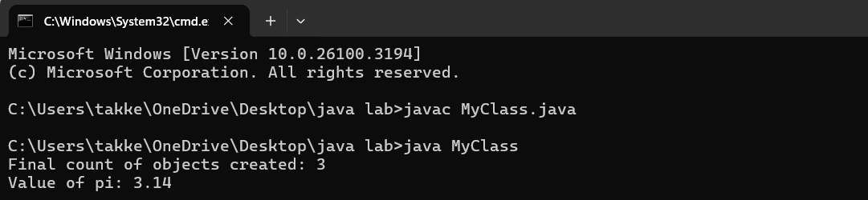**ERRORS:**

|  |  |  |
| --- | --- | --- |
| **SI.NO** | **ERROR MESSAGE** | **ERROR RECTIFICATION** |
| **1.** | Not Putting the semi-colon after calling a function, | Put the semi-colon after calling a function. |
| **2.** | Not giving the indentation properly. | All the indentation must be correct to run the code correct |

**IMPORTANT POINTS:**

1. We must declare the initial value of the variable before declaring the final one.
2. Here the main objective is to increase the count according to the number of objects we make, i.e the count increases when the no.of objects are increasing.

**CLASS DIAGRAM:**

|  |
| --- |
| Myclass |
| * Count: int * Pi: double |
| + myclass( )  + main(args: String[]): void |