You need to follow below steps to up and running the Sravy Ecommerce Application.

1. Create database “ecommerce” in SQL Server.
2. Run “SravyEcommerceDbScript_12072021.sql” file by selecting the “ecommerce” database.
3. Change your connection string as your setting in appsettings.json.

Architecture:

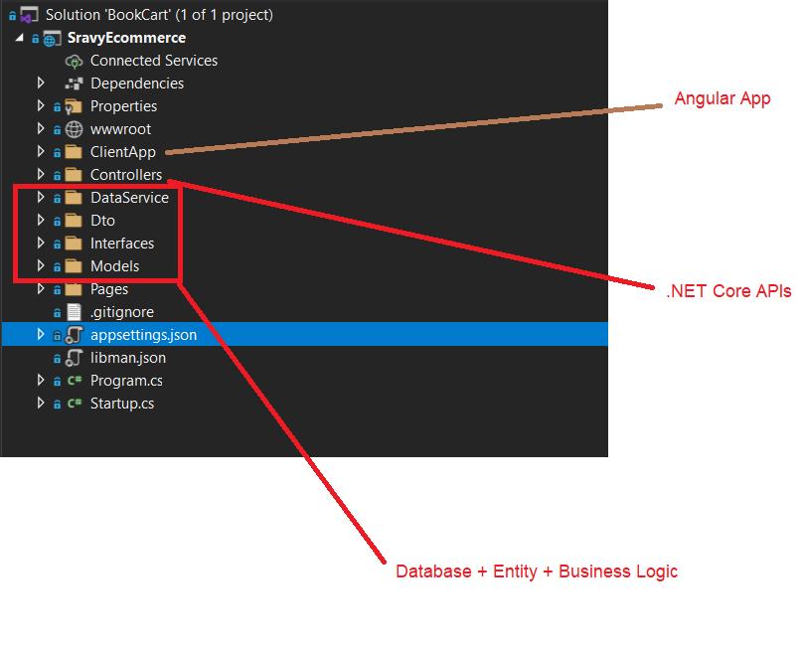

This is a shopping application targeting the user who will be shopping across multiple categories such as Women Clothing, Shoes, Children clothing and other House hold items

User Stories:

As a User, I should be able to Register and Login/Logout from the website

As a User, I should be able to Search items to add to cart

As a User, I should be able to set price filters to customize the listing

As a User, I should be able to view Items in multiple categories

As a User, I should be able to add/Clear multiple items to my Cart

As a User, I should be able to select multiple items to my Wishlist

As a User, I should be able to CheckOut the items added to Cart

As a User, I should be able to View My Orders History

Getting Starteded

These instructions will get you a copy of the project up and running on your local machine for development and testing purposes. See deployment for notes on how to deploy the project on a live system.