**1)Creating a new react application:**

Create a new React Application with the name “myfirstreact”, Run the application to print “welcome to the first session of React” as heading of that page.

1. To create a new React app, Install Nodejs and Npm from the following link:

<https://nodejs.org/en/download/>

1. Install Create-react-app by running the following command in the command prompt:



1. To create a React Application with the name of “myfirstreact”, type the following command:



1. Once the App is created, navigate into the folder of myfirstreact by typing the following command:



1. Open the folder of myfirstreact in Visual Studio Code
2. Open the App.js file in Src Folder of myfirstreact
3. Remove the current content of “App.js”
4. Replace it with the following:

1. Run the following command to execute the React application:



1. Open a new browser window and type “localhost:3000” in the address bar

**This is the explanation for the given:**

I have created new react application with the name myfirstproject, after all installing the prerequisites for the application

Then after successfully installed, go visual studio code then modify the app.js with what has given.

**App.js:**

function App() {

  return (

    <div>

      <h1>welcome to the first session of React</h1>

    </div>

  );

}

Run the project with terminal and then after successfully open the browser and check.

The below is the image I have got after the installation

**Output:**

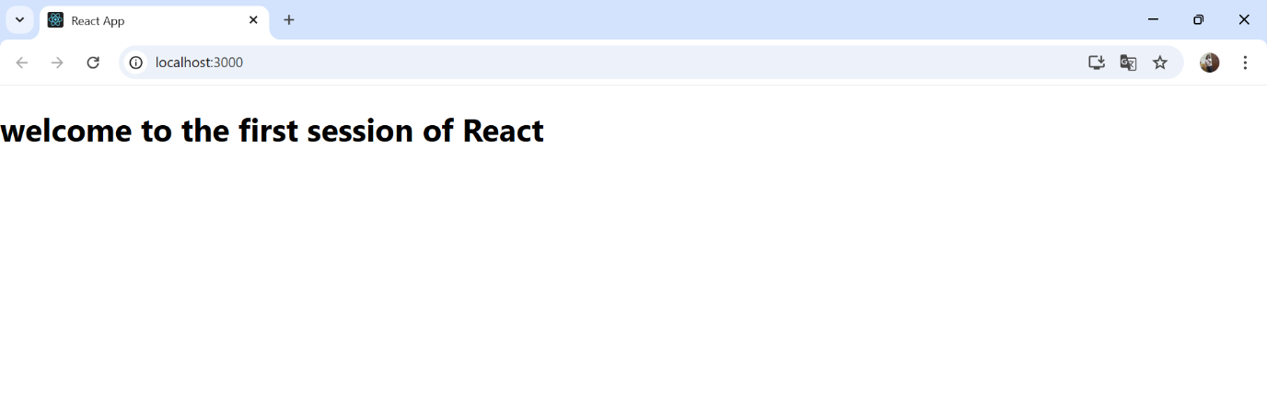

**2)Creating a project named studentapp:**

1. Create a React project named “StudentApp” type the following command in terminal of Visual studio:



1. Create a new folder under Src folder with the name “Components”. Add a new file named “Home.js”
2. Type the following code in Home.js

1. Under Src folder add another file named “About.js”
2. Repeat the same steps for Creating “About” and “Contact” component by adding a new file as ”About.js”, “Contact.js” under “Src” folder and edit the code as mentioned for “Home” Component.
3. Edit the App.js to invoke the Home, About and Contact component as follows:

1. In command Prompt, navigate into StudentApp and execute the code by typing the following command:



1. Open browser and type “localhost:3000” in the address bar

**This is the explanation:**

I created a folder name as studentapp:

After all the above instructions these is the output:

**Output:**

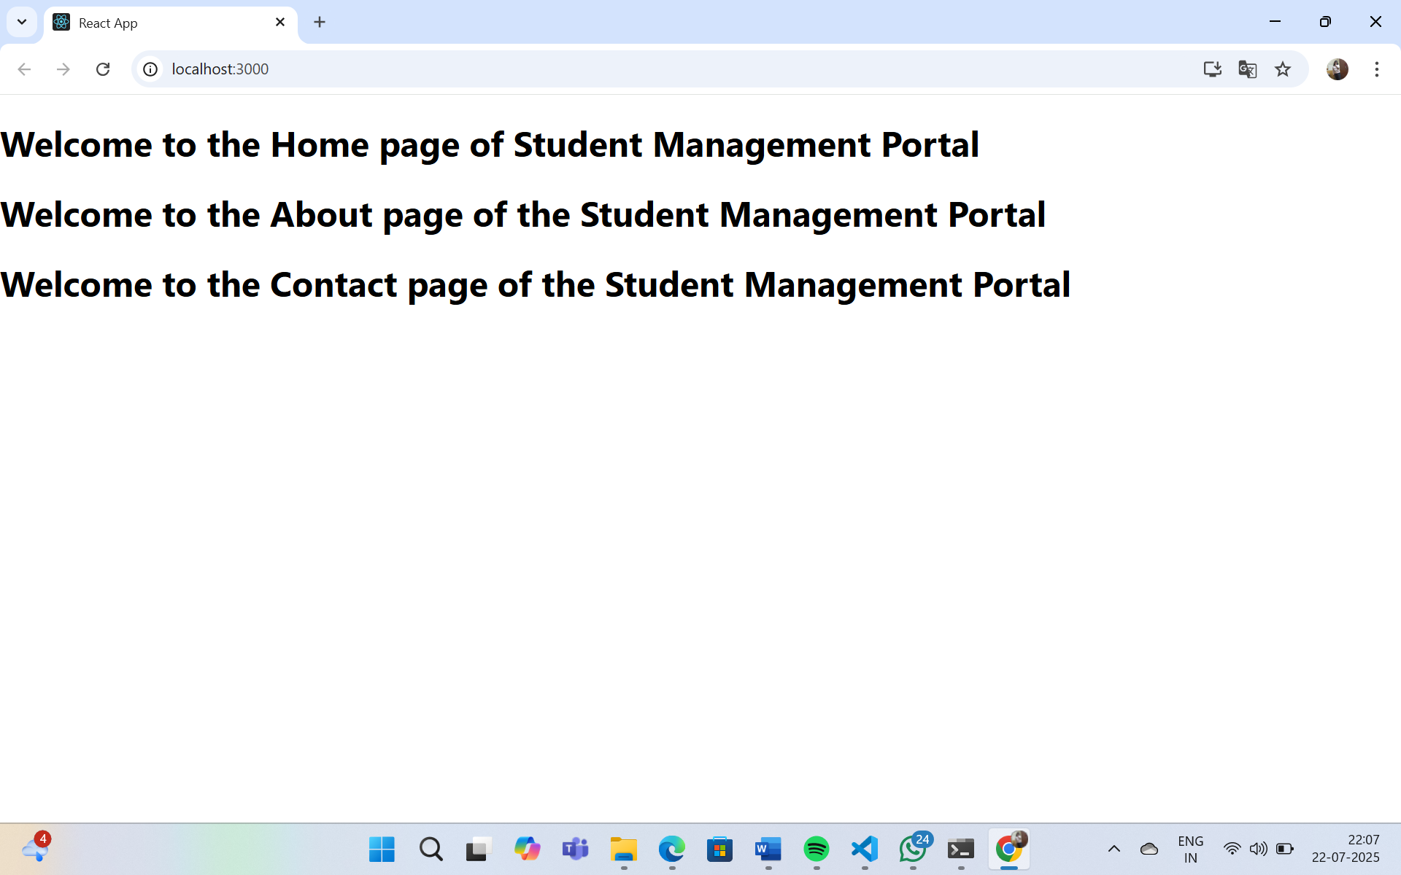

**3) Creating a scorecalculatorapp:**

**Explanation:**

Create a project name it as scorecalculatorapp, open visual studio code and open the folder and then open the in src create new folder as Components and src/components create new file name it as calculatescore.js.

**CalculateScore.js:**

import React from 'react';

import '../Stylesheets/mystyle.css';

function CalculateScore(props) {

  const average = props.total / props.goal;

  return (

    <div className="container">

      <h2>Student Score Calculator</h2>

      <p><strong>Name:</strong> {props.name}</p>

      <p><strong>School:</strong> {props.school}</p>

      <p><strong>Total Score:</strong> {props.total}</p>

      <p><strong>Goal:</strong> {props.goal}</p>

      <p><strong>Average Score:</strong> {average}</p>

    </div>

  );

}export default CalculateScore;

**Output:**

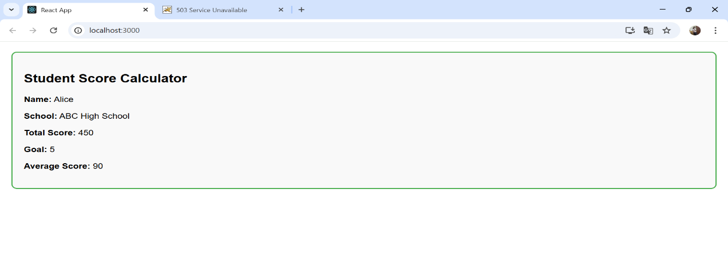

**4) Creating a tool called Blogapp:**

**Explanation:**

Create a new react application using *create-react-app* tool with the name as “blogapp”,

Open visual studio code in src create required files for the project.

The required files are Post.js and Posts.js.

**Output:**

**5) Creating a react app**

My Academy team at Cognizant want to create a dashboard containing the details of ongoing and completed cohorts. A react application is created which displays the detail of the cohorts using react component. You are assigned the task of styling these react components.

Download and build the attached react application.



1. Unzip the react application in a folder
2. Open command prompt and switch to the react application folder
3. Restore the node packages using the following commands

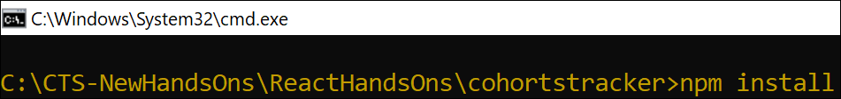

*Figure 1: Restore packages*

1. Open the application using VS Code
2. Create a new CSS Module in a file called “CohortDetails.module.css”
3. Define a css class with the name as “box” with following properties

*Width = 300px;*

*Display = inline block;*

*Overall 10px margin*

*Top and bottom padding as 10px*

*Left and right padding as 20px*

*1 px border in black color*

*A border radius of 10px*

1. Define a css style for html <dt> element using tag selector. Set the font weight to 500.
2. Open the cohort details component and import the CSS Module
3. Apply the box class to the container div

Define the style for <h3> element to use “green” color font when cohort status is “ongoing” and “blue” color in all other scenarios.

**Explanation:**

By creating and follow all the above and getting the final result is the below image

**Final Result:**

