1. **Cricketapp:**
2. ListofPlayers

* Declare an array with 11 players and store details of their names and scores using the map feature of ES6

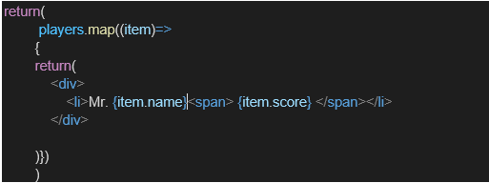

* Filter the players with scores below 70 using arrow functions of ES6.

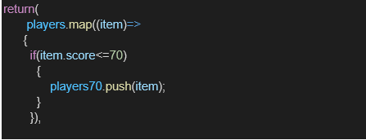

1. IndianPlayers
   1. Display the Odd Team Player and Even Team players using the Destructuring features of ES6

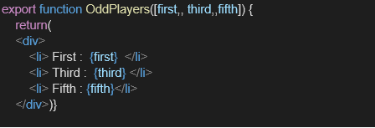

* 1. Declare two arrays T20players and RanjiTrophy players and merge the two arrays and display them using the Merge feature of ES6

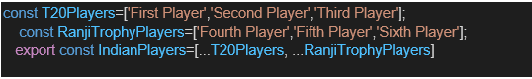

Display these two components in the same home page using a simple if else in the flag variable.

**Explanation:**

The above is the notes, how to create the react app named as cricketapp. And creating the necessary files and run the app through the terminal. And getting the output, in app.js first we have const flag=true is one component and the other is const flag=false is another component.

**Output:**

**When flag=true**

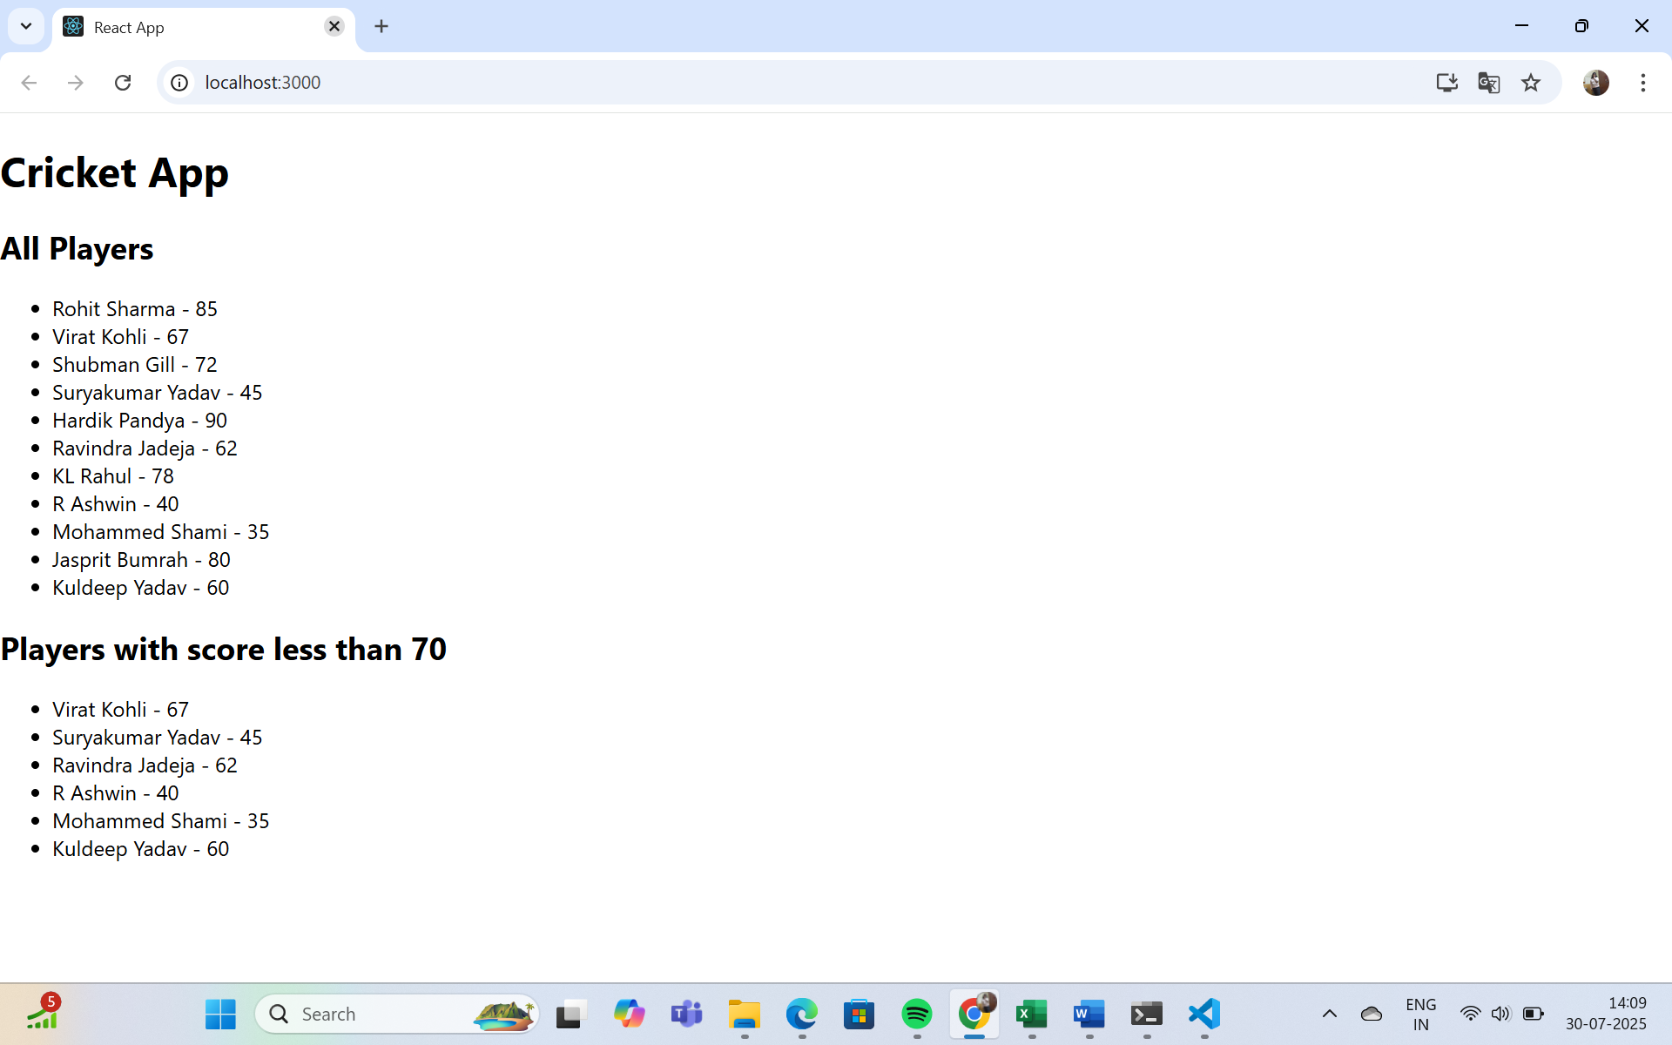

**When flag=false**

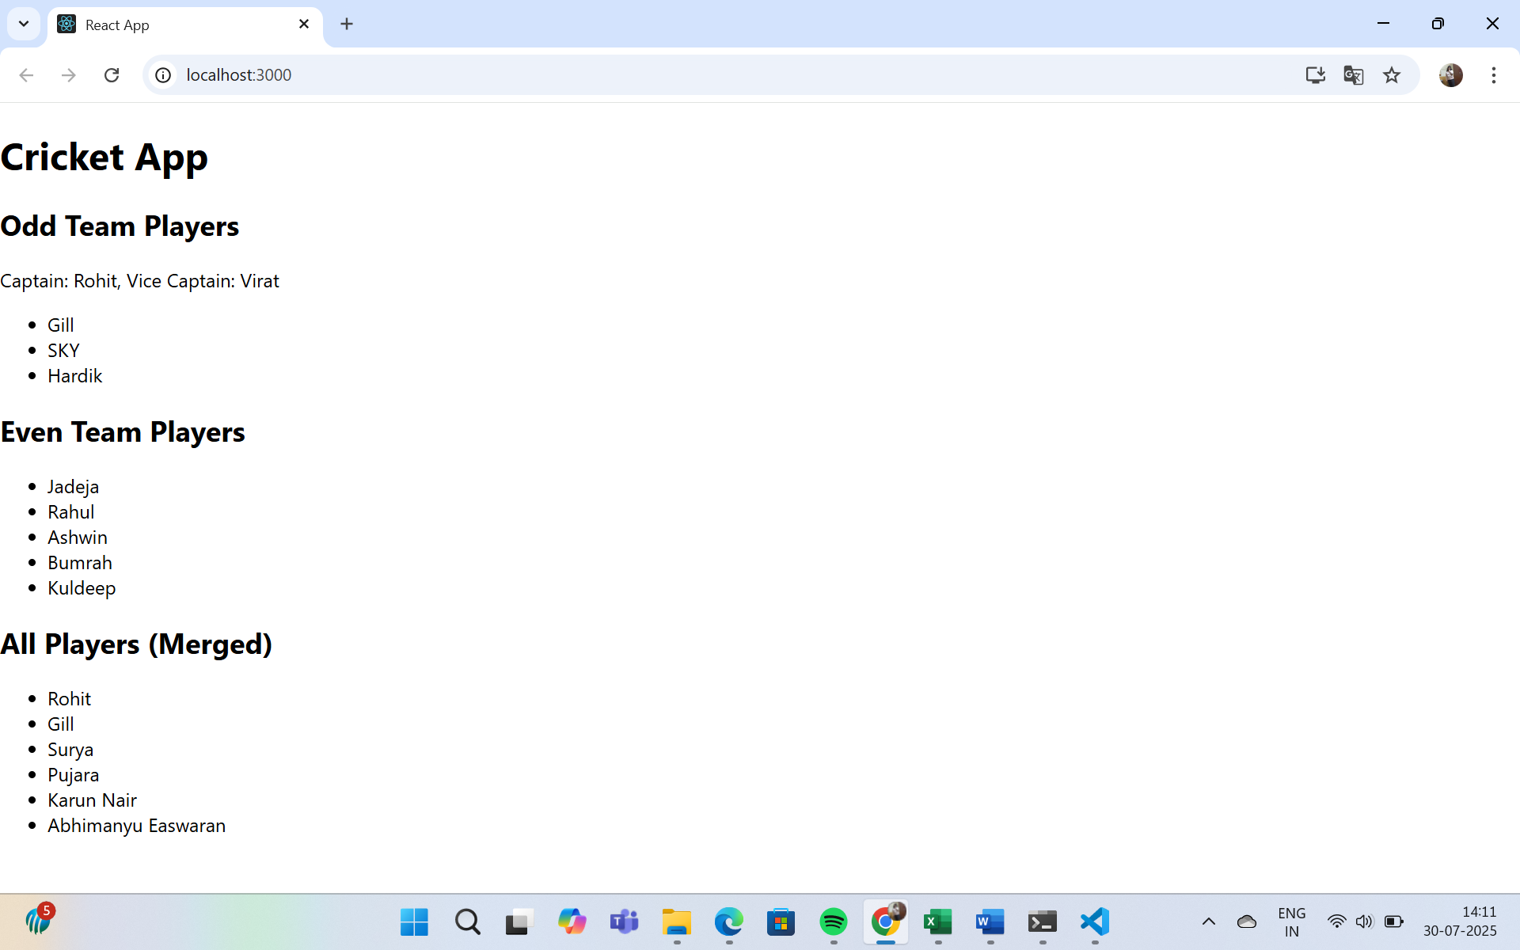

1. **Officespacerentalapp**

* Create a React Application named “officespacerentalapp” which uses React JSX to create elements, attributes and renders DOM to display the page.
* Create an element to display the heading of the page.
* Attribute to display the image of the office space
* Create an object of office to display the details like Name, Rent and Address.
* Create a list of Object and loop through the office space item to display more data.
* To apply Css, Display the color of the Rent in Red if it’s below 60000 and in Green if it’s above 60000.

**Explanation:**

The above is the given and we need do according the above points.

After creating the folder then do changes in the App.js file:

App.js:

import React from 'react';

function App() {

  // Single office object

  const office = {

    name: "Workspace Hub",

    rent: 55000,

    address: "123 MG Road, Bangalore"

  };

  // List of offices

  const officeList = [

    { name: "Workspace Hub", rent: 55000, address: "123 MG Road, Bangalore" },

    { name: "Tech Towers", rent: 75000, address: "456 IT Park, Hyderabad" },

    { name: "City CoWorks", rent: 45000, address: "789 Connaught Place, Delhi" }

  ];

  // JSX elements

  return (

    <div style={{ padding: '20px', fontFamily: 'Arial' }}>

      {/* Heading */}

      <h1 style={{ textAlign: 'center', color: '#2c3e50' }}>

        Office Space Rental App

      </h1>

      {/* Image */}

      <img

        src="https://images.unsplash.com/photo-1524758631624-e2822e304c36"

        alt="Office Space"

        style={{ width: '100%', maxHeight: '300px', objectFit: 'cover', borderRadius: '8px' }}

      />

      {/* Single Office Info */}

      <h2>Featured Office</h2>

      <p><strong>Name:</strong> {office.name}</p>

      <p>

        <strong>Rent:</strong>{" "}

        <span style={{ color: office.rent < 60000 ? 'red' : 'green' }}>

          {office.rent}

        </span>

      </p>

      <p><strong>Address:</strong> {office.address}</p>

      {/* List of offices */}

      <h2>Available Offices</h2>

      <ul>

        {officeList.map((o, index) => (

          <li key={index}>

            <strong>{o.name}</strong> -{" "}

            <span style={{ color: o.rent < 60000 ? 'red' : 'green' }}>

              {o.rent}

            </span>

            <br />

            <em>{o.address}</em>

          </li>

        ))}

      </ul>

    </div>

  );

}

export default App;

**Output:**

1. **Eventexamplesapp:**

Create a React Application “eventexamplesapp” to handle various events of the form elements in HTML.

1. Create “Increment” button to increase the value of the counter and “Decrement” button to decrease the value of the counter. The “Increase” button should invoke multiple methods.
   1. To increment the value
   2. Say Hello followed by a static message.

1. Create a button “Say Welcome” which invokes the function which takes “welcome” as an argument.

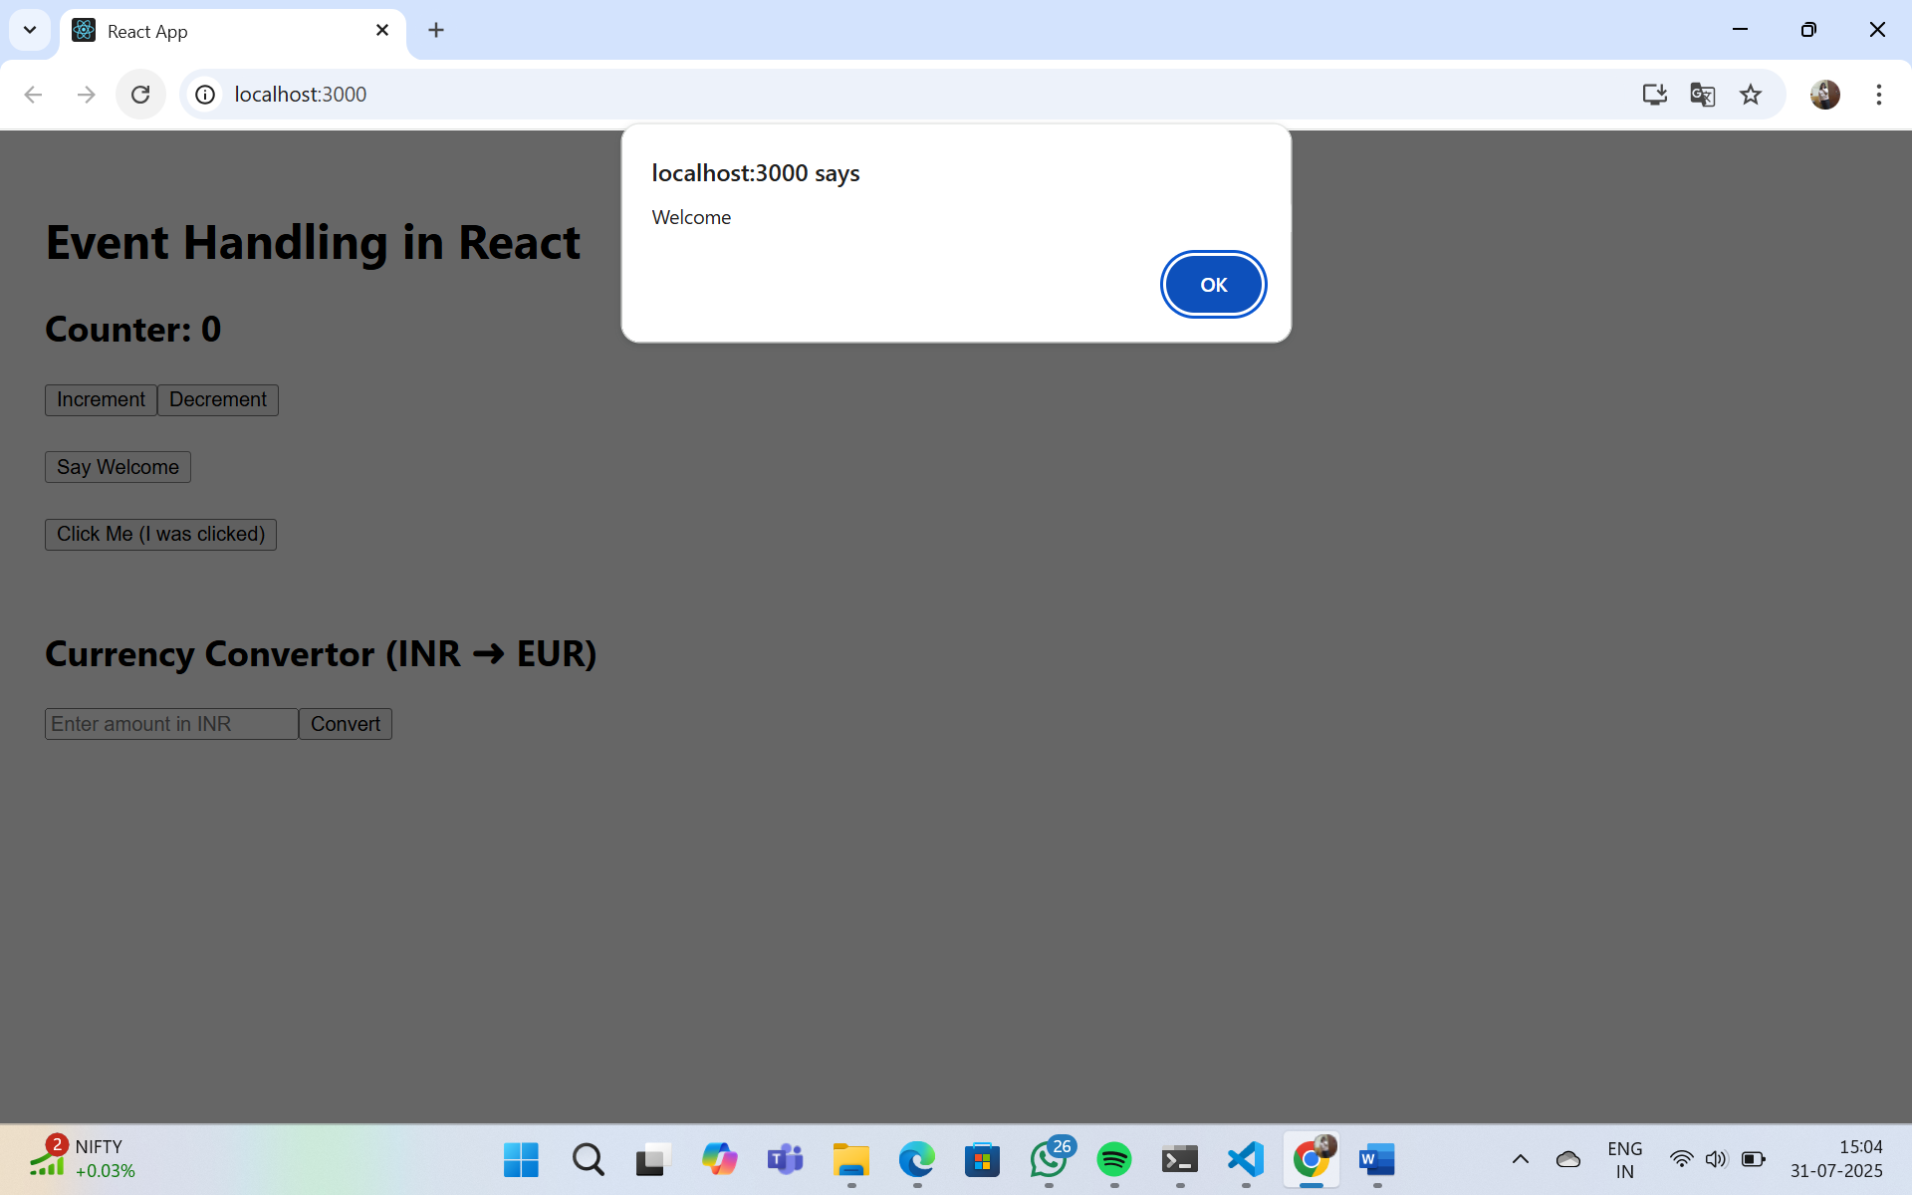

1. Create a button which invokes synthetic event “OnPress” which display “I was clicked”

Create a “CurrencyConvertor” component which will convert the Indian Rupees to Euro when the Convert button is clicked.

Handle the Click event of the button to invoke the handleSubmit event and handle the conversion of the euro to rupees.

1. **Ticketbookingapp**

Create a React Application named “ticketbookingapp” where the guest user can browse the page where the flight details are displayed whereas the logged in user only can book tickets.

The Login and Logout buttons should accordingly display different pages. Once the user is logged in the User page should be displayed. When the user clicks on Logout, the Guest page should be displayed.

**After executing**

**After login**

1. **Bloggerapp**

Create a React App named “bloggerapp” in with 3 components.

1. Book Details
2. Blog Details
3. Course Details

Implement this with as many ways possible of Conditional Rendering.

**Output:**

