Question 1

Table Creation

CREATE TABLE Employee

(

Emp_ID INT NOT NULL,

Manager_ID INT,

First_Name VARCHAR(50) NOT NULL,

Last_Name VARCHAR(50) NOT NULL,

Emp_Title VARCHAR(50) NOT NULL,

Salary VARCHAR(50) NOT NULL,

Joining_Date VARCHAR(50) NOT NULL,

DEP VARCHAR(50) NOT NULL

)

INSERT INTO Employee

VALUES

(1,null,'Monika','Arora','Manager','100000','02/20/14 9:00','HR'),

(2,1,'Niharika','Verma','Executive','80000','06/11/14 9:00','Admin'),

(3,1,'Vishal','Singhal','Manager','300000','02/20/14 9:00','HR'),

(4,null,'Amitabh','Singh','Manager','500000','02/20/14 9:00','Admin'),

(5,4,'Vivek','Bhati','Asst. Manager','500000','06/11/14 9:00','Admin'),

(6,5,'Vipul','Diwan','Executive','200000','06/11/14 9:00','Account'),

(7,4,'Satish','Kumar','Lead','75000','01/20/14 9:00','Account'),

(8,4,'Geetika','Chauhan','Lead','90000','04/11/14 9:00','Admin')

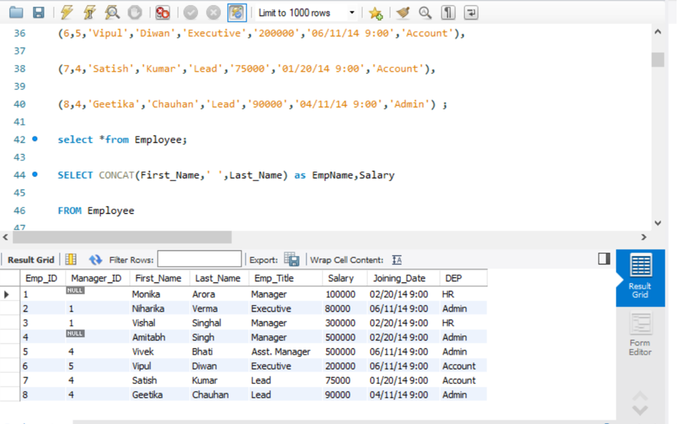

1.2

SELECT CONCAT(First_Name,' ',Last_Name) as EmpName,Salary

FROM Employee

WHERE Salary BETWEEN 50000 AND 100000

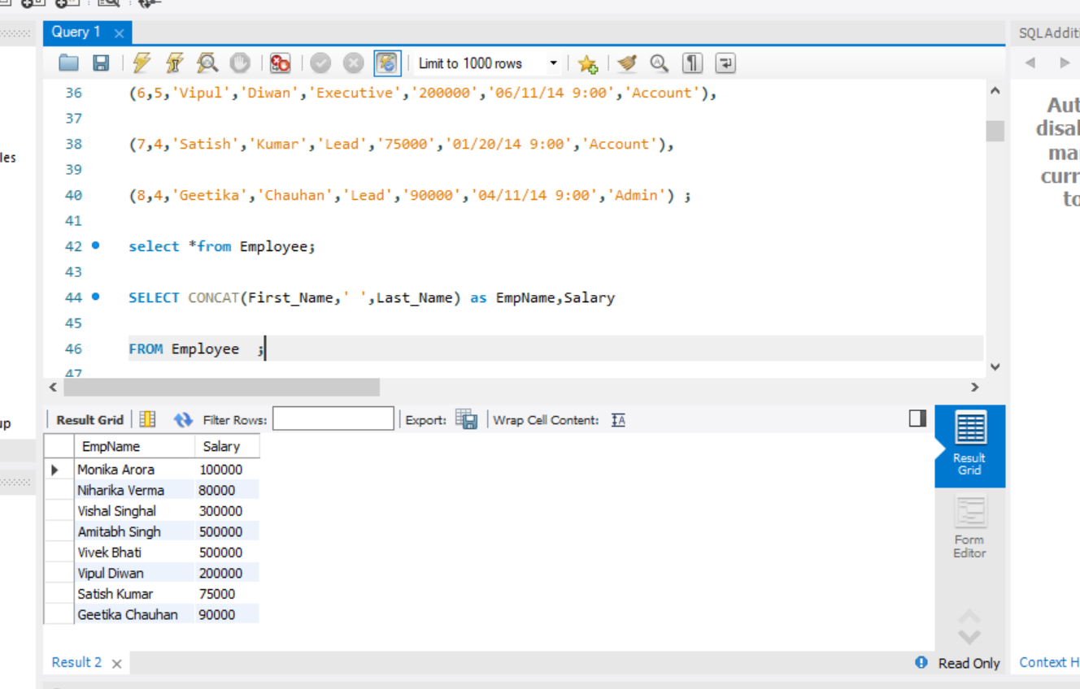

1.3

SELECT CONCAT(emp.First_Name,' ',emp.Last_Name) AS EmployeeName,

   CONCAT(mgr.First_Name,' ',mgr.Last_Name) AS ManagerName

FROM Employee emp JOIN Employee mgr ON

emp.Manager_ID=mgr.Emp_ID

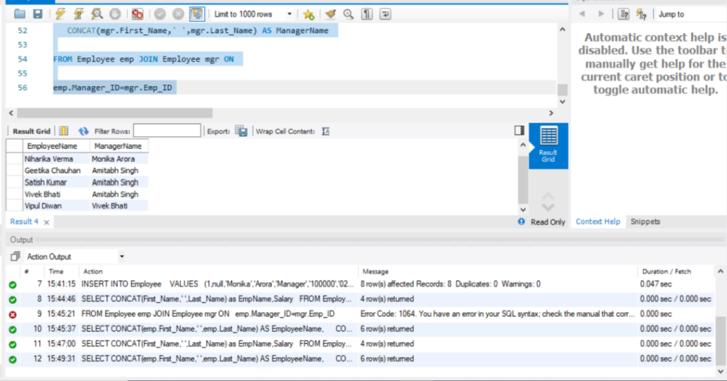

1.4

SELECT DEP,COUNT(*) AS Count

FROM Employee

GROUP BY DEP

ORDER BY Count DESC

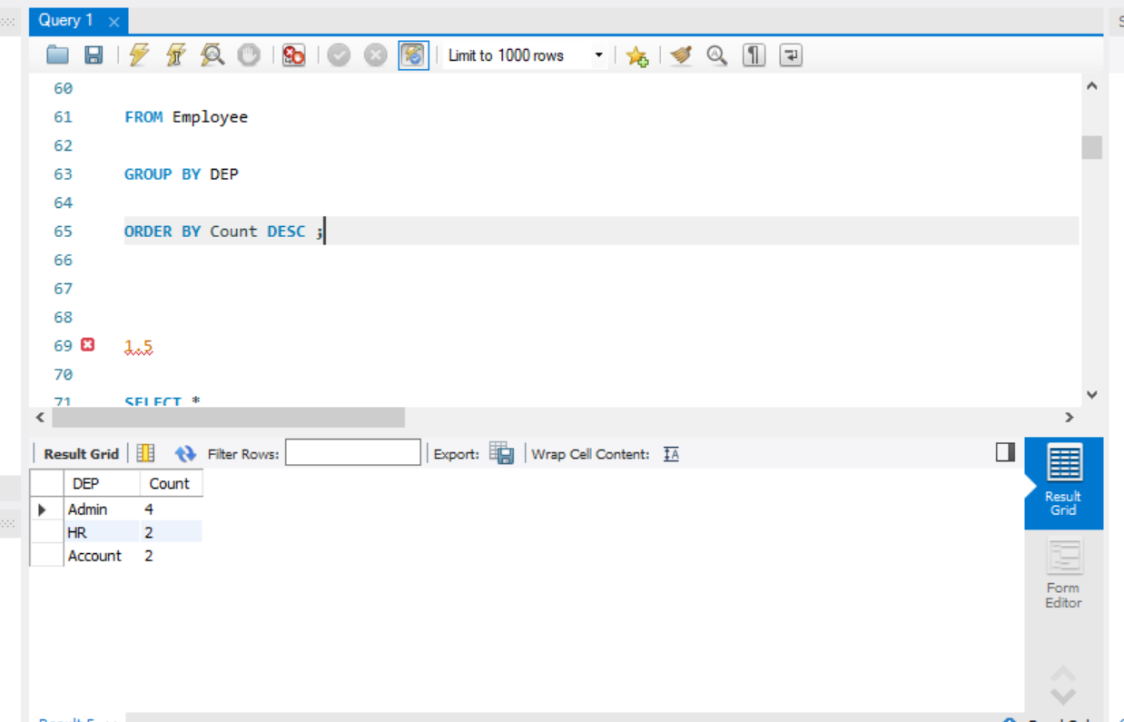

1.5

SELECT *

FROM(

SELECT CONCAT(First_Name,' ',Last_Name) AS EmpName,Salary,

DENSE_RANK() OVER (ORDER BY Salary DESC)r

FROM Employee) e

WHERE e.r=5

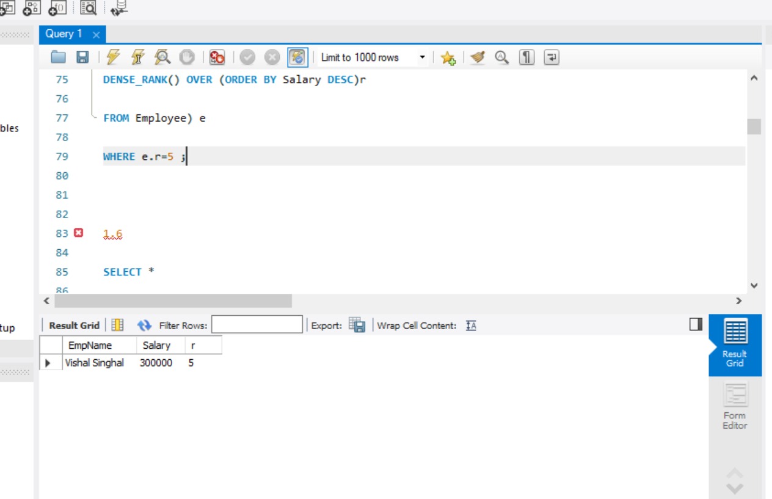

1.6

SELECT *

FROM(

SELECT CONCAT(First_Name,' ',Last_Name) AS EmpName,Salary,

DENSE_RANK() OVER (ORDER BY Salary DESC)r

FROM Employee) e

WHERE e.r=3

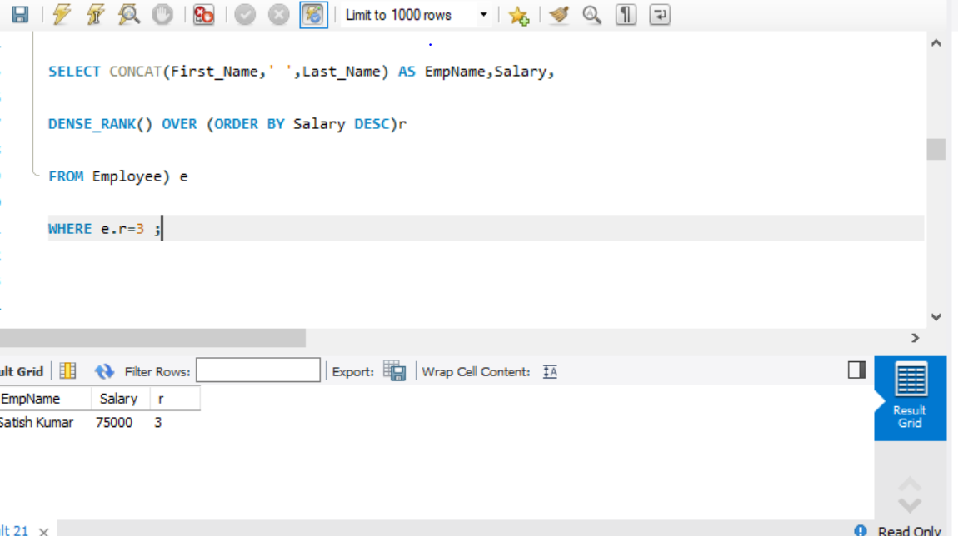

1.7

SELECT *

FROM(

SELECT *,

ROW_Number() OVER (PARTITION BY EMP_ID ORDER BY Emp_ID) r

FROM Employee) e

WHERE e.r<>1

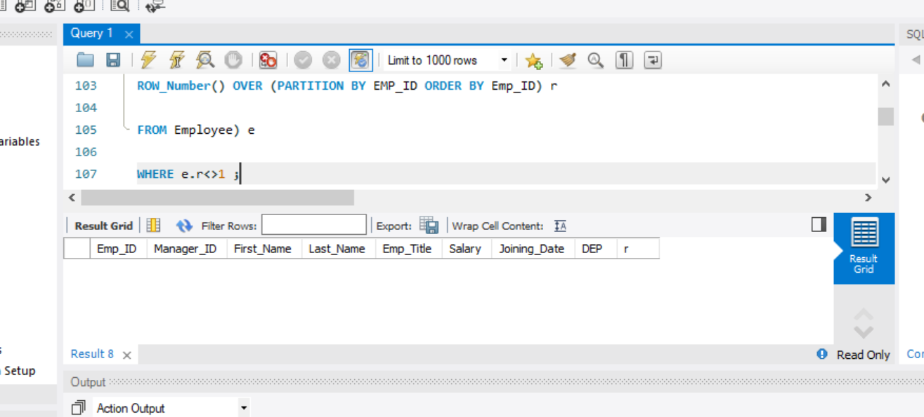

1.8

SELECT *

FROM Employee

WHERE Manager_ID =' ' or

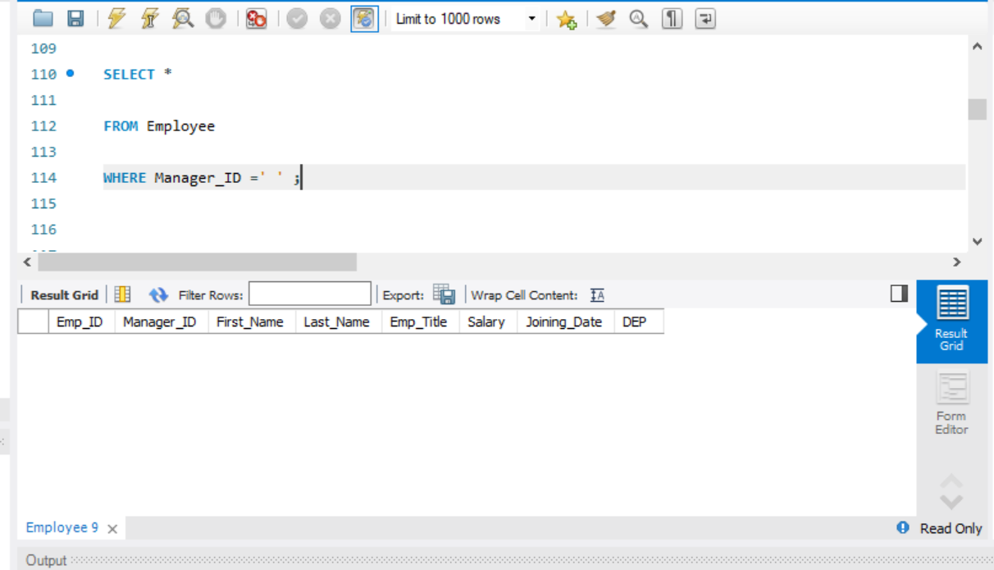

Question 2

Table Creation

Customer Table

CREATE TABLE Customer

(

CustID INT PRIMARY KEY,

CustName VARCHAR(50),

City VARCHAR(50),

Grade INT,

SalesMan_ID INT

)

INSERT INTO Customer

VALUES

(3001,'Nick Rimando','New York',100,5001),

(3002,'Brad Davis','New York',200,5001),

(3003,'Graham Zusi','California',200,5002),

(3004,'Julian Green','London',300,5002),

(3005,'Fabian John','Paris',300,5006),

(3006,'Geoff Rock','Berlin',100,5003),

(3007,'Rozy Altidor','Moscow',200,5007),

(3008,'Brad Gujan','London',300,5005)

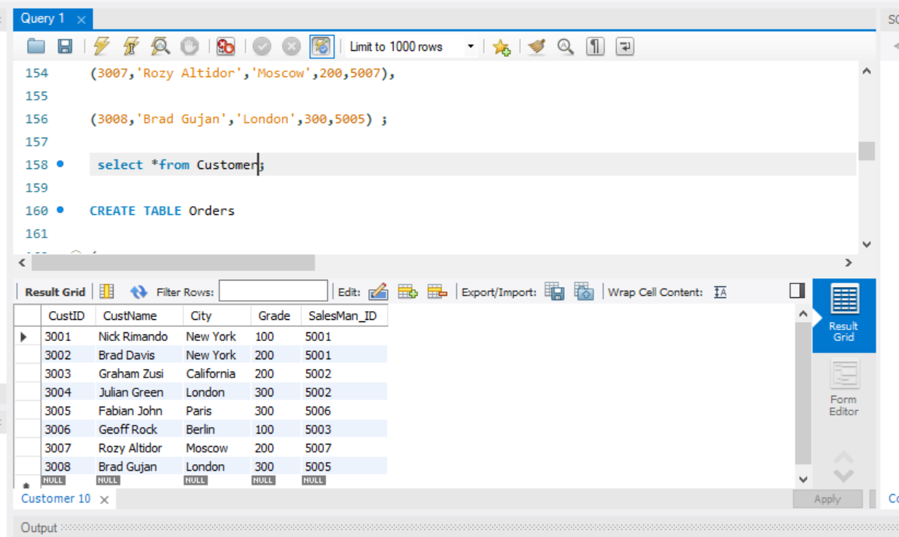

Orders Table

CREATE TABLE Orders

(

OrderNo INT,

OrderDate DATE,

Order_Amt MONEY,

Cust_ID INT REFERENCES Customer(CustID),

SalesMan_Id INT,

Commision Varchar(3)

)

INSERT INTO Orders

VALUES

(1,'2005/12/22',160,3001,5002,'13%'),

(9,'2005/08/10',190,3001,5005,'11%'),

(2,'2005/07/13',500,3002,5001,'15%'),

(4,'2005/07/15',420,3002,null,'0'),

(7,'2005/12/22',1000,3003,null,'0'),

(5,'2006/10/02',820,3004,5001,'15%'),

(8,'2006/11/03',2000,3004,5001,'15%'),

(10,'2006/10/09',1500,3005,5006,'14%'),

(12,'2006/10/20',1800,3005,5003,'12%')

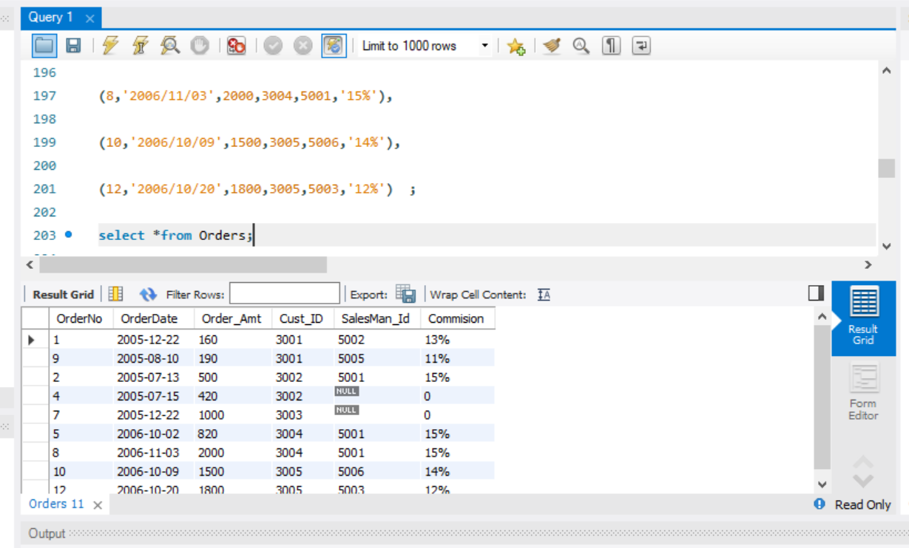

2.1

SELECT c.CustID,c.CustName,Count(o.Cust_ID) NoOfOrders

FROM Customer c JOIN Orders o ON

c.CustID=o.Cust_ID

GROUP BY CustID,CustName

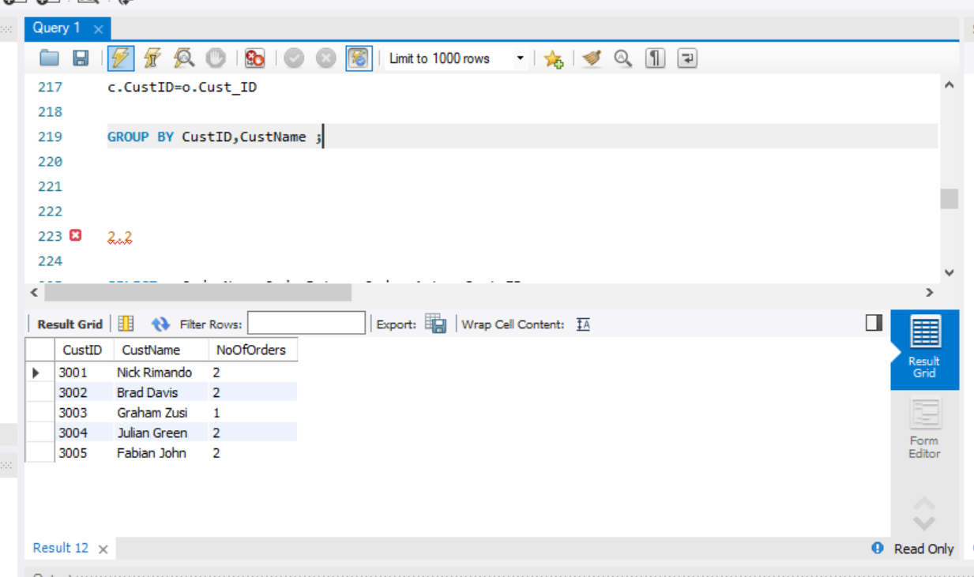

2.2

SELECT o.OrderNo,o.OrderDate,o.Order_Amt,o.Cust_ID

FROM Orders o

WHERE o.Cust_ID NOT IN (SELECT c.CustID

     FROM Customer as c)

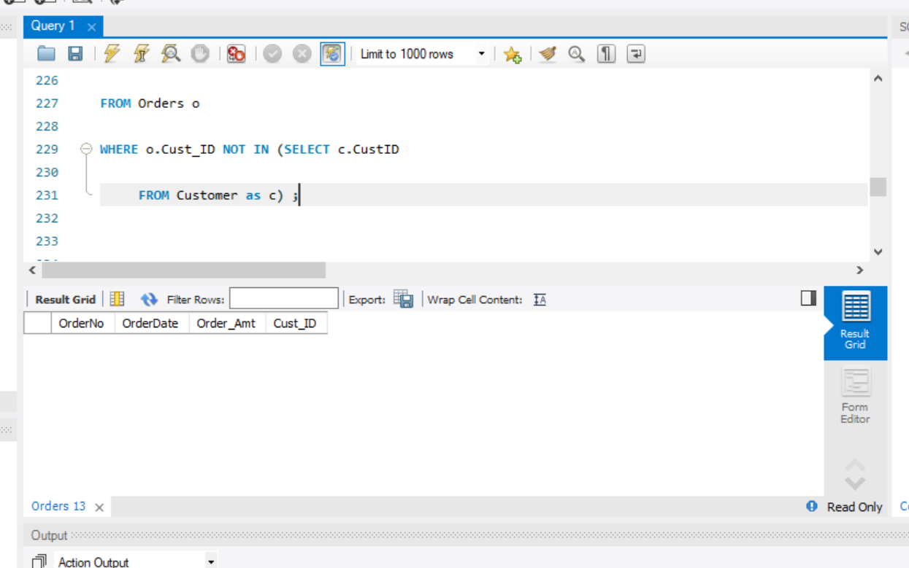

2.3

SELECT DISTINCT c.CustName

FROM Customer c JOIN Orders o ON

c.CustID=o.Cust_ID

WHERE MONTH(o.OrderDate)=7 OR MONTH(o.OrderDate)=8

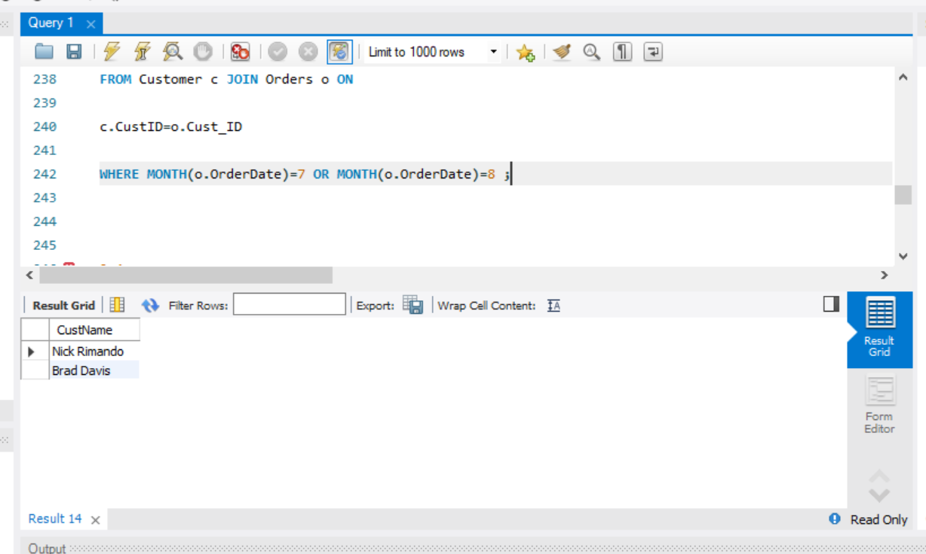

2.4

SELECT c.CustID,c.CustName,o.Order_Amt

FROM Customer c LEFT OUTER JOIN Orders o ON

o.Cust_ID=c.CustID

WHERE O.Order_Amt<(SELECT AVG(Order_Amt) FROM Orders)

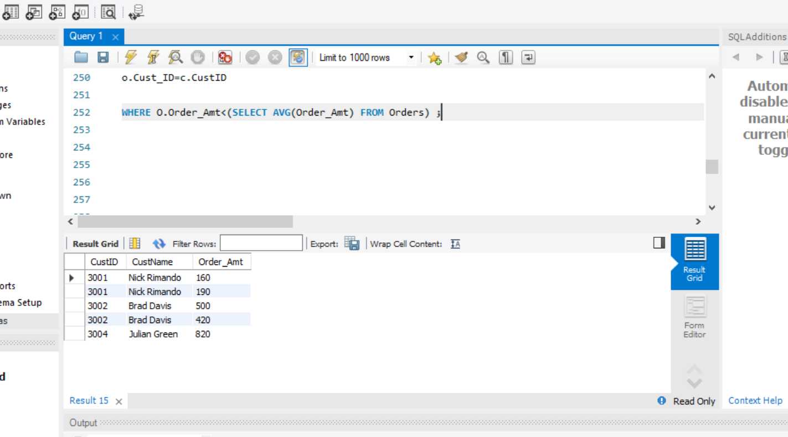

Question 3

3.1

SELECT MIN(Order_Amt) MinimumAmt,MAX(Order_Amt) MaximumAmt,AVG(Order_Amt) AverageAmt

FROM Orders

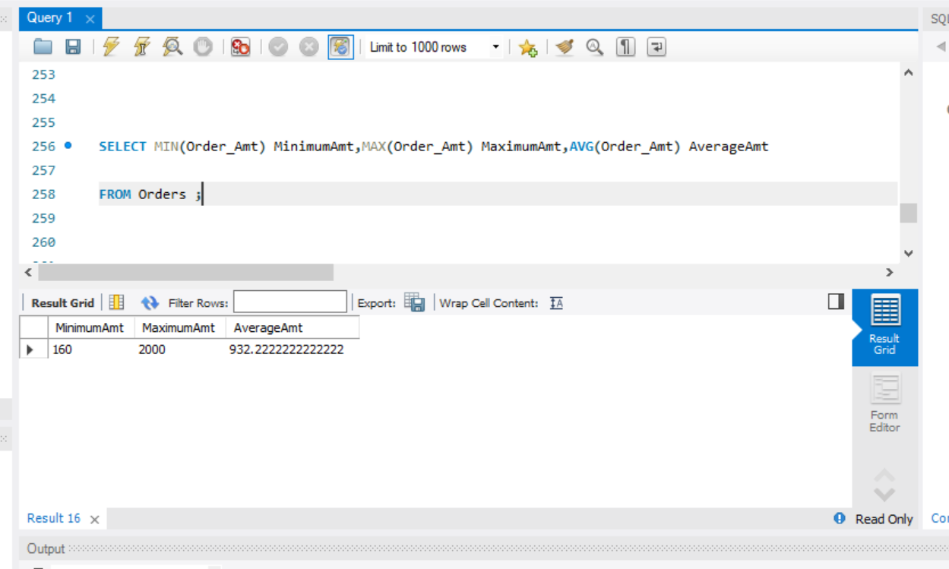

3.2

SELECT c.City,COUNT(o.OrderNo) as No_Of_Order,SUM(o.Order_Amt) as Order_Value

FROM Customer c JOIN Orders o ON

c.CustID=o.Cust_ID

GROUP BY City

ORDER BY Order_Value

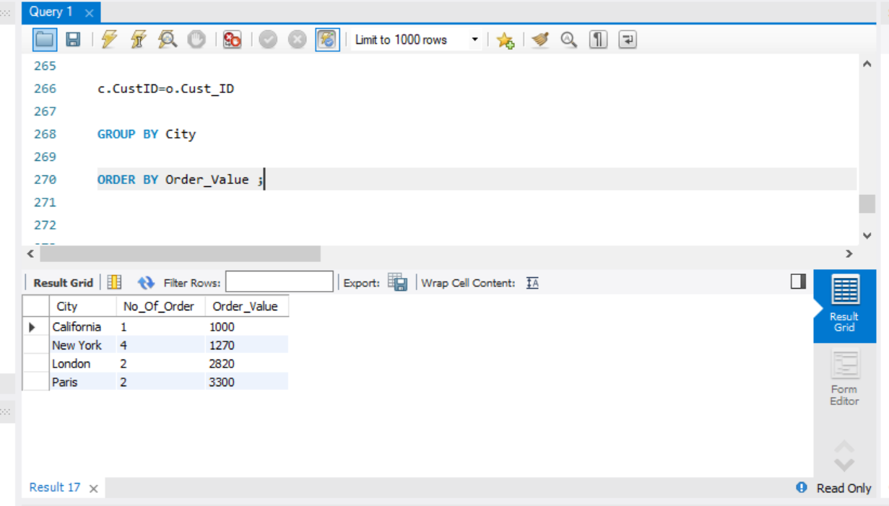

3.3

SELECT c.CustID,SUM(o.Order_Amt) as Total

FROM Customer c JOIN Orders o ON

c.CustID=o.Cust_ID

GROUP BY CustID

ORDER BY Total DESC limit 2;

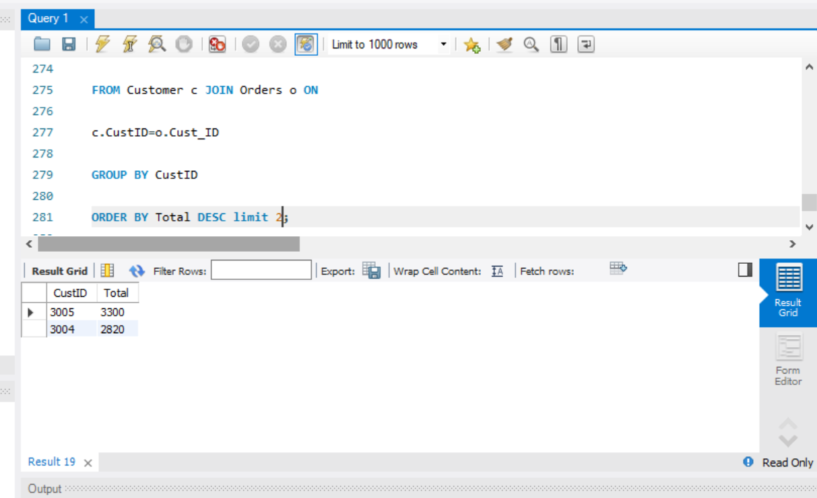

3.4

SELECT c.City,COUNT(*) OrderNo,SUM(o.Order_Amt) MaxOrderAmount

FROM Customer c JOIN Orders o ON

c.CustID=o.Cust_ID

Group by City

Order BY MaxOrderAmount DESC limit 1;

