- Installing Visual Studio Code
- Objective: Set up the development environment using Visual Studio for coding and debugging.
- Required Resource:
- Visual Studio (available for windows, Mac. Linux) https://code.visualstudio.com/
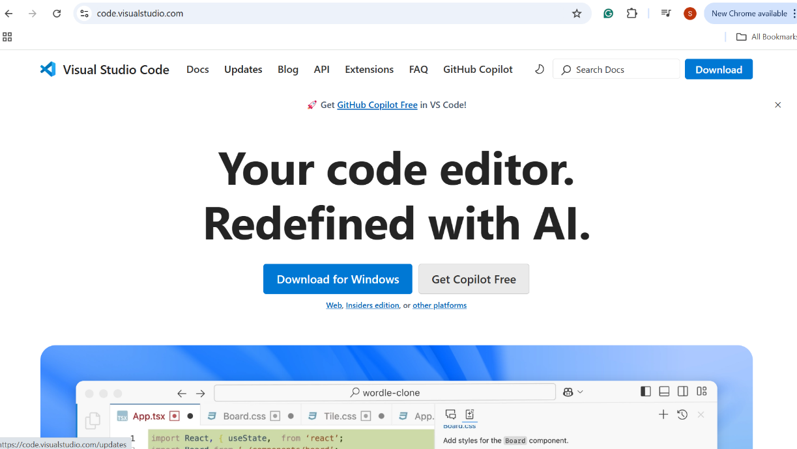
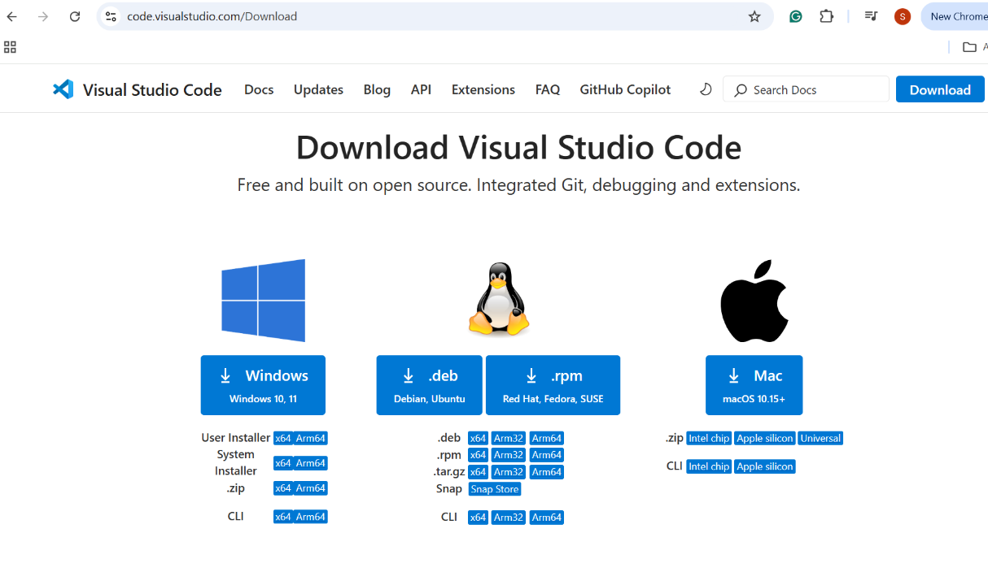
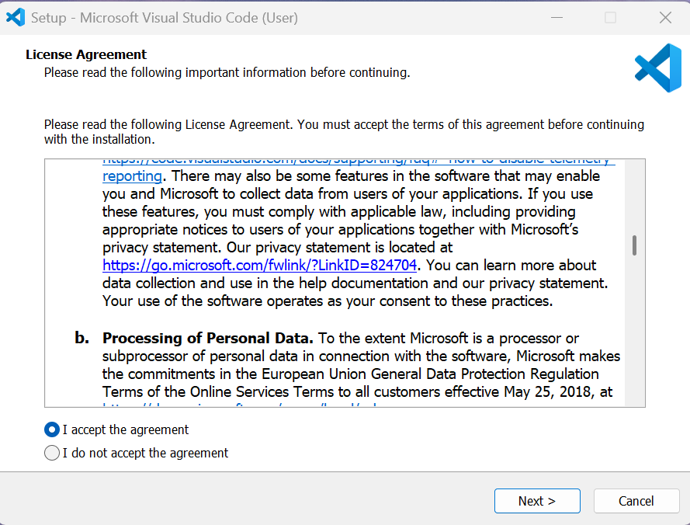
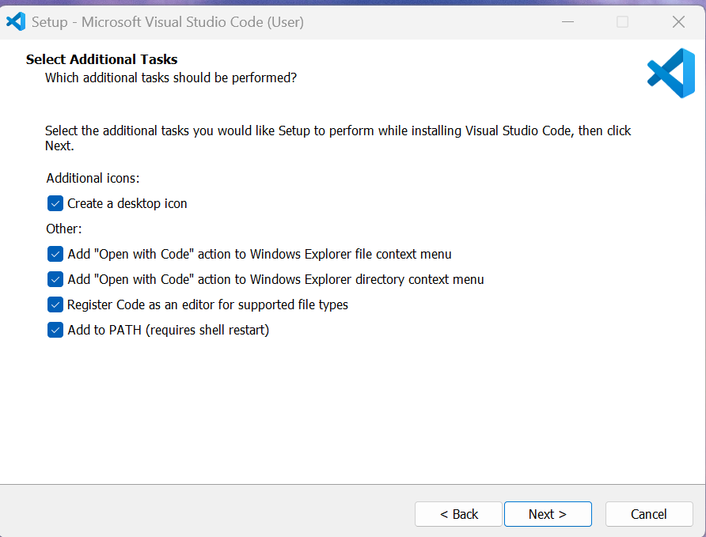
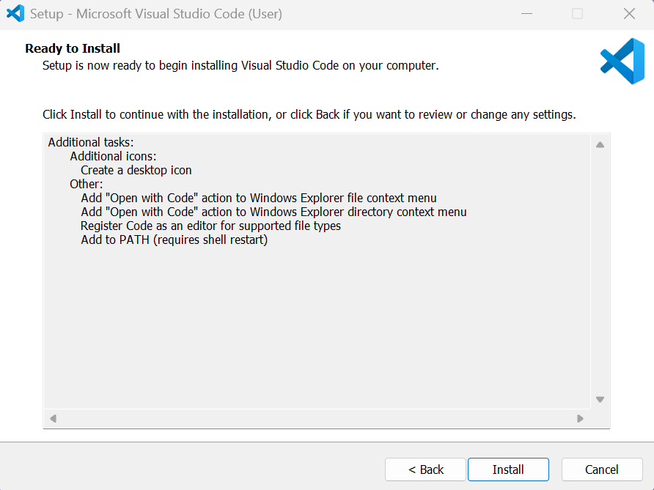
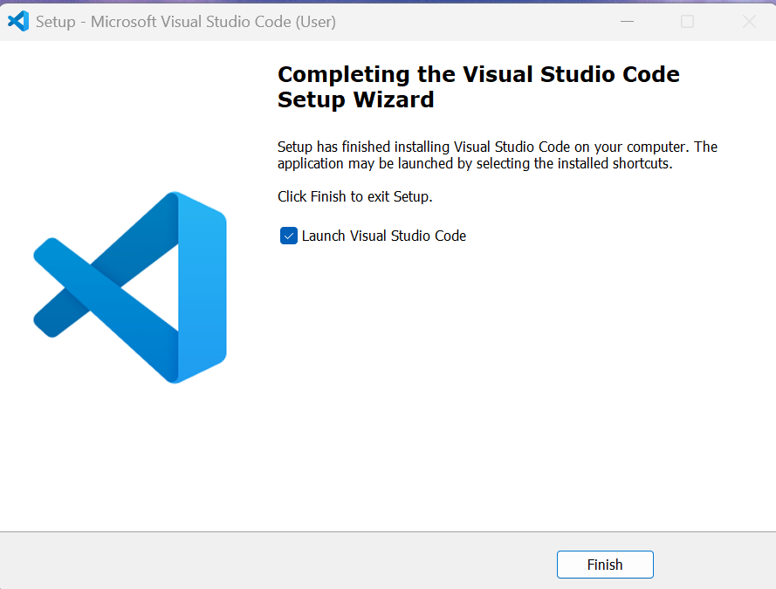
- GitHub Creation
- Objective: Set up a GitHub account and repository for version control.
- Required Resources:
- Sign up to GitHub in Visual Studio Code by clicking Extension Marketplace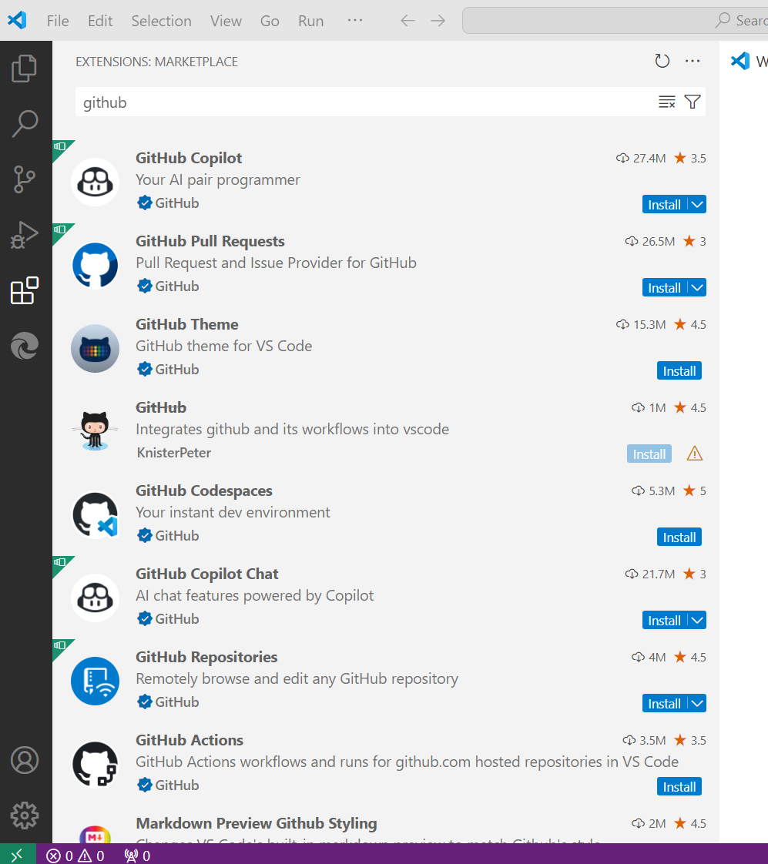
- Install GitHub Pull Requests, GitHub Codespaces and GitHub Repositories.
- Then sign up to GitHub and then click allow
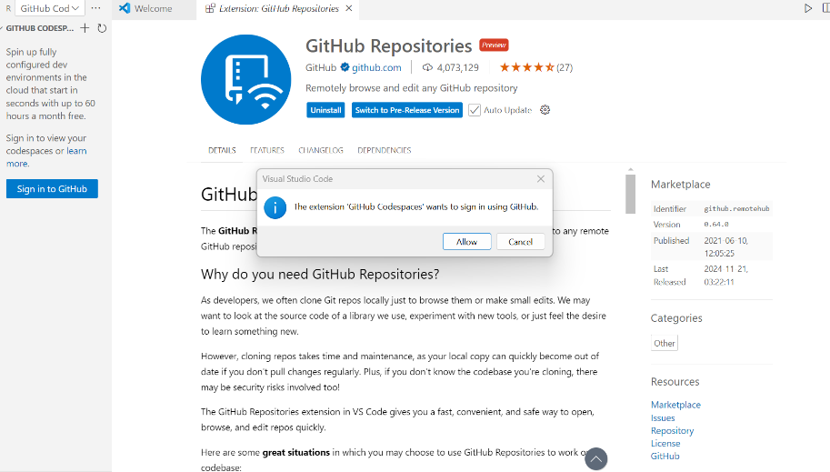
- After completing Download and install Git from https://git-scm.com/
Initialize a Git Repository:
- Open your website folder in Visual Studio Code.
- Open the terminal in VS Code by going to Terminal > New Terminal.
- In the terminal, run the following command to initialize a Git repository (command: git init)
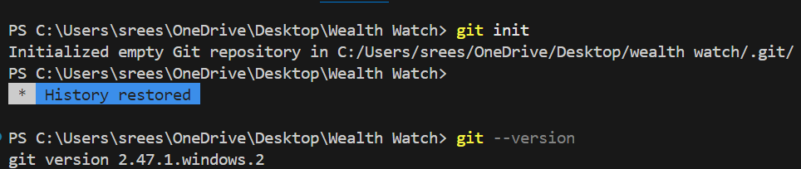
- If we use git –version command it gives the version of the git.
- Now, to create a GitHub Repository go to GitHub and Login.
- Click on the + icon in the top right corner and select New repository.
- Give your repository a name (e.g., wealth-watch).
- Optionally, add a description.
- Choose whether the repository should be public or private.
- Click Create repository.
- Now, link your Local Repository to GitHub copy the repository URL from GitHub (https://github.com/username/wealth-watch.git)
- in Visual Studio Code, run the following command to link your local repository to GitHub:

(git remote add origin https://github.com/username/repository-name.git ) . Replace username and repository-name.
- To stage all files for the first commit, run: (git add .)

- Set your Git Username and Email Globally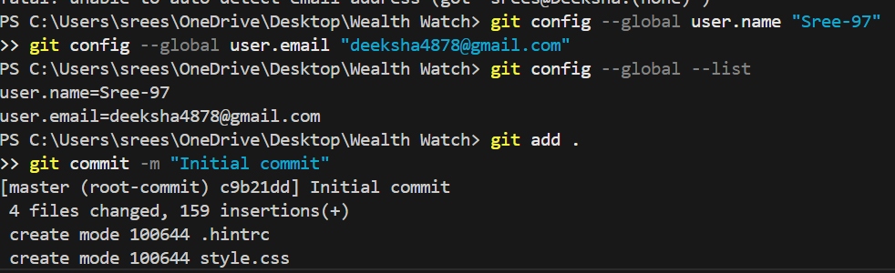

- Commit again using commands (git add.), and then (git commit -m “Initial commit”)

- Create and switch to a New Branch(optional)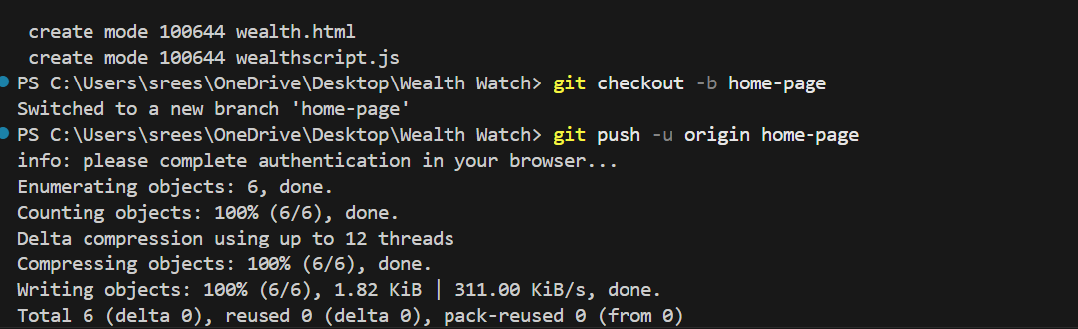

- This will upload your local repository and set the remote origin for future pushes.

- Go back to your GitHub page and refresh it. You should now see your repository with the files from your local project and the new branch.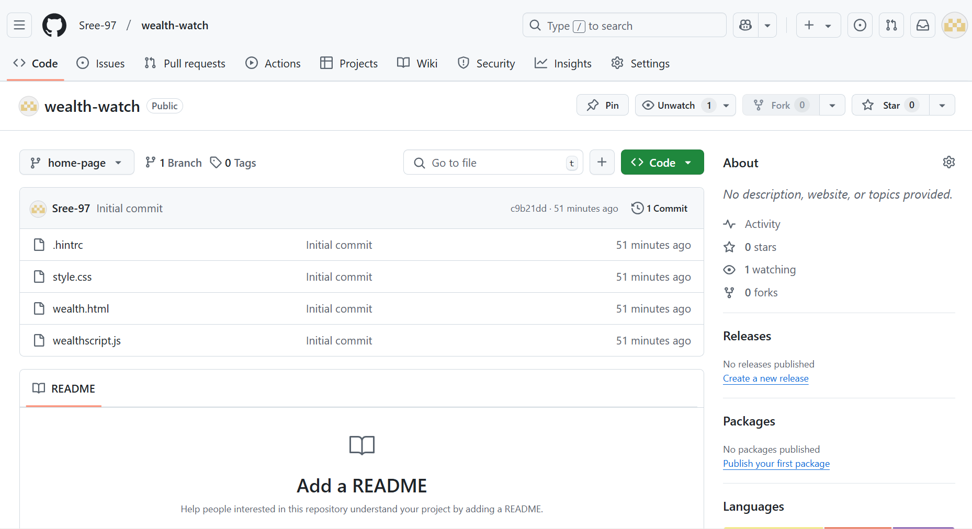

- Get
- To get your GitHub Repository Link click on the ‘code’ green button.

- Copy the repository URL to share.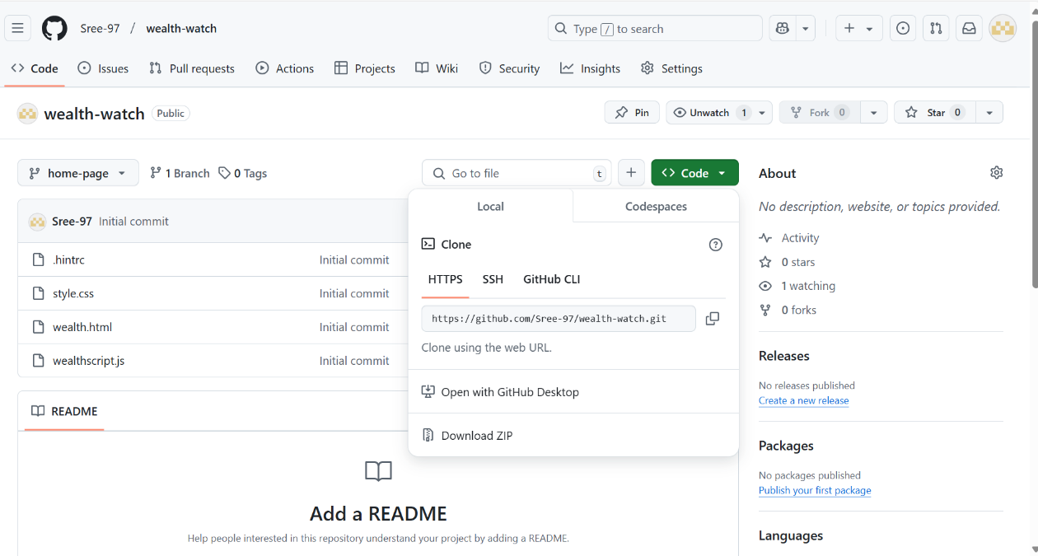

- Java Installation:
Objective: Install the latest Java Development Kit (JDK) and configure environment variables.
Required Resources:
JDK download from https://www.oracle.com/java/technologies/downloads/#java17-windows
Command prompt
Steps:
Download the latest JDK installer for your operating system.
Run the installer and follow the prompts to complete the installation.
Set the path and open command prompt and run commands (java –version).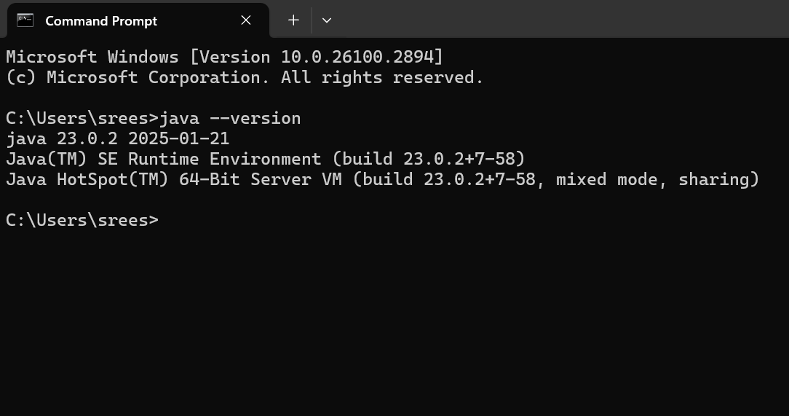

Basic Website Development

Project Name: Wealth Watch
Objective: The Expense Tracker is a simple web application that allows users to add and view their expenses. It helps users track their spending by categorizing expenses and displaying totals dynamically.
Key Features:
Add new expenses (Expense Name, amount, category,).
Display a list of recorded expenses.
Calculate and display the total expenses dynamically.
Simple and user-friendly interface using HTML, CSS, and JavaScript.
Technologies Used:
Frontend: HTML, CSS, JavaScript
Version Control: Git, GitHub
Development Tools: Visual Studio Code, Chrome Developer Tools
Project Setup
Create files & folders (wealth watch—wealth.html, style.css, wealthscript.js)
Develop the user interface in html file and then design the user interface by applying styles (CSS) and the final step is implemented JavaScript functions to capture user input, display expenses dynamically and calculate total expenses.
