**Scatter Plot**

A graph in which the values of two variables are [plotted](https://www.google.com/search?rlz=1C1ONGR_enIN1060IN1060&q=plotted&si=AMnBZoFHF1DJLZWpTBtQDK262RMpl4WUFAwHZNth6TMMCGcrBc6OlQXEBHc-5-UiLRrQgtDKeINhedcnxrsxCNUNNf8OSE5e_w%3D%3D&expnd=1) along two [axes](https://www.google.com/search?rlz=1C1ONGR_enIN1060IN1060&q=axes&si=AMnBZoFyML4eMiMHeTZQESAU1BAp63uqCFahvSs65lejQ0Y8VFwILrGRnLFXxkowU7ugMW8f0o7FzLJ58JxgHqi_lPb8ks9dAQ%3D%3D&expnd=1), the pattern of the resulting points revealing any correlation present.

**Box and Whisker Plot**

We use these box plots or graphical representation to know:

* Distribution Shape
* Central Value
* Variability

When we plot a graph for the box plot, we outline a box from the first quartile to the third quartile. A vertical line that goes through the box is the median. The whiskers (small lines) go from each quartile towards the minimum or maximum value, as shown in the figure below.

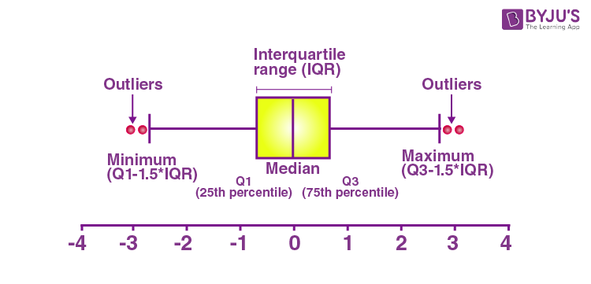

**Positively Skewed**: If the distance from the median to the maximum is greater than the distance from the median to the minimum, then the box plot is positively skewed.

**Negatively Skewed**: If the distance from the median to minimum is greater than the distance from the median to the maximum, then the box plot is negatively skewed.

**Symmetric**: The box plot is said to be symmetric if the median is equidistant from the maximum and minimum values.

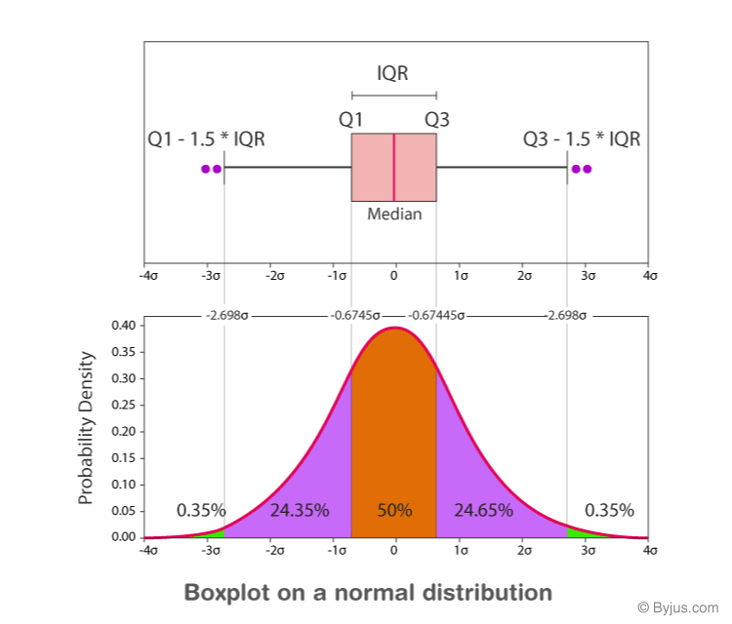

### Box Plot Example

**Example:**

Find the maximum, minimum, median, first quartile, third quartile for the given data set: 23, 42, 12, 10, 15, 14, 9.

**Solution:**

Given: 23, 42, 12, 10, 15, 14, 9.

Arrange the given dataset in ascending order.

9, 10, 12, 14, 15, 23, 42

Hence,

Minimum = 9

Maximum = 42

Median = 14

First Quartile = 10 (Middle value of 9, 10, 12 is 10)

Third Quartile = 23 (Middle value of 15, 23, 42 is 23).

Quartile is a special case of Quantile.

Mean, Median and Mode are measures of Central Tendency of Data

**Q1 What is a box plot?**

A box plot is a special type of diagram that shows the quartiles in a box and the line extending from the lowest to the highest value.

**Q2 What is the five-number summary in the box plot?**

The five-number summary in the box plot is minimum, maximum, median, first quartile, and third quartile.

**Q3 When can we say that the box plot is symmetric?**

The box plot is said to be symmetric if the median is equidistant from the minimum and maximum value.

**Q4 Mention the two conditions that represent the outliers.**

Outliers are greater than Q3+(1.5. IQR) or less than Q1-(1.5. IQR)

**Q5 What are the first quartile and third quartile in the box plot?**

The first quartile is the middle value of the lower half of the data, and it is represented by Q1.  
The third quartile is the middle value of the upper half of the data and is represented by Q3.