Applicant User Guide — University of Peradeniya Online Application System
Version 1.0 · November 2026

1. Introduction
This guide walks you through applying for an Academic or Academic Support post at the University of Peradeniya using the online Application Management System (AMSUOP). It covers every stage, in the order you will meet them:
- Finding the advertisement and pressing Apply Now
- Creating an account (Register) and confirming it with an e-mailed OTP (one-time code)
- Signing in (Login + OTP)
- Choosing the post and filling in the 12-step online application
- Uploading documents, previewing and submitting
- Receiving the confirmation e-mail with your application PDF, downloading the PDF again, and tracking your application
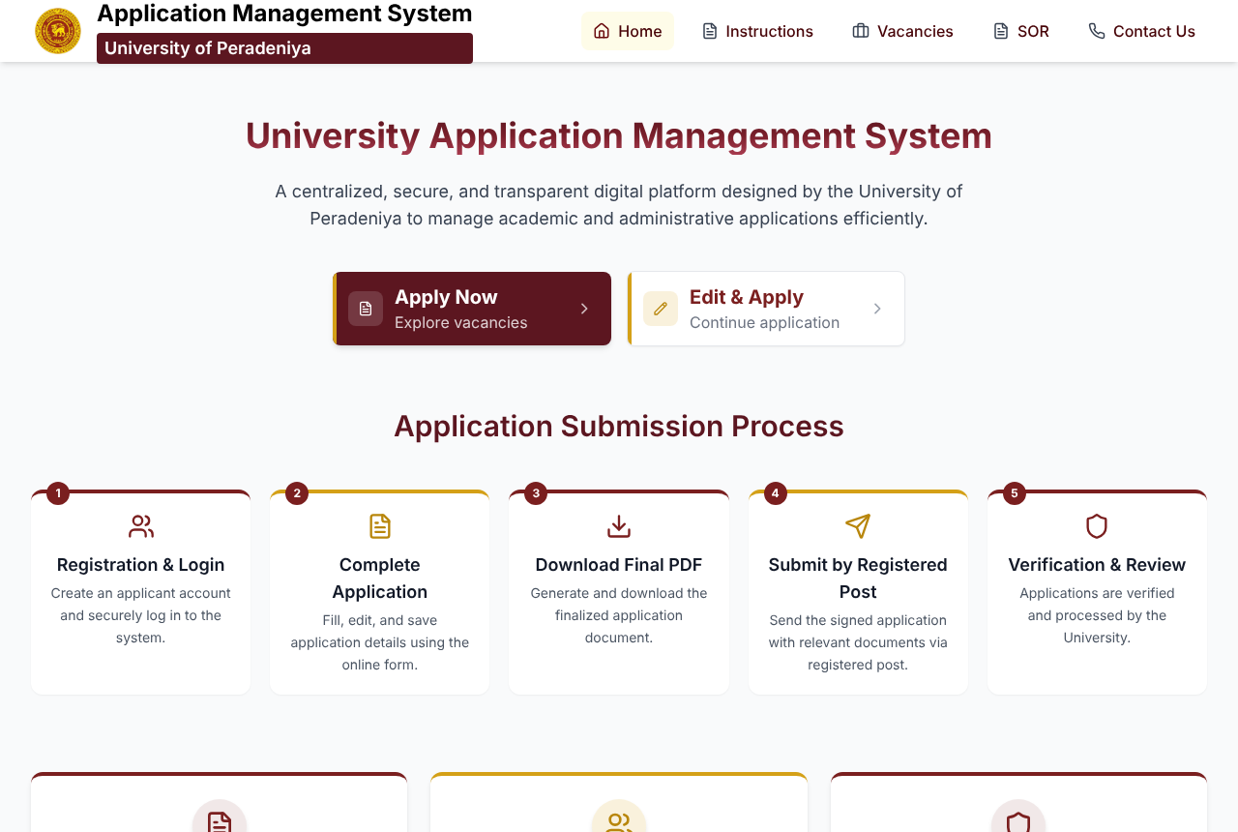
Home page of the Application Management System
The home page summarises the process: register and log in, complete the application online, download the final PDF, send the signed application with the relevant documents by registered post, and the University verifies and reviews it.
Tip: The system works on phones and tablets as well as computers. For the long form and document uploads, a computer is the most comfortable.

2. Before you start
Have the following ready. You can save and come back at any time before the closing date, but having everything at hand makes the process much quicker.
You will need | Notes
A personal e-mail address you can open now | Your OTP codes and the confirmation e-mail with your application PDF are sent here.
Your NIC (or passport) number and mobile number | Entered when you register, e.g. 991234567V or 200012345678; mobile e.g. 0771234567.
A recent passport-size colour photograph | JPG or PNG, front-facing, plain light background. It is printed on your application PDF.
Scanned copies of your documents | Birth Certificate, NIC/Passport, degree certificate(s), and where relevant postgraduate certificates, service letters, and extra-curricular certificates. PDF, JPG or PNG, max 5 MB each.
Details of education, employment, publications and referees | Dates of each job (from / to), and names, designations and contact details of two referees.
Password rules: at least 8 characters, using at least three of: lowercase letters, uppercase letters, digits, symbols (for example Peradeniya@2026).
Closing date: you can start, save and edit a draft at any time until the closing date shown on the advertisement. After the closing date, drafts can no longer be submitted.

3. Finding the advertisement (vacancy)
- Open the system and click Vacancies in the top menu (or Apply Now – Explore vacancies on the home page).
- Use the tabs All / Academic / Academic Support to filter the list. Each card shows the advertisement number (e.g. UOP/AE/2025/08), title and closing date.
- Click View Notice on the advertisement you are interested in.
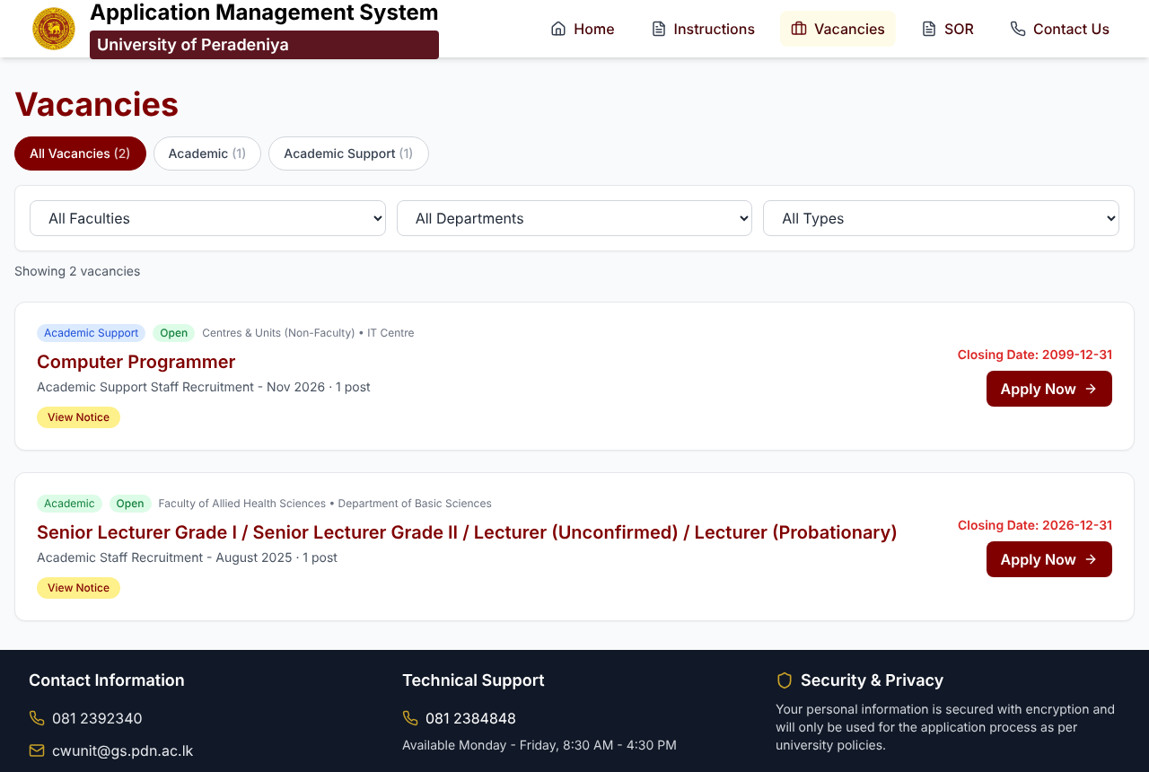
Vacancies list with All / Academic / Academic Support tabs
The advertisement page shows the full notice: published date, closing date, the advance-copy deadline (for permanent public-service staff), and every opening under the notice — the department, faculty, posts available and the qualifications required.
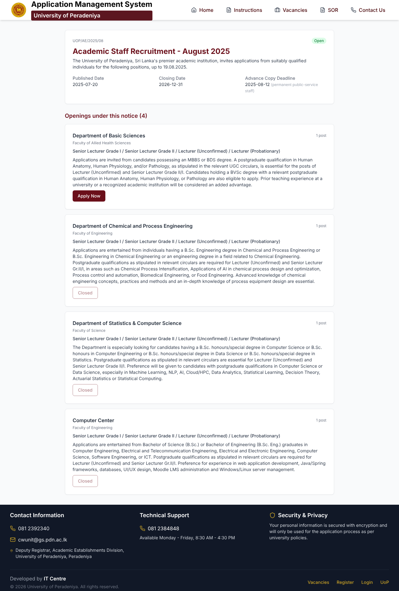
Advertisement detail page with openings and Apply Now buttons
- An opening that is still accepting applications shows a red Apply Now button.
- An opening that is no longer accepting applications shows Closed.
Read the requirements for the opening carefully before applying.

4. Apply Now
Click Apply Now on the opening you want. What happens next depends on whether you are signed in:
Your situation | What the system does
New applicant (no account yet) | Opens the Register page. After you register and verify your e-mail, you are brought straight back to this advertisement.
Already have an account, not signed in | On the Register page, click Login at the bottom. After login and OTP you are returned to this advertisement.
Already signed in | Goes directly to Start Your Application, where you choose the post (Section 8).
Applications can only be started from an advertisement’s Apply Now button, so that every application is linked to the correct notice and opening.

5. Register and verify your e-mail (OTP)

5.1 Fill in the registration form
Enter:
- Full Name
- NIC / Passport number (e.g. 991234567V or 200012345678)
- E-mail address — use one you can open right now
- Mobile number (e.g. 0771234567)
- Password and Confirm Password — the two ticks under the password turn green when it meets the rules
Then click Register. The button stays disabled until every field is valid.
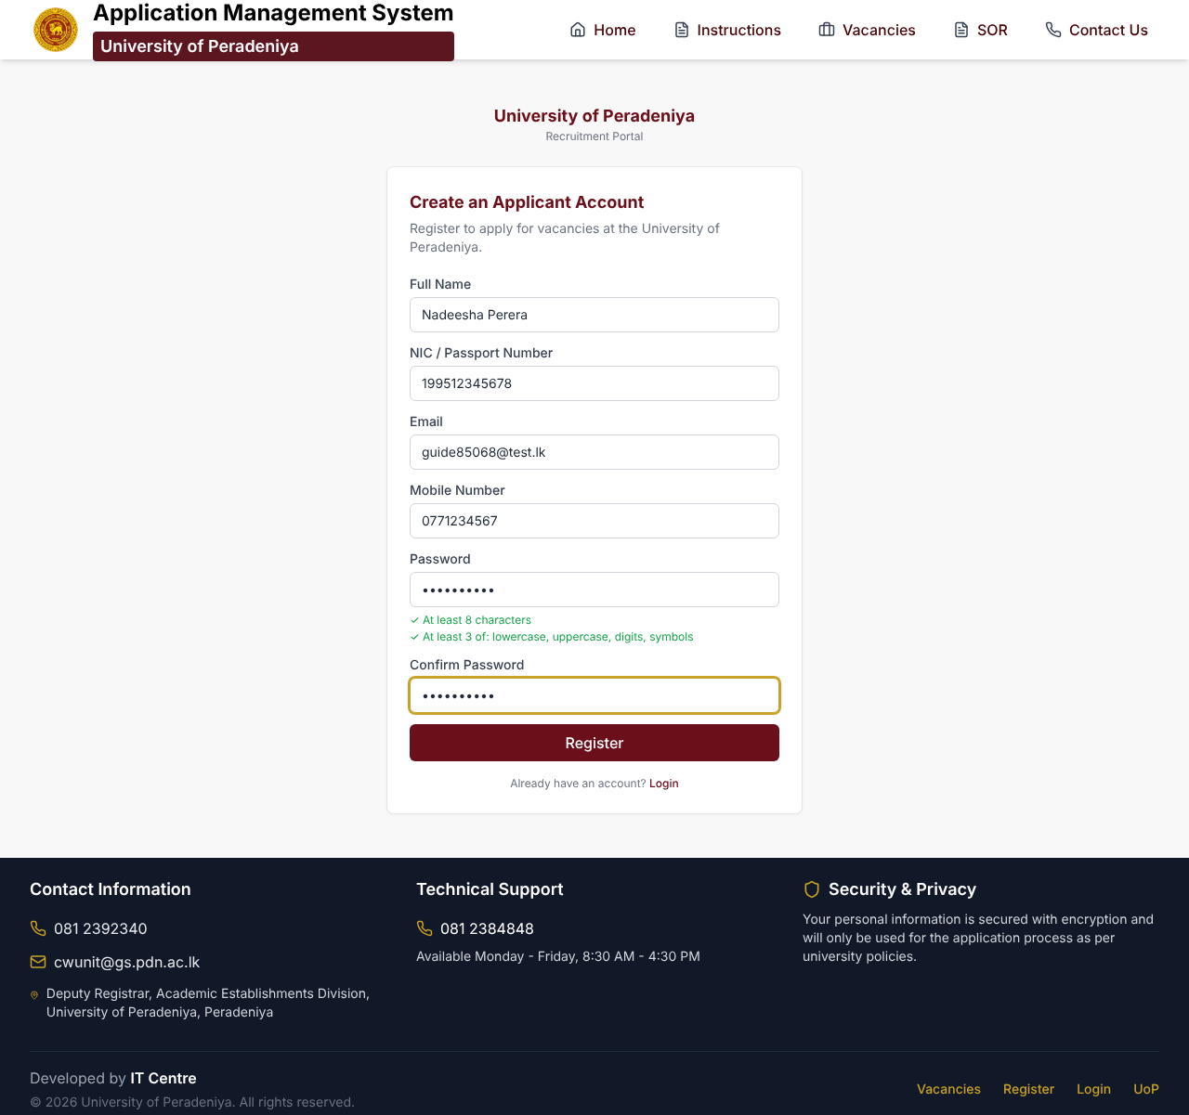
Registration form, filled in

5.2 Enter the verification code (OTP)
A 6-digit verification code is e-mailed to you immediately. It looks like this:
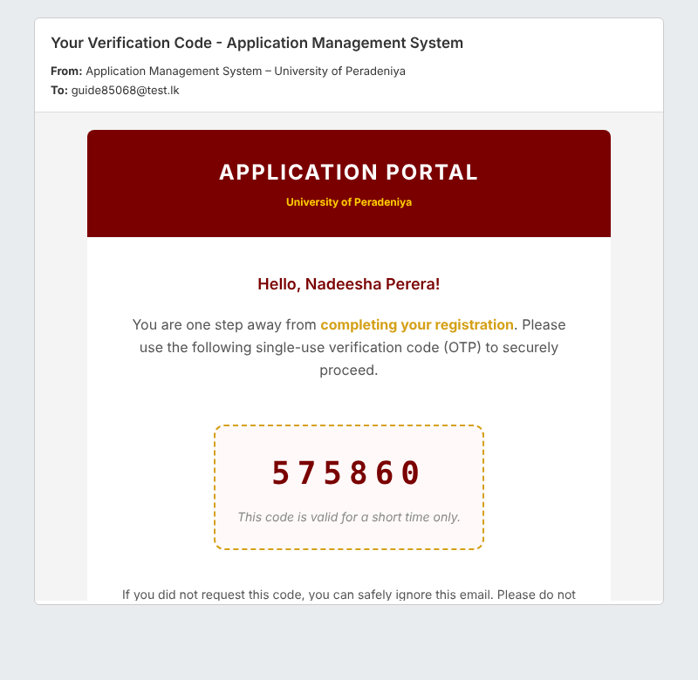
Verification code e-mail
Type the 6-digit code into the Verify Your Email page and click Verify & Continue.
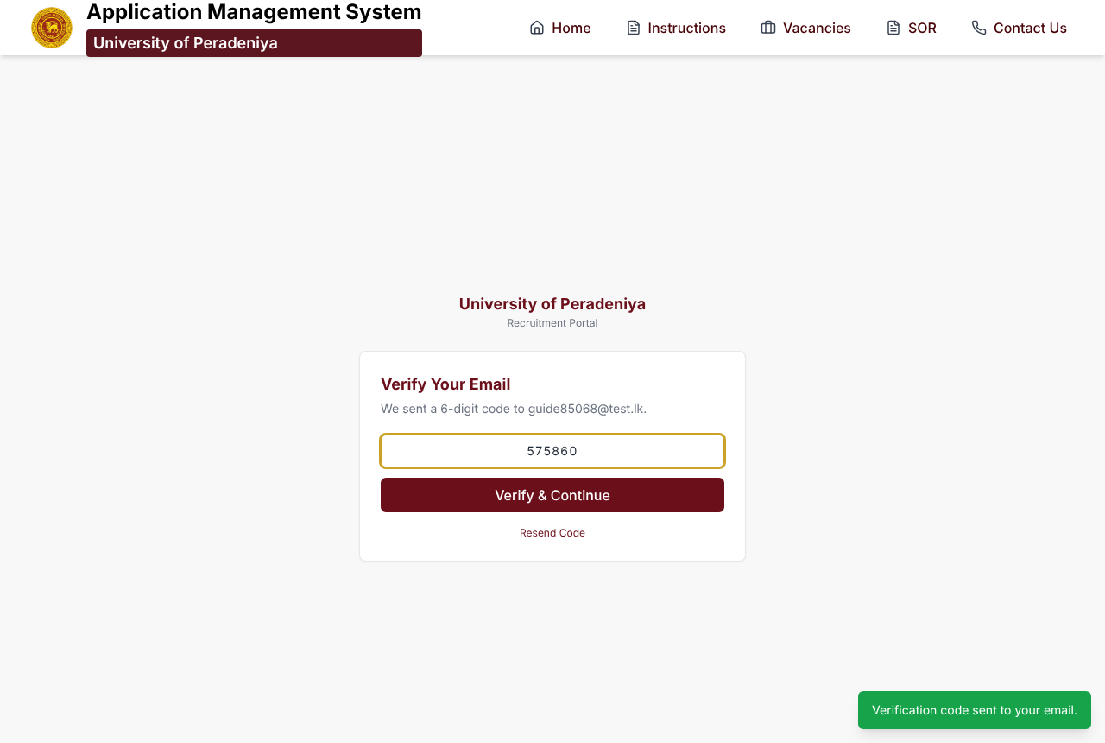
Verify Registration page with the 6-digit code entered
- The code is valid for 5 minutes. If it expires or does not arrive, click Resend Code.
- Check your Spam / Junk folder if the e-mail is not in your inbox.
- Your account is only created after the code is verified. If you entered the wrong e-mail address, simply register again with the correct one.
When the code is accepted you see Registration successful!, you are signed in, and you are taken back to the advertisement to press Apply Now again.

6. Login (with OTP) and forgotten password

6.1 Login
- Click Login (bottom of the Register page, or the footer link), enter your e-mail and password, and click Login.
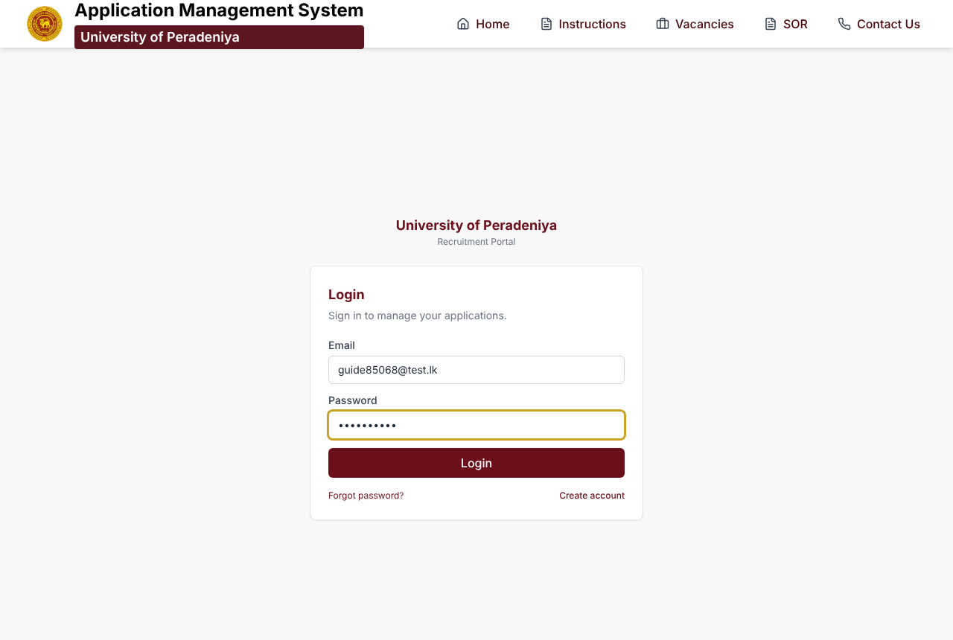
Login page
- A new 6-digit login code is e-mailed to you. Enter it on the Enter Login Code page and click Verify & Login. (Codes expire after 5 minutes; use Resend Code if needed.)
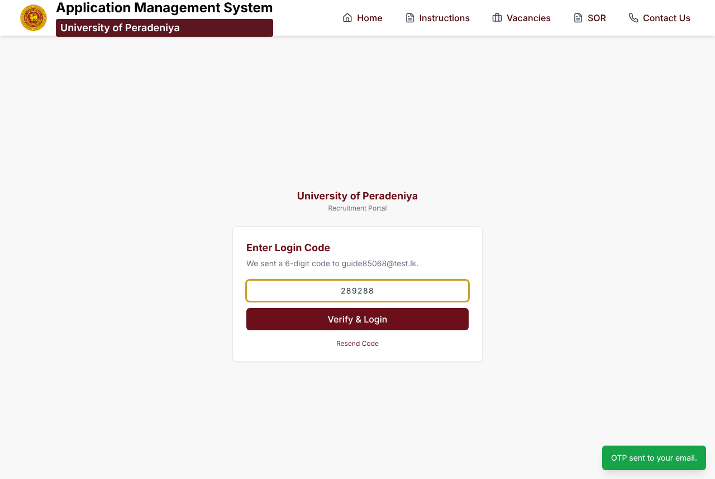
Enter Login Code page
- You arrive at your Dashboard — or, if you started from an advertisement’s Apply Now button, back at that advertisement.

6.2 Forgot your password?
- On the Login page click Forgot password?
- Enter your registered e-mail and click Send Code.
- Enter the 6-digit code on the Verify Code page and click Verify.
- Choose a new password on Set a New Password and click Reset Password, then log in with it.
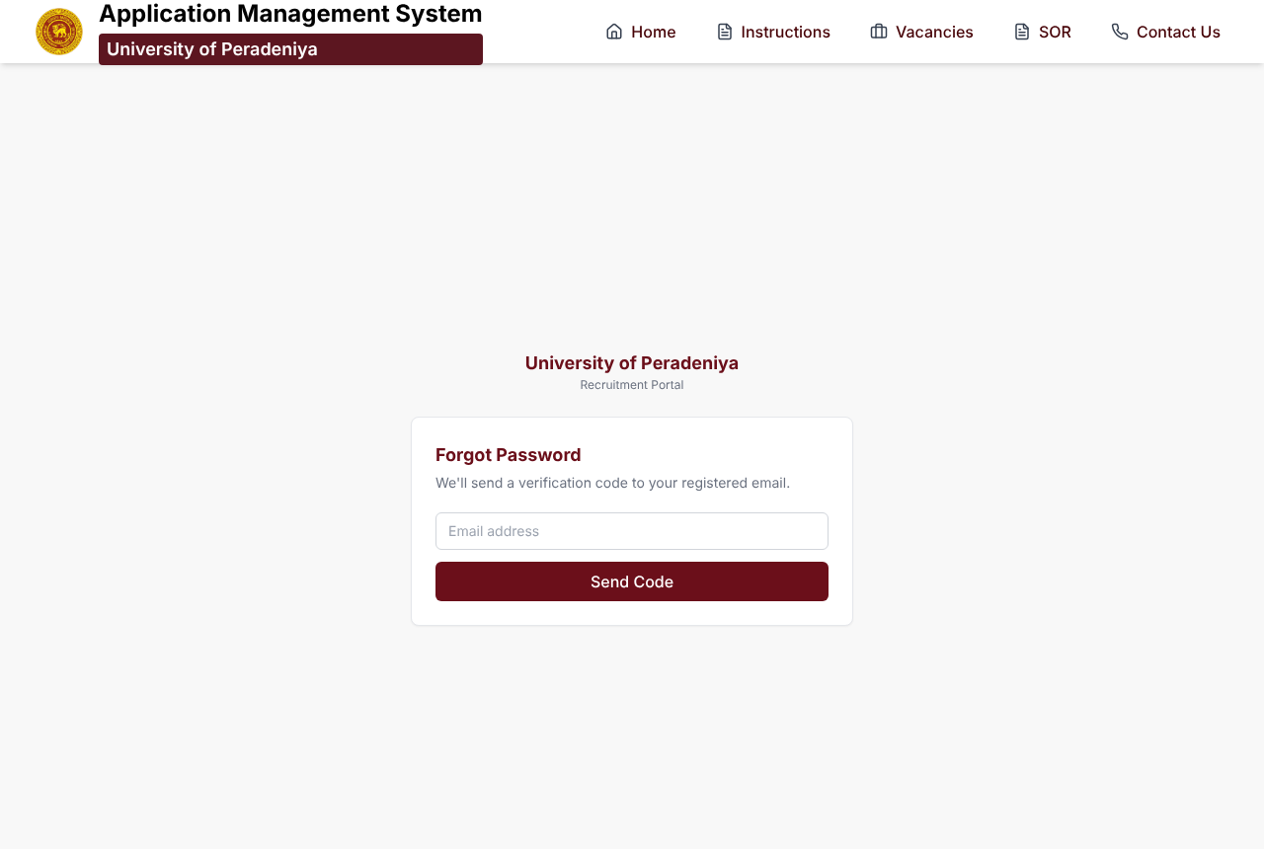
Forgot Password page
Security: never share your password or OTP codes. University staff will never ask you for them. Always log out (top-right menu) on a shared computer.

7. Your Dashboard
After logging in you land on the Applicant Portal dashboard.
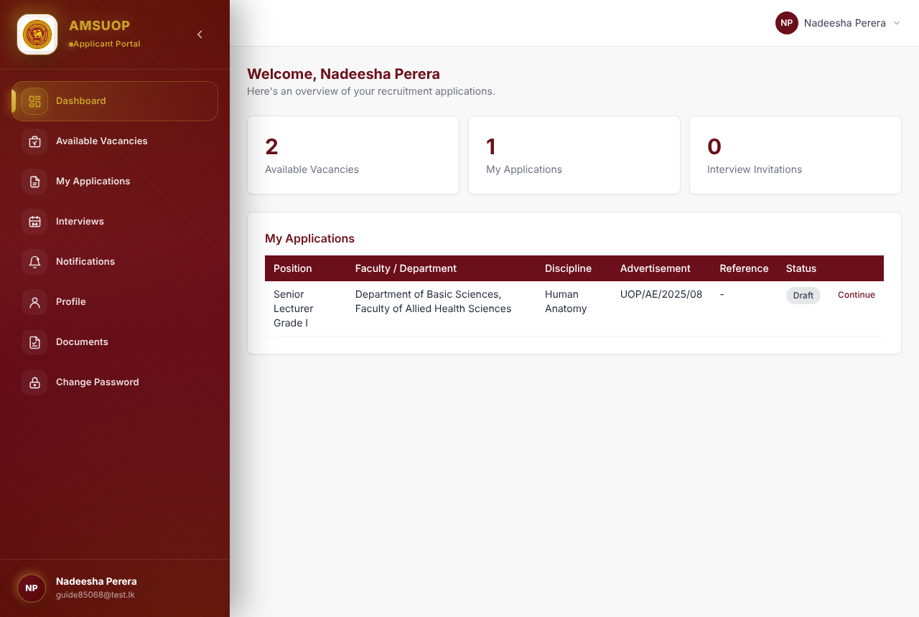
Applicant dashboard showing counts and the My Applications table
At the top are three counts: Available Vacancies, My Applications and Interview Invitations.
My Applications lists each application with its position, faculty/department, discipline, advertisement, reference number and status:
Status | Meaning | Action
Draft | Started but not yet submitted. No reference number yet. | Continue — reopen the form where you left off.
Submitted | Received by the University; reference number issued. | View — see progress and download the PDF.
Later statuses (e.g. Documents Verified, Shortlisted, Interview Scheduled) | Your application is moving through the selection process. | Watch Notifications and Interviews.
The left-hand menu:
- Dashboard — this overview
- Available Vacancies — open advertisements (same as the public Vacancies page)
- My Applications — all your drafts and submitted applications
- Interviews — interview invitations, date, time and venue
- Notifications — messages from the University about your applications
- Profile — your account details
- Documents — the documents you have uploaded
- Change Password
On a phone the menu folds away behind the menu button; everything else works the same.
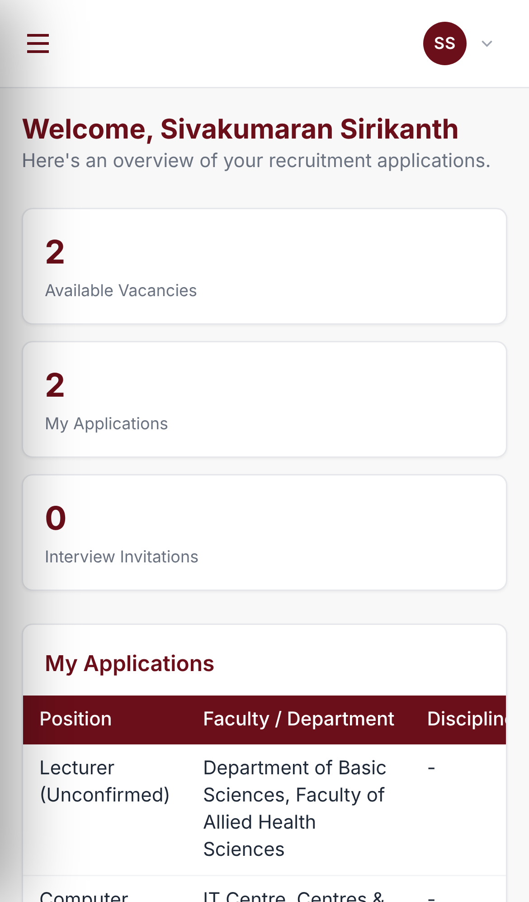
Dashboard on a mobile phone

8. Start your application (choose the post)
After pressing Apply Now while signed in, the Start Your Application page opens.
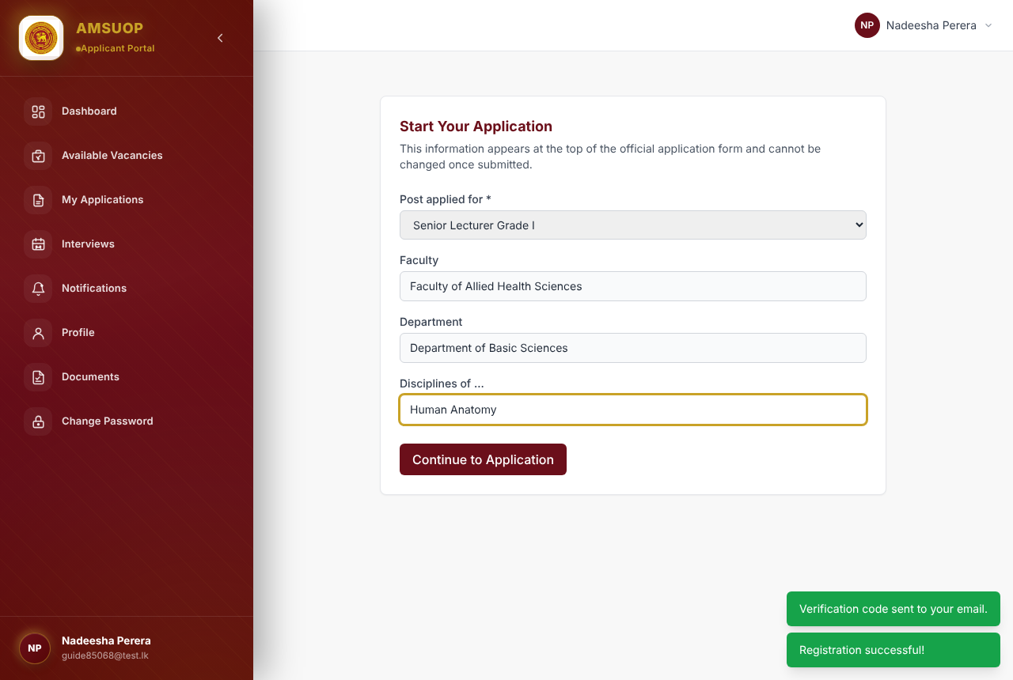
Start Your Application page: post, faculty, department and discipline
- Post applied for — choose the exact post from the list (e.g. Senior Lecturer Grade I, Senior Lecturer Grade II, Lecturer (Unconfirmed), Lecturer (Probationary), or the Academic Support post advertised).
- Faculty and Department are filled in from the advertisement and cannot be changed.
- Disciplines of … — type the subject area you are applying in (e.g. Human Anatomy), where relevant.
- Click Continue to Application.
Important: the post you choose here is printed at the top of your official application form and cannot be changed after submission. If you want to apply for a different post, start a separate application.
Your application is now created as a Draft and the 12-step form opens.

9. How the online form works
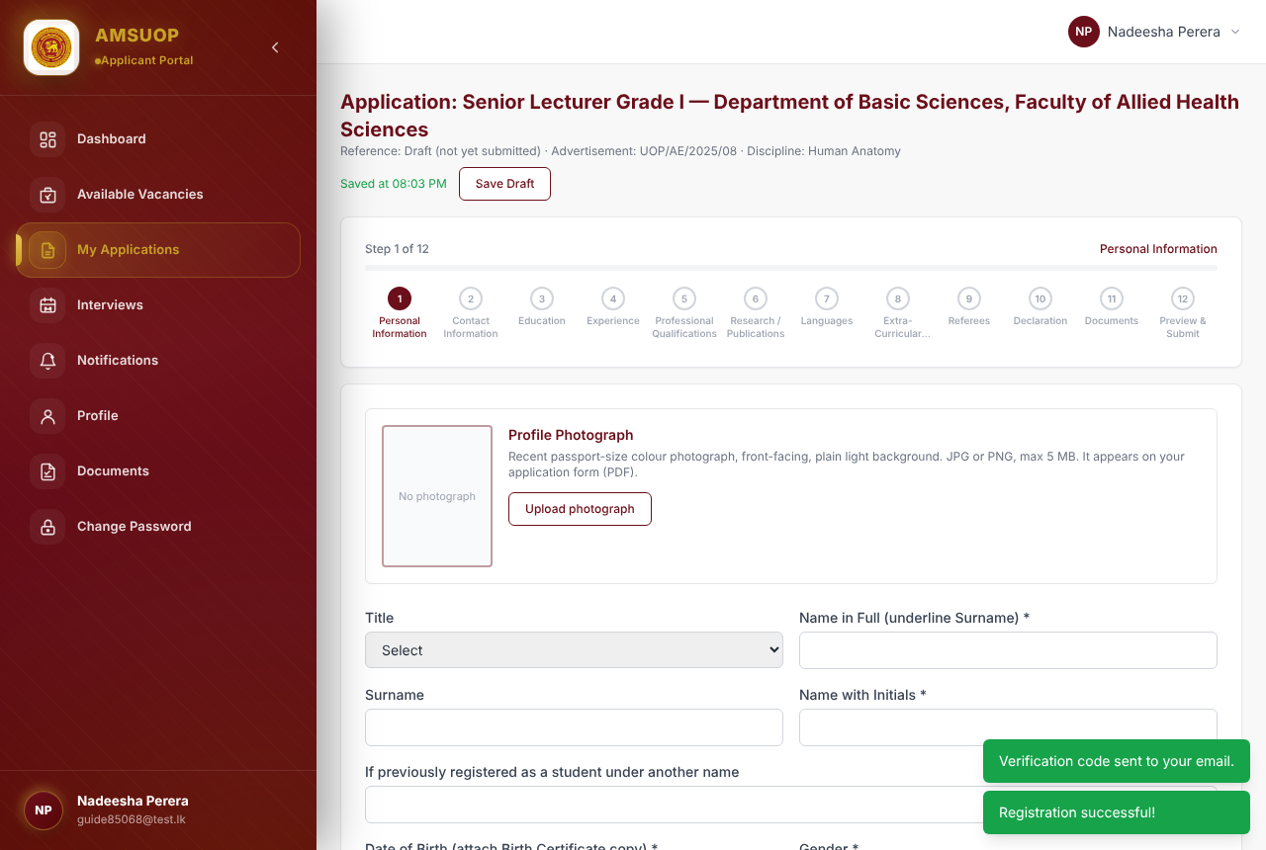
The application form: header, save status, Save Draft and the 12-step bar
The header shows the post, department and faculty, the reference (“Draft (not yet submitted)” until you submit), the advertisement number and your discipline.
The step bar shows all 12 steps:
# | Step | # | Step
1 | Personal Information | 7 | Languages
2 | Contact Information | 8 | Extra-Curricular Activities
3 | Education | 9 | Referees
4 | Experience | 10 | Declaration
5 | Professional Qualifications | 11 | Documents
6 | Research / Publications | 12 | Preview & Submit
Use Next and Back at the bottom of each step, or click a step number to jump to it.
Saving — you will not lose your work:
- The form saves automatically every few seconds while you type and whenever you leave a field. “Saved at hh:mm” confirms the last save.
- Click Save Draft at any time to save immediately.
- You can log out and come back later: open My Applications → Continue. Your draft is kept until the closing date.
Required fields are marked with *. Next stays disabled until every required field in the current step is complete; a red message under a field tells you what is missing.
Your details are reused. Personal, contact, education, experience and similar details are kept in your applicant profile, so a second application starts with them already filled in. Each submitted application keeps its own fixed copy, so later edits do not change an application you have already submitted.
If the closing date passes while your application is still a draft, the form shows that the closing date has passed and the draft can no longer be edited or submitted.

10. Steps 1–10 of the form, one by one

Step 1 — Personal Information
- Profile Photograph: click Upload photograph and choose a recent passport-size colour photo (JPG or PNG, max 5 MB). A preview appears at once; this photo is printed on your application PDF. Use the same button to replace it.
- Fill in Title, Name in Full (underline surname), Surname, Name with Initials, any previous name used as a student, Date of Birth, Gender, Civil Status, Nationality and, for Sri Lankan citizens by registration, the registration reference number and date of the certificate of citizenship.
- Your age is calculated automatically from your date of birth and shown in Years, Months, Days.
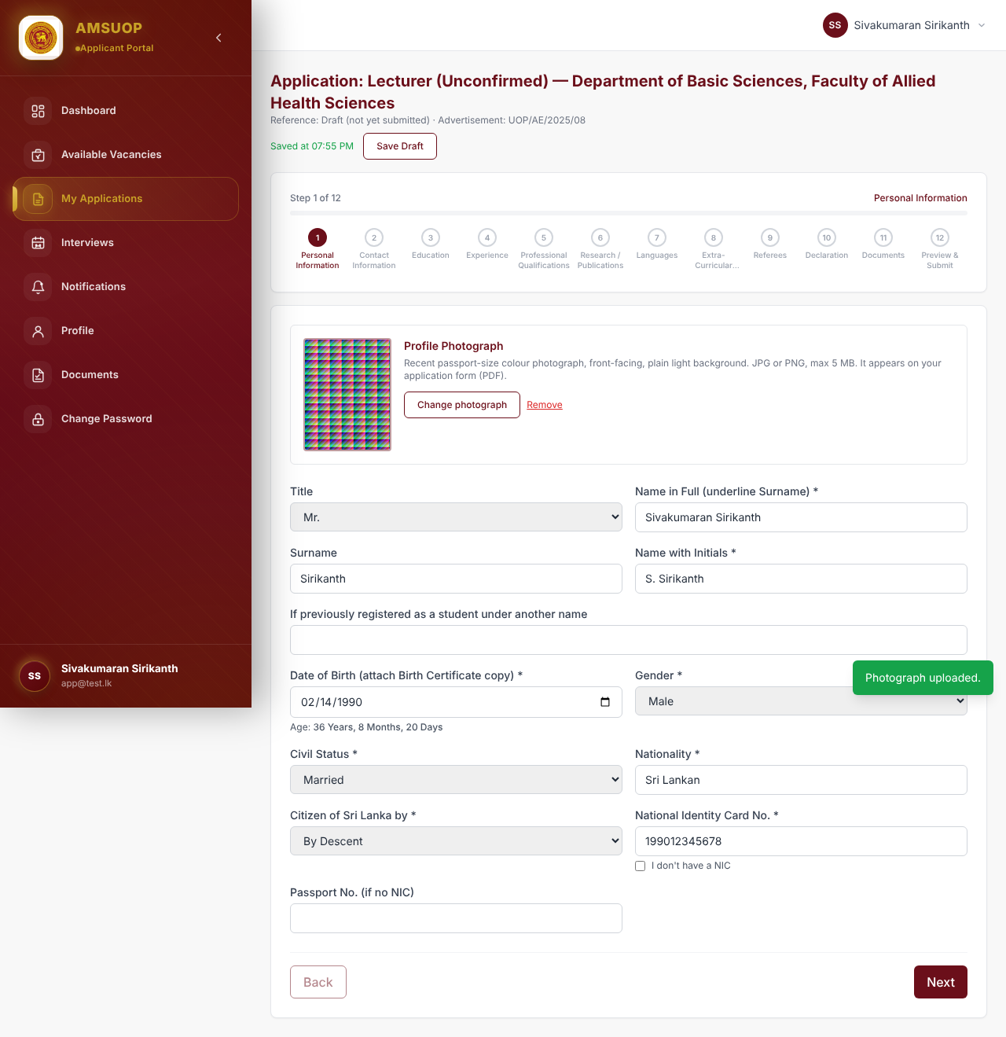
Step 1: Personal Information with profile photograph and age

Step 2 — Contact Information
- Permanent Address (address, province, district, postal code) — required.
- Current Address — only if different from the permanent address.
- Official Address (Optional) — your workplace address, if any.
- Mobile Phone (required), Residence Phone, Office Phone, E-mail.
Choose the Province first; the District list then shows that province’s districts.
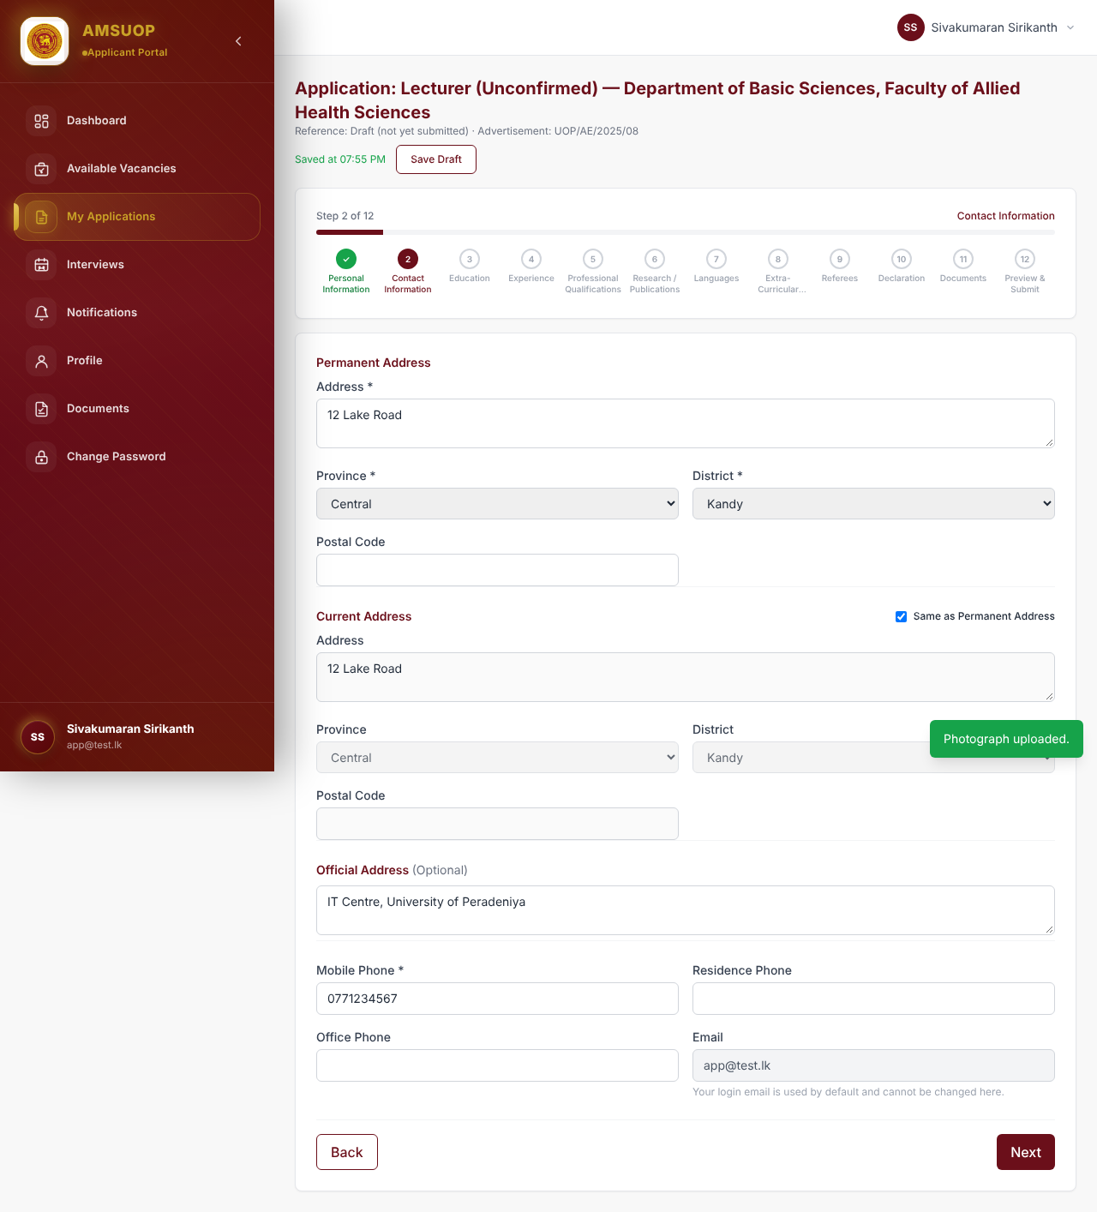
Step 2: Contact Information including the optional Official Address

Step 3 — Education
- University Education — at least one entry. For each degree: Degree / Qualification, University / Institution, From and To year, Course Followed, Date of Final Exam, Class / Grade and GPA. Use + Add Qualification for more.
- Postgraduate Qualifications (optional) — Qualification, Institution, type (Coursework / Coursework and Research / Research), Duration, Part Time / Full Time, SLQF Level (7–12) and Effective Date. Use + Add Postgraduate Qualification.
- Board Certification — MBBS/BDS graduates only.
- Academic Distinctions / Scholarships / Medals / Prizes — include the awarding institution.
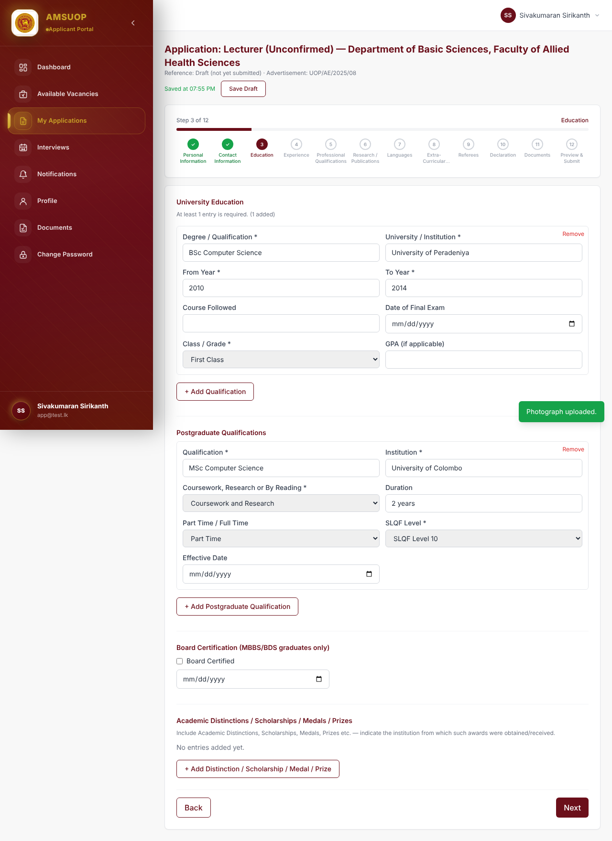
Step 3: Education with university and postgraduate qualifications

Step 4 — Experience (employment)
- Current Occupation (optional): Designation, Department / Institution, From date, Salary Drawn, and Employment basis — Permanent or On Contract / Assignment basis (required once you enter a current occupation).
- Previous Employment (optional): + Add Previous Employment for each earlier post, with From and To dates and Reasons for Leaving.
- The Duration of every job is calculated for you in Years, Months, Days and appears on the preview and PDF.
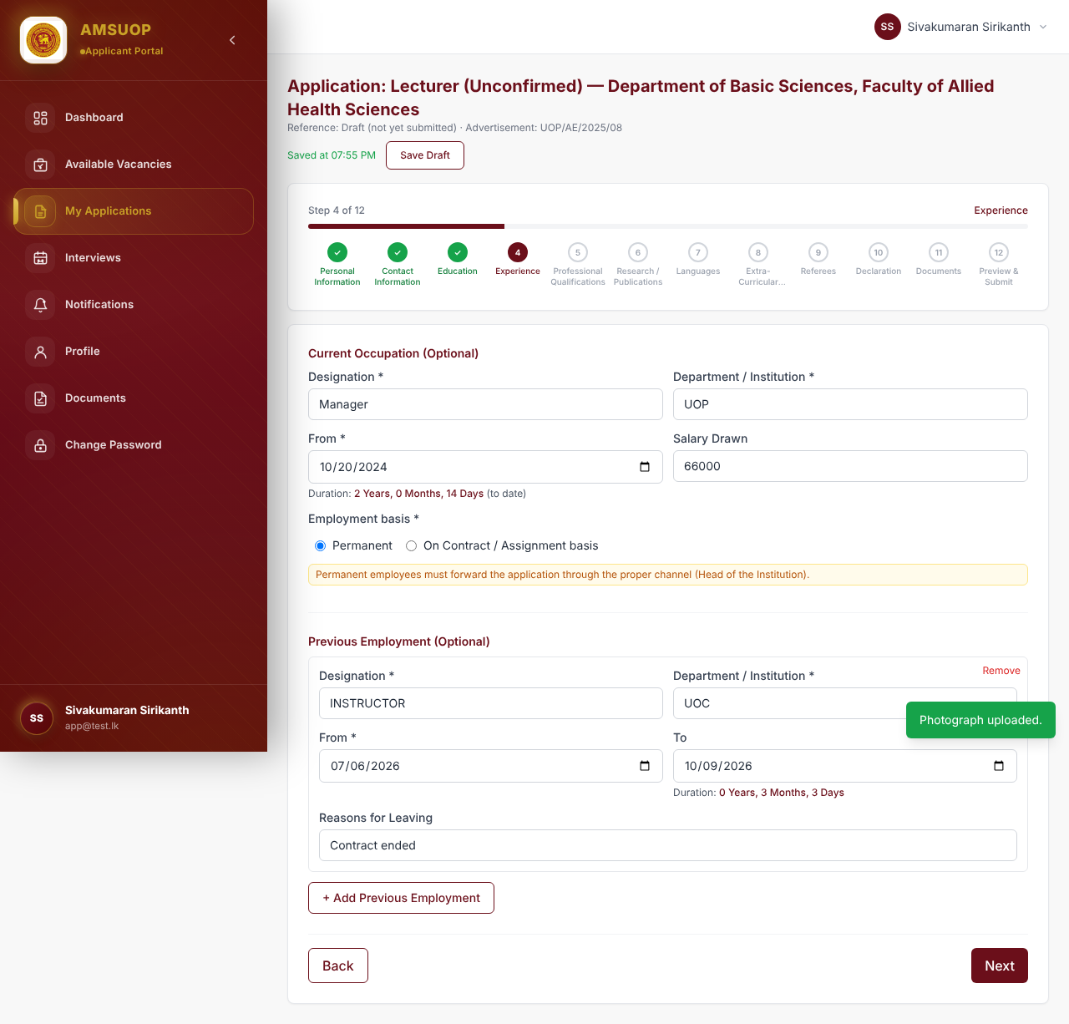
Step 4: Experience with employment basis and calculated duration
If you are in permanent public-service employment, you must also send an advance copy of your application through your Head of Institution (“proper channel”) by the advance-copy deadline in the advertisement.

Step 5 — Professional Qualifications (memberships)
Add each professional body membership with + Add Membership: Professional Body / Organization, Membership No, Membership Level / Grade, Year Joined, Expiry Date. Leave empty if none.
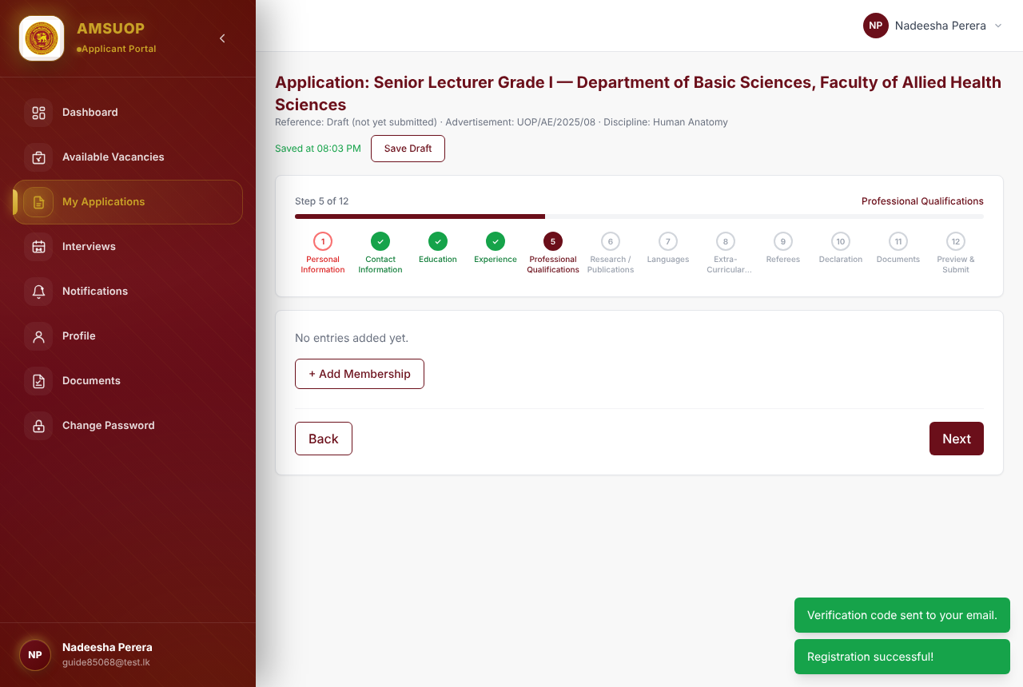
Step 5: Professional Qualifications / memberships

Step 6 — Research / Publications
Add each publication with + Add Publication (type, title of article or book, authors, source/journal, year or date of publication, ISBN where applicable). Leave empty if none.
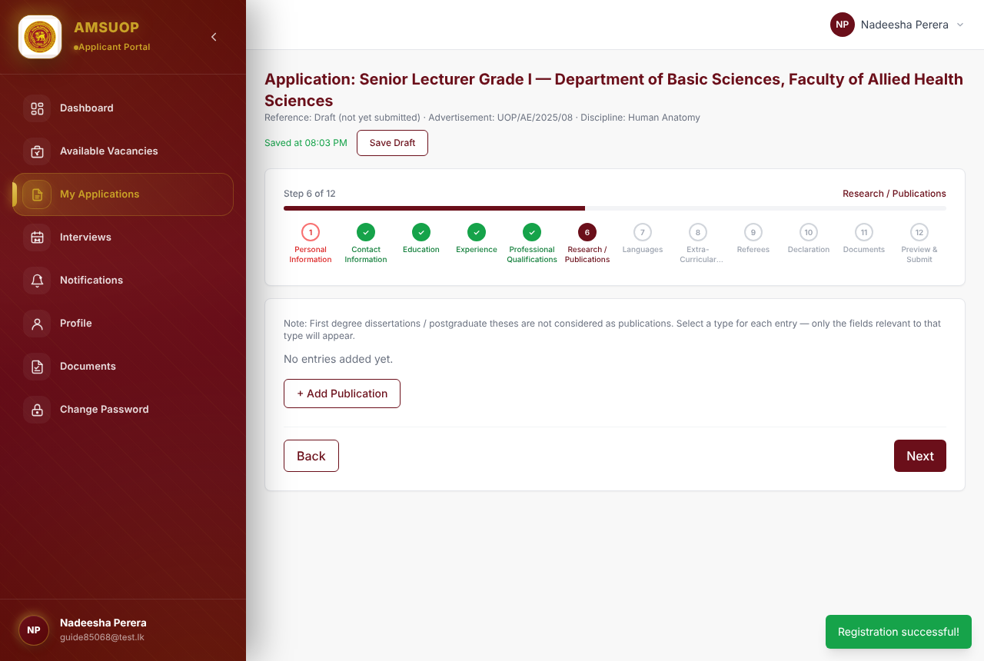
Step 6: Research / Publications

Step 7 — Languages
For Sinhala, Tamil and English, state the highest examination passed in each language.
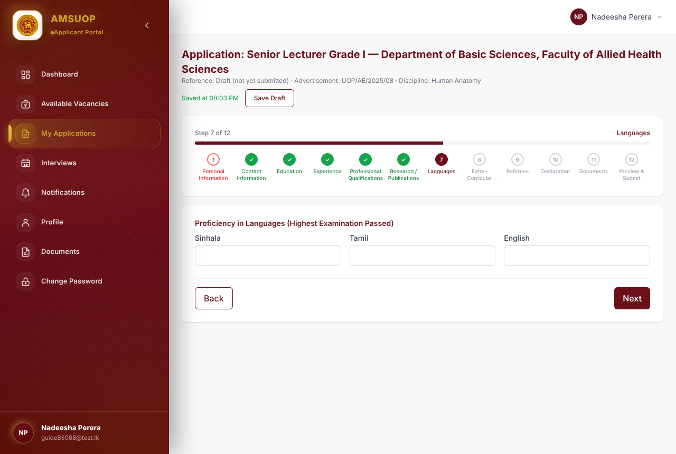
Step 7: Languages

Step 8 — Extra-Curricular Activities
Two free-text sections, both optional:
- Extra-Curricular Activities at university, national and international level (sports, societies, cultural activities, leadership, community service). Attach certificates in Step 11.
- Any Other Relevant Particulars not covered elsewhere.
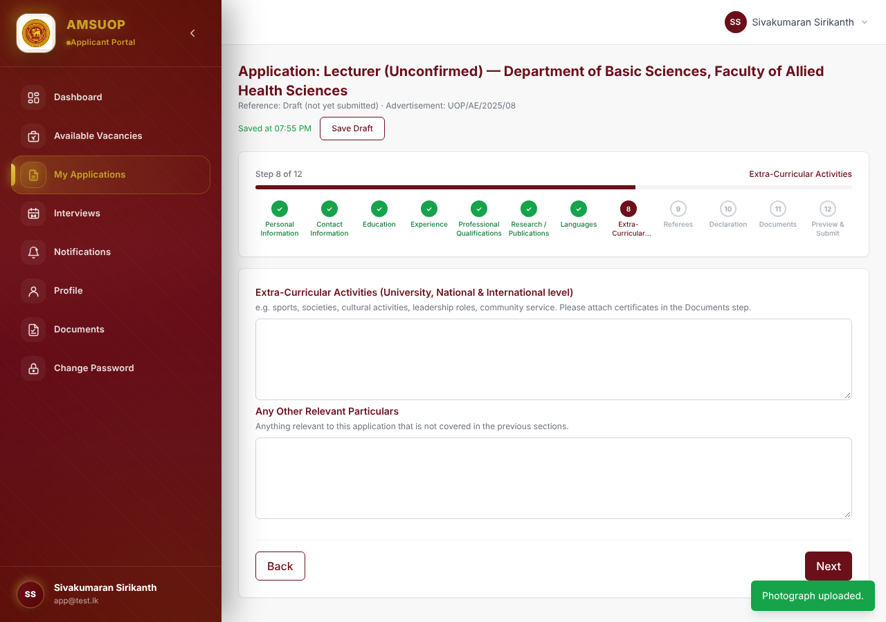
Step 8: Extra-Curricular Activities

Step 9 — Referees
Give at least two referees who are not related to you: Name, Designation, Institution, Address, Telephone No and E-mail. Use + Add Referee for more.
When you submit, each referee receives a short e-mail saying you have named them on your application. Make sure their e-mail addresses are correct and let them know in advance.
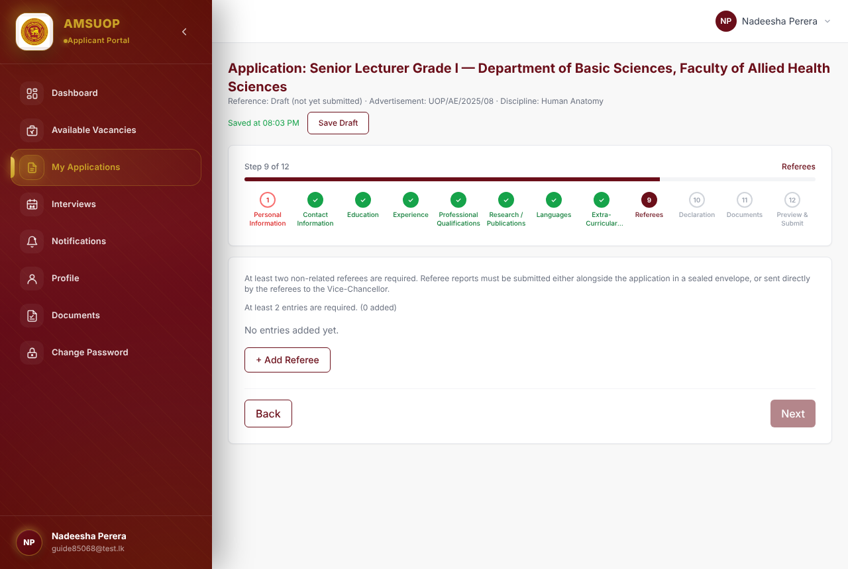
Step 9: Referees

Step 10 — Declaration
Answer the career questions first. Ticking any of these boxes opens a required details box:
- Commendations / Punishments During Career
- Vacation of Post Notice served by another university or government institution
- Bond Violator — if ticked, give the Bond Value and University / Institution
Then complete the declaration:
- Read the declaration and tick I agree to the above declaration (required).
- Tick I am willing to resign from my current post, if selected, if it applies.
- Signature: type your full name. Check it against the “Name on file” shown below the box.
- The Date is filled in automatically when you submit.
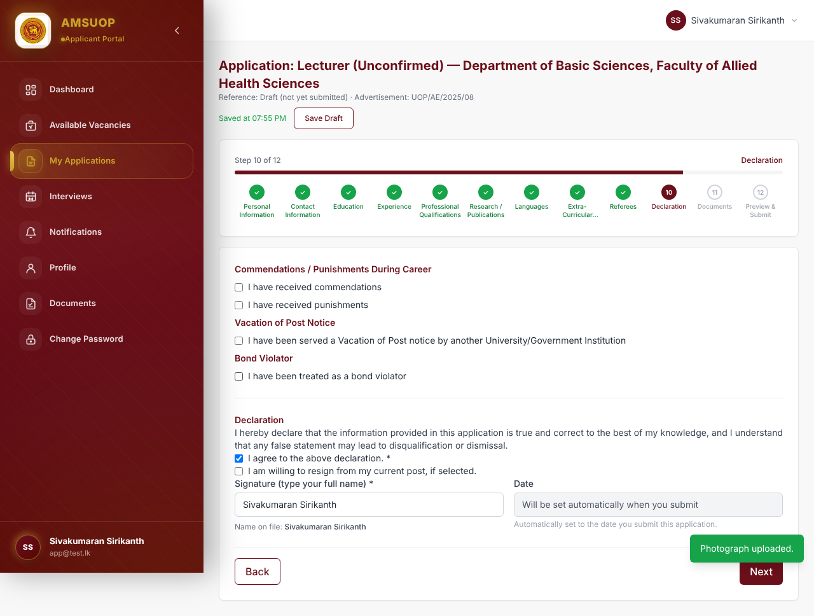
Step 10: Declaration with commendations, vacation of post, bond and the declaration

11. Step 11 — Documents
All supporting documents for this application are uploaded on this one page, grouped by type. Each group accepts several files at once — select (or drag and drop) all of that group’s files together.
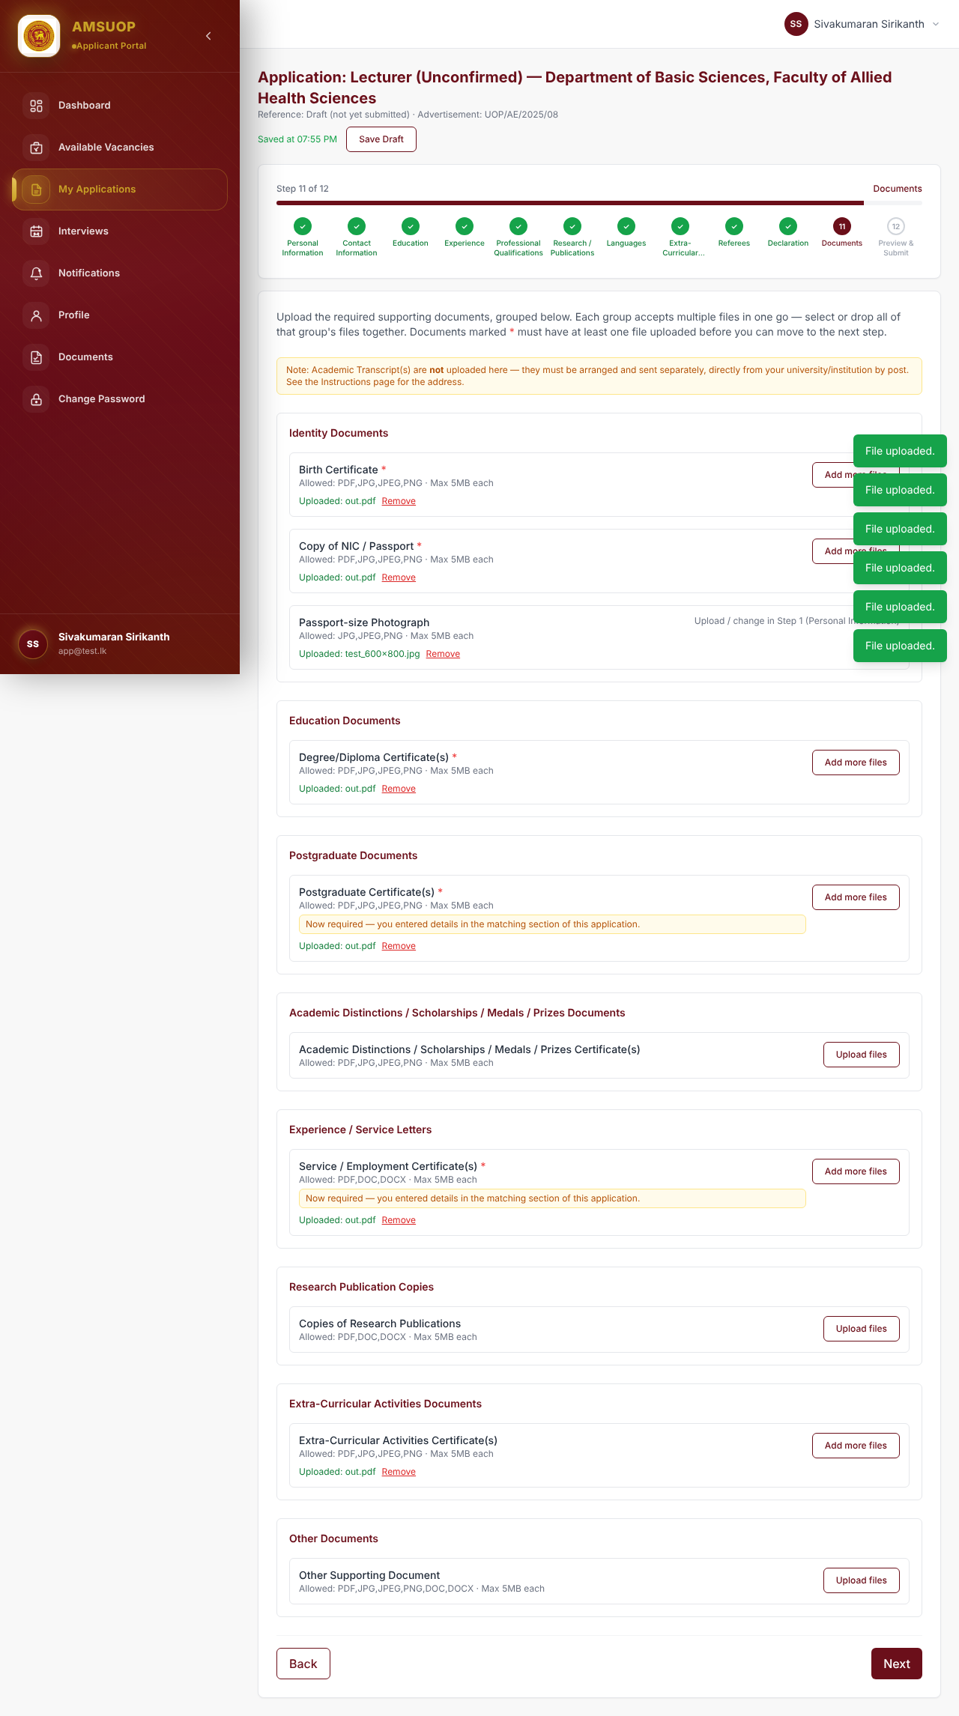
Step 11: Documents grouped by type, with required items marked *
Group | Document | Required?
Identity Documents | Birth Certificate | Yes
Identity Documents | Copy of NIC / Passport | Yes
Identity Documents | Passport-size Photograph | Uploaded in Step 1 (shown here for reference)
Education Documents | Degree / Diploma Certificate(s) | Yes
Postgraduate Documents | Postgraduate Certificate(s) | Required if you entered a postgraduate qualification
Academic Distinctions | Certificates for distinctions, scholarships, medals, prizes | Optional
Experience / Service Letters | Service / Employment Certificate(s) | Required if you entered employment details
Research Publication Copies | Copies of research publications | Optional
Extra-Curricular Activities | Certificate(s) | Required if you entered extra-curricular activities
Other Documents | Other Supporting Document | Optional
How to upload
- Click Upload files (or Add more files) on the document row.
- Choose the file(s). Allowed types are shown on each row (PDF, JPG, JPEG, PNG; DOC/DOCX for service letters and publications). Maximum 5 MB per file.
- Wait for “Uploaded: …” to appear in green. Use Remove to delete a wrong file.
A yellow “Now required” note means the document became compulsory because you filled in the matching section of the form. Documents marked * must have at least one file before you can continue.
Academic transcripts are NOT uploaded here. They must be sent separately, directly from your university/institution, by post. See the Instructions page for the address.
Tips for good scans: scan in colour at about 200–300 dpi, make sure every page is readable and straight, and combine multi-page documents into one PDF. Large photos are automatically compressed by the system, so phone photos of documents are acceptable if they are clear.

12. Step 12 — Preview & Submit

12.1 Check the preview carefully
The preview shows your whole application exactly as it will be submitted: personal and contact details (including the official address), education with postgraduate type, part/full time and SLQF level, every job with its duration in Years, Months, Days and employment basis, memberships, publications, languages, extra-curricular activities, referees, declaration answers and the list of uploaded documents.
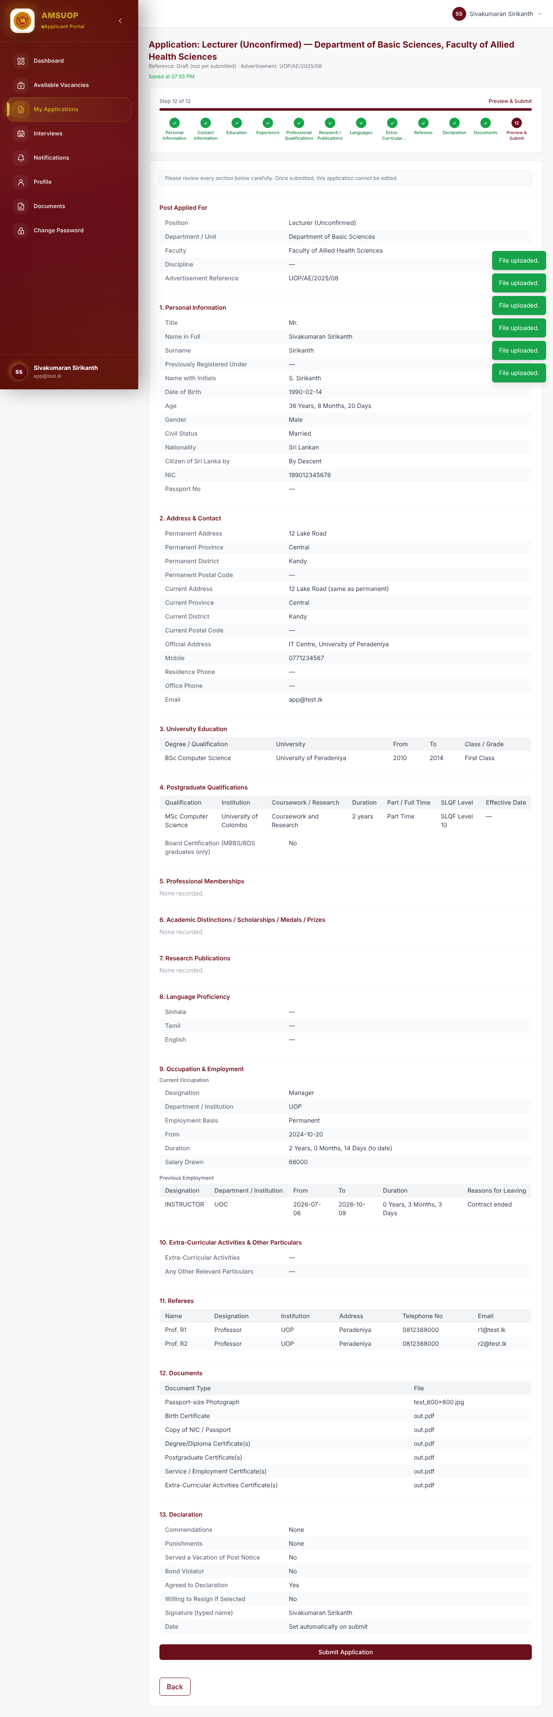
Step 12: Preview of the full application before submission
If something is wrong, click the step in the step bar (or Back), correct it, and return to Preview & Submit.

12.2 Submit
- Click Submit Application.
- Confirm in the pop-up box. After submission the application can no longer be edited.
- A “Submitting your application…” screen appears while the system checks your application, generates your PDF and sends the e-mails. Do not close or refresh the page — this can take a few seconds.
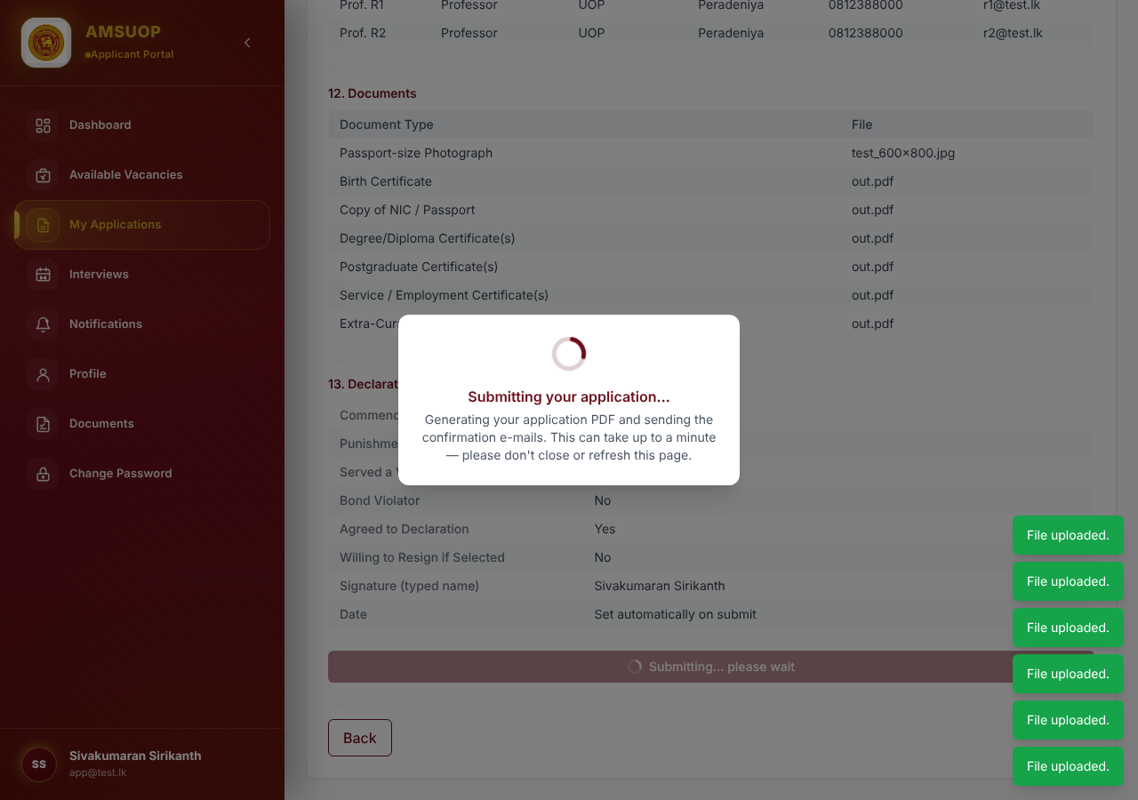
Submitting your application… loading screen
- When it finishes you see “Application submitted successfully! Reference: …” and the application page opens with status Submitted and your reference number (e.g. AHS/AHS-BASIC/LU/000001).
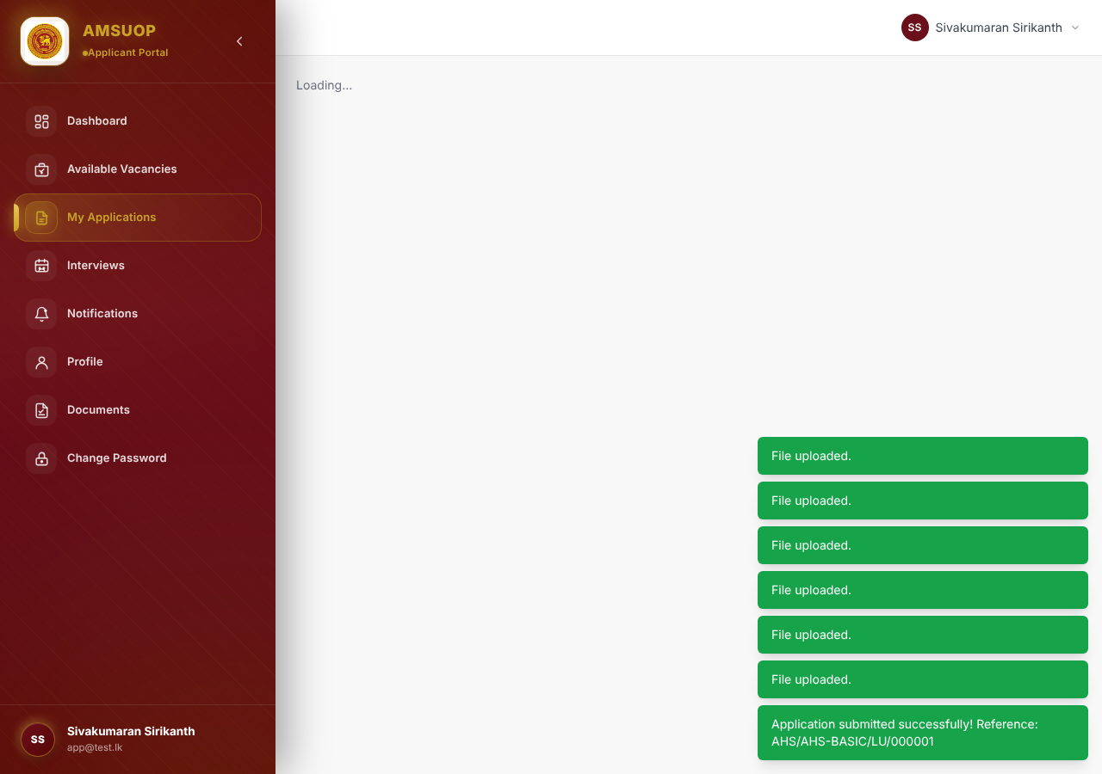
Application page after successful submission
If a required step is incomplete, the system shows “Please complete ‘…’ before submitting” and takes you to that step. Fix it and submit again.

13. After submission: confirmation e-mail, PDF download and posting

13.1 Confirmation e-mail with your application PDF
Within a few minutes you receive an e-mail titled “Application Submitted – <your reference number>”. It confirms the post, department, faculty and advertisement, gives your reference number, and has your completed application form attached as a PDF.
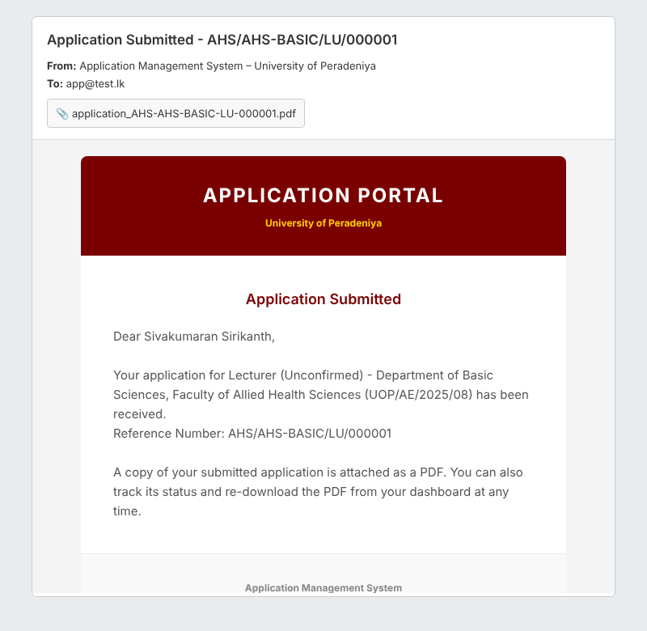
Confirmation e-mail with the application PDF attached
At the same time, each of your referees receives a short notice that you have named them on your application.

13.2 Download the PDF from the system
You can download your application again at any time:
- Go to My Applications and click View on the submitted application.
- In the Official Application Form — PDF Export box, click Download PDF.
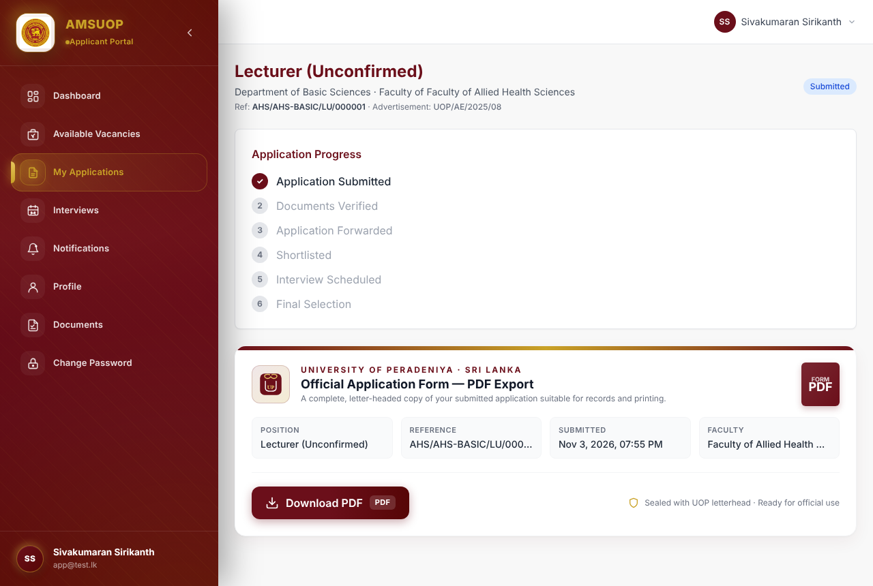
Application page with progress tracker and Download PDF button

13.3 What the PDF contains
The PDF is your official application form on University letterhead:
- the heading shows only the post you applied for, with your profile photograph at the top right;
- your age and each employment period in Years, Months, Days;
- every section of the form, numbered as on the printed application (including 8. Professional Memberships), referees and the declaration;
- a For Official Use – Head of Department / Institution box at the end.
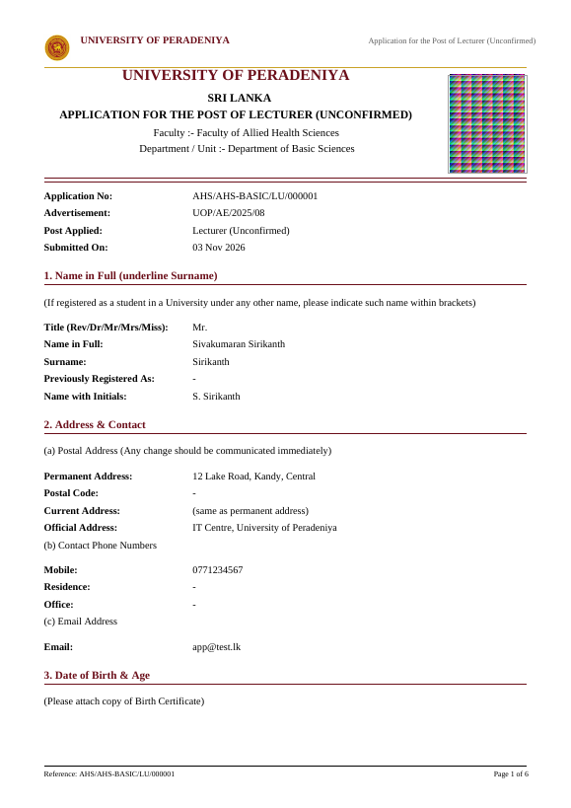
First page of the application PDF

13.4 Print, sign and post
- Print the PDF and sign the declaration.
- If you are in permanent public-service employment, have the For Official Use section completed by your Head of Department / Institution and forward it through proper channel by the advance-copy deadline in the advertisement.
- Send the signed application with the relevant documents by registered post to the address and in the manner given in the advertisement / Instructions page, before the closing date. Quote your reference number.
- Ask your university to send your academic transcripts directly to the University (they are not uploaded online).
Keep the confirmation e-mail and the PDF. Quote your reference number in all correspondence.

14. Tracking your application
My Applications lists every application you have started or submitted, with its status. Click View to open a submitted application, or Continue to finish a draft.
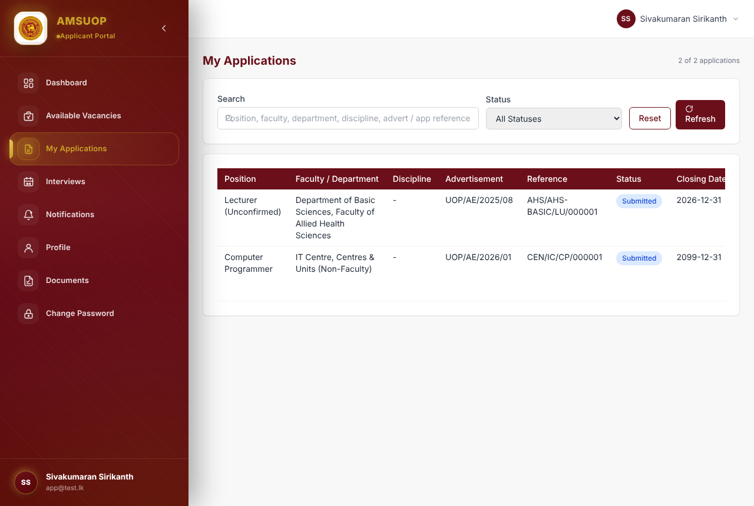
My Applications list
The application page shows an Application Progress tracker:
- Application Submitted
- Documents Verified
- Application Forwarded
- Shortlisted
- Interview Scheduled
- Final Selection
Each stage turns on as the University processes your application. You will also be informed through:
- Notifications in the left-hand menu — messages about your applications;
- Interviews — if you are called for interview, the date, time and venue appear here;
- E-mail to your registered address.
Applying for more than one post? Go back to Available Vacancies, press Apply Now on the next opening and choose the post. Your saved profile details are reused, so you only need to check them, upload any documents specific to that application, and submit.

15. Frequently asked questions and troubleshooting
Problem / question | What to do
I did not receive the OTP e-mail. | Wait a minute and check Spam / Junk. Click Resend Code. Make sure the e-mail address you typed is correct.
“Invalid or expired code”. | Codes last 5 minutes and only the latest code works. Click Resend Code and use the new code.
The Register button is greyed out. | A field is incomplete or invalid; look for red messages. Check the password ticks (8+ characters, three character types) and that both passwords match.
I forgot my password. | Login → Forgot password? → enter e-mail → code → set a new password (Section 6.2).
The Next button is greyed out. | A required field (*) in the current step is empty or invalid. Red messages show which one.
Did my work save? | Look for “Saved at hh:mm” near the top, or click Save Draft. You can close the browser and continue later from My Applications → Continue.
A file will not upload. | Check the file type allowed on that row and that it is under 5 MB. Compress or re-scan large PDFs.
Province / District will not select. | Choose the Province first; the District list then loads.
I made a mistake after submitting. | Submitted applications cannot be edited. Contact the Academic Establishments Division quoting your reference number.
Can I apply for more than one post? | Yes. Start a separate application from Apply Now for each post or opening.
The closing date passed before I submitted. | Drafts cannot be submitted after the closing date. Submit well before the deadline.
Where is my application PDF? | Attached to the confirmation e-mail, and available any time from My Applications → View → Download PDF.
Do I upload academic transcripts? | No. They must be sent directly by your university/institution by post.

Contact
- Application enquiries: Deputy Registrar, Academic Establishments Division, University of Peradeniya, Peradeniya — 081 2392340 — cwunit@gs.pdn.ac.lk
- Technical support (system problems): 081 2384848, Monday–Friday, 8:30 AM – 4:30 PM
When you contact us, give your full name, NIC number, registered e-mail and, if you have one, your application reference number. Never send your password or OTP.

