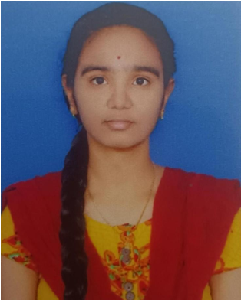
PASALA SREE VARSHITHA
📞 7670960501 | 📧 sreevarshitha04@gmail.com | 📍 Saipeta, Kadapa – 516002
💼 LinkedIn: https://www.linkedin.com/in/sree-varshitha-b7a58634a
💻 GitHub: https://share.google/8bji7VA4BEp9nvl1W
🏆 HackerRank: https://share.google/CAUwmeHQj0K6RYN7b

SUMMARY
To secure a challenging role in a dynamic organization where I can contribute to innovative projects and grow professionally. With a passion for continuous learning, I aim to make a meaningful impact while evolving in my career.

EDUCATION
ANNAMACHARYA INSTITUTE OF TECHNOLOGY AND SCIENCES, RAJAMPET  B.Tech – Specializing in Artificial Intelligence and Machine Learning | CGPA: 8.56  NARAYANA OLYMPIAD JR. COLLEGE, KADAPA  Intermediate | CGPA: 8.42  NARAYANA ENGLISH MEDIUM HIGH SCHOOL, KADAPA  SSC | CGPA: 10  SKILLS  Programming : Python, C, SQL  Web Technologies : HTML, CSS  Tools & Platforms : Basic Knowledge in Jupyter Notebook, Google Colab | 2023 – 2027  2021 – 2023  2020 – 2021

INTERNSHIPS AND CERTIFICATIONS
- Frontend Development Internship (CODTECH): Completed assigned frontend tasks and awarded an Internship Experience Certificate. Developed projects including: Interactive Quiz Application, Real-Time Chat Application, Personal Portfolio, and E-Learning Platform UI.
- DevOps and Cloud Computing Certification: Completed professional certification courses covering DevOps and Cloud Computing (AWS).
- Python Fundamentals (Infosys Springboard & CODEXINTERN): Completed the course certified by Infosys through Springboard, alongside a hands-on Python Fundamentals Internship and certification from CodexIntern.
- HackerRank Skill Certifications: Earned verified skill certifications in Python (Basic) and SQL (Basic).
- C-Language Certification: Successfully finished the structured C-Language course from Matrix Foundation, Kadapa.
- AI Foundations Workshop: Completed a technical workshop on AI Foundations from Srivensi Technologies Pvt. Limited.
- Foundational C# with Microsoft Certification: Earned a Microsoft-backed foundational C# certification via freeCodeCamp.

DECLARATION
I hereby declare that all the information provided above is true and correct to the best of my knowledge belief.
(PASALA SREE VARSHITHA)

