|  |  |
| --- | --- |
| A picture of a winding road and trees  **data visualization using tableau**  **SSA - 2** | **RYAAN RIAZ AHAMED**  **811720243034**  **AI&DS – 3rd YEAR** |

**DUAL AXIS CHART**

Introduction

Data visualization is a key aspect of any analytics profession. It communicates a data story in a simplistic, yet aesthetically pleasing and impactful manner. According to Vitaly Friedman, the “main goal of data visualization is to communicate information clearly and effectively through graphical means”.

And there’s no better tool than Tableau for achieving this! Tableau is one of the most trusted tools by the community. It has been recognized as a Leader in the Gartner Magic Quadrant for Analytics and Business Intelligence Platforms for 8 years in a row. That’s incredible!

In this article, we are going to see how to create the most desirable and useful dual axis charts.

Pre-Requisites

For the article and task make sure you have tableau installed in your system. I am using [Tableau Public](https://public.tableau.com/en-us/s/), which you can download for free. The data we’ll be using is the US sample superstore dataset widely used in the Tableau community.

Create Dual Axis Charts

A dual axis chart is used to present the relationship between two variables. More specifically, these charts are useful for demonstrating the relationship between two or more measures with different amplitude and scale. The dual axis charts help in presenting plenty of information in the limited space present on your dashboard and also allows you to understand the trends, you may have missed otherwise.

For example, in our US Super Store dataset, we have the Profit and Sales measures. These two measures have different magnitude and scale. Let’s directly dive into the implementation in a stepwise manner.

Here, for our visualization, we are going to use three attributes Sub-Category from the dimensions and two measures i.e. Profit and Sales.

Open a new worksheet and add the Sub-category from the dimension pane to the Columns shelf.

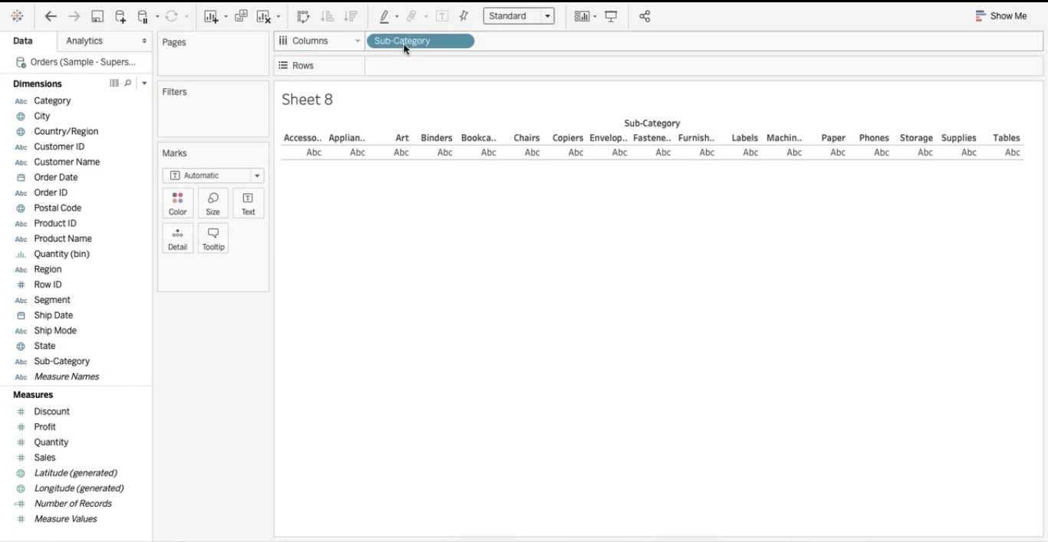

Now pick Sales from the Measures pane and drop in the Row shelf below the Sub-Category. Similarly, Select Profit measure and drop next to the Sales in Row shelf. After this step, your visualization will look as shown in the image below.

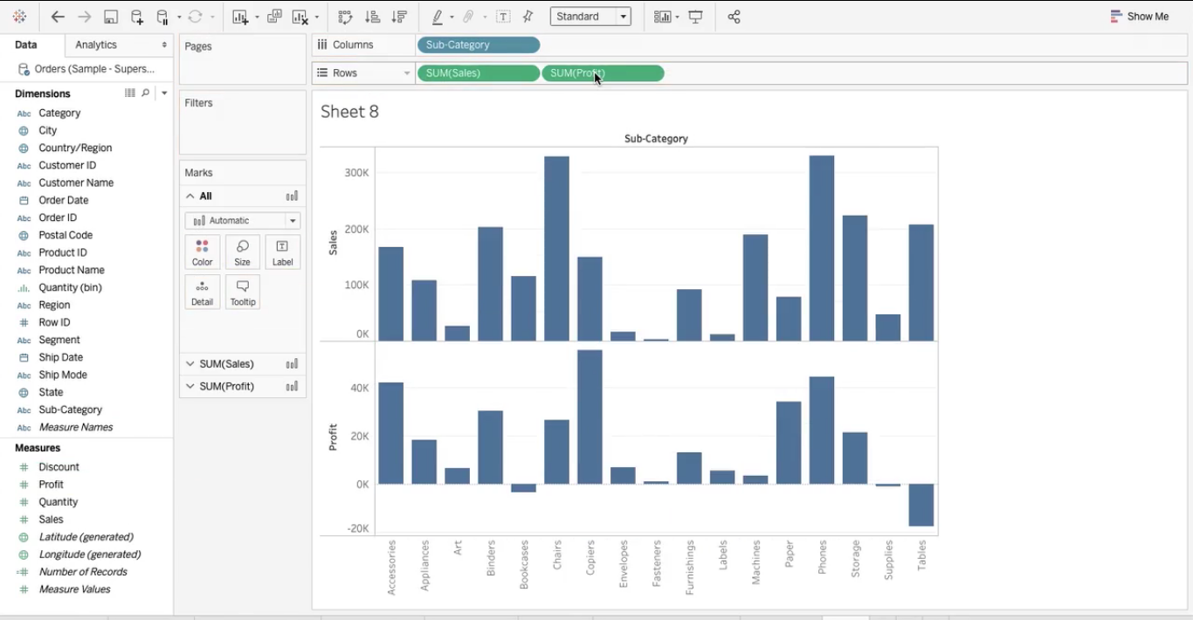

Here we have two charts present on multiple axes. The next step is to convert these two different charts into a dual axis chart. For this click on the triangle present on the profit pill in the rows shelf.

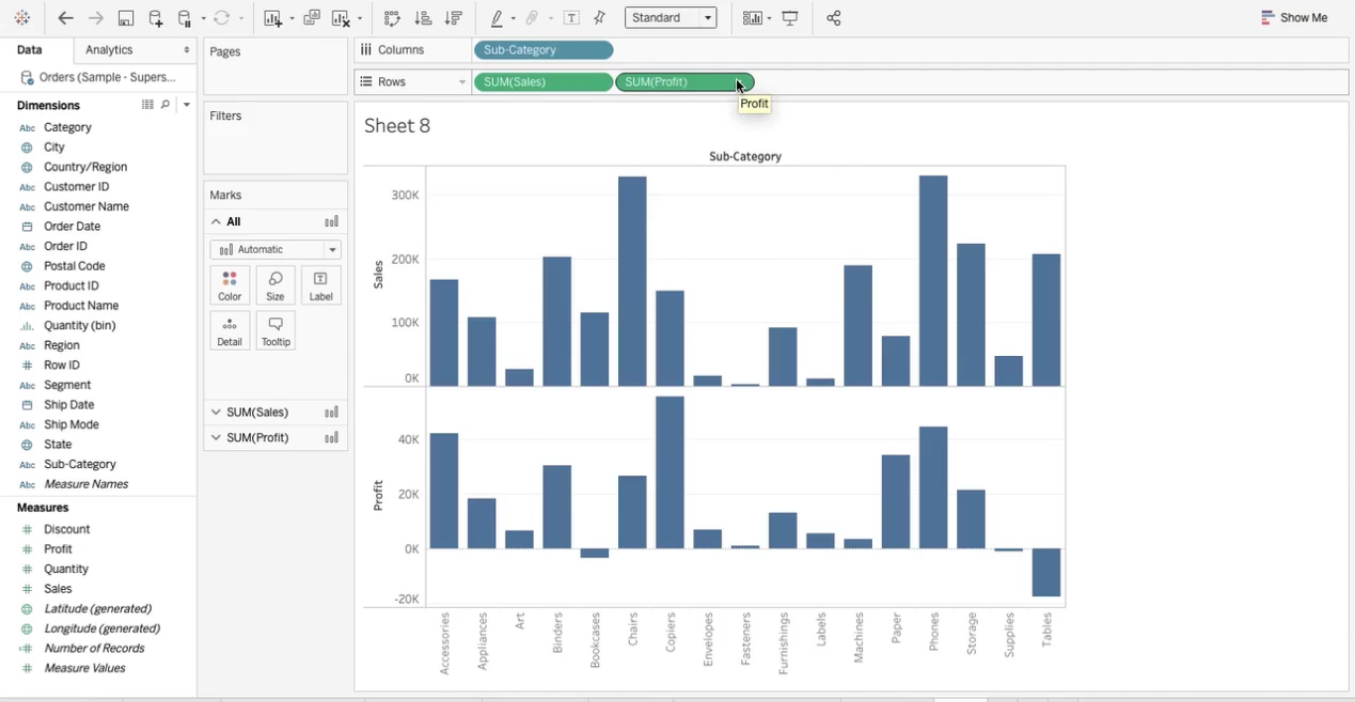

Hereafter, you will have a drop-down menu just select the Dual axis option from that.

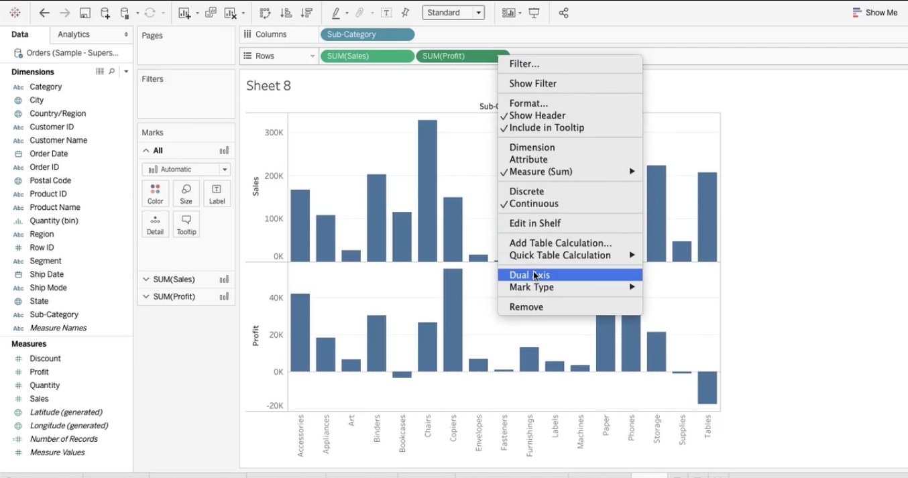

Once you select the Dual axis boom! your visualization changes completely. Like this

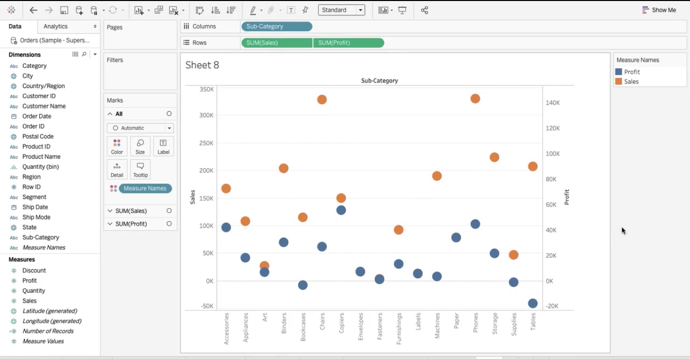

Although you have a dual axis visualization, they are on different scales. Now there is a need to bring both measures on the same scale using synchronize axis. For this right-click on any axis Profit or Sales and select synchronize axis from the menu. As shown in the following image.

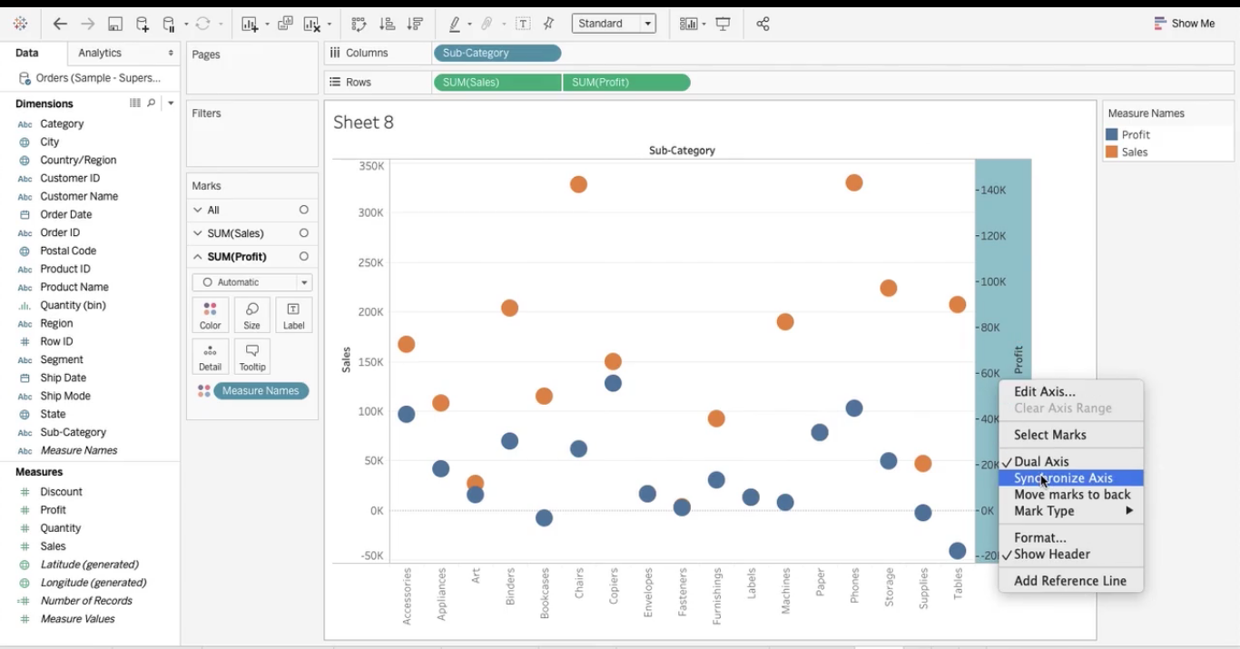

Here is the result you have your Dual axis chart with synchronized axes.

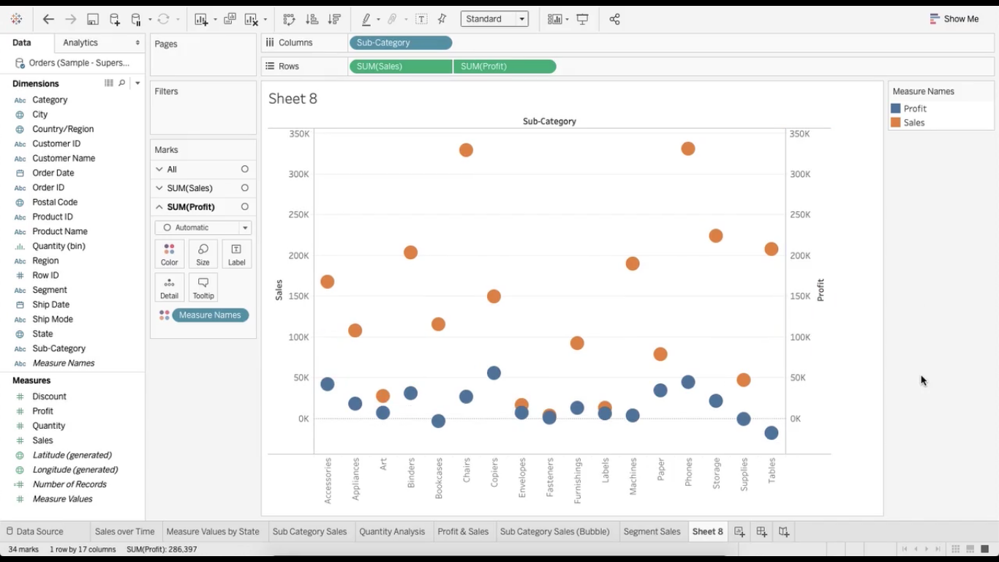

To make it more interesting you can further play around with it. Like changing the shape of Sales from Automatic to bar in the markets card or changing the respective colours, adding borders.

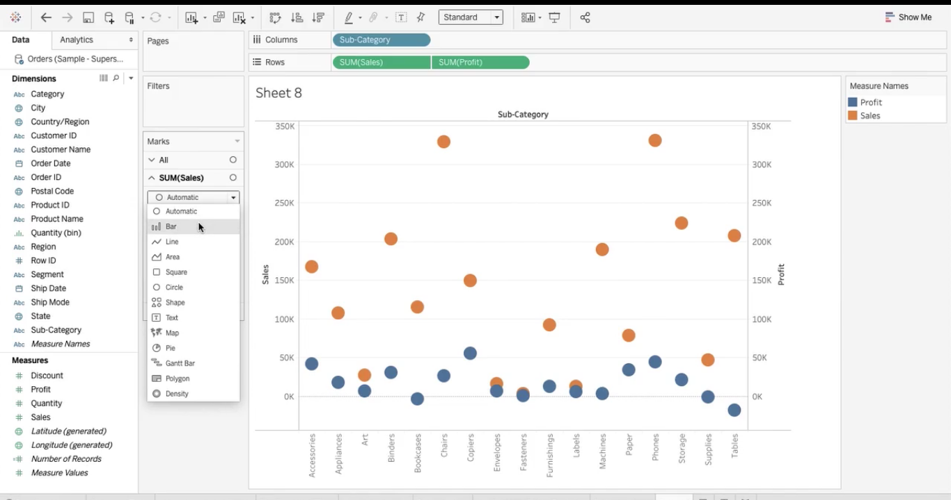

Similarly, you can go to Profit and change its shape to a line. Your final visualization will look like this. Interesting right!

