SREELAKSHMI S

Developer

+91 8086845648 

[sree1806200@gmail.com ](mailto:sree1806200@gmail.com)

Kerala,India

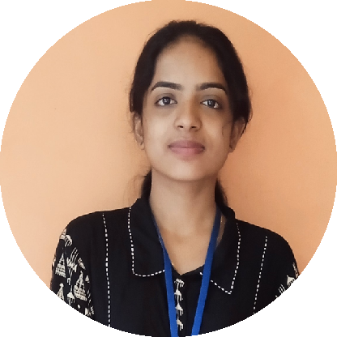

 www.linkedin.com/in/sree-lakshmi-s-j800a61c4

 [@sree1806200](https://medium.com/%40sree1806200)  [Sree12j](https://github.com/Sree12j)

# EDUCATION

2023 - Now

# MASTER OF COMPUTER APPLICATION

AIMAT ,MARAMPALLY / INDIA, ALUVA

2020 - 2023

# BACHELOR OF COMPUTER APPLICATION

AL-AMEEN COLLEGE ,EDATHALA

2018 - 2020

# HIGHER SECONDARY

ST MARY'S HSS ,MORAKKALA

- 2018

# SSLC

BETHLEHEM GIRL'S H S,NJARALLOR

# PROFESSIONAL SUMMARY

A young, aspiring developer eager to solve real-world problems and support colleagues in achieving shared goals. Passionate about learning new technologies and delivering innovative, impactful solutions. Known for strong problem-solving skills, adaptability, and a collaborative approach to development projects.

# PROJECTS

**PLANT LEAF DISEASE DETECTION SYSTEM**



## JULY 2024 – NOVEMBER 2024

### Technologies Used:

* **Front-End:** HTML, CSS
* **Back-End:** Python
* **Algorithm:** Convolutional Neural Network (CNN)

This project is designed to detect diseases in plant leaves, extract useful features, and classify the diseases effectively using a ready-made dataset.

# ROADLAZA

## ROADLAZA

**FEBRUARY 2023 – APRIL 2023 (FULL TIME)**

### Technologies Used:

* **Front-End:** HTML, CSS, JavaScript
* **Back-End:** Python

It is a website used for reporting accidents.it make the duties of police easier and more comfortable

# SKILLS

 C

 C++

 HTML

 CSS

 JAVASCRIPT

# COLLEGE NOTES GALLERY

## OCTOBER 2022 – DECEMBER 2022

### Technologies Used:

* **Front-End:** HTML, CSS, JavaScript

PYTHON

PHP

JAVA

MYSQL

REACT

* + **Back-End:** PHP, MySQL

It is a website used for sharing notes. Notes that wanted for the user can be found in the website

**LANGUAGES ** MALAYALAM  ENGLISH

**CERTIFICATIONS REACT WORKSHOP** SEPTEMBER 4-SEPTEMBER 9

* + - AIMAT,MARAMPALLY



* + - Issued by EDURE

# AICTE Training And Learning (ATAL) Academy Faculty Development Program

AUGUST 26 - AUGUST31

* + - * MES COLLEGE FOR ADVANCED STUDIES
      * ISSUED BY ATAL

# THE JOY OF COMPUTING USING PYTHON

JANUARY-APRIL

* + - * 12 WEEK COURSE
      * ISSUED BY NPTEL

**REFERENCES MS.SHAHILA SHAHUL** ASSISTANT PROFESSOR



Department of computer science AIMAT,marampally [shahilashahul@gmail.com](mailto:shahilashahul@gmail.com)

+91 9747901710