BLDC_Controller - Technical User Manual

1. Bill of Materials
Unnamed: 0 | Reference_IDs | Make | Model | Part_Number | Type | Description | Qty
0 | U2 | Infineon | IMC300A | IMC300A | Power Management IC | Power Management IC  <|im_end|> | 1
1 | C1 | Murata | GRM31CR71E106KA12 | GRM31CR71E106KA12 | Capacitor | Multilayer Ceramic Capacitor  <|im_end|> | 1
2 | CON1 | Phoenix Contact | MSTBVA 2.5/2-G | MSTBVA 2.5/2-G | Terminal Block | Terminal block, 2.5 mm² cross-section, 2-pole, with spring connection<|im_end|> | 1
3 | U3 | STMicroelectronics | STM32G474 | STM32G474 | Microcontroller | 32-bit ARM Cortex-M4F Microcontroller  <|im_end|> | 1
4 | U1 | Texas Instruments | BQ76952 | BQ76952 | IC | Power Management IC, Battery Management | 1
5 | D1 | Vishay | SS34 | SS34 | Resistor | 0.25W, 1% Metal Film Resistor  <|im_end|> | 1
6 | R1, R2 | Yageo | RC0402FR-0710KL | RC0402FR-0710KL | Resistor | 0710kOhm, 0402 package | 2

2. System Overview
**Power_Distribution - Functional Description**
**Overview:**
The Power_Distribution subsystem consists of 5 components connected via 6 unique signals.
**Components:**
- CON1: Phoenix Contact MSTBVA 2.5/2-G
- D1: Phoenix Contact MSTBVA 2.5/2-G
- C1: Phoenix Contact MSTBVA 2.5/2-G
- U1: Vishay SS34
- CON2: Texas Instruments BQ76952
**Signals:**
- 12V_IN
- GND
- 12V_PROT
- V_BAT
- GND_REF
- BMS_HW_ALERT
**Signal Flow:**
CON1(Pin_1) -> D1(ANODE): 12V_IN
CON1(Pin_2) -> C1(NEG): GND
D1(CATHODE) -> C1(POS): 12V_PROT
D1(CATHODE) -> U1(BAT+): V_BAT
C1(NEG) -> U1(GND): GND_REF
U1(ALERT) -> CON2(Pin_1): BMS_HW_ALERT

3. Subsystems & Wiring Diagrams

Power_Distribution
**Power_Distribution - Functional Description**
**Overview:**
The Power_Distribution subsystem consists of 5 components connected via 6 unique signals.
**Components:**
- CON1: Phoenix Contact MSTBVA 2.5/2-G
- D1: Phoenix Contact MSTBVA 2.5/2-G
- C1: Phoenix Contact MSTBVA 2.5/2-G
- U1: Vishay SS34
- CON2: Texas Instruments BQ76952
**Signals:**
- 12V_IN
- GND
- 12V_PROT
- V_BAT
- GND_REF
- BMS_HW_ALERT
**Signal Flow:**
CON1(Pin_1) -> D1(ANODE): 12V_IN
CON1(Pin_2) -> C1(NEG): GND
D1(CATHODE) -> C1(POS): 12V_PROT
D1(CATHODE) -> U1(BAT+): V_BAT
C1(NEG) -> U1(GND): GND_REF
U1(ALERT) -> CON2(Pin_1): BMS_HW_ALERT
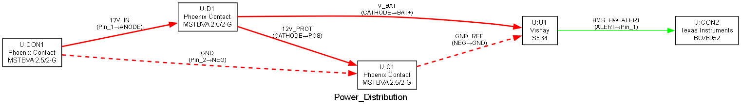

Control_Interface
**Control_Interface - Functional Description**
**Overview:**
The Control_Interface subsystem consists of 5 components connected via 9 unique signals.
**Components:**
- U1: Texas Instruments BQ76952
- U3: Texas Instruments BQ76952
- U2: STMicroelectronics STM32G474
- R1: STMicroelectronics STM32G474
- PWR_3V3: Yageo RC0402FR-0710KL
**Signals:**
- I2C_Data
- I2C_Clock
- BMS_ALERT
- SPI_CLK
- SPI_MOSI
- SPI_MISO
- SPI_CS
- CS_PULLUP
- 3V3_SYS
**Signal Flow:**
U1(SDA) -> U3(I2C_SDA): I2C_Data
U1(SCL) -> U3(I2C_SCL): I2C_Clock
U1(ALERT) -> U3(PE0): BMS_ALERT
U3(SPI1_SCK) -> U2(SPI_CLK): SPI_CLK
U3(SPI1_MOSI) -> U2(SPI_MOSI): SPI_MOSI
U2(SPI_MISO) -> U3(SPI1_MISO): SPI_MISO
U3(SPI1_NSS) -> U2(SPI_CS): SPI_CS
U3(SPI1_NSS) -> R1(Pin_1): CS_PULLUP
R1(Pin_2) -> PWR_3V3(NET): 3V3_SYS
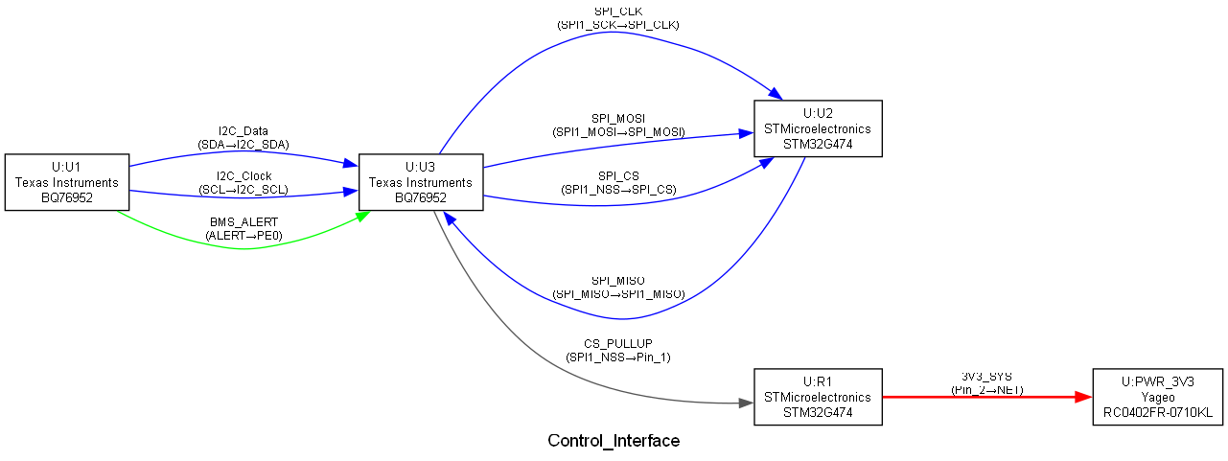

Motor_Drive
**Motor_Drive - Functional Description**
**Overview:**
The Motor_Drive subsystem consists of 5 components connected via 9 unique signals.
**Components:**
- U3: STMicroelectronics STM32G474
- U2: STMicroelectronics STM32G474
- M1: Infineon IMC300A
- R2: Yageo RC0402FR-0710KL
- D1: Vishay SS34
**Signals:**
- PWM_U
- PWM_V
- PWM_W
- DRV_FAULT
- PHASE_U
- PHASE_V
- PHASE_W
- V_SENSE
- DC_BUS
**Signal Flow:**
U3(PA0) -> U2(IN_U): PWM_U
U3(PA1) -> U2(IN_V): PWM_V
U3(PA2) -> U2(IN_W): PWM_W
U2(FAULT) -> U3(PB0): DRV_FAULT
U2(OUT1) -> M1(U): PHASE_U
U2(OUT2) -> M1(V): PHASE_V
U2(OUT3) -> M1(W): PHASE_W
R2(Pin_1) -> U2(VDC): V_SENSE
D1(CATHODE) -> U2(VDC): DC_BUS
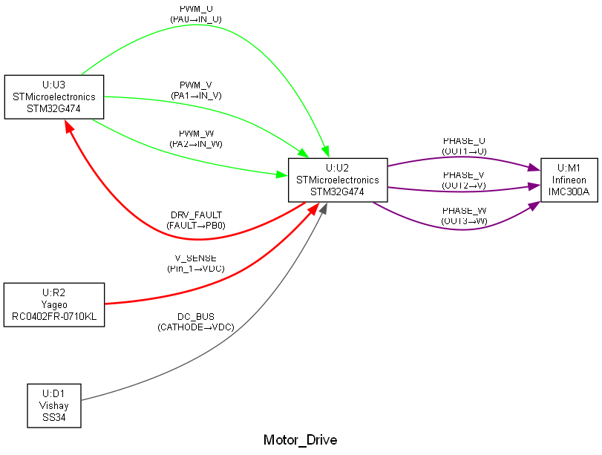

4. Connectivity Data

Control_Interface
System_Name | Subsystem_Name | Component_ID | Make | Model | Source_Pin | Target_ID | Target_Pin | Signal_Name
BLDC_Controller | Control_Interface | U1 | Texas Instruments | BQ76952 | SDA | U3 | I2C_SDA | I2C_Data
BLDC_Controller | Control_Interface | U1 | Texas Instruments | BQ76952 | SCL | U3 | I2C_SCL | I2C_Clock
BLDC_Controller | Control_Interface | U1 | Texas Instruments | BQ76952 | ALERT | U3 | PE0 | BMS_ALERT
BLDC_Controller | Control_Interface | U3 | STMicroelectronics | STM32G474 | SPI1_SCK | U2 | SPI_CLK | SPI_CLK
BLDC_Controller | Control_Interface | U3 | STMicroelectronics | STM32G474 | SPI1_MOSI | U2 | SPI_MOSI | SPI_MOSI
BLDC_Controller | Control_Interface | U2 | Infineon | IMC300A | SPI_MISO | U3 | SPI1_MISO | SPI_MISO
BLDC_Controller | Control_Interface | U3 | STMicroelectronics | STM32G474 | SPI1_NSS | U2 | SPI_CS | SPI_CS
BLDC_Controller | Control_Interface | U3 | STMicroelectronics | STM32G474 | SPI1_NSS | R1 | Pin_1 | CS_PULLUP
BLDC_Controller | Control_Interface | R1 | Yageo | RC0402FR-0710KL | Pin_2 | PWR_3V3 | NET | 3V3_SYS

Motor_Drive
System_Name | Subsystem_Name | Component_ID | Make | Model | Source_Pin | Target_ID | Target_Pin | Signal_Name
BLDC_Controller | Motor_Drive | U3 | STMicroelectronics | STM32G474 | PA0 | U2 | IN_U | PWM_U
BLDC_Controller | Motor_Drive | U3 | STMicroelectronics | STM32G474 | PA1 | U2 | IN_V | PWM_V
BLDC_Controller | Motor_Drive | U3 | STMicroelectronics | STM32G474 | PA2 | U2 | IN_W | PWM_W
BLDC_Controller | Motor_Drive | U2 | Infineon | IMC300A | FAULT | U3 | PB0 | DRV_FAULT
BLDC_Controller | Motor_Drive | U2 | Infineon | IMC300A | OUT1 | M1 | U | PHASE_U
BLDC_Controller | Motor_Drive | U2 | Infineon | IMC300A | OUT2 | M1 | V | PHASE_V
BLDC_Controller | Motor_Drive | U2 | Infineon | IMC300A | OUT3 | M1 | W | PHASE_W
BLDC_Controller | Motor_Drive | R2 | Yageo | RC0402FR-0710KL | Pin_1 | U2 | VDC | V_SENSE
BLDC_Controller | Motor_Drive | D1 | Vishay | SS34 | CATHODE | U2 | VDC | DC_BUS

Power_Distribution
System_Name | Subsystem_Name | Component_ID | Make | Model | Source_Pin | Target_ID | Target_Pin | Signal_Name
BLDC_Controller | Power_Distribution | CON1 | Phoenix Contact | MSTBVA 2.5/2-G | Pin_1 | D1 | ANODE | 12V_IN
BLDC_Controller | Power_Distribution | CON1 | Phoenix Contact | MSTBVA 2.5/2-G | Pin_2 | C1 | NEG | GND
BLDC_Controller | Power_Distribution | D1 | Vishay | SS34 | CATHODE | C1 | POS | 12V_PROT
BLDC_Controller | Power_Distribution | D1 | Vishay | SS34 | CATHODE | U1 | BAT+ | V_BAT
BLDC_Controller | Power_Distribution | C1 | Murata | GRM31CR71E106KA12 | NEG | U1 | GND | GND_REF
BLDC_Controller | Power_Distribution | U1 | Texas Instruments | BQ76952 | ALERT | CON2 | Pin_1 | BMS_HW_ALERT

