**EXERCISE -1 (CONTROL STRUCTURES)**

**CODE**

-- Customers table

CREATE TABLE Customers (

CustomerID NUMBER PRIMARY KEY,

Name VARCHAR2(100),

Age NUMBER,

Balance NUMBER,

IsVIP VARCHAR2(5)

);

/

-- Loans table

CREATE TABLE Loans (

LoanID NUMBER PRIMARY KEY,

CustomerID NUMBER REFERENCES Customers(CustomerID),

InterestRate NUMBER,

DueDate DATE

);

/

-- Insert Customers

INSERT INTO Customers (CustomerID, Name, Age, Balance, IsVIP) VALUES (1, 'Alice', 65, 12000, 'FALSE');

INSERT INTO Customers (CustomerID, Name, Age, Balance, IsVIP) VALUES (2, 'Bob', 45, 8000, 'FALSE');

INSERT INTO Customers (CustomerID, Name, Age, Balance, IsVIP) VALUES (3, 'Charlie', 70, 15000, 'FALSE');

-- Insert Loans

INSERT INTO Loans (LoanID, CustomerID, InterestRate, DueDate) VALUES (101, 1, 10.0, SYSDATE + 20);

INSERT INTO Loans (LoanID, CustomerID, InterestRate, DueDate) VALUES (102, 2, 11.5, SYSDATE + 40);

INSERT INTO Loans (LoanID, CustomerID, InterestRate, DueDate) VALUES (103, 3, 12.0, SYSDATE + 10); COMMIT;

**Scenario 1:** The bank wants to apply a discount to loan interest rates for customers above 60 years old.

BEGIN

FOR customer_rec IN (SELECT CustomerID FROM Customers WHERE Age > 60) LOOP

UPDATE Loans

SET InterestRate = InterestRate - 1

WHERE CustomerID = customer_rec.CustomerID;

END LOOP;

COMMIT;

END;

/

SELECT * FROM Loans;

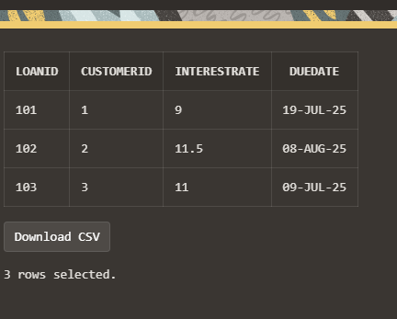

**Scenario 2:** A customer can be promoted to VIP status based on their balance(balance > 10000).

BEGIN

FOR customer_rec IN (SELECT CustomerID FROM Customers WHERE Balance > 10000) LOOP

UPDATE Customers

SET IsVIP = 'TRUE'

WHERE CustomerID = customer_rec.CustomerID;

END LOOP;

COMMIT;

END;

/

SELECT * FROM Customers;

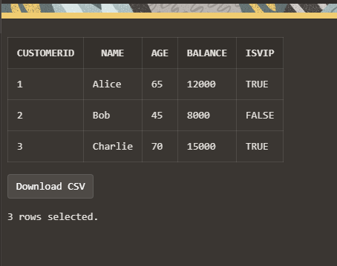

**Scenario 3:** The bank wants to send reminders to customers whose loans are due within the next 30 days.

BEGIN

FOR loan_rec IN (

SELECT L.LoanID, L.CustomerID, L.DueDate, C.Name

FROM Loans L

JOIN Customers C ON L.CustomerID = C.CustomerID

WHERE L.DueDate BETWEEN SYSDATE AND SYSDATE + 30

) LOOP

DBMS_OUTPUT.PUT_LINE('Reminder: Dear ' || loan_rec.Name ||

', your loan (ID: ' || loan_rec.LoanID ||

') is due on ' || TO_CHAR(loan_rec.DueDate, 'DD-MON-YYYY'));

END LOOP;

END;

/

