**Exercise-2(Stored Procedures)**

**CODE:**

CREATE TABLE accounts (

account_id NUMBER PRIMARY KEY,

account_type VARCHAR2(20),

balance NUMBER(12, 2)

);

CREATE TABLE employees (

emp_id NUMBER PRIMARY KEY,

name VARCHAR2(50),

department_id NUMBER,

salary NUMBER(10, 2)

);

-- Sample accounts

INSERT INTO accounts VALUES (101, 'SAVINGS', 10000);

INSERT INTO accounts VALUES (102, 'SAVINGS', 15000);

INSERT INTO accounts VALUES (103, 'CURRENT', 20000);

INSERT INTO accounts VALUES (104, 'SAVINGS', 5000);

-- Sample employees

INSERT INTO employees VALUES (1, 'Alice', 10, 30000);

INSERT INTO employees VALUES (2, 'Bob', 10, 28000);

INSERT INTO employees VALUES (3, 'Charlie', 20, 32000);

INSERT INTO employees VALUES (4, 'Diana', 20, 35000);

COMMIT;

**Scenario - 1: The bank needs to process monthly interest for all savings accounts.**

CREATE OR REPLACE PROCEDURE ProcessMonthlyInterest AS

BEGIN

UPDATE accounts

SET balance = balance + (balance * 0.01)

WHERE account_type = 'SAVINGS';

COMMIT;

END;

/

**Scenario 2:** The bank wants to implement a bonus scheme for employees based on their performance.

CREATE OR REPLACE PROCEDURE UpdateEmployeeBonus(

p_department_id IN NUMBER,

p_bonus_percent IN NUMBER

) AS

BEGIN

UPDATE employees

SET salary = salary + (salary * p_bonus_percent / 100)

WHERE department_id = p_department_id;

COMMIT;

END;

/

**Scenario 3:** Customers should be able to transfer funds between their accounts.

CREATE OR REPLACE PROCEDURE TransferFunds(

p_from_account IN NUMBER,

p_to_account IN NUMBER,

p_amount IN NUMBER

) AS

v_balance NUMBER;

BEGIN

-- Lock the source account row

SELECT balance INTO v_balance

FROM accounts

WHERE account_id = p_from_account

FOR UPDATE;

IF v_balance < p_amount THEN

RAISE_APPLICATION_ERROR(-20001, 'Insufficient funds in source account.');

END IF;

-- Deduct from source

UPDATE accounts

SET balance = balance - p_amount

WHERE account_id = p_from_account;

-- Credit to destination

UPDATE accounts

SET balance = balance + p_amount

WHERE account_id = p_to_account;

COMMIT;

END;

/

EXEC TransferFunds(101, 103, 3000);

EXEC UpdateEmployeeBonus(10, 10);

EXEC ProcessMonthlyInterest;

Accounts :

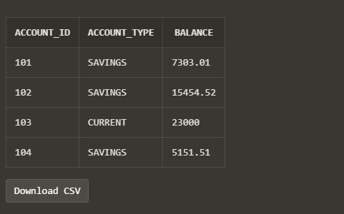

Employees:

