AI assisted coding 2303A52227
ASSIGNMENT 2

Lab 2: Exploring Additional AI Coding Tools beyond Copilot – Gemini (Colab) and Cursor AI

Task 1: Cleaning Sensor Data
- Scenario:
- You are cleaning IoT sensor data where negative values are invalid.
- Task:
Use Gemini in Colab to generate a function that filters out all negative numbers from a list.
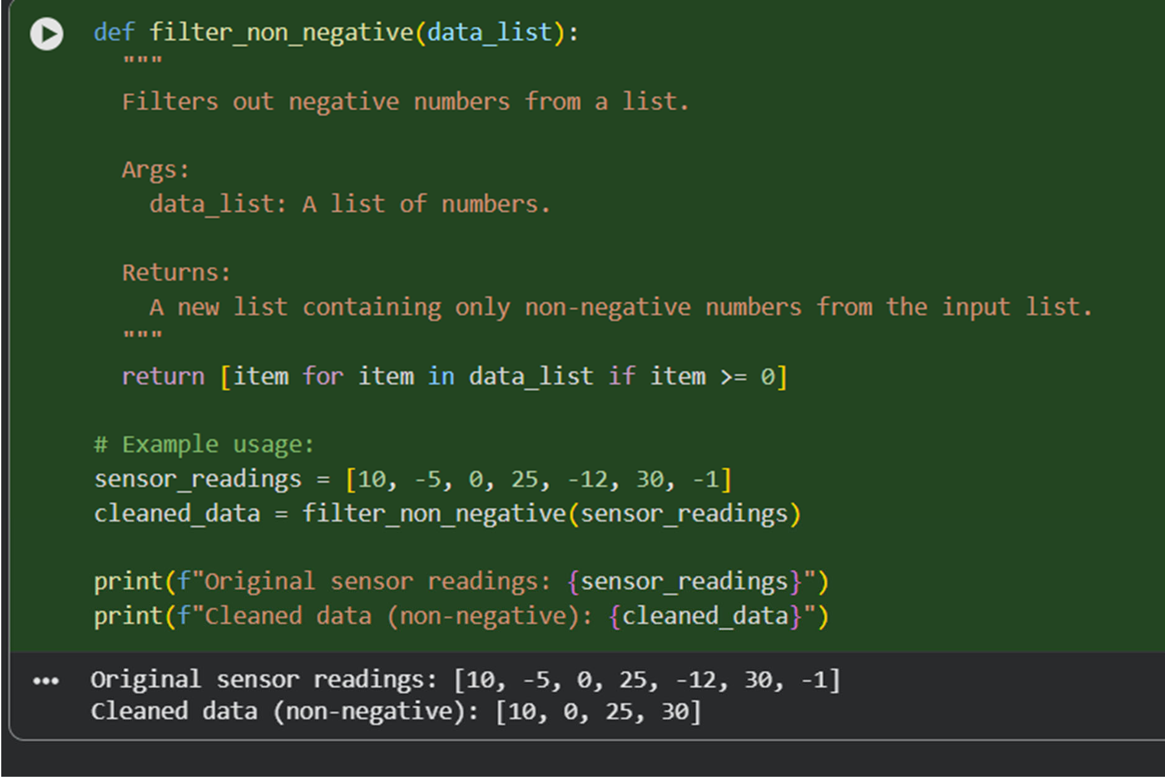

Task 2: String Character Analysis
- Scenario:
You are building a text-analysis feature.
- Task:
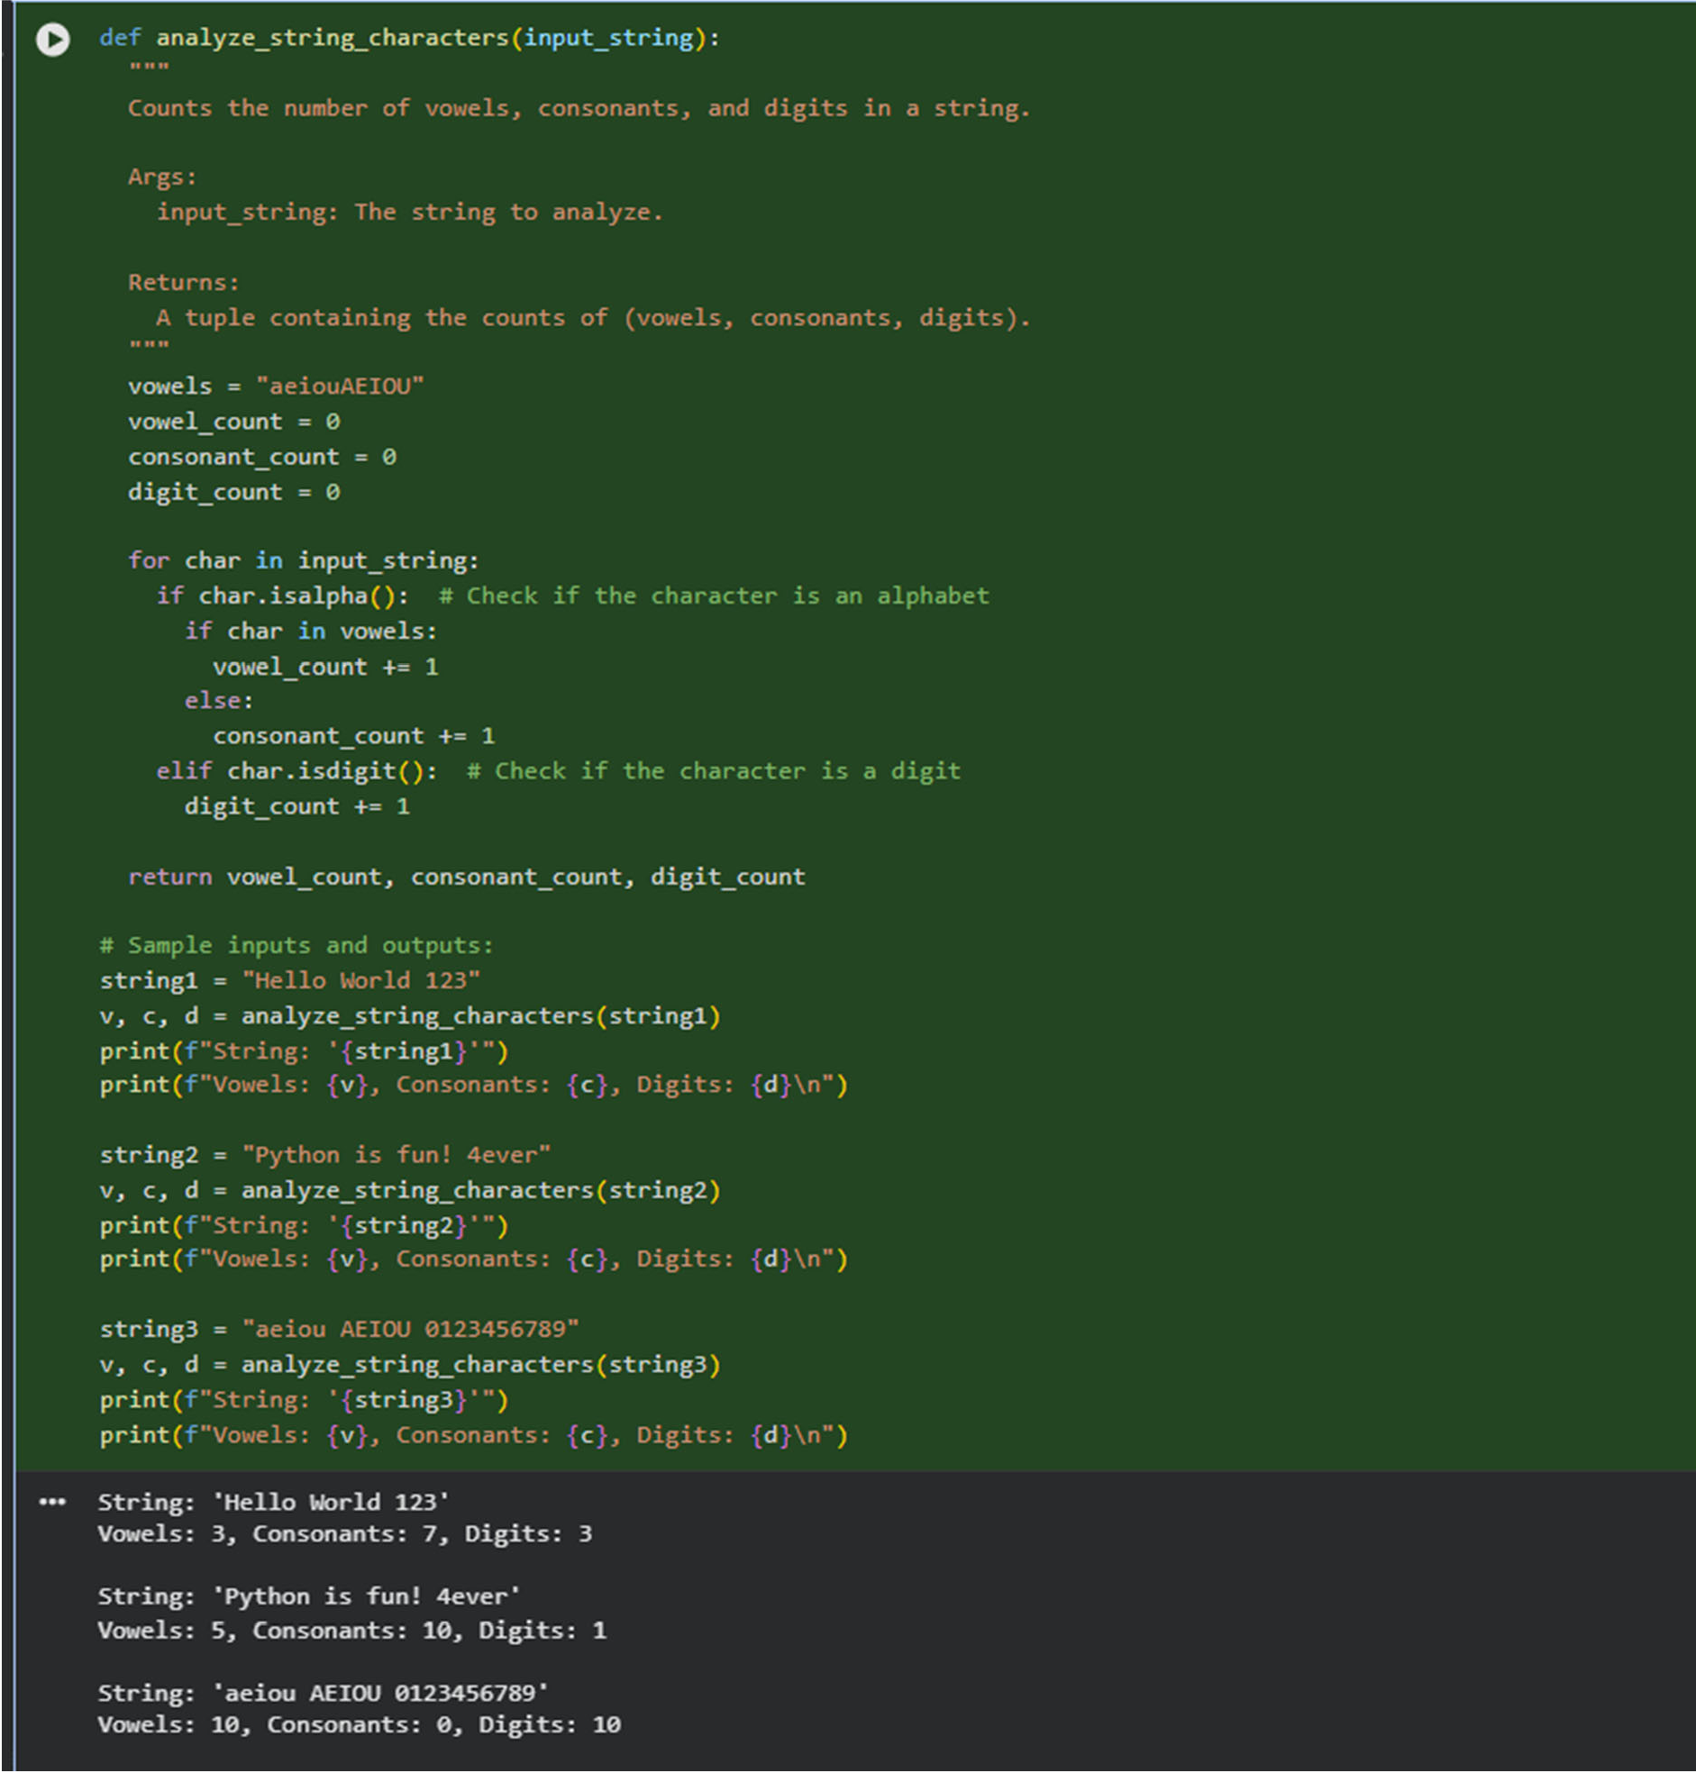
Use Gemini to generate a Python function that counts vowels, consonants, and digits in a string.

Task 3: Palindrome Check – Tool Comparison

Task 3
- Scenario:
You must decide which AI tool is clearer for string logic.
- Task:
Generate a palindrome-checking function using Gemini and Copilot, then compare the results.
GEMINI
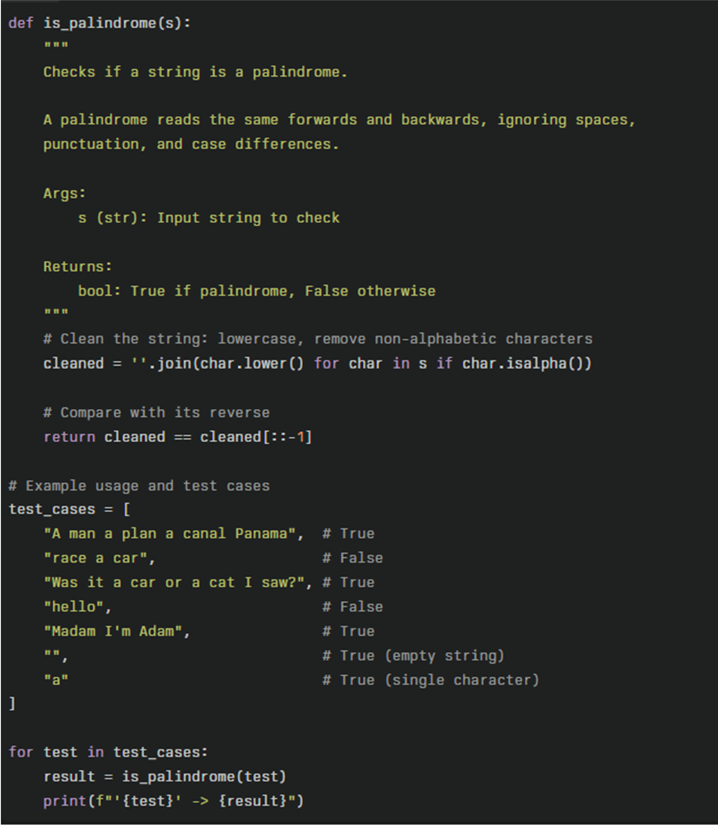

COPILOT
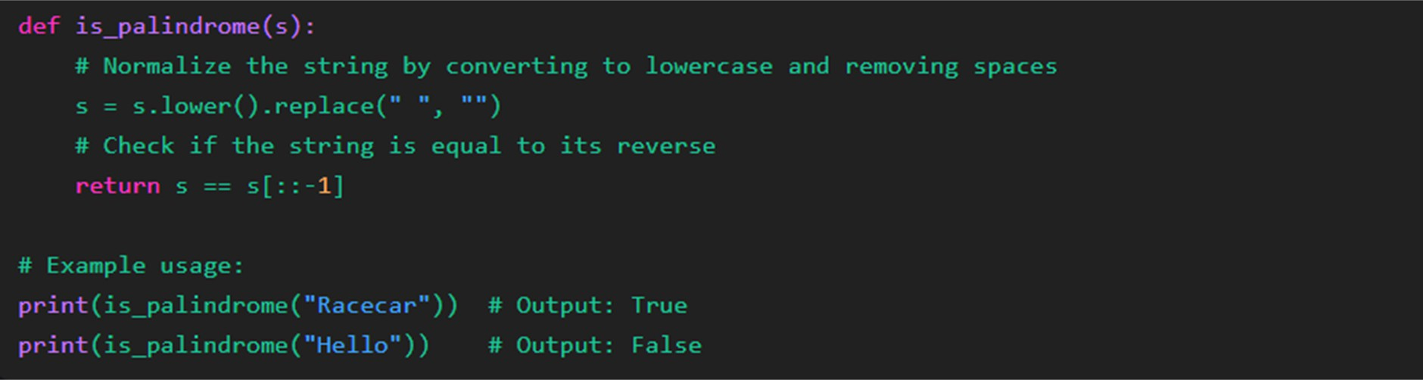

OBSERVATIONS

3 Key Differences:
- Character filtering: First code removes only spaces, second removes all nonalphabetic characters
- Code style: First is minimal (no docstring, modifies input), second is production- ready (docstring, doesn't modify input, list comprehension)
- Test coverage: First tests 2 simple cases, second tests 7 diverse cases including punctuation, empty string, and edge cases

Task 4: Code Explanation Using AI
- Scenario:
You are reviewing unfamiliar code written by another developer.
- Task:
Ask Gemini to explain a Python function (prime check OR palindrome check) line by line.

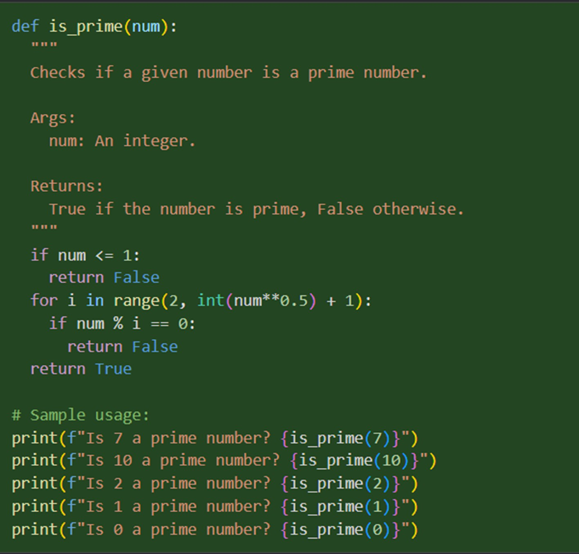
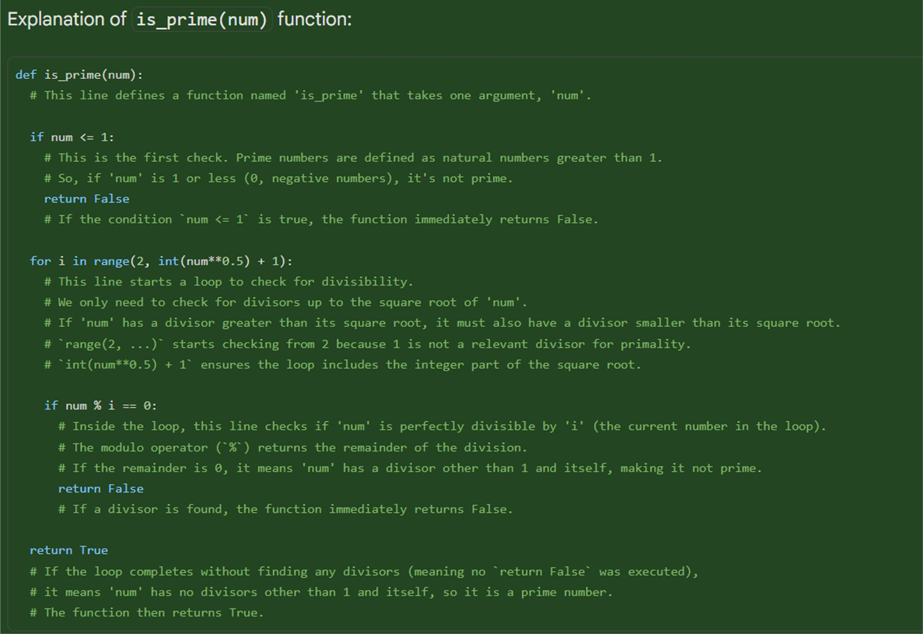
MY COMMENTS ON THIS

I understand the prime function now. The square root check make sense because factors come in pairs, so only need to test up to √n. Loop starts from 2 skip 1 since 1 not count. Early return when find divisor save time. If no divisor after loop, it is prime.

