AI ASSISTED CODING 2303A52227ASSIGNMENT 3

Task 1: Progressive Prompting for Calculator Design

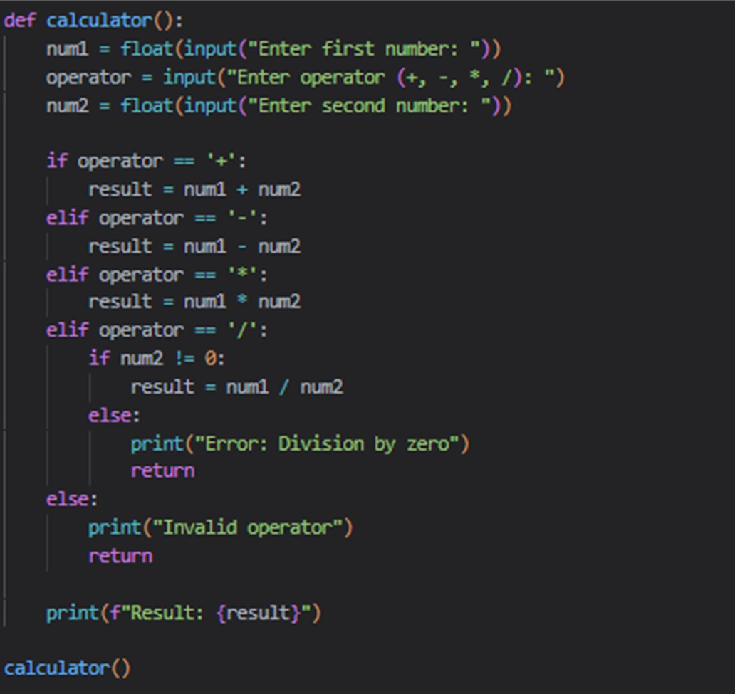

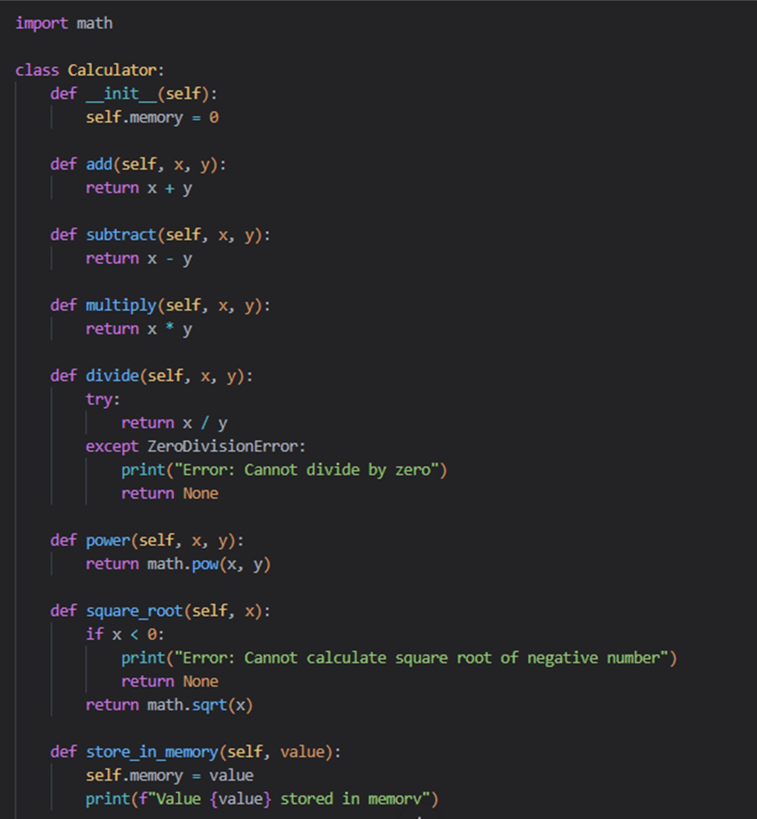
after giving detailed prompt

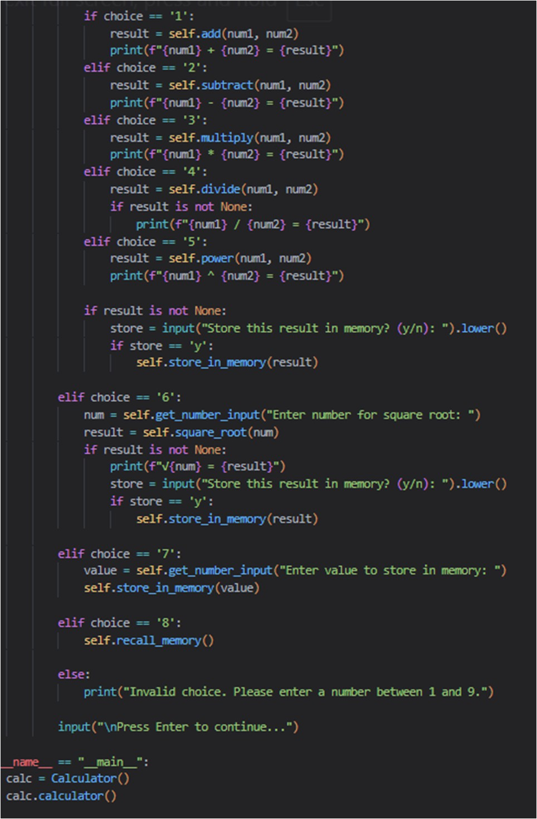
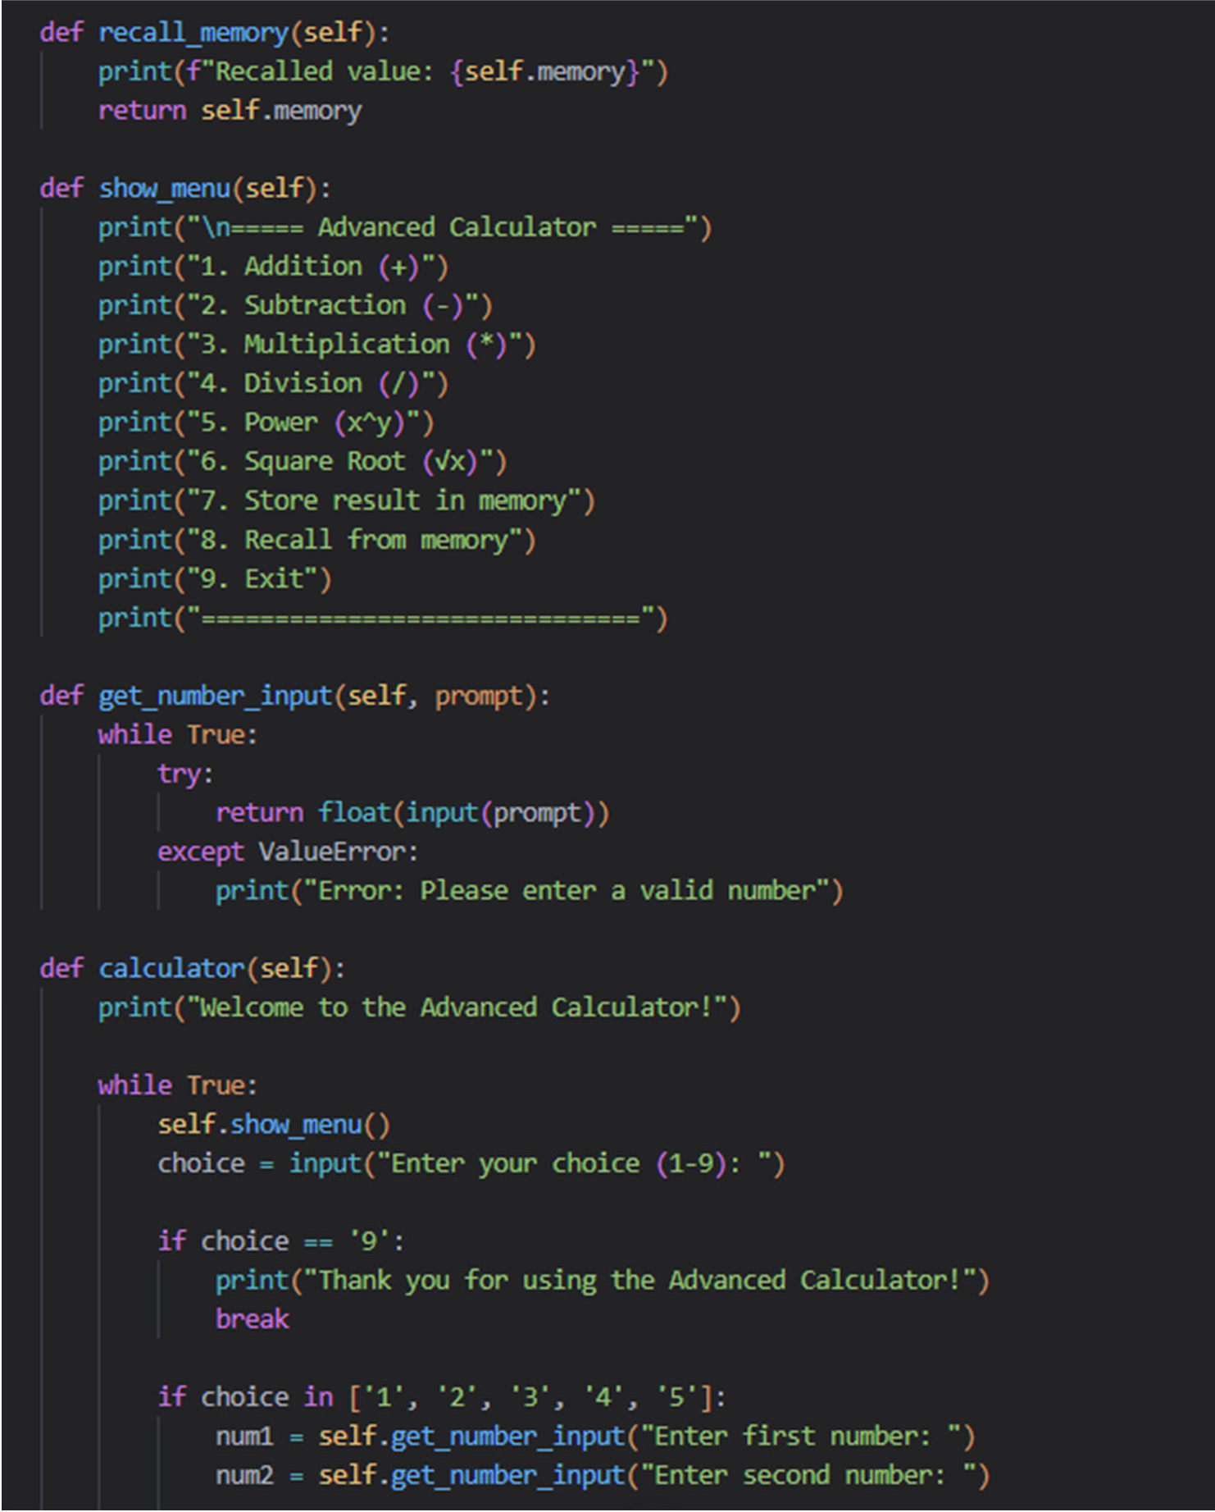

output

output
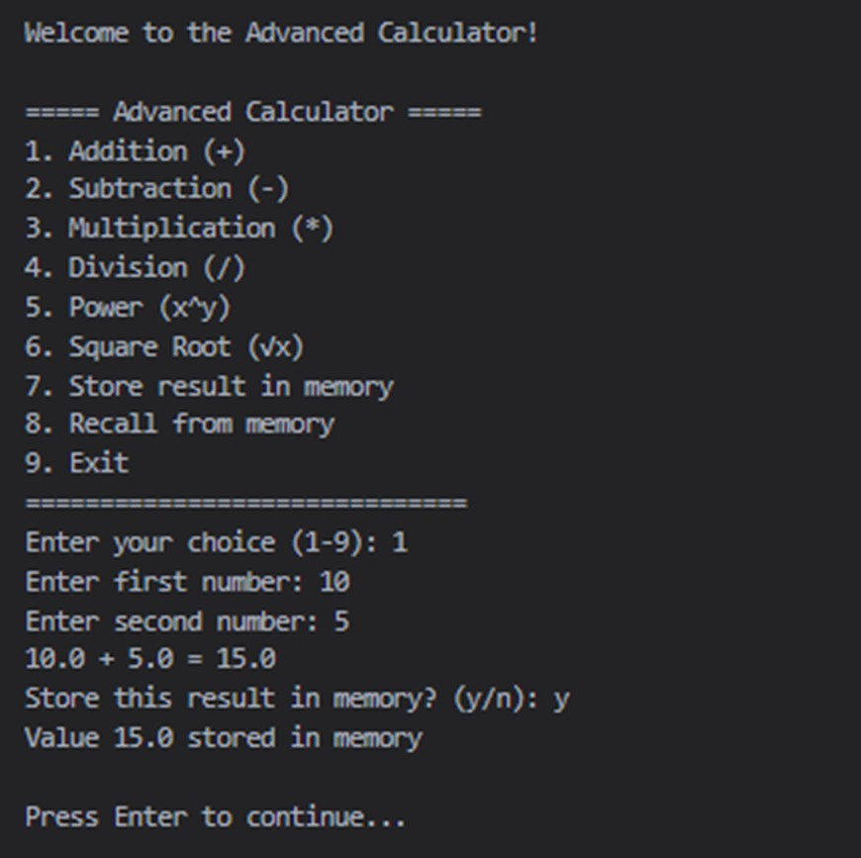

Task 2: Refining Prompts for Sorting Logic
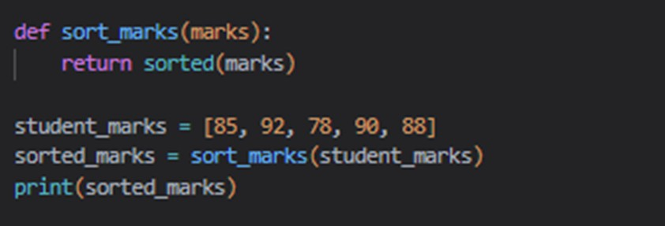

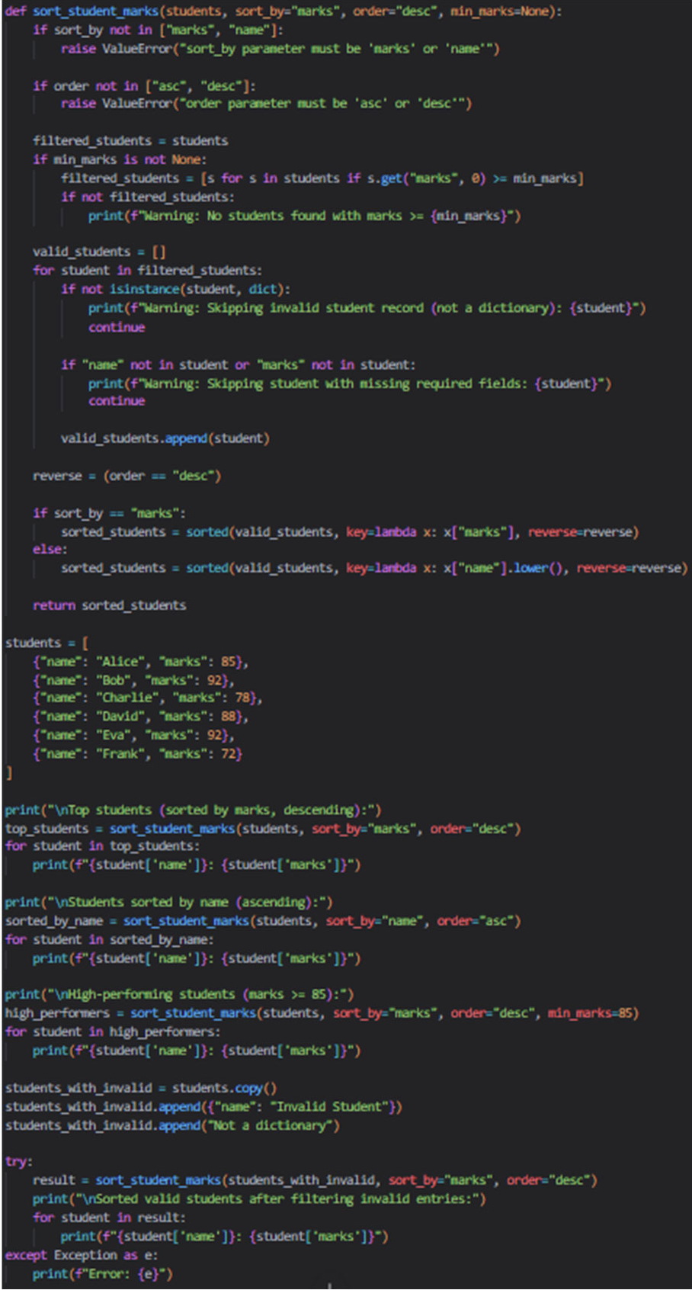
after giving detailed prompt

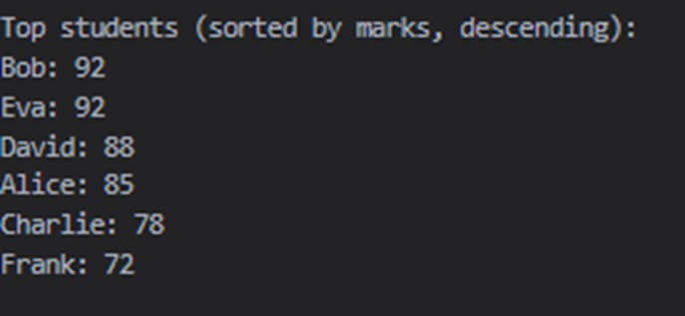
output

Task 3: Few-Shot Prompting for Prime Number Validation

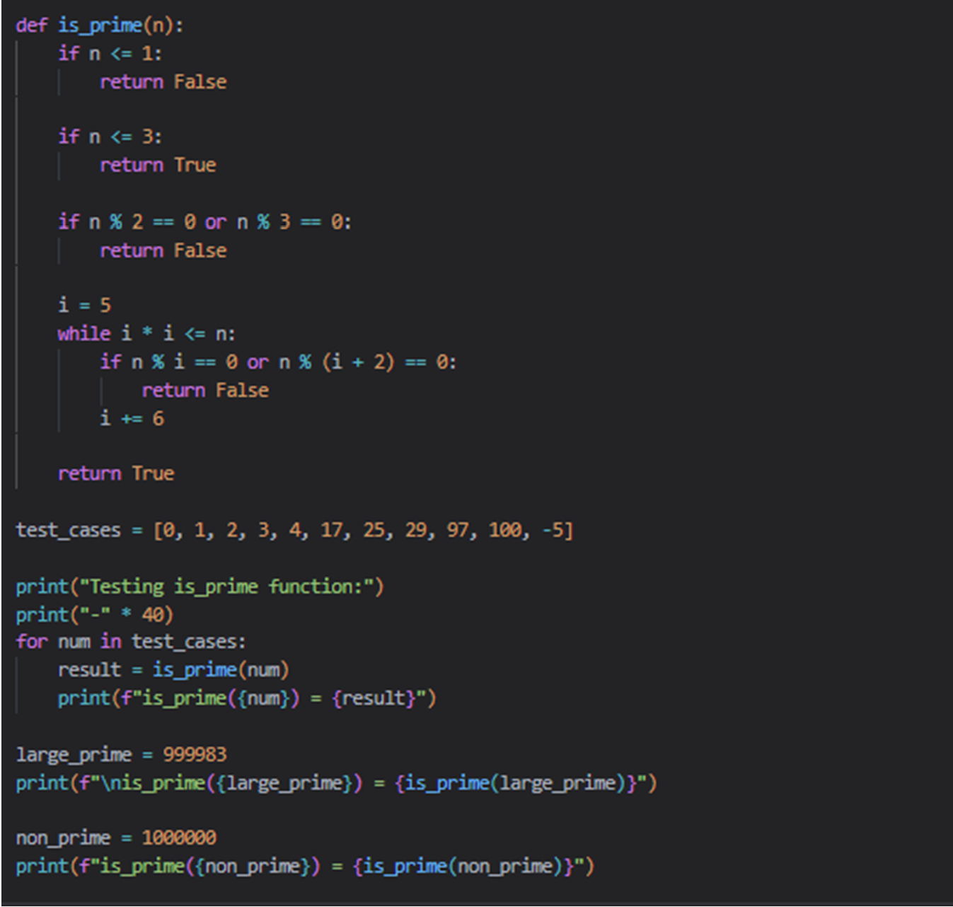

output
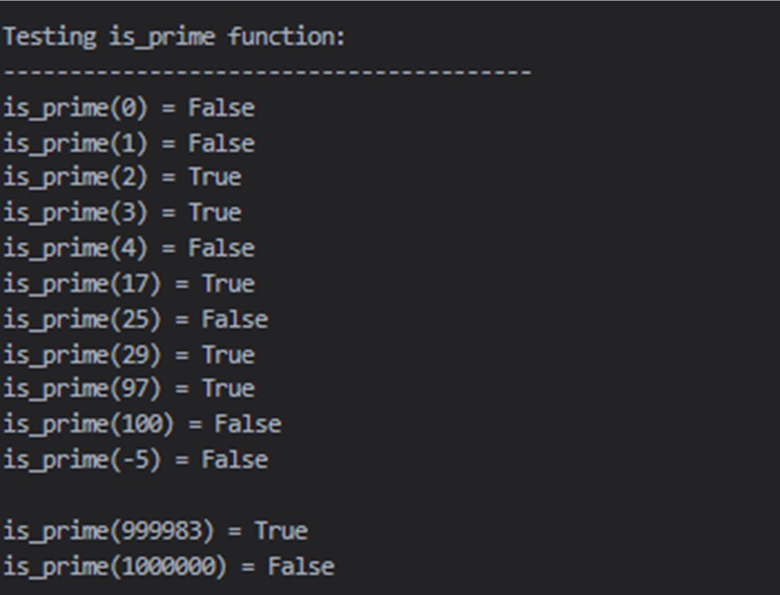

Task 4: Prompt-Guided UI Design for Student Grading System
import tkinter as tk
from tkinter import ttk, messagebox, scrolledtext import datetime

class StudentGradingSystem:
def init (self, root):
self.root = root
self.root.title("Student Grading System") self.root.geometry("800x600") self.root.configure(bg="#f0f0f0")

main_frame = ttk.Frame(root, padding="20") main_frame.grid(row=0, column=0, sticky=(tk.W, tk.E, tk.N, tk.S))

info_frame = ttk.LabelFrame(main_frame, text="Student Information", padding="10")
info_frame.grid(row=0, column=0, columnspan=2, sticky=(tk.W, tk.E), pady=10)

ttk.Label(info_frame, text="Student Name:").grid(row=0, column=0, sticky=tk.W, pady=5)
self.name_var = tk.StringVar()
ttk.Entry(info_frame, textvariable=self.name_var, width=30).grid(row=0, column=1, sticky=tk.W, pady=5, padx=5)

ttk.Label(info_frame, text="Student ID:").grid(row=1, column=0, sticky=tk.W, pady=5)
self.id_var = tk.StringVar()

ttk.Entry(info_frame, textvariable=self.id_var, width=30).grid(row=1, column=1, sticky=tk.W, pady=5, padx=5)

marks_frame = ttk.LabelFrame(main_frame, text="Subject Marks (0-100)", padding="10")
marks_frame.grid(row=1, column=0, columnspan=2, sticky=(tk.W, tk.E), pady=10)

subjects = ["Mathematics", "Science", "English", "History", "Computer Science"] self.mark_vars = {}

for i, subject in enumerate(subjects):
ttk.Label(marks_frame, text=f"{subject}:").grid(row=i, column=0, sticky=tk.W, pady=5)
self.mark_vars[subject] = tk.StringVar(value="0")
ttk.Entry(marks_frame, textvariable=self.mark_vars[subject], width=10).grid(row=i, column=1, sticky=tk.W, pady=5, padx=5)

button_frame = ttk.Frame(main_frame) button_frame.grid(row=2, column=0, columnspan=2, pady=15)

ttk.Button(button_frame, text="Calculate Grade", command=self.calculate_grade).grid(row=0, column=0, padx=10)
ttk.Button(button_frame, text="Clear Form", command=self.clear_form).grid(row=0, column=1, padx=10)
ttk.Button(button_frame, text="Save Results", command=self.save_results).grid(row=0, column=2, padx=10)
ttk.Button(button_frame, text="Help", command=self.show_help).grid(row=0, column=3, padx=10)

result_frame = ttk.LabelFrame(main_frame, text="Results", padding="10")

result_frame.grid(row=3, column=0, columnspan=2, sticky=(tk.W, tk.E), pady=10)

self.result_text = scrolledtext.ScrolledText(result_frame, width=70, height=8, font=("Arial", 10))
self.result_text.grid(row=0, column=0, sticky=(tk.W, tk.E)) self.result_text.configure(state='disabled')

self.status_var = tk.StringVar() self.status_var.set("Ready to calculate grade")
status_bar = ttk.Label(root, textvariable=self.status_var, relief=tk.SUNKEN, anchor=tk.W)
status_bar.grid(row=1, column=0, sticky=(tk.W, tk.E))

def validate_marks(self):
for subject, var in self.mark_vars.items():
try:
mark = float(var.get())
if mark < 0 or mark > 100:
messagebox.showerror("Input Error", f"{subject} marks must be between 0 and 100")
return False except ValueError:
messagebox.showerror("Input Error", f"Please enter a valid number for {subject} marks")
return False return True

def calculate_grade(self):
if not self.validate_marks() or not self.name_var.get().strip():

return

marks = [float(var.get()) for var in self.mark_vars.values()] total = sum(marks)
percentage = (total / 500) * 100

if percentage >= 90:
grade = "A+" grade_color = "green"
elif percentage >= 80:
grade = "A" grade_color = "green"
elif percentage >= 70:
grade = "B" grade_color = "blue"
elif percentage >= 60:
grade = "C" grade_color = "blue"
elif percentage >= 50:
grade = "D" grade_color = "orange"
else:
grade = "F" grade_color = "red"

result = f"Student Name: {self.name_var.get()}\n" result += f"Student ID: {self.id_var.get()}\n"
result += f"{'='*40}\n"

for subject, mark in zip(self.mark_vars.keys(), marks):
result += f"{subject}: {mark}/100\n" result += f"{'='*40}\n"
result += f"Total Marks: {total}/500\n"
result += f"Percentage: {percentage:.2f}%\n" result += f"Grade: {grade}\n"

self.result_text.configure(state='normal') self.result_text.delete(1.0, tk.END) self.result_text.insert(tk.END, result)

grade_start = result.find(f"Grade: {grade}") + 7 grade_end = grade_start + len(grade)
self.result_text.tag_add("grade", f"1.{grade_start}", f"1.{grade_end}") self.result_text.tag_config("grade", foreground=grade_color, font=("Arial", 10, "bold"))

self.result_text.configure(state='disabled')
self.status_var.set(f"Grade calculated successfully! Grade: {grade}, Percentage:
{percentage:.2f}%")

self.current_result = {
"name": self.name_var.get(), "id": self.id_var.get(),
"marks": dict(zip(self.mark_vars.keys(), marks)), "total": total,
"percentage": percentage, "grade": grade
}

def clear_form(self):
self.name_var.set("") self.id_var.set("")
for var in self.mark_vars.values():
var.set("0")

self.result_text.configure(state='normal') self.result_text.delete(1.0, tk.END) self.result_text.configure(state='disabled')

self.status_var.set("Form cleared. Ready for new entry.")

def save_results(self):
if not hasattr(self, 'current_result') or not self.current_result: messagebox.showinfo("No Results", "Please calculate grades first before saving.") return

try:
filename = f"grade_report_{self.current_result['name'].replace(' ', '_')}_{datetime.datetime.now().strftime('%Y%m%d_%H%M%S')}.txt"
with open(filename, 'w') as f:
f.write("STUDENT GRADE REPORT\n")
f.write("=" * 40 + "\n")
f.write(f"Name: {self.current_result['name']}\n") f.write(f"ID: {self.current_result['id']}\n")
f.write(f"Date: {datetime.datetime.now().strftime('%Y-%m-%d %H:%M:%S')}\n") f.write("-" * 40 + "\n")

f.write("SUBJECT MARKS:\n")
for subject, mark in self.current_result['marks'].items(): f.write(f"{subject}: {mark}/100\n")
f.write("-" * 40 + "\n")
f.write(f"Total Marks: {self.current_result['total']}/500\n") f.write(f"Percentage: {self.current_result['percentage']:.2f}%\n") f.write(f"Grade: {self.current_result['grade']}\n")
f.write("=" * 40 + "\n")
f.write("This is an auto-generated report from Student Grading System")

self.status_var.set(f"Results saved successfully to {filename}") messagebox.showinfo("Save Successful", f"Grade report saved to {filename}")
except Exception as e:
messagebox.showerror("Save Error", f"Failed to save results: {str(e)}")

def show_help(self):
help_text = """
Student Grading System Help

- Enter the student's name and ID in the respective fields.
- Enter marks for each subject (0-100) in the subject fields.
- Click "Calculate Grade" to compute the total marks, percentage, and grade.
- Results will be displayed in the Results section with color-coded grades.
- Click "Save Results" to save the current results to a text file.
- Click "Clear Form" to reset all fields for a new student.

Grading Scale:
- A+ : 90-100%

- A : 80-89%
- B : 70-79%
- C : 60-69%
- D : 50-59%
- F : Below 50%

Note: All marks must be between 0 and 100. The system will validate your inputs. """
messagebox.showinfo("Help", help_text)

if name == " main ":
root = tk.Tk()
app = StudentGradingSystem(root) root.mainloop()

Task 5: Analyzing Prompt Specificity in Unit Conversion Functions
def convert_distance(value, from_unit, to_unit):
from_unit = from_unit.lower() to_unit = to_unit.lower()

if value < 0:
raise ValueError("Distance value cannot be negative")

supported_units = ["km", "kilometer", "kilometers", "miles", "mile", "m", "meter", "meters", "ft", "foot", "feet"]

unit_map = {

"km": "km", "kilometer": "km", "kilometers": "km", "miles": "miles", "mile": "miles",
"m": "m", "meter": "m", "meters": "m",
"ft": "ft", "foot": "ft", "feet": "ft"
}

if from_unit not in unit_map:
raise ValueError(f"Unsupported source unit: {from_unit}. Supported units are: km, miles, m, ft")
if to_unit not in unit_map:
raise ValueError(f"Unsupported target unit: {to_unit}. Supported units are: km, miles, m, ft")

from_unit = unit_map[from_unit] to_unit = unit_map[to_unit]

if from_unit == to_unit:
return round(value, 4)

KM_TO_MILES = 0.621371
MILES_TO_KM = 1.60934
KM_TO_METERS = 1000.0
MILES_TO_FEET = 5280.0
METERS_TO_KM = 0.001
FEET_TO_MILES = 1 / 5280.0

if from_unit == "km" and to_unit == "miles": result = value * KM_TO_MILES
elif from_unit == "miles" and to_unit == "km":

result = value * MILES_TO_KM
elif from_unit == "km" and to_unit == "m":
result = value * KM_TO_METERS
elif from_unit == "m" and to_unit == "km":
result = value * METERS_TO_KM
elif from_unit == "miles" and to_unit == "ft":
result = value * MILES_TO_FEET
elif from_unit == "ft" and to_unit == "miles":
result = value * FEET_TO_MILES
elif from_unit == "km" and to_unit == "ft":
meters = value * KM_TO_METERS result = meters * 3.28084
elif from_unit == "ft" and to_unit == "km":
meters = value / 3.28084
result = meters * METERS_TO_KM
elif from_unit == "miles" and to_unit == "m":
km = value * MILES_TO_KM result = km * KM_TO_METERS
elif from_unit == "m" and to_unit == "miles":
km = value * METERS_TO_KM result = km * KM_TO_MILES
elif from_unit == "m" and to_unit == "ft":
result = value * 3.28084
elif from_unit == "ft" and to_unit == "m":
result = value * 0.3048 else:
raise ValueError(f"Conversion from {from_unit} to {to_unit} is not supported")

return round(result, 4)

def show_conversion_examples(): examples = [
(10, "km", "miles"),
(5, "miles", "km"),
(1, "km", "m"),
(1, "miles", "ft"),
(1000, "m", "km"),
(5280, "ft", "miles"),
(2.5, "m", "ft"),
(100, "ft", "m"),
(3, "km", "ft"),
(10000, "ft", "km")
]

print("Unit Conversion Examples:") print("-" * 50)
for value, from_unit, to_unit in examples:
try:
result = convert_distance(value, from_unit, to_unit) print(f"{value} {from_unit} = {result} {to_unit}")
except ValueError as e:
print(f"Error converting {value} {from_unit} to {to_unit}: {e}")

show_conversion_examples()

print("\n" + "="*50)

print("Interactive Unit Conversion") print("="*50)

while True:
try:
value = float(input("\nEnter value to convert (or 0 to exit): ")) if value == 0:
break

from_unit = input("Convert from (km/miles/m/ft): ").lower() to_unit = input("Convert to (km/miles/m/ft): ").lower()

result = convert_distance(value, from_unit, to_unit) print(f"\nResult: {value} {from_unit} = {result} {to_unit}")

except ValueError as e:
print(f"Error: {e}") except Exception as e:
print(f"An unexpected error occurred: {e}")

print("\nThank you for using the Unit Conversion Tool!")

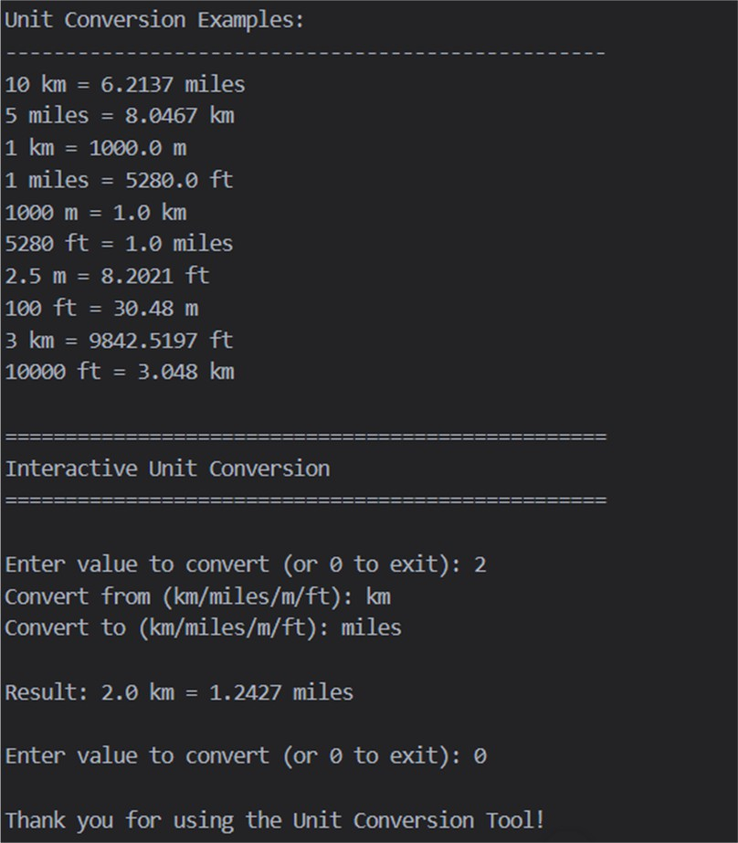
output

