ASSIGNMENT 4

Task 1: Zero-shot Prime Number Checker
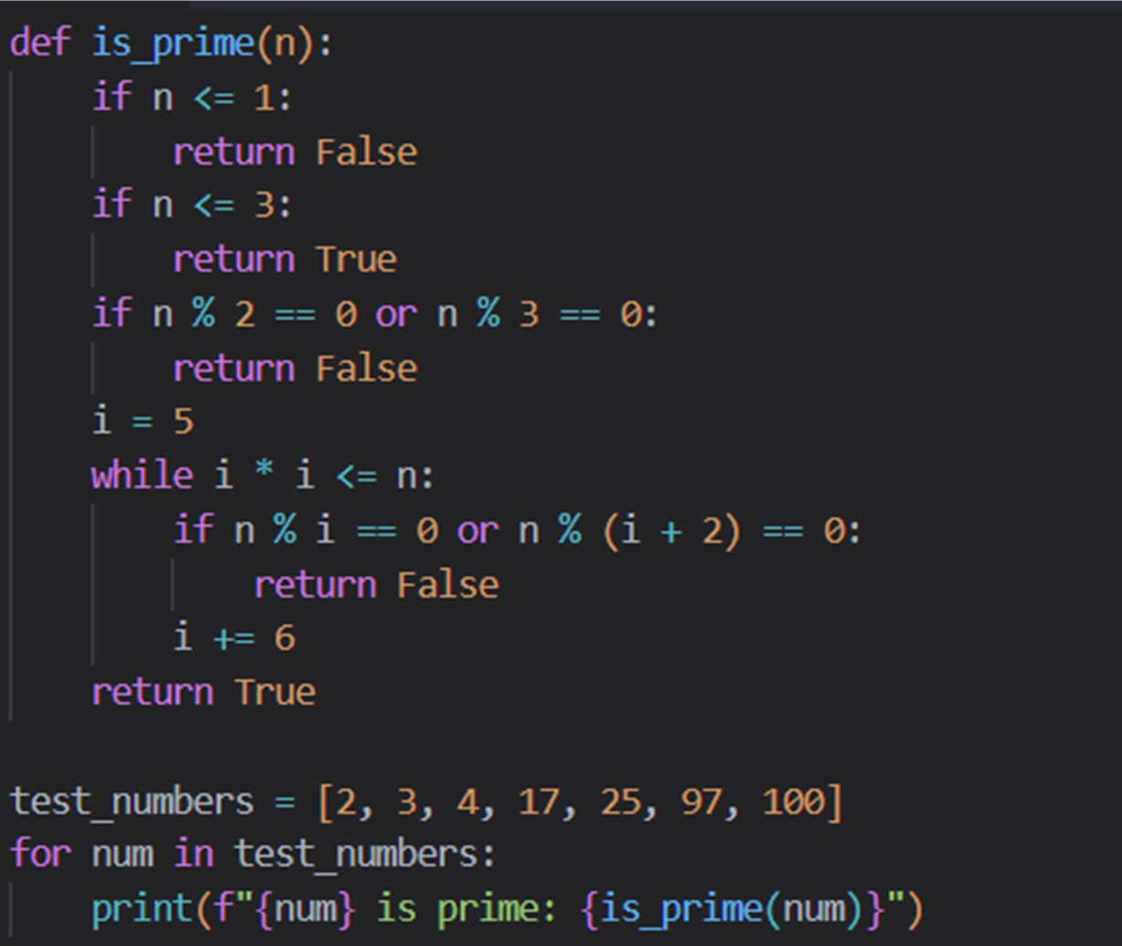
prompt : Write a Python function to determine whether a given number is prime

output
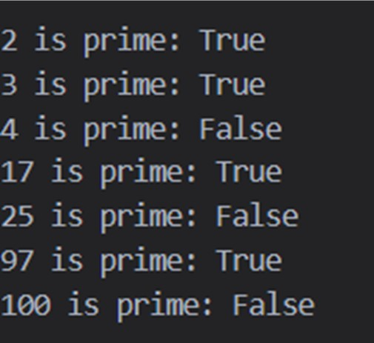

Task 2: One-shot List Sum Function
prompt : Write a Python function that calculates the sum of elements in a list
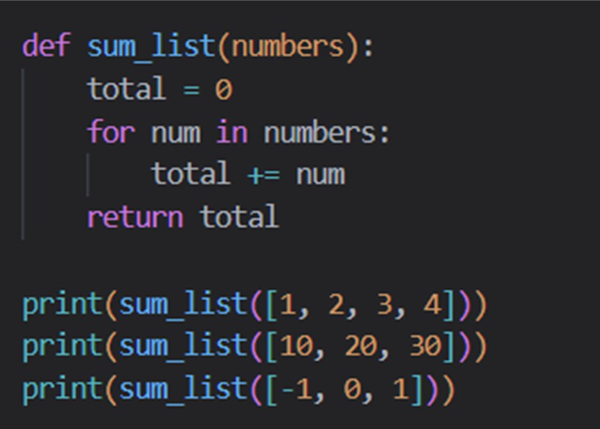

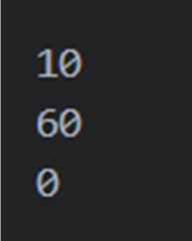

Task 3: Few-shot Digit Extraction Function
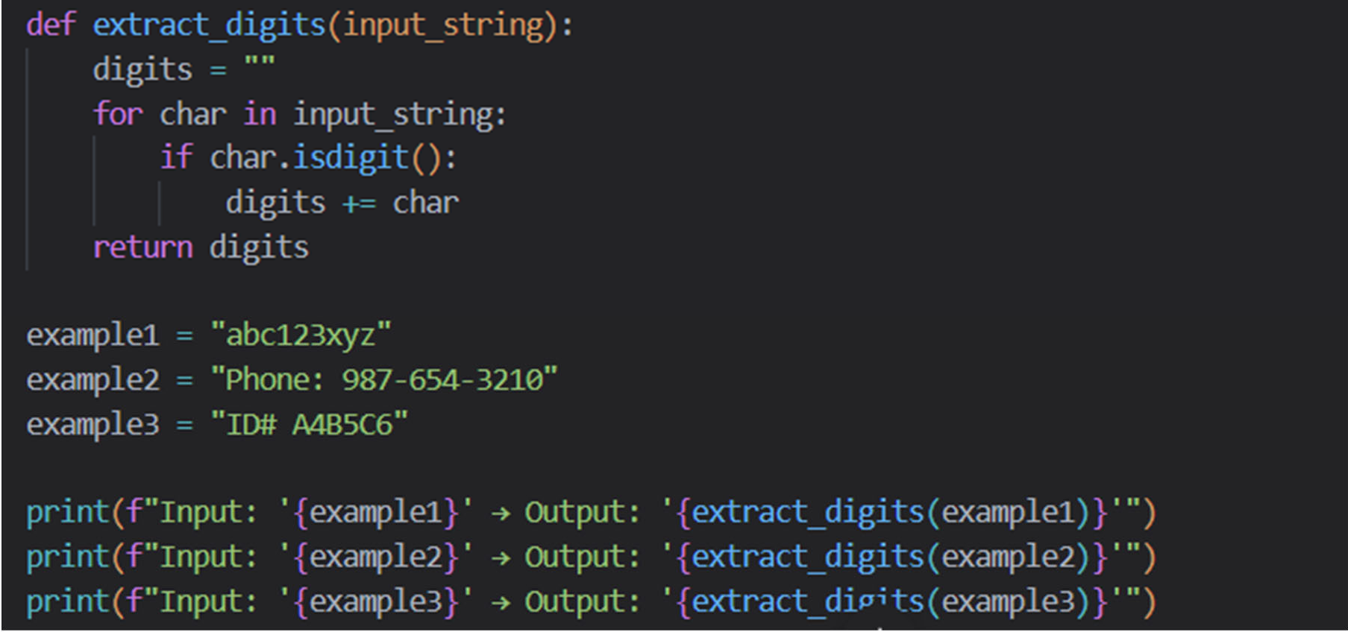
prompt : Write a Python function that extracts digits from an alphanumeric string

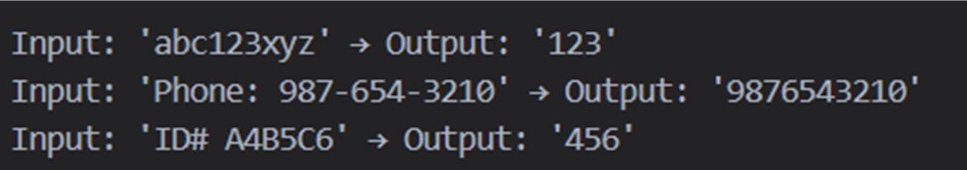
output

Task 4: Zero-shot vs Few-shot Vowel Counter
prompt: Write a Python function that counts the number of vowels in a string Zero-shot Version
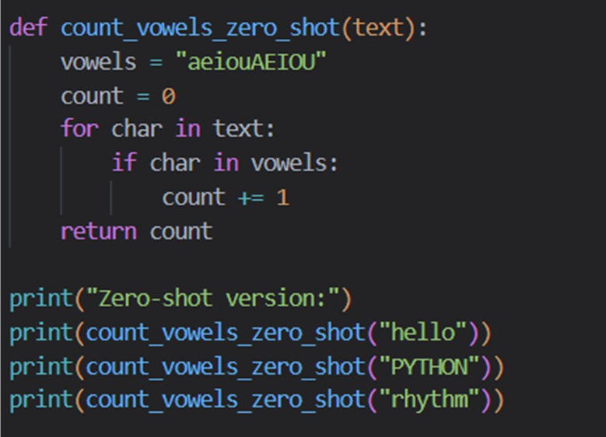

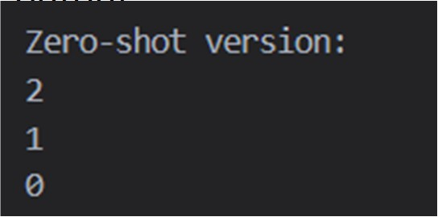
Few-shot Version
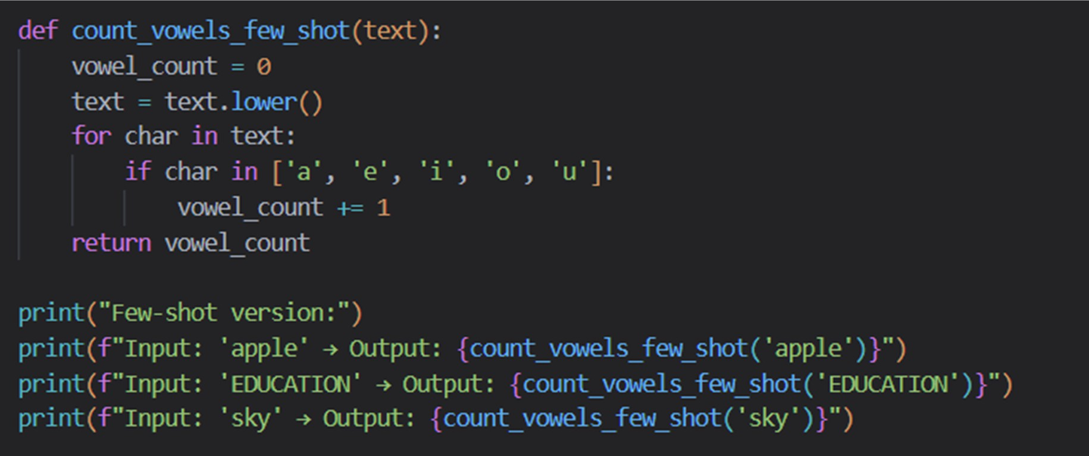

output
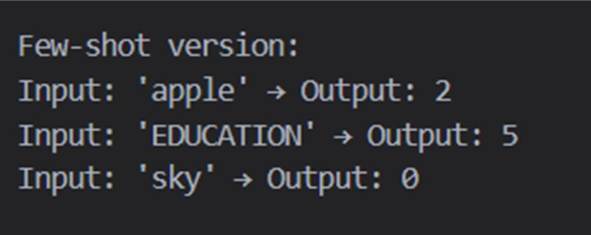

Task 5: Few-shot Minimum of Three Numbers
prompt : Write a Python function that determines the minimum of three numbers without using the built-in min() function
