SIMATS ENGINEERING
ASSESSMENT TOOL 3
COURSE NAME: DESIGN AND ANALYSIS OF ALGORITHMS
COURSE CODE: CSA0613
NAME: Sree Laksha S V
REGNO:192421108
CO2-AT3
Q35. Debugging Closest Pair Code (Comparison with Wrong Variable)
Aim
To debug the given brute-force Closest Pair algorithm, identify the logical error in the comparison statement, correct the implementation, optimize the code by reducing unnecessary tuple indexing, analyze the time complexity, and provide the final commented program.

1. Introduction
The Closest Pair Problem is a computational geometry problem in which we are given a set of points on a two-dimensional plane. The objective is to determine the pair of points having the minimum Euclidean distance between them.
The brute-force approach compares every possible pair of points and keeps track of the smallest distance found.

2. Given Incorrect Python Program
import math
def closest_pair(points):
min_dist = float('inf')
for i in range(len(points)):
for j in range(i+1, len(points)):
x1, y1 = points[i]
x2, y2 = points[j]
dist = math.sqrt((x1-x2)**2 + (y1-y2)**2)
if dist < i: # ERROR
min_dist = dist
return min_dist

3. Error Analysis
The major logical error is:
if dist < i:
This is wrong because
- dist stores the Euclidean distance between two points.
- i is simply the loop index (0,1,2,3,...).
The algorithm should compare the newly calculated distance with the smallest distance found so far, not with the loop variable.
For example, Suppose
Distance = 4.2, Loop index i = 3
Comparison becomes
4.2 < 3
which is False.
Even if
Minimum distance = 10
the algorithm will never update it because it is comparing with 3 instead of 10.
As a result, the smallest distance is not stored correctly.

4. Correct Logic
The comparison should be
if dist < min_dist:
min_dist = dist
Now,
- Initially
min_dist = infinity
- First calculated distance is always smaller than infinity.
- Every new distance is compared with the smallest distance found so far.
- If smaller, update the minimum distance.
This guarantees the correct answer.
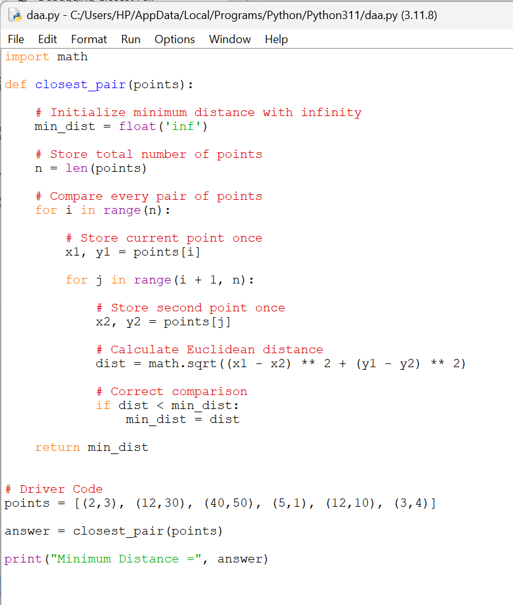
5. Optimized Python Program
6. Sample Output
Minimum Distance = 1.4142135623730951
The closest points are
(2,3)
(3,4)
Distance
√((3−2)²+(4−3)²)
= √(1+1)
= √2
= 1.414
Output Screenshot:
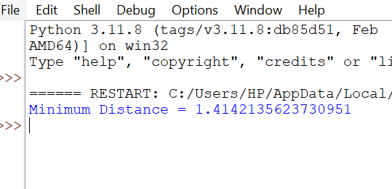

9. Optimization Performed
The original code repeatedly accessed:
points[i][0]
points[i][1]
points[j][0]
points[j][1]
inside the nested loops.
Instead, we store the coordinates once:
x1, y1 = points[i]
x2, y2 = points[j]
Similarly, in C:
int x1 = points[i][0];
int y1 = points[i][1];

int x2 = points[j][0];
int y2 = points[j][1];
Benefits
- Fewer array accesses.
- Cleaner and more readable code.
- Slightly improved efficiency.
- Easier debugging.

10. Time Complexity Analysis
Let n be the number of points.
The outer loop runs:
n times
The inner loop runs approximately:
n-1
n-2
...
1
Total comparisons:
n(n−1)/2
Therefore,
Time Complexity:
O(n²)
because every pair of points is examined exactly once.
Space Complexity:
O(1)
Only a few variables are used regardless of the number of points.

11. Debugging Summary
Issue | Incorrect Code | Correct Code
Comparison | if dist < i | if dist < min_dist
Problem | Compared distance with loop index | Compared with smallest distance found so far
Result | Minimum distance not updated correctly | Correct minimum distance maintained

12. Conclusion
The original program contained a logical error where the computed distance was compared against the loop variable i instead of the current minimum distance. This prevented the algorithm from preserving the smallest distance correctly. After replacing the condition with if (dist < min_dist) and optimizing coordinate access by storing point values in local variables, the brute-force algorithm correctly computes the closest pair. The corrected implementation examines every unique pair of points, requires O(n²) time and O(1) extra space, and produces the correct minimum Euclidean distance.

