1. How to create Series with nd array

import pandas as pd

import numpy as np

arr=np.array([10,14,18,22])

s = pd.Series(arr)

print(s)

output:

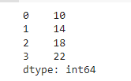

1. How to create Series with Mutable index

import pandas as pd

import numpy as np

arr=np.array(['a','e','c','d'])

s=pd.Series(arr,index=['first','second','third','fourth'])

print(s)

output:

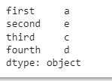

1. Creating a series from a Dictionary

import pandas as pd

d ={'Name' : 'Hardik', 'Iplteam' : 'MI','Runs' : 1500}

s = pd.Series(d)

print(s)

output:

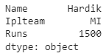

1. Print all the values of the Series by multiplying them by 2.

import pandas as pd

s=pd.Series([1,2,3,4,5])

print('To Multiply all values in a series by 2')

print('..............................')

print(s*2)

print('To find the Square of all the values in a series')

print('................................')

print(s**2)

print('To print all the values in a series that are greater than 2')

print('.................................')

print(s[s>2])

output:

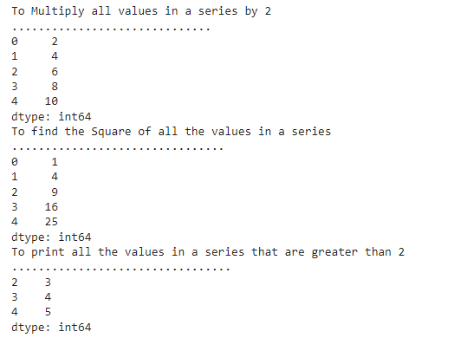

1. Print Square of all the values of the series.

import pandas as pd

s1=pd.Series([10,15,18,22,55,77,42,48,97])

s = pd.Series(arr)

print (s.head())

print(s.head(3))

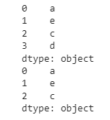

1. Print all the values of the Series that are greater than2

import pandas as pd

s=pd.Series([1,2,3,4,5])

print('To print all the values in a series that are greater than 2')

print('.................................')

print(s[s>2])

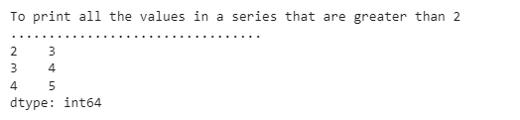

1. Addition of two series

import pandas as pd

s1=pd.Series([1,2,3,4,5],index=['a','b','c','d','e'])

s2=pd.Series([10,20,30,40,50],index=['a','b','c','d','e'])

s3=pd.Series([5,14,23,32],index=['a','b','c','d'])

print('To Add Series1 $ series2')

print('..........................')

print(s1+s2)

print('To add series2 & series3')

print('...........................')

print(s2+s3)

print('To add Series2 & Series3 and filled Non matching index with 0')

print('................................')

print(s2.add(s3,fill_value=0))

output:

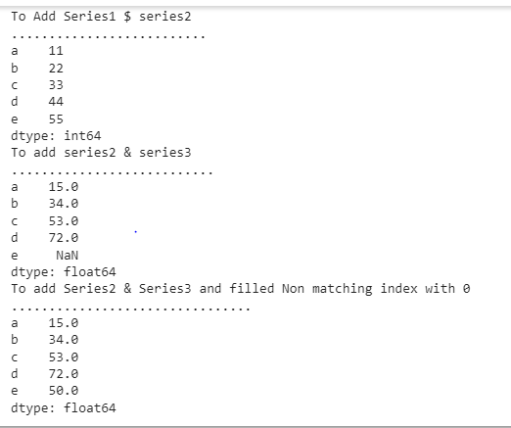

1. Print the first and last 5 elements of a series

import pandas as pd

import numpy as np

arr=np.array([10,15,18,22,55,77,42,48,97])

s = pd.Series(arr)

print (s.tail())

print(s.tail(5))

output:

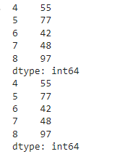

1. Print the values from index 0 to 5

import pandas as pd

import numpy as np

arr=np.array([10,15,18,22,55,77])

s = pd.Series(arr)

print(s.loc[:5])

output:

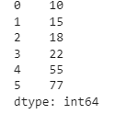

1. Selection Using loc, iloc index label

import pandas as pd

import numpy as np

arr=np.array([10,15,18,22,54,77])

s = pd.Series(arr)

print(s.iloc[:4])

output:

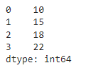

1. Retrieve subsets of data using slicing

import pandas as pd

import numpy as np

arr=np.array([10,15,18,22,55,77])

s = pd.Series(arr,index=['A','B','C','D','E','F'])

print(s[1:5:2])

output:



**Q2 Dataframe**

1. create Dataframe From Series

import pandas as pd

s = pd.Series(['a','b','c','d'])

df=pd.DataFrame(s)

print(df)

output:



1. DataFrame from List of Dictionaries

import pandas as pd

name=pd.Series(['Hardik','Virat'])

team=pd.Series(['MI','RCB'])

dic={'Name':name,'Team':team}

df=pd.DataFrame(dic)

print(df

output:

