**Name: SREELAKSHMI M NAIR**

**Roll No: 46**

**Batch: B**

**Date: 02-06-2022**

**NETWORKING & SYSTEM ADMINISTRATION LAB**

**Experiment No.: 20**

**Aim**

NETCAT Installation.

1. **Install**

To install netcat on Ubuntu.

Syntax: $ sudo apt-get install netcat

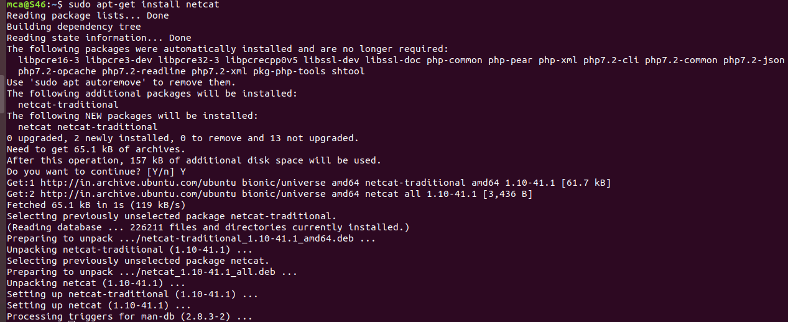

1. **sudo nc -l -p 1234**

To send message from one console and receive from another console by an advanced packet analyser.

Syntax: $ nc -l -p 1234

$ nc <ip address>

**Output:-**

C:\Users\Student\Downloads\a2.1.png

**C:\Users\Student\Downloads\a2.1.png**