**NETWORKING & SYSTEM ADMINISTRATION LAB**

**Name: Sreelakshmi M Nair**

**Roll No: 40**

**Batch: B**

**Date: 04/04/2022**

**Experiment No.: 28**

**Aim**

Build and install software from source code, familiarity with make and cmake utilities expected.

**Procedure**

**Step 1** : Create a Shell Script

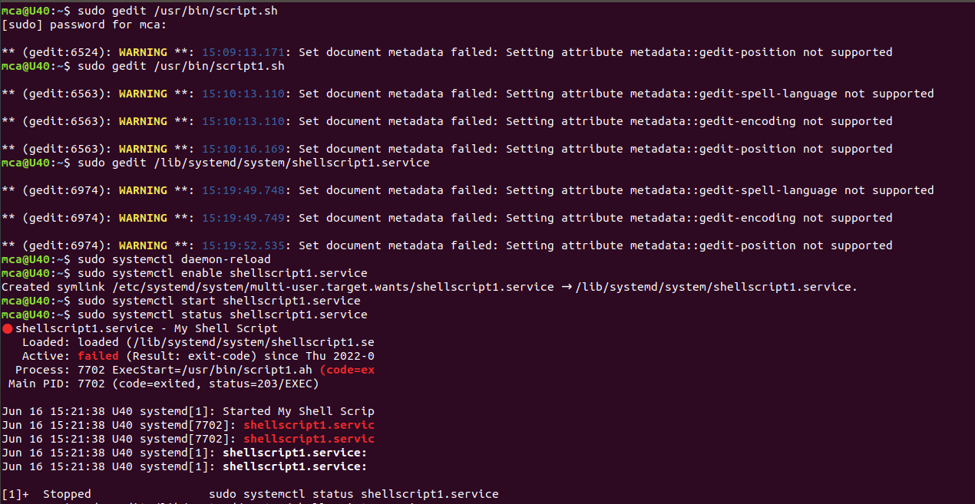

Add the following sample script.

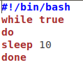

Save script and set execute permission.

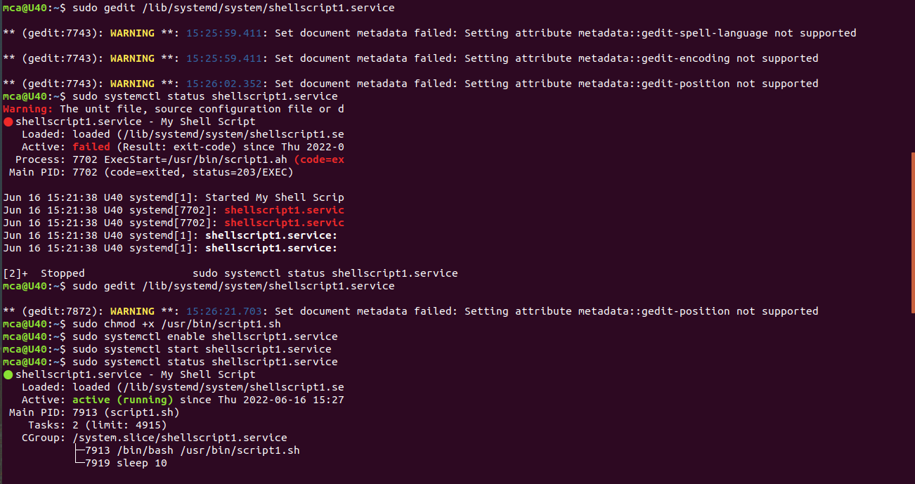

## Step 2: Create A SystemD File, and  add the following content and update the script filename and location. You can also change the description of the service.

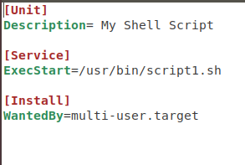

## Step 4: Enable New Service



