**NETWORKING & SYSTEM ADMINISTRATION LAB**

**Name: SREELAKSHMI M NAIR**

**Roll No: 40**

**Batch: B**

**Date: 06/06/2022**

**Experiment No.: 23**

**Aim**

Install and use the latest version of Wireshark on Ubuntu.

**Procedure**

**Step 1** : First update APT package repository.

Syntax: $ sudo apt update

**Output:**

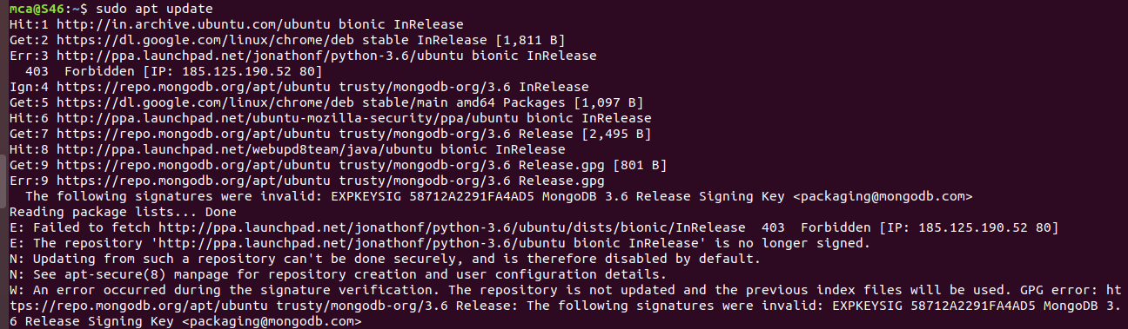

**Step 2** : Install wireshark

Syntax: $ sudo apt install wireshark

Now press **y** and then press **Enter.**

**Output:**

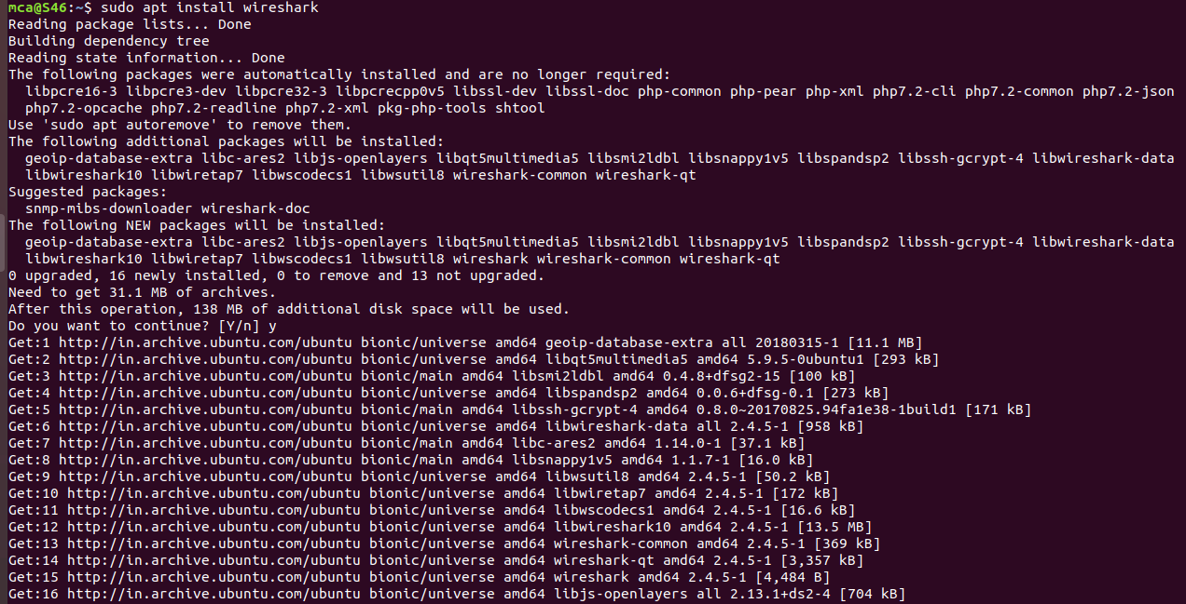

**Step 3** : By default, Wireshark must be started as **root** privileges in order to work. If you want to run Wireshark without **root** privileges or without **sudo**, then select **Yes** and press **Enter**.

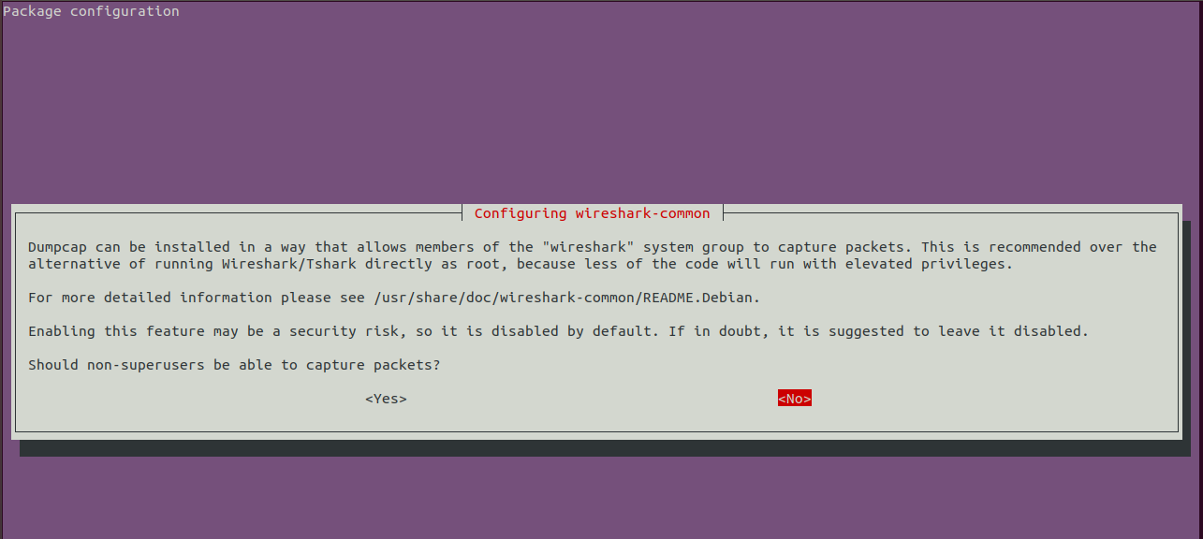

Wireshark should be installed.

**Step 4** : To add user to the wireshark group:

Syntax: sudo adduser $mca wireshark

**Output:**



**Step 5** : Now that Wireshark is installed, you can start Wireshark from the **Application Menu** of Ubuntu.

If you did not enable Wireshark to run without **root** privileges or **sudo**, then the command should be:

Syntax: sudo wireshark



Wireshark should start.

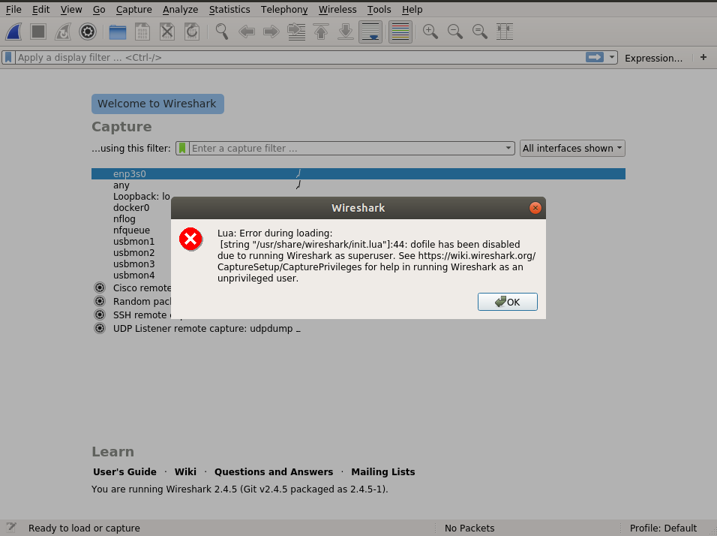

When we start Wireshark, you will see a list of interfaces that you can capture packets to and from.

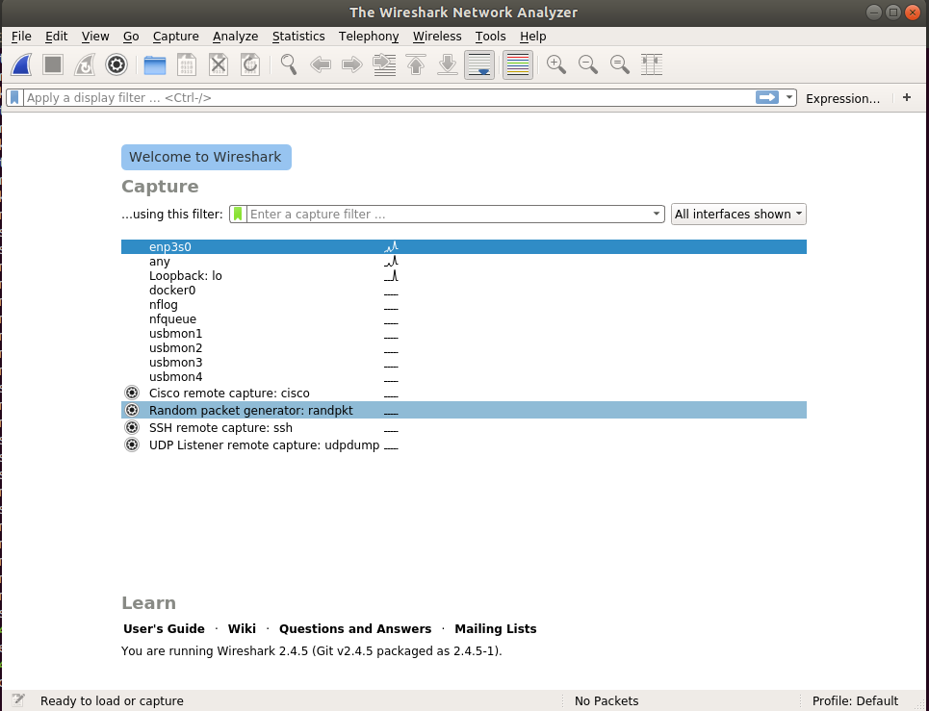

Now to start capturing packets, just select the interface and click on the **start capturing packets** icon above.

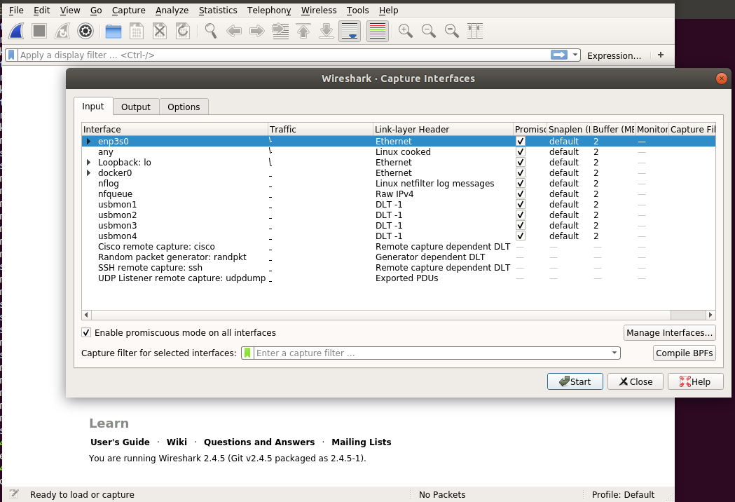

We can capture packets on any network interface.

