**NETWORKING & SYSTEM ADMINISTRATION LAB**

**Name: Sreelakshmi M Nair**

**Roll No: 40**

**Batch: B**

**Date: 23/05/2022**

**Experiment No.: 19**

**Aim**

Docker Installation.

**Procedure**

**Step 1:**  Open the terminal on Ubuntu.

**Step 2:** Remove any docker files that are running in the system, using the following

command:

$ sudo apt-get remove docker docker-engine docker.io

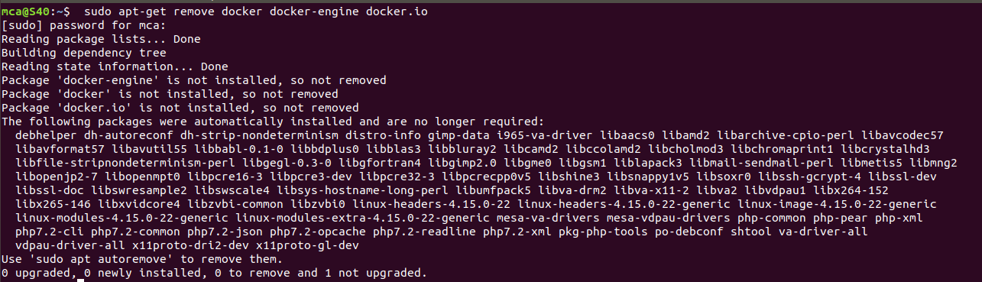

**Step 3:** Check if the system is up-to-date using the following command:

$ sudo apt-get update

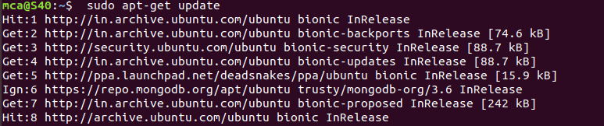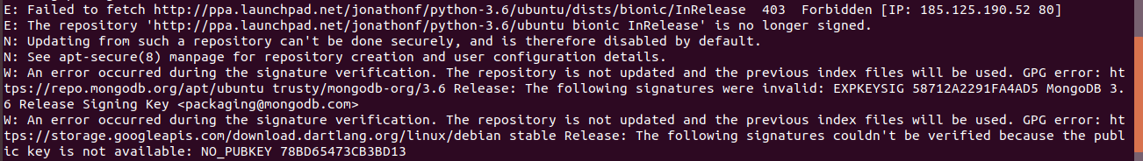

**Step 4:** Install Docker using the following command:

$ sudo apt install docker.io

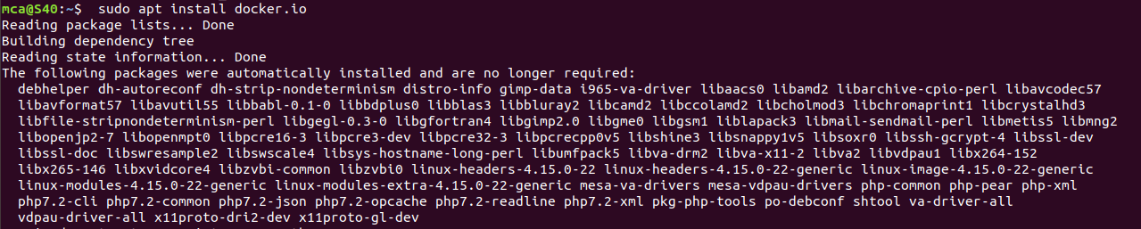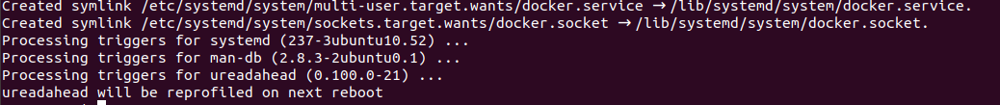

Step 5: Install all the dependency packages using the following command:

$ sudo snap install docker



Step 6: Before testing Docker, check the version installed using the following command:

$ docker –version



Step 7: Pull an image from the Docker hub using the following command:

$ sudo docker run hello-world

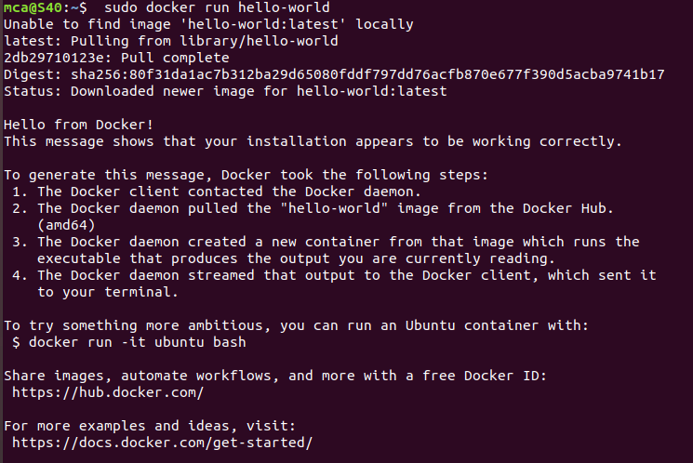

Step 8: Check if the docker image has been pulled and is present in your system using

the following command:

$ sudo docker images



Step 9: To display all the containers pulled, use the following command:

$ sudo docker ps -a



**Step 10:** To check for containers in a running state, use the following command:

$ sudo docker ps

