**Name: Sreelakshmi M Nair**

**Roll No: 40**

**Batch: B**

**Date: 31/03/2022**

**NETWORKING & SYSTEM ADMINISTRATION LAB**

**Experiment No.: 3**

**Aim**

Familiarization of the linux commands.

**Procedure**

**26.cut -d**

This command is used to cut and display the content based on the delimiter given.

Syntax :- $ cut –d delimiter –fieldnumber filename

Output :-

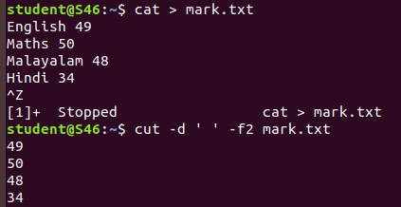

**27. cut -b**

This command is used tocut and display the content based on the specified byte number.

Syntax :- $ cut –b bytenumber filename

Output :-

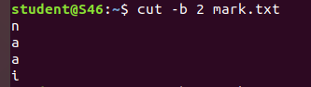

**28. cut --complement -c**

This command is used to erase the specified character and display the remaining content of the file.

Syntax :- $ cut --complement –c characternumber filename.txt

Output :-

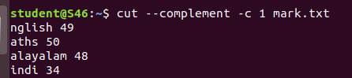

**29. paste**

This command is used to paste the contents from the specified file.

Syntax :- $ paste filename

Output :-

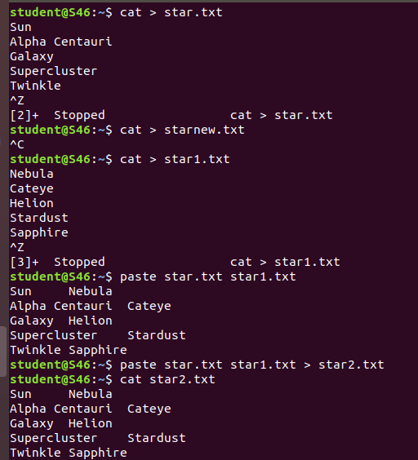

**30. paste file1 file2 > file3**

This command is used to paste the contents from the specified files to another file.

Syntax :- $ paste file1 file2 > file3

Output:-



**31. paste -s**

This command is used to paste the contents sequentially. It reads all the lines from the file and merges all these lines into a single linewith each line separated by tab.

Syntax :- paste –s file1 file2

Output :-

C:\Users\MyPc\Documents\Swetha\paste -s.png

**32. paste -d**

This command is used to paste the contents from the given files with the delimiter given.

Syntax :- $ paste –d delimiter file1 file2

Output :-

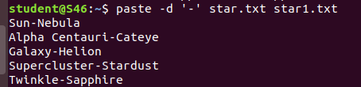

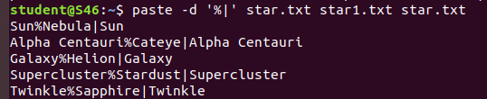

**33. more**

This command is used to view the text files in the command prompt, displaying one screen at a time in case the file is large.

Syntax :- $ more filename

Output :-

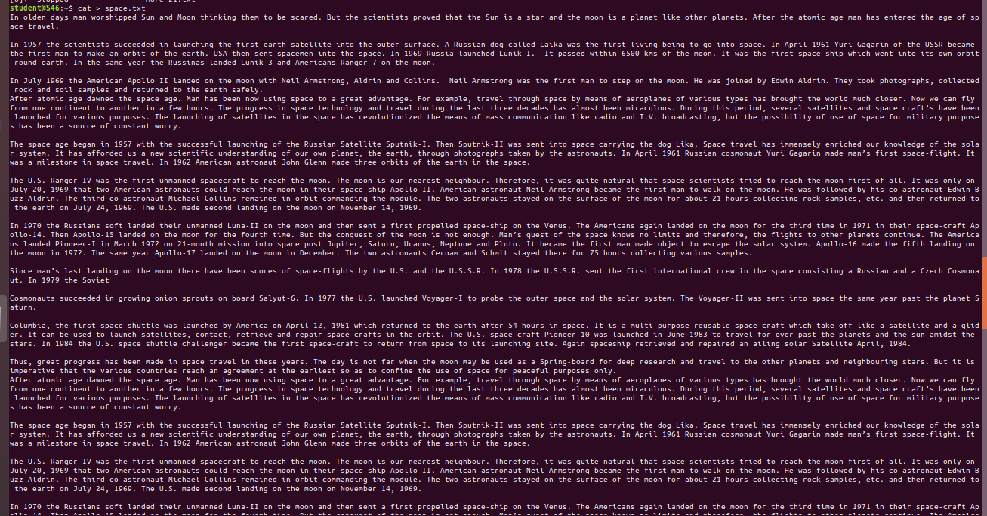

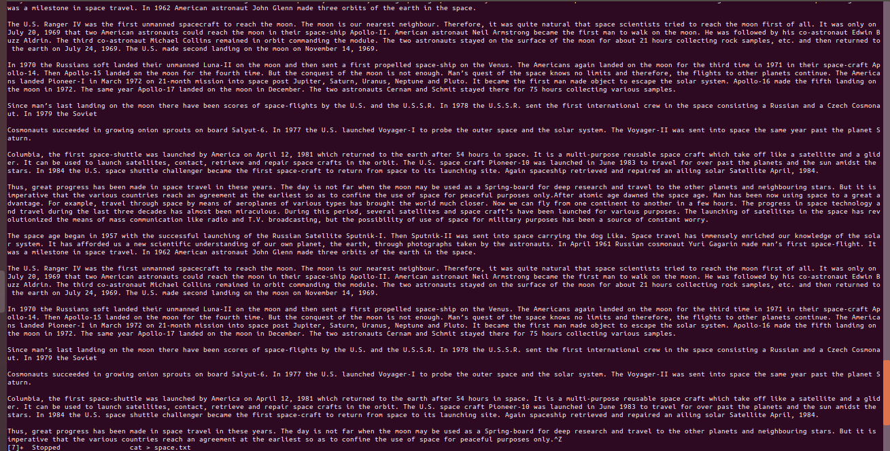

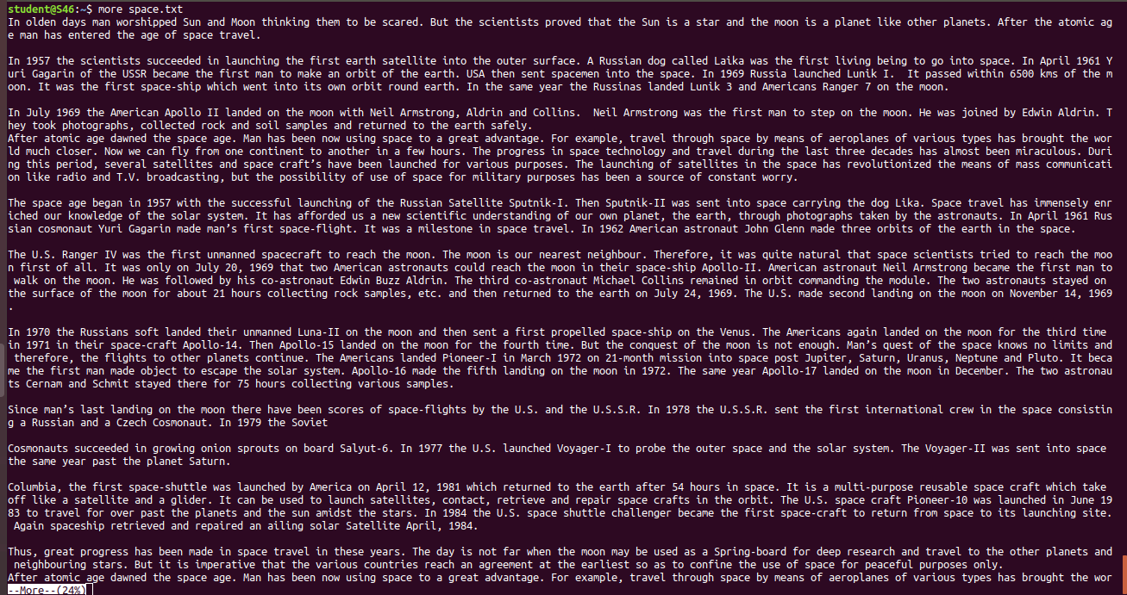

**34. more -number**

This command is used to display display the lines to the specified number from head.

Syntax :- $ more -number

Output :- 

**35. more +number**

This command use the line number from where we want to displaying the text content.

Syntax :- $ more +number

Output :-

