**Name: Sreelakshmi M Nair**

**Roll No: 40**

**Batch: B**

**Date: 25/04/2022**

**NETWORKING & SYSTEM ADMINISTRATION LAB**

**Experiment No.: 7**

**Aim**

Familiarization of the linux commands.

**Procedure**

**1. sudo useradd**

This command is used to add new user.

Syntax :- $ sudo useradd username

Output :-



**2. sudo passwd**

This command is used to add password to the user.

Syntax :- $ sudo passwd username

Output :-

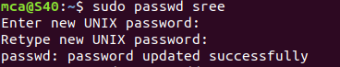

**4. sudo usermod**

This command is used to add members.

Syntax :- $sudo usermod -G groupname username

Output :-



**7. delete**

**sudo userdel username -** used to delete user.

**sudo groupdel groupname -** used to delete group name.

Syntax :- $  **sudo userdel username**

$ **sudo groupdel groupname**

Output :-





**9. chmod**

This command is used change directory permission of files.

**chmod +rwx**

**chmod -wx**

**chmod -rwx**

Syntax :- $ chmod +wx filename

$ chmod -wx filename

$ chmod -rwx filename

Output :-

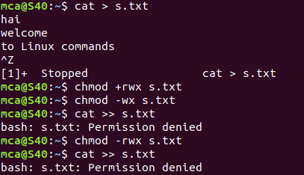

**10. chown**

This command is used to give ownership to user .

Syntax :-

$ sudo chown username filename

Output :-

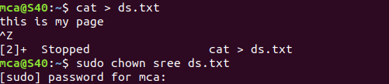

**11. ls -l**

This command is used to show the ownership details of particular file.

Syntax :-

$ ls -l filename.txt

Output :-



**12. ssh**

This command is used to provide a secure encrypted connection between two hosts over an insecure network.

Syntax :-

$ ssh mca@ipaddress

Output :-

