**Name: Sreelakshmi M Nair**

**Roll No: 40**

**Batch: B**

**Date: 21/04/2022**

**NETWORKING & SYSTEM ADMINISTRATION LAB**

**Experiment No.: 6**

**Aim**

Familiarization of the linux commands.

**Procedure**

**1. read**

This command is used to read the content of a line to a variable.

Syntax :- $ read variablename

Output :-





**2. locate**

This command is used to locate a file/particular directory.

Syntax :- $ locate filename.txt

Output :-



**3. locate -i**

This command is used to ingore case sensitivity of the specified pattern.

Syntax :- $ locate -i filename.txt

Output :-



**4. find**

This command is used to display contents of particular directory.

Syntax :- $ find filename.txt

Output :-



**5. grep**

This command will let you search through all the text in a given file.

Syntax :- $ grep word filename.txt

Output:-



**grep -i**

command used for a case insensitive search

Syntax: $ grep -i filename.txt

Output:



**grep -v**

command used for inverted search.

Syntax: $ grep -v filename.txt

Output:

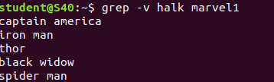

**grep -A1**

command used to display line after the result.

Syntax: $ grep -A1 filename.txt

Output:



**grep -B1**

command used to display line before the result.

Syntax: $ grep -B1 filename.txt

Output:



**grep -C1**

command used to display line before and after the result.

Syntax: $ grep -C1 filename.txt

Output:

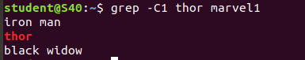

**6. def**

This command is used to get a report on system disc space usage.

Syntax :- $ def filename.txt

Output :-



**7. df -m**

This command is used to see the report in mega bytes.

Syntax :- $ def -m filename.txt

Output :-



**8. du**

This command is used to check how space a file or directory takes

Syntax :- $ du filename.txt

Output :-



**9. wc -word count**

This command is used for counting purpose which is used to find the number of lines,the number of words,the number of characters and the number of bytes.

**wc -l** (count number of lines)

**wc -w** (count number of words)

**wc -c** (count number of characters)

**wc -m** (count number of bytes)

Syntax :- $ wc -l filename.txt

$ wc -w filename.txt

$ wc -c filename.txt

$ wc -m filename.txt

Output :-

