**Name: Sreelakshmi M Nair**

**Roll No: 40**

**Batch: B**

**Date: 05/05/2022**

**NETWORKING & SYSTEM ADMINISTRATION LAB**

**Experiment No.: 8**

**Aim**

write shell script to print details

**Program**

#!/bin/bash

echo "enter your name"

read name

read $name

echo "course of studing"

read course

echo $course

echo "year of studing"

read yr

echo $yr

echo "entered details is:"

echo $name $course $yr

**Output:**

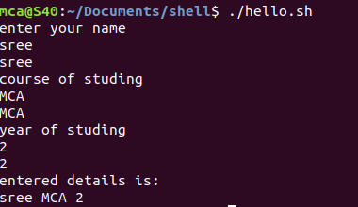

**Aim**

write shell script to find largest of two numbers

**Program**

#!/bin/bash

echo "Enter the first number"

read a

echo "enter the second number"

read b

if [ $a -gt $b ]

then

echo $a" is largest"

else

echo $b "is largest"

fi

**Output:**

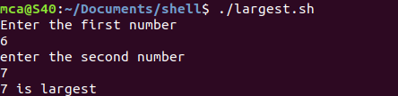

**Aim**

write shell script to find largest of three numnbers

**Program**

#!/bin/bash

echo "Enter the first number"

read a

echo "enter the second number"

read b

echo "enter the second number"

read c

if [ $a -gt $b ] && [ $a -gt $c]

then

echo $a" is largest"

elif [ $b -gt $c ] && [ $b -gt $c]

then

echo $b "is largest"

else

echo $c "is largest"

fi

**Output:**

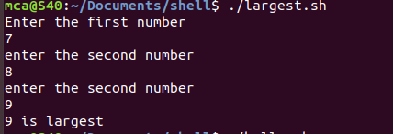

**Aim**

write shell script to print sum of two numbers

**Program**

#!/bin/bash

echo "Enter the first number"

read num1

echo "enter the second number"

read num2

sum=$(($num1+$num2))

echo "the sum is:"$sum

**Output:**

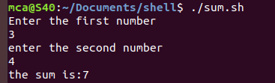

**Aim**

write shell script to print number is even or odd

**Program**

#!/bin/bash

echo "Enter the first number"

read a

r=$(($ % 2))

if [ $r == 0 ]

then

echo "number is even"

else

echo "number is odd"

fi

**Output:**

