Hackathon: AtomQuest — Real-Time Video Support Platform

AssistLens — Login Credentials & Architecture
Project: AssistLens — Real-Time Video Support Platform
Repository: https://github.com/SreeRag1907/AssistLens

1. Demo URLs
Service | URL
Web application (primary demo URL) | https://assist-lens.vercel.app/
REST API | https://assistlens-api.onrender.com
LiveKit WebSocket (browser) | wss://livekit-server-production-46a6.up.railway.app/
MinIO (object storage) | https://hopeful-consideration-production-1b98.up.railway.app

2. Login credentials

Agent (support staff)
Field | Value
Email | agent@assistlens.dev
Password | demo-agent-pass

Capabilities: Create/end sessions, join calls, share invite links, start/stop recording, view own session history.

Admin (operations)
Field | Value
Login page | https://assist-lens.vercel.app/admin/login
Email | admin@assistlens.dev
Password | demo-admin-pass

Capabilities: View all agents' sessions, participant lists, event logs, recordings; forcibly end any active session.

Customer (end user)
Field | Value
Access | Short invite link only — e.g. {WEB_URL}/j/xk9m2pqa
Account | None required
Flow | Open link → pre-join camera/mic check → Join now

Customers receive the invite link from the agent (copy, SMS, or branded email).

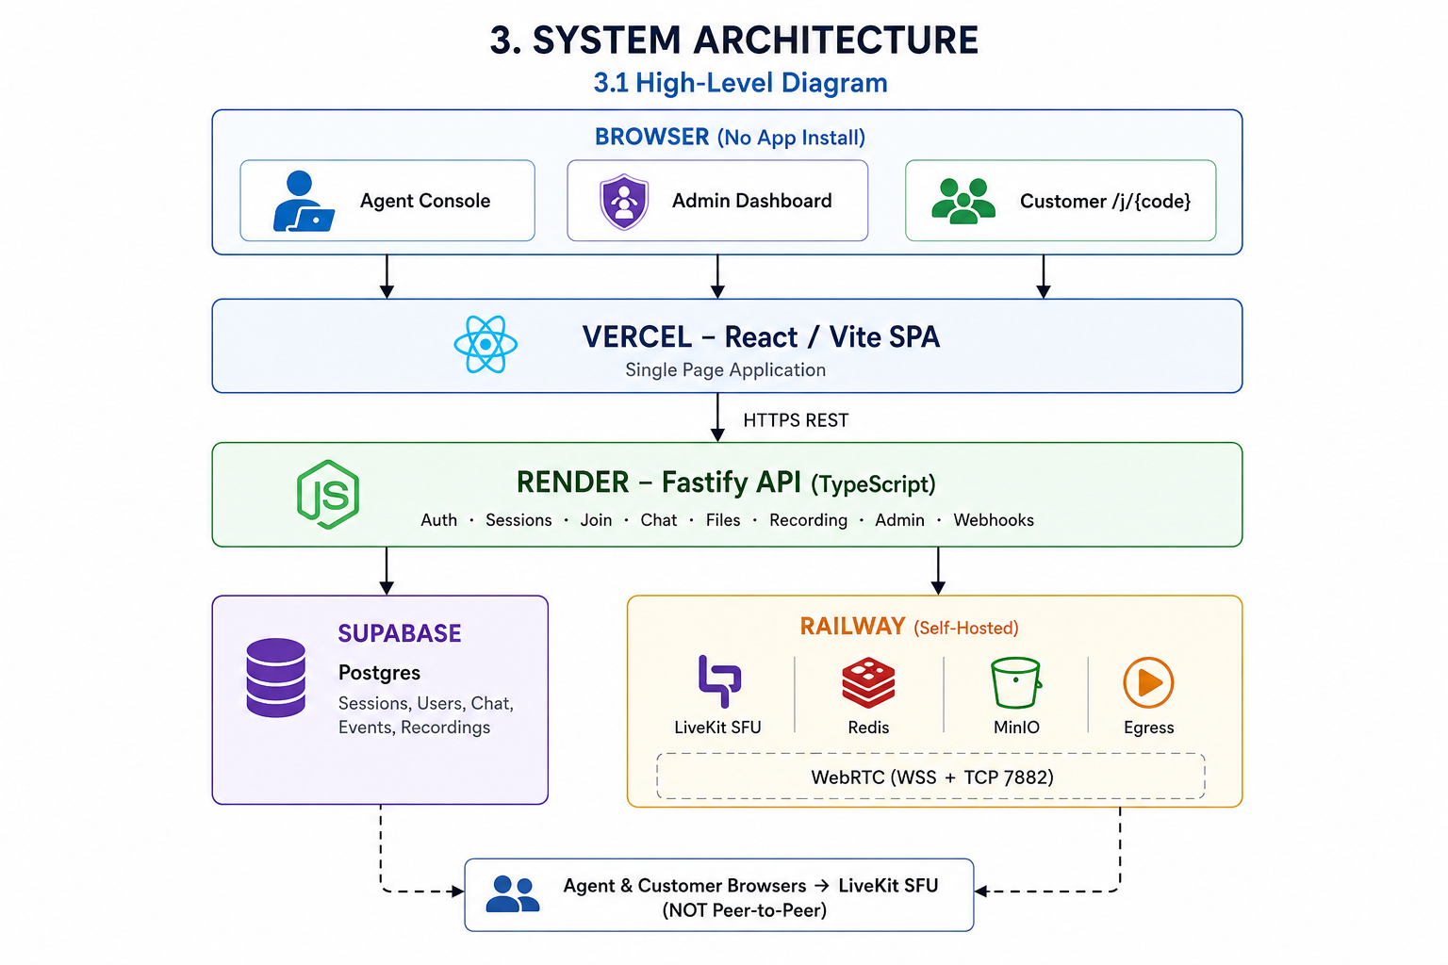

3.2 Media routing (compliance)
- Not P2P: All audio/video flows through our self-hosted LiveKit SFU container.
- Not a hosted video API: LiveKit Server + Egress run in our Railway containers — not LiveKit Cloud, Twilio, Daily, etc.
- Signaling: Browser ↔ LiveKit WebSocket (wss://)
- Media: WebRTC via SFU; Railway TCP proxy on port 7882 for ICE

3.3 Recording pipeline
- Agent clicks Record → API calls LiveKit Egress API
- Egress worker (Chrome composite) joins room via Redis job queue
- On stop → MP4 uploaded to MinIO
- LiveKit webhook → API updates recording status to ready
- Agent downloads MP4 from session detail

3.4 Deployment map
Layer | Provider | Service name
Frontend | Vercel | React SPA
Backend API | Render | assistlens-api
Database | Supabase | PostgreSQL
LiveKit SFU | Railway | livekit-server
Redis | Railway | Redis plugin
Object storage | Railway | minio
Recording | Railway | egress

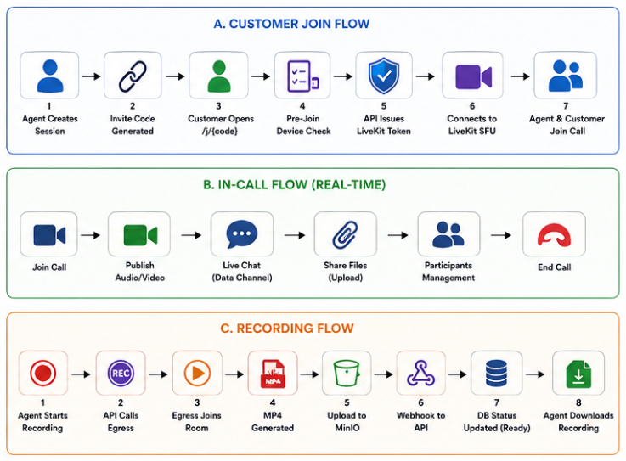

4. Data flow — customer join
- Agent creates session → API inserts row + short invite_code
- Agent shares /j/{code}
- Customer opens link → GET /api/invite/:code validates session
- Customer submits name → POST /api/join → API mints scoped LiveKit token
- Customer connects to LiveKit SFU and publishes camera/mic
- LiveKit webhook → API records participant_joined in Postgres
- Agent receives customer's media stream from SFU (not directly from customer browser)

5. Security & access control
Actor | Credential | LiveKit grants
Agent | JWT (Bearer) | publish, subscribe, room admin
Admin | Separate JWT | API admin routes only
Customer | Invite code → scoped token | publish, subscribe only

6. Observability
- Health: GET https://assistlens-api.onrender.com/api/health
- Metrics: GET https://assistlens-api.onrender.com/api/metrics (Prometheus format)

7. Notes for judges
- Full setup instructions: repository README.md
- Railway infra guide: infra/railway/README.md
- If demo login fails, verify Render env vars AGENT_EMAIL, AGENT_PASSWORD, ADMIN_EMAIL, ADMIN_PASSWORD match this document.

AssistLens — Self-hosted visual customer support

