Alphadynamic Test Assignment

Name: V. Sree Sai Bhavesh

Phone No: 9515736045

Email: [saibhavesh8@gmail.com](mailto:saibhavesh8@gmail.com)

**YouTube Analysis**

**Dataset:** <https://drive.google.com/file/d/16B8mnWqbq1UMNug34xrqtVdi75Qw0w6N/view?usp=sharing>

**Colab Link:**

<https://drive.google.com/file/d/146nMsuKGAlqmzPqyOn0yggn4Z4aZKoz2/view?usp=sharing>

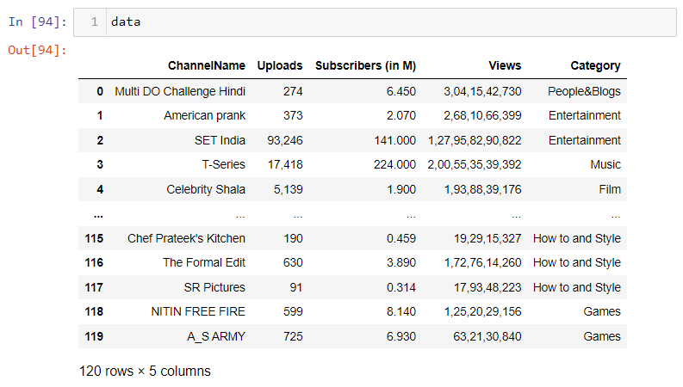

**Different Categories involved with their size in dataset**

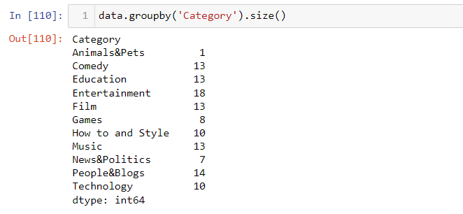

**Highest Subscribers**

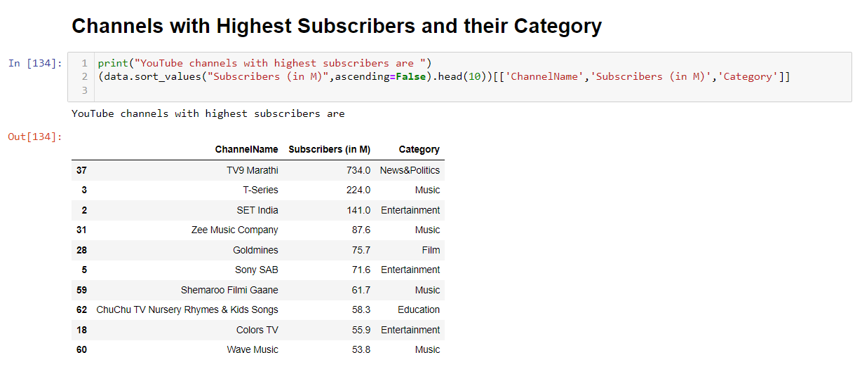

**Highest Views**

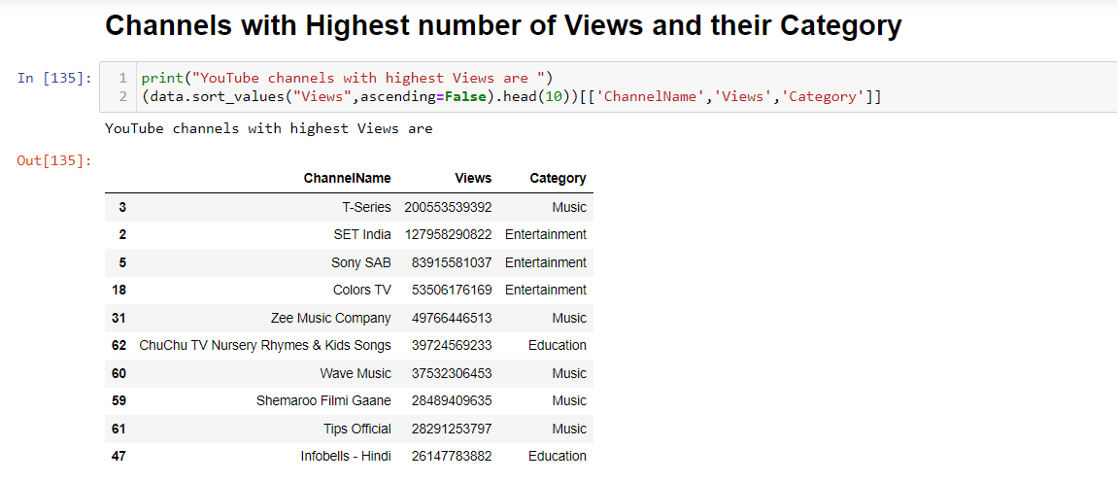

**No of Channels**

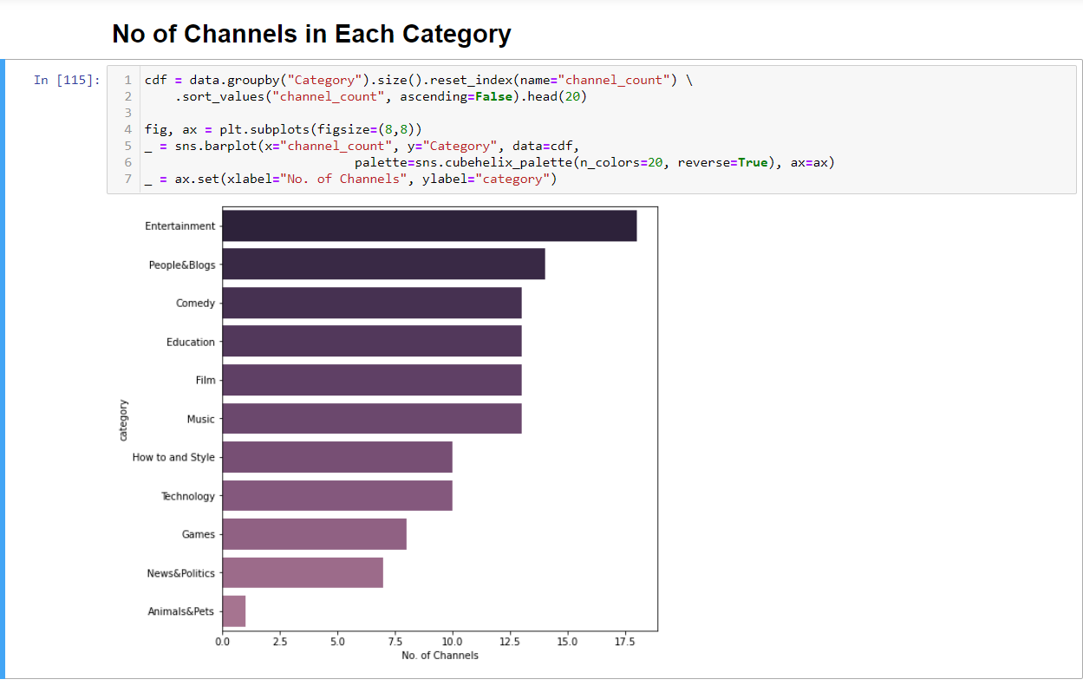

**Category with more Top 20 Subscribers**

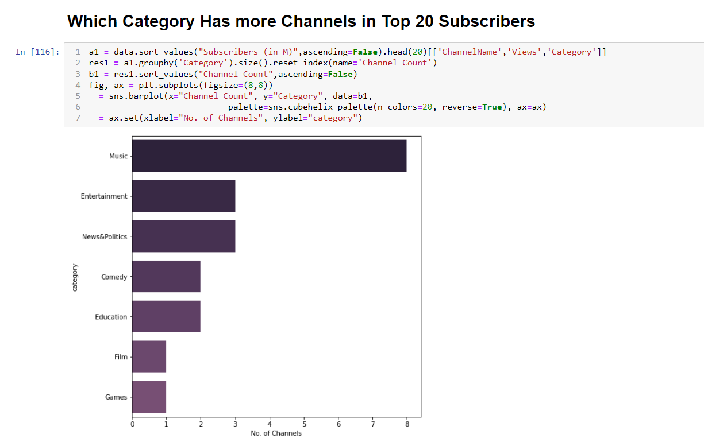

**Category with more Top 20 View Channels**

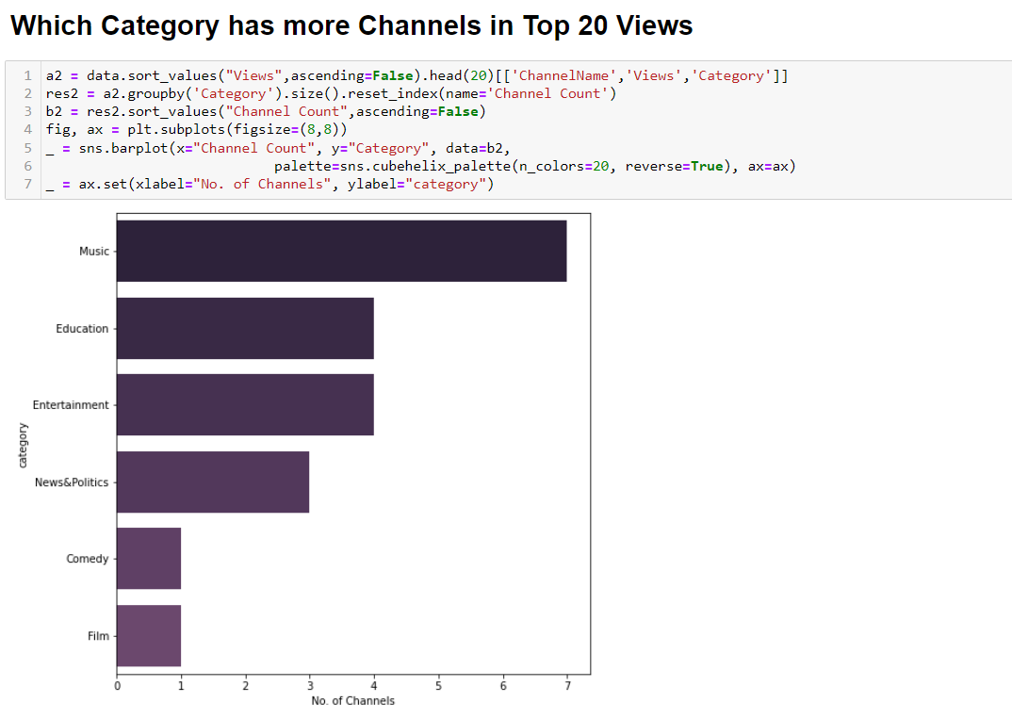

**Top Categories from Top 20 Categories of Views and Subscribers**

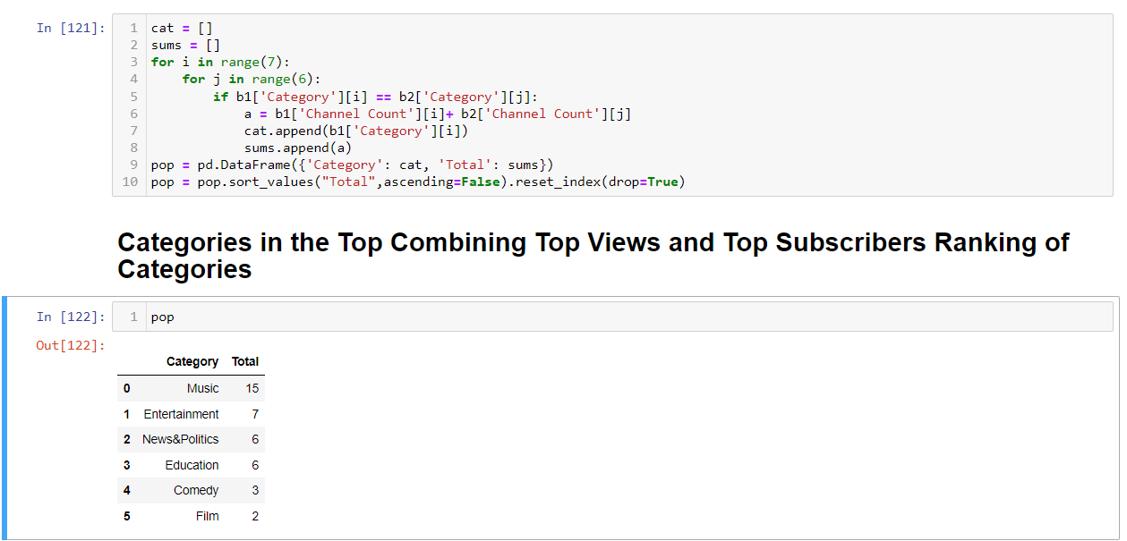

We can see Top 20 Subscribers channel and views channel are different. Now it is hard to decide which channel is most popular. So, for this purpose now we would combine both giving equal importance to both subscribers and views.

No of Views may be large because of large upload of videos by the channel, craze of the video or because of large no of subscribers. Views may be in millions because of its popularity and work by the channel. This need to be justified, and channels with large video would have large no of total views and channels with minimal videos would have small no of total views, it does not mean channel with minimal videos are less popular, so in considering this we need to formulate a solution in finding popular channel. One solution would be dividing total no of views to the total number of uploads, which give average count of views for videos in the channel, and this number could be near to the range of no of subscribers.

Now we would have average views and no of subscribers. We can add them as we are considering both as equal important in knowing the popularity of the channel, and both the numbers would be on the same range. This would help us to get different top 20 channels which are popular on basis on both views and subscribers.

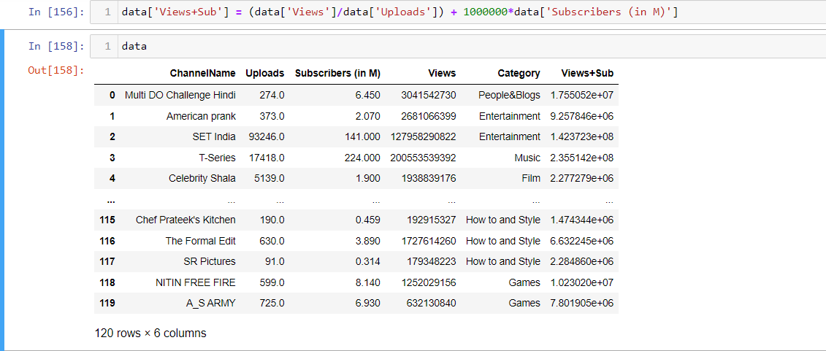

**Sorting rows based on popularity (descending order of Views+Sub):**

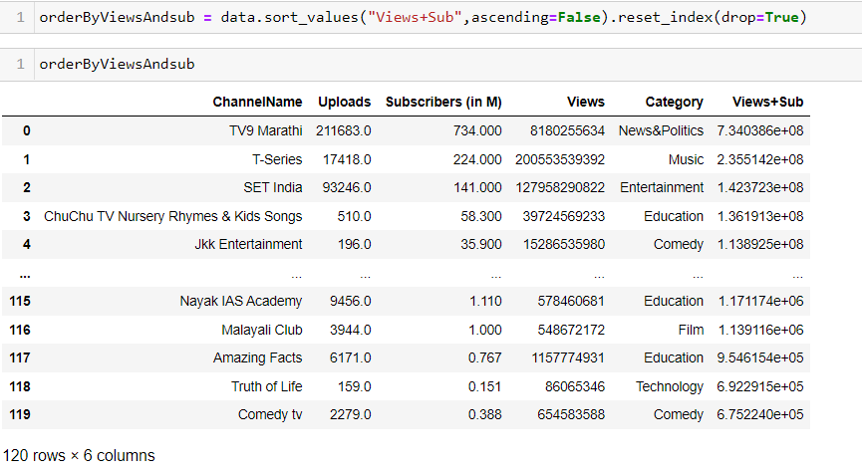

**Now checking Top 20 Channels:**

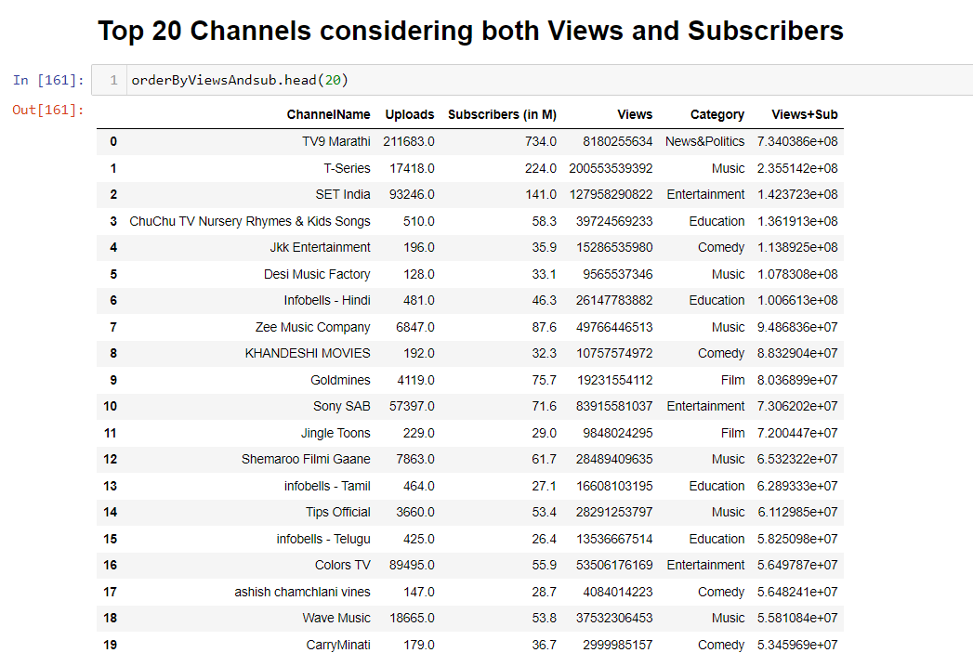

We can see change in order of channels after considering both factors now our new popularity chart does not follow order of solemnly views or subscribers.

The 4th top of the channel with respect to subscribers is Zee Music Company of Music Category but after considering average views as well, its position changed to 7, Similarly Gold mines and other channels as well changed their order.

**Category Ranking Considering Views and Subscriptions**

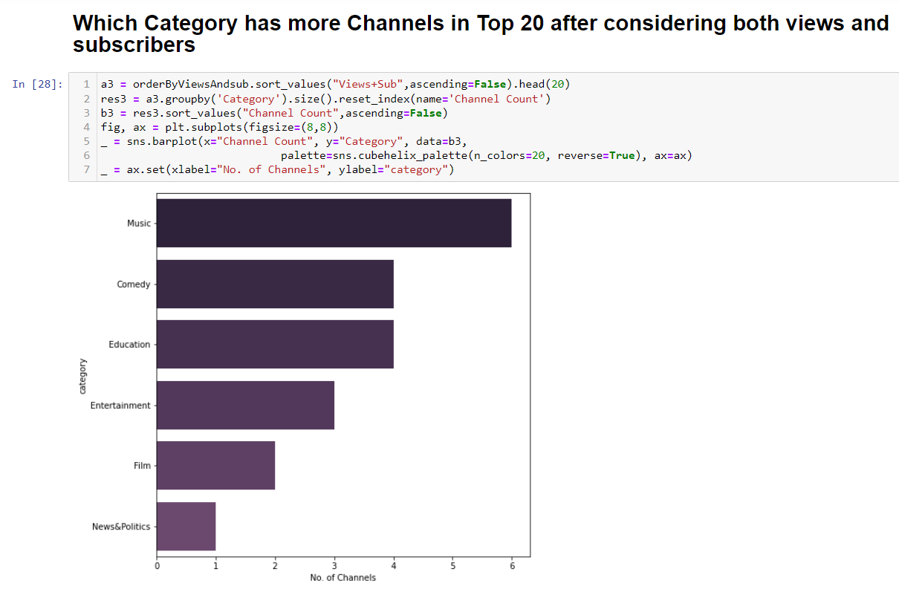

**Google Search Trends:**

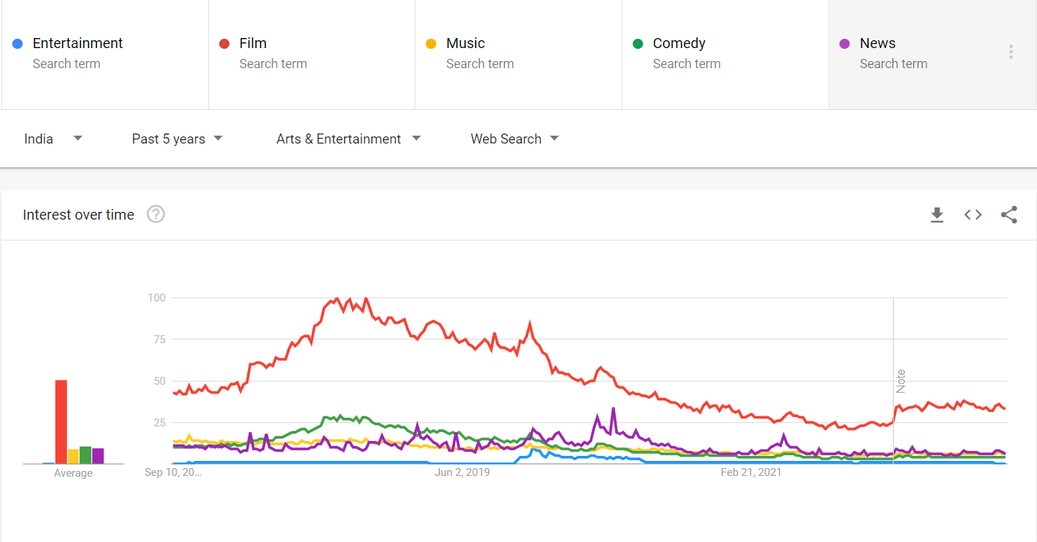

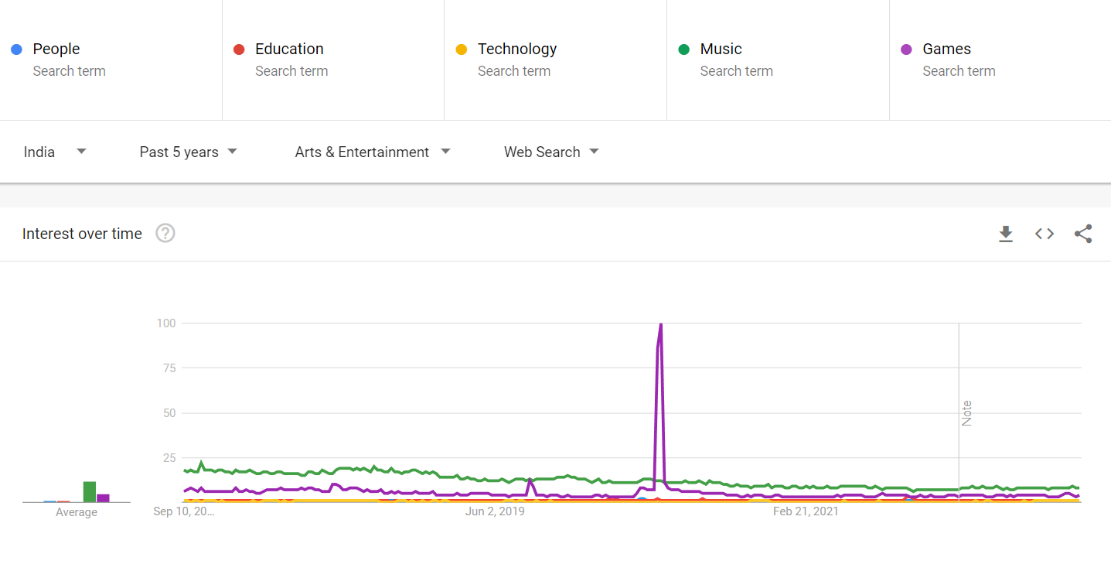

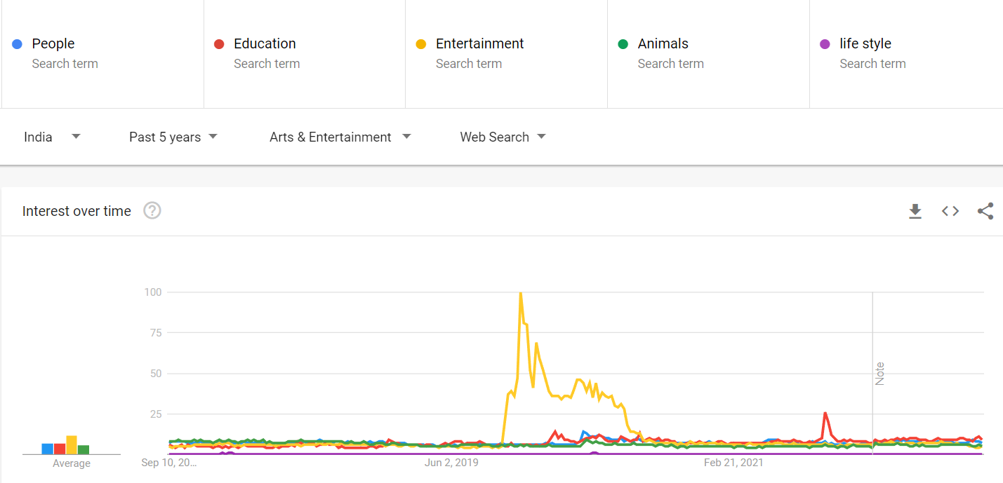

YouTube Channels:

1. **SET India:**

This was a YouTube channel comes under the category Entertainment. According to the YouTube trends this channel is 3rd considering views and Subscribers. 3rd considering only subscribers, 2nd considering only views, and moreover this channel category is 4th most popular category in YouTube considering views and subscriptions.

According to Google trends Entertainment would be 6th most popular search category

1. **T-Series:**

This was a channel comes under Music category. According to YouTube stats music was most popular category and by the google trends it was 4th most popular search category.

1. **TV9 – Marati:**

This was a channel comes under news category. According to YouTube stats it was 6th populous category and by google trends it was 3rd most populous search category.

1. **Jkk Entertainment:**

This was a channel comes under Comedy Category. According to YouTube stats Comedy was 2nd most trending category whereas regarding google trends it was 2nd most populous category.

1. **Info-bells Hindi:**

This was a channel comes under Education Category. According to YouTube stats it was 3rd most popular category, whereas by google trends it was some what less popular holding position of 7-8.