A MAJOR PROJECT REPORT ON

DataSage AI: AI for Deep Data Insights & Exploration
Submitted in partial fulfillment for the award of the degree of
BACHELOR OF TECHNOLOGY
In
Artificial Intelligence and Machine Learning
By
J.S.T. VAMSI KRISHNA (22A81A6122)
T.L.N.V.S.M.L. DHEERAJ (22A81A6160)
DAGULURI RAJU (22A81A6115)
D. PRAGATHI LAKSHMI DEVI (22A85A6116)
N.K. SRI CHAITANYA (22A81A6144)
K. BHAVYA NAGA SRI (22A81A6127)

Under the Esteemed Supervision of
Ms. G. Venkata Lakshmi, M.Tech.
ASSISTANT PROFESSOR

Department of Artificial Intelligence and Machine Learning
SRI VASAVI ENGINEERING COLLEGE (Autonomous)
(Affiliated to JNTUK, Kakinada)
Pedatadepalli, Tadepalligudem - 534101, A.P
2025-2026

SRI VASAVI ENGINEERING COLLEGE (Autonomous)
Department of ARTIFICIAL INTELLIGENCE & MACHINE LEARNING
Pedatadepalli, Tadepalligudem



CERTIFICATE
This is to certify that the Project Report entitled "DataSage AI: AI for Deep Data Insights & Exploration" submitted by J.S.T. VAMSI KRISHNA (22A81A6122), T.L.N.V.S.M.L. DHEERAJ (22A81A6160), DAGULURI RAJU (22A81A6115), D. PRAGATHI LAKSHMI DEVI (22A85A6116), N.K. SRI CHAITANYA (22A81A6144), K. BHAVYA NAGA SRI (22A81A6127) for the award of the degree of Bachelor of Technology in the Department of Artificial Intelligence and Machine Learning during the academic year 2025-26.
Name of Project Guide | Head of the Department
Mrs. G. Venkata Lakshmi  Assistant Professor  External | Dr. G. Loshma, M.Tech., Ph.D.  Professor & HOD

DECLARATION
We hereby declare that the project report entitled "DataSage AI: AI for Deep Data Insights & Exploration" submitted by us to Sri Vasavi Engineering College (Autonomous), Tadepalligudem, affiliated to JNTUK Kakinada in partial fulfillment of the requirement for the award of the degree of B.Tech in Artificial Intelligence and Machine Learning is a record of Bonafide project work carried out by us under the guidance of Ms. G. Venkata Lakshmi, Assistant Professor. We further declare that the work reported in this project has not been submitted and will not be submitted, either in part or in full, for the award of any other degree in this institute or any other institute or University.
Project Associates
J.S.T. VAMSI KRISHNA (22A81A6122)
T.L.N.V.S.M.L. DHEERAJ (22A81A6160)
DAGULURI RAJU (22A81A6115)
D. PRAGATHI LAKSHMI DEVI (22A85A6116)
N. KRISHNA SRI CHAITANYA (22A81A6144)
K. BHAVYA NAGA SRI (22A81A6127)

ACKNOWLEDGEMENT
First and foremost, we express our sincere gratitude to our esteemed institute Sri Vasavi Engineering College, for giving us this golden opportunity to fulfill our warm dream to become an engineer.
Our sincere gratitude to our project guide Ms. G. Venkata Lakshmi, Asst. Professor, Department of Artificial Intelligence and Machine Learning, for her timely cooperation and valuable suggestions while carrying out this project.
We express our sincere thanks and heartfelt gratitude to Dr. Loshma Gunisetti, Professor & Head of the Department, Department of Artificial Intelligence and Machine Learning, for permitting us to do our project.
We express our sincere thanks and heartfelt gratitude to Dr. G.V.N.S.R. Ratnakara Rao, Principal, for providing a favorable environment and supporting us during the development of this project.
Our special thanks to the management and all the teaching and non-teaching staff members, Department of Artificial Intelligence and Machine Learning, for their support and cooperation in various ways during our project work. It is our pleasure to acknowledge the help of all those respected individuals.
We would like to express our gratitude to our parents and friends who helped us to complete this project.

Project Associates
J.S.T. VAMSI KRISHNA (22A81A6122)
T.L.N.V.S.M.L. DHEERAJ (22A81A6160)
DAGULURI RAJU (22A81A6115)
D. PRAGATHI LAKSHMI DEVI (22A85A6116)
N. KRISHNA SRI CHAITANYA (22A81A6144)
K. BHAVYA NAGA SRI (22A81A6127)

ABSTRACT
DataSage AI is an intelligent data exploration and visualization platform designed to address the growing complexity of modern data analysis. It empowers users, regardless of their technical expertise, to move beyond static reports and engage with their data through a dynamic, automated, and intuitive workflow. The platform's core mission is to transform raw, user-uploaded datasets into clear, actionable intelligence with minimal effort.
The architecture is centered around a high-performance backend built with FastAPI and the Polars data frame library for blazingly fast computations. At its heart, a sophisticated AIService orchestrates interactions with multiple Large Language Models (LLMs) via the OpenRouter API, featuring role-based model routing and automatic fallback chains. This multi-model engine dynamically generates entire dashboard blueprints, intelligently selecting the most relevant KPIs and visualizations, which are then fully hydrated with data on the server. This server-side rendering approach ensures the client-side application remains lightweight and highly responsive. A Natural Language to SQL pipeline powered by DuckDB enables zero-hallucination data querying, while a LangGraph-based agentic analysis system provides self-correcting, multi-step analytical reasoning.
The user experience is delivered through a modern React application featuring a dynamic dashboard rendered with Plotly.js, a real-time WebSocket-powered AI Chat for natural language querying with streaming responses, and a dedicated Insights page with Recharts visualizations. Asynchronous tasks, such as initial dataset processing and analysis, are managed by a Celery worker queue with Redis to ensure the UI is never blocked.
Furthermore, the platform implements a fully operational Retrieval-Augmented Generation (RAG) pipeline combining FAISS dense retrieval with BM25 sparse retrieval through Reciprocal Rank Fusion, along with a Mem0-inspired memory system that extracts and persists conversational facts for long-term context awareness. A ChromaDB-backed Belief Store enables subjective novelty detection through semantic surprisal scoring.
By integrating advanced multi-model AI techniques, agentic reasoning, and a robust server-driven architecture, DataSage AI demonstrates the transformative potential of using LLMs as collaborative partners in analytics. It successfully bridges the gap between complex datasets and human understanding, ultimately enabling faster, more confident, and truly data-driven decision-making for a wider audience.

TABLE OF CONTENTS
Chapter 1 | INTRODUCTION | 1-6
1.1 | Introduction | 2
1.2 | Motivation | 2
1.3 | Objective | 3
1.4 | Scope | 5
1.5 | Project Outline | 5
Chapter 2 | LITERATURE SURVEY | 7-8
Chapter 3 | SYSTEM STUDY AND ANALYSIS | 9-14
3.1 | Problem Statement | 10
3.2 | Existing System Limitations | 11
3.3 | Proposed System | 11
3.4 | Advantages of the Proposed System | 12
3.5 | Functional Requirements | 12
3.6 | Non-Functional Requirements | 13
3.7 | Software Requirements | 13
3.8 | Hardware Requirements | 14
Chapter 4 | SYSTEM DESIGN | 15-16
4.1 | System Architecture | 16
Chapter 5 | TECHNOLOGIES | 17-21
5.1 | React (Frontend Framework) | 17
5.2 | Plotly.js (Data Visualization Library) | 17
5.3 | FastAPI (Backend Framework) | 18
5.4 | Polars (Data Manipulation Library) | 18
5.5 | Celery (Asynchronous Task Queue) | 19
5.6 | MongoDB (NoSQL Database) | 19
5.7 | Redis (In-Memory Data Store) | 20
5.8 | DuckDB, LangGraph, OpenRouter, FAISS & ChromaDB | 20-21
Chapter 6 | IMPLEMENTATION | 22-29
6.1 | Implementation Phases | 22
6.2 | Code Implementation | 26
Chapter 7 | TESTING | 30-31
7.1 | Test Objectives | 30
7.2 | Types of Testing Performed | 31
Chapter 8 | OUTPUT & SCREENSHOTS | 32-35
Chapter 9 | CONCLUSION AND FUTURE WORK | 36-38
9.1 | Conclusion | 36
9.2 | Future Enhancement | 37
Chapter 10 | REFERENCES | 39-40

CHAPTER - 1
INTRODUCTION

1.1 Introduction
In today's data-driven landscape, the ability to quickly and accurately interpret vast datasets is no longer a luxury but a necessity. However, the tools required for sophisticated data analysis have traditionally been complex, demanding significant technical expertise and manual effort. This creates a critical gap between the data organizations possess and the actionable intelligence they need to make informed decisions. DataSage AI was conceived and engineered to bridge this gap, serving as an intelligent, automated platform designed to democratize data exploration and visualization for users of all skill levels.
The core mission of DataSage AI is to transform the user's role from a manual data processor to a high-level strategist. Instead of wrestling with complex queries and chart configurations, users can simply upload a dataset and let the AI act as an expert co-pilot. By leveraging multiple Large Language Models (LLMs) through the OpenRouter API with intelligent role-based routing, the platform automates the entire analytical workflow—from identifying key performance indicators (KPIs) and surfacing hidden patterns to generating a complete, interactive dashboard tailored to the specific nuances of the data.
Built on a high-performance, asynchronous architecture using FastAPI, Polars, and Celery, the backend is designed for scalability and responsiveness. The frontend, a dynamic single-page application built with React, Tailwind CSS, and Plotly.js, provides a fluid and intuitive user experience. Through features like real-time WebSocket-powered natural language querying via an AI Chat, Natural Language to SQL execution via DuckDB, agentic multi-step analysis via LangGraph, and one-click AI Redesign capabilities, DataSage AI moves beyond static reporting, offering a truly conversational and exploratory approach to data analysis.
This project demonstrates a new paradigm in business intelligence, where the synergy between human curiosity and artificial intelligence unlocks deeper insights, faster. By implementing advanced features such as Retrieval-Augmented Generation (RAG), a Mem0-inspired conversational memory system, and a self-correcting agentic analysis pipeline, DataSage AI empowers individuals and organizations to harness the full potential of their data and drive confident, evidence-based decision-making.

1.2 Motivation for DataSage AI
- Growing Data Complexity & The "Analysis Gap": While organizations are collecting more data than ever, the tools to analyze it remain complex and require specialized skills. This creates a significant "analysis gap" where valuable insights are locked away in raw data, inaccessible to the business users and decision-makers who need them most.
- The Inefficiency of Manual BI Tools: Traditional Business Intelligence (BI) platforms are powerful but often slow and manual. Users must know which questions to ask, how to construct queries, and how to design effective visualizations from scratch. This process is time-consuming, error-prone, and stifles true data exploration.
- Democratizing AI for Analytics: The recent advancements in Large Language Models (LLMs) present a unique opportunity to fundamentally change how we interact with data. There is a need for a platform that can successfully harness these models to act as an "AI Data Analyst," automating the entire workflow from data ingestion to insight delivery.
- The Need for Dynamic, Not Static, Dashboards: Most dashboards are static templates that fail to adapt to the unique characteristics of a given dataset. The motivation behind DataSage AI is to create a system that intelligently analyzes the schema and content of any uploaded data and dynamically generates a bespoke, insightful dashboard perfectly tailored to that specific context.
- Bridging Conversational and Visual Analysis: Users think in natural language, but data tools often require structured queries. This project is motivated by the desire to create a seamless experience where a user can move fluidly between a conversational chat with an AI and rich, interactive visualizations, using both to build a deeper understanding of their data.

1.3 Objectives of DataSage AI
- Develop a Full-Stack, Asynchronous Web Application: To build a high-performance, scalable platform using a modern stack, with FastAPI for the backend API, React with Tailwind CSS for the interactive frontend, MongoDB for flexible data persistence, and Redis for caching and task brokering.
- Implement an AI-Powered Dashboard Generation Engine: To create a system where a Large Language Model (LLM) can autonomously analyze a dataset's metadata and content, intelligently select the most relevant KPIs and chart types, and generate a complete, well-structured dashboard blueprint in a single API call.
- Architect a Server-Side Data Hydration Pipeline: To ensure a fast and lightweight user experience by performing all heavy data computations on the backend. This includes having the server calculate all KPI values and render all chart data points before sending the final, ready-to-display configuration to the client.
- Build a Conversational Data Analysis Interface: To enable users to query their data and generate visualizations using natural language through a real-time WebSocket-powered AI Chat with streaming responses. This includes implementing a Natural Language to SQL pipeline using DuckDB for zero-hallucination data querying and a Mem0-inspired memory system for long-term conversational context.
- Automate Intensive Data Processing: To utilize an asynchronous task queue with Celery and Polars to handle the entire data onboarding workflow in the background, including file validation, data cleaning, statistical analysis, and metadata extraction, without blocking the user interface.
- Establish Advanced Semantic and Agentic Features: To implement a fully operational RAG pipeline combining FAISS dense retrieval with BM25 sparse retrieval through Reciprocal Rank Fusion for context-aware insights. Additionally, to build a LangGraph-based agentic analysis system (QUIS) with a self-correcting Planner-Analyst-Critic loop for autonomous, multi-step data exploration.

1.4 Scope
The scope of the DataSage AI project is to develop a full-stack, AI-driven analytics platform that automates the transformation of raw, user-uploaded datasets (CSV, Excel, JSON) into interactive and intelligent dashboards. The system features an asynchronous backend pipeline built with FastAPI and Celery, responsible for file ingestion, data cleaning, statistical analysis (including correlations, hypothesis testing, PCA, clustering, and anomaly detection), and comprehensive metadata extraction using Polars for high-performance data processing. At its core, the platform leverages multiple Large Language Models via the OpenRouter API with role-based routing and fallback chains to dynamically generate a complete dashboard blueprint, including relevant KPIs and multiple Plotly.js visualizations, which are fully hydrated with real data on the server before being rendered on the React frontend.
The scope also encompasses a real-time WebSocket-powered AI Chat interface for natural language data querying with streaming responses, a Natural Language to SQL execution pipeline using DuckDB, and a fully operational Retrieval-Augmented Generation (RAG) system combining FAISS dense retrieval with BM25 sparse retrieval. Additionally, the platform includes a LangGraph-based agentic analysis system (QUIS) with self-correcting multi-step reasoning, a Mem0-inspired conversational memory system, and a ChromaDB-backed Belief Store for subjective novelty detection. Collectively, these features position DataSage AI as a comprehensive, domain-agnostic tool for automated data exploration, visualization, and intelligent analysis.

1.5 Project Outline
- Backend Foundation & Service Architecture: The project began by establishing a high-performance backend using FastAPI. A modular, service-oriented architecture was designed to separate concerns, with distinct services for user authentication, file storage, and dataset management. An asynchronous task queue using Celery and Redis was implemented early on to ensure that all time-consuming data processing would not block the main API, guaranteeing a responsive user experience.
- Data Processing & AI Integration: With the core architecture in place, the focus shifted to the platform's intelligence. A powerful AnalysisService was built using Polars to handle high-speed data computations. The central AIService was then developed to orchestrate all interactions with external Large Language Models via the OpenRouter API. A key part of this phase was the creation of a dynamic PromptFactory, which constructs context-rich prompts that enable the AI to make intelligent, data-driven decisions.
- Frontend Development & Dynamic Rendering: The user interface was developed as a React single-page application. The primary architectural goal was to create a "thin" client. The main Dashboard page was engineered to fetch a single, fully-hydrated JSON configuration from the backend. A versatile DashboardComponent was built to act as a dynamic renderer, capable of displaying any component (KPI, chart, or table) specified in the backend's response. Plotly.js was integrated to handle the rendering of all complex and interactive visualizations.
- Feature Implementation & Refinement: Once the core end-to-end workflow was functional, advanced features were layered on top. This included the development of the AI Chat interface for conversational analysis and the AIDesignerService for structured, few-shot dashboard generation. A FAISS vector database was integrated to add semantic search capabilities, and the entire system underwent iterative refinement to improve the quality of AI responses and the overall performance.
- Testing & Deployment Preparation: The final phase involved comprehensive testing of the entire application stack, from API endpoint validation to ensuring the graceful handling of errors from the AI model and background tasks. The frontend and backend components were prepared for containerization with Docker, outlining a clear path for scalable cloud deployment.

CHAPTER - 2
LITERATURE SURVEY

Literature Survey
S.NO | Paper Title | Authors/Year | Key Contributions | Techniques/Frameworks | Relation to Project
1. | Local AI: On-Device Machine Learning for Data Privacy | Lane et al. (2015) | Discusses benefits and architectures for running ML on local devices | On-device inference, edge computing | Validates the "runs locally and offline" approach for privacy-sensitive data analysis
2. | Plotly: An Open-Source Graphing Library for Interactive Data Visualization | Inc. Plotly Technologies (2015) | High-quality, interactive visualizations for web apps | Plotly.js, Dash | Matches the interactive charting and in-chat visualization features of DataSage AI
3. | Towards Automatic Data Cleaning: An End-to-End Framework | Chu et al. (2016) | Automatic detection & correction of data errors | FAHES, Holistic data cleaning pipelines | Aligns with the preprocessing phase for datasets before visualization
4. | Retrieval-Augmented Generation for Knowledge-Intensive NLP | Lewis et al. (2020) | Combines retrieval with generative models for better factual accuracy | RAG architecture | Aligns with the AI Q&A feature using structured/unstructured data retrieval
5. | QUIS: Question-guided Insights Generation for Automated EDA | Manatkar et al. (2024) | Two-stage system: question generation → statistical testing for insights | LLM-driven iterative question generation; statistical tests | Direct blueprint for the agentic QUIS system; enables plug-in insight generation

CHAPTER - 3
SYSTEM STUDY AND ANALYSIS

3.1 Problem Statement
In today's data-driven world, organizations across all sectors are generating massive volumes of data at an unprecedented rate. However, the tools required to analyze and derive actionable insights from this data remain complex, expensive, and largely inaccessible to non-technical users. Traditional Business Intelligence (BI) platforms demand significant expertise in query languages, data modeling, and visualization design, creating a critical gap between the data an organization possesses and the intelligence it can extract from it.
To address this challenge, DataSage AI aims to develop an intelligent, AI-powered web platform that automates the entire data analysis workflow. By leveraging multiple Large Language Models (LLMs) through the OpenRouter API with role-based routing, a high-performance backend built with FastAPI and Polars, and a dynamic React frontend with Plotly.js and Recharts visualizations, the system transforms raw user-uploaded datasets (CSV, Excel, JSON) into fully interactive, insightful dashboards with minimal user effort.
The platform bridges the gap between complex data and human understanding by offering an automated, intuitive, and scalable AI-driven analytics solution featuring agentic multi-step analysis, Retrieval-Augmented Generation, Natural Language to SQL querying, and conversational memory—all working together to democratize data exploration for users of all skill levels.
Key Objectives:
- To develop a full-stack, asynchronous web application using FastAPI for the backend, React with Tailwind CSS for the frontend, MongoDB for data persistence, and Redis for caching and task brokering.
- To implement an AI-powered dashboard generation engine where a Large Language Model (LLM) autonomously analyzes dataset metadata, selects relevant KPIs and chart types, and generates a complete dashboard blueprint.
- To architect a server-side data hydration pipeline that performs all heavy data computations on the backend using Polars, ensuring the client remains lightweight and responsive.
- To build a real-time WebSocket-powered conversational data analysis interface (AI Chat) with streaming responses, Natural Language to SQL execution via DuckDB, and a Mem0-inspired memory system for long-term conversational context awareness across interactions.
- To automate intensive data processing tasks using an asynchronous Celery task queue, handling file validation, data cleaning, statistical analysis, and metadata extraction in the background without blocking the UI.
- To implement a fully operational RAG pipeline combining FAISS dense and BM25 sparse retrieval with Reciprocal Rank Fusion, and to build a LangGraph-based agentic analysis system (QUIS) with a self-correcting Planner-Analyst-Critic loop for autonomous, multi-step data exploration.

3.2 Existing System Limitations
- Manual Configuration Overhead: Traditional BI tools like Tableau and Power BI require users to manually select data fields, configure chart types, write queries, and design dashboard layouts, which is time-consuming and demands significant technical expertise.
- Limited Accessibility for Non-Technical Users: Most existing analytics platforms are designed for data analysts and engineers, leaving business users and decision-makers unable to independently explore and interpret their data.
- Static and Inflexible Dashboards: Conventional dashboard systems use rigid, pre-built templates that fail to adapt to the unique characteristics and schema of each uploaded dataset, often requiring manual reconfiguration for different data types.
- Lack of Conversational Interaction: Existing tools do not provide natural language interfaces for data querying, forcing users to learn structured query languages or complex filter mechanisms to extract insights.
- No Automated Insight Discovery: Current platforms require users to know which questions to ask beforehand. They lack the ability to automatically surface hidden patterns, correlations, and anomalies within datasets.
- Performance Bottlenecks with Large Datasets: Many existing tools rely on client-side data processing, leading to slow rendering and poor user experience when handling large or complex datasets.

3.3 Proposed System
The proposed system, DataSage AI: AI for Deep Data Insights & Exploration, is an intelligent web-based data analytics platform that leverages Large Language Models (LLMs) to automate the entire data exploration and visualization workflow. The system empowers users to upload raw datasets (CSV, Excel) and receive fully interactive, AI-generated dashboards tailored to the specific characteristics of their data.
The platform features a high-performance asynchronous backend built with FastAPI and Polars for blazingly fast data processing. A sophisticated AIService orchestrates interactions with LLMs to dynamically generate dashboard blueprints, intelligently selecting relevant KPIs and visualizations. All data computations are performed server-side, and the fully hydrated configuration is delivered to the React frontend for rendering with Plotly.js. Users can also interact with their data through a conversational AI Chat interface for natural language querying and instant visual responses.
Deployed as a modern web application, DataSage AI provides easy accessibility, scalability, and reliability. By integrating advanced AI techniques with a robust server-driven architecture, it bridges the gap between complex datasets and human understanding, enabling faster, more confident, and truly data-driven decision-making for a wider audience.

3.4 Advantages of the Proposed System
- Automated Dashboard Generation: The AI autonomously analyzes uploaded datasets and generates complete, context-aware dashboards with relevant KPIs and visualizations, eliminating the need for manual configuration and enabling faster time-to-insight for all users.
- Natural Language Data Interaction: The AI Chat feature allows users to query their data conversationally, making sophisticated analytics accessible to non-technical users without requiring knowledge of SQL or programming.
- High-Performance Server-Side Processing: By leveraging Polars and FastAPI for all data computations on the backend, the system ensures fast response times and a lightweight client experience, even with large datasets.
- Dynamic and Adaptive Visualizations: Unlike static templates, DataSage AI dynamically tailors its dashboard designs to the unique schema and content of each dataset, producing relevant and insightful visualizations every time.
- Scalable and Modular Architecture: The use of Celery for asynchronous task processing, MongoDB for flexible storage, and a service-oriented backend architecture ensures the platform can scale to handle growing data volumes and additional features.
- User Accessibility and Ease of Use: The platform features an intuitive, modern web interface with a dark-mode theme and responsive design, requiring minimal technical knowledge to upload data and explore insights.
- Semantic Search Foundation: The integration of FAISS vector embeddings provides a foundation for semantic search and RAG capabilities, enabling deeper, context-aware analytical responses.
- Comprehensive Data Insights: The system automatically identifies correlations, patterns, outliers, and statistical summaries, providing analytical depth that supports further exploration and data-driven planning.
- Cloud-Ready Deployment: The containerized architecture supports cloud deployment, enabling remote access and integration with modern DevOps workflows for production-readiness.

3.5 Functional Requirements
- Dataset Upload & Ingestion: Accepts user-uploaded datasets in CSV, Excel, and JSON formats, validates file integrity with SHA-256 duplicate detection, and processes them through an automated 8-stage Celery pipeline including data cleaning, domain detection, profiling, statistical analysis, and vector indexing.
- AI-Powered Dashboard Generation: Dynamically generates complete dashboard blueprints using LLMs, including KPI selection, chart type determination, and layout design based on dataset schema and content analysis.
- Conversational AI Chat: Enables real-time WebSocket-powered natural language querying with streaming responses, inline chart generation, image upload support, and Natural Language to SQL execution via DuckDB for zero-hallucination data queries. Maintains conversational memory via a Mem0-inspired fact extraction system.
- Interactive Visualization & Exploration: Renders interactive Plotly.js charts (bar, line, pie, scatter, heatmap, etc.) with features like tooltips, zoom, and filtering, along with a Charts Studio for manual chart configuration, a dedicated Insights page with Recharts visualizations, and an agentic QUIS analysis system for autonomous multi-step data exploration.

3.6 Non-Functional Requirements
- Performance: The system should generate dashboards and respond to chat queries within seconds, leveraging Polars for high-speed data processing and Celery for non-blocking background tasks.
- Scalability: The architecture should support increasing data volumes, concurrent users, and the addition of new analytical modules through its modular, service-oriented design.
- Usability: The user interface must be intuitive, responsive, and accessible across devices, with a modern design that requires no prior data analysis experience.
- Reliability: The system must provide consistent and accurate AI-generated insights, with robust error handling for AI model failures and background task processing.
- Security: User data and uploaded datasets should be securely handled with proper authentication, ensuring privacy and data isolation between users.

3.7 Software Requirements
- Web Browser: Google Chrome / Microsoft Edge / Firefox (latest versions)
- IDE: Visual Studio Code (VS Code)
- Programming Languages: Python (Backend), JavaScript/JSX (Frontend)
- Backend Stack: FastAPI, Polars, Celery, Redis, MongoDB (Motor/PyMongo), FAISS, ChromaDB, DuckDB, LangGraph, LangChain, OpenRouter API, sentence-transformers, scikit-learn, SciPy
- Frontend Stack: React, Vite, Plotly.js, Recharts, Zustand, Framer Motion, Tailwind CSS
- Development Tools: Docker, Git, pnpm (frontend), uv (backend package manager)

3.8 Hardware Requirements
- Client Devices: Desktop, Laptop, Tablet, or Smartphone with a modern web browser
Minimum System Requirements:
- Multi-core processor (Intel i5 / AMD Ryzen 5 or equivalent)
- 8 GB RAM or higher (recommended for running LLM models locally)
- 20 GB+ SSD storage (for models, vector databases, and uploaded datasets)
Web Server:
A moderately powered server (cloud-based or local) capable of hosting FastAPI applications, running Celery workers, Redis broker, MongoDB, and handling concurrent API requests.

CHAPTER - 4
SYSTEM DESIGN

4.1 System Architecture
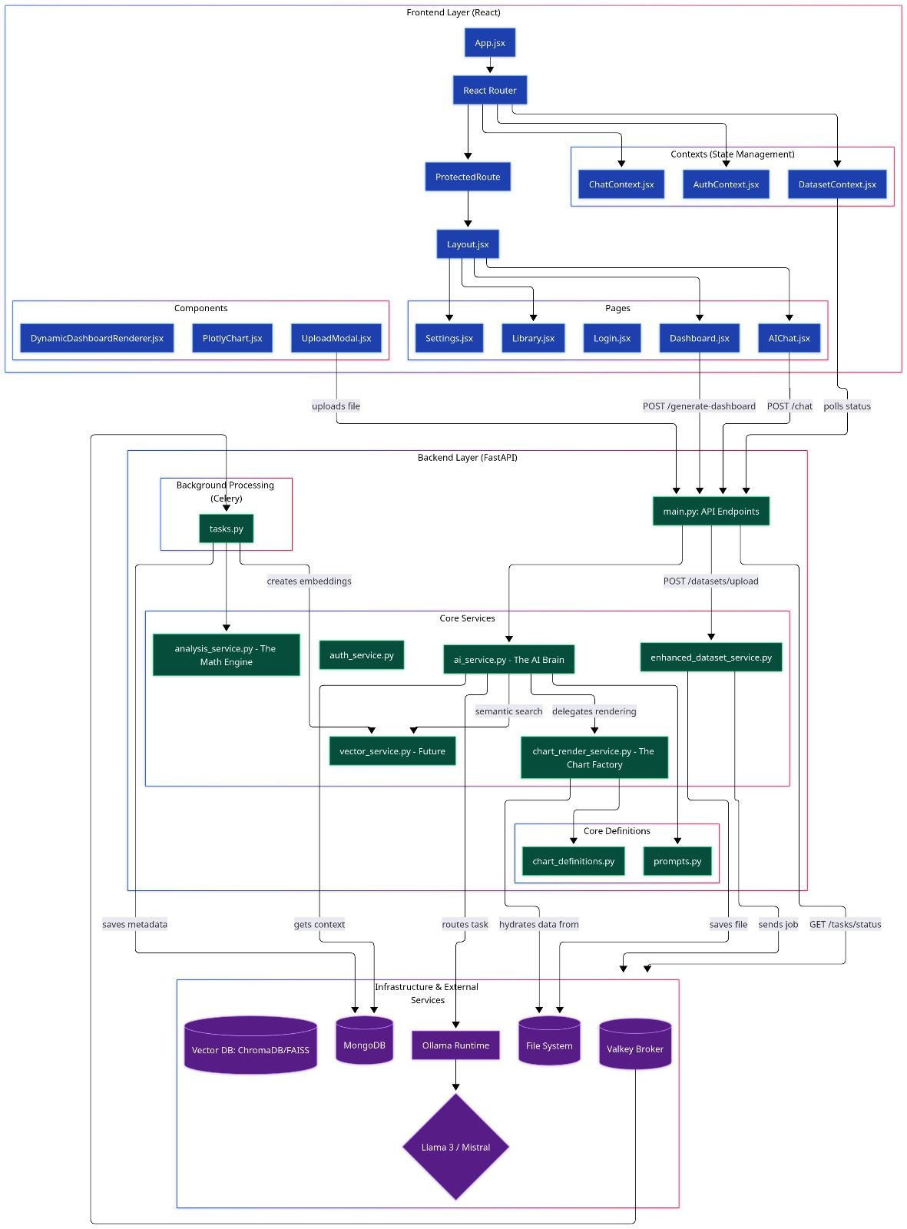
Figure 4.1: DataSage AI System Architecture

CHAPTER - 5
TECHNOLOGIES

5.1 React (Frontend Framework)
React serves as the foundation for the DataSage AI user interface, enabling the creation of a highly interactive and responsive single-page application (SPA). We chose React for its component-based architecture, which allows for the development of reusable UI elements like dynamic charts and KPI cards. The UI is styled with Tailwind CSS v4 for utility-first responsive design, enhanced with Radix UI primitives for accessible component patterns. Its efficient state management, handled by Zustand with persist middleware, ensures a seamless and fast user experience as data is updated and dashboards are redesigned in real-time.

5.2 Plotly.js (Data Visualization Library)
Plotly.js is the primary rendering engine for all data visualizations within DataSage AI. It was selected over simpler libraries for its comprehensive support for a vast range of advanced chart types, from basic bars and lines to complex heatmaps and 3D plots. Its declarative JSON-based configuration aligns perfectly with our backend architecture, allowing the AI to dynamically generate complex visualization blueprints that are rendered with high fidelity and interactivity on the frontend. Additionally, Recharts is used on the dedicated Insights page for lightweight, responsive area and scatter chart visualizations.

5.3 FastAPI (Backend Framework)
FastAPI is the high-performance Python framework that powers the entire backend API. It was chosen for its asynchronous capabilities, which are essential for handling concurrent I/O-bound operations like database queries, file system access, and long-polling requests to external AI models. FastAPI's built-in data validation with Pydantic, automatic OpenAPI documentation, and WebSocket support for real-time chat streaming significantly accelerated development and ensured a robust, reliable API. Rate limiting is enforced via SlowAPI across all critical endpoints.

5.4 Polars (Data Manipulation Library)
Polars is the core data processing engine used throughout the backend, particularly in the AnalysisService and data hydration functions. We made a strategic decision to use Polars instead of the more traditional Pandas library due to its superior performance, memory efficiency, and multi-core parallelism. Written in Rust, Polars allows DataSage AI to perform complex aggregations, transformations, and statistical analyses on large datasets at blazingly fast speeds.

5.5 Celery (Asynchronous Task Queue)
Celery is a critical component for ensuring a responsive user experience. It works in tandem with a Redis broker and result backend to offload all time-consuming and computationally intensive tasks—such as initial dataset processing, statistical analysis, domain detection, data profiling, chart recommendations, and vector embedding generation—to background workers through an 8-stage processing pipeline with granular progress tracking. This asynchronous architecture ensures that the main FastAPI application is never blocked, allowing the user to continue interacting with the platform while their data is being processed.

5.6 MongoDB (NoSQL Database)
MongoDB serves as the primary data store for the application via the Motor async driver for the FastAPI application and PyMongo for Celery workers. As a NoSQL, document-oriented database, it is perfectly suited for storing the flexible and complex nested JSON structures required by DataSage AI, including user profiles, dataset metadata, AI-generated dashboard blueprints, conversational histories with auto-archiving at 500 messages, extracted memory facts, and cached analysis results. Its scalability and native support for JSON-like documents make it an ideal choice for a modern, AI-driven application.

5.7 Redis (In-Memory Data Store & Message Broker)
Redis serves a dual role in the DataSage AI architecture. As the message broker for Celery, it manages the distribution of background tasks across workers. Simultaneously, it provides high-speed caching for DataFrames (with a fallback to in-memory LRU caching), WebSocket connection tracking and rate limiting (30 messages/minute, 5 connections per user), and serves as the result backend for completed Celery tasks.

5.8 DuckDB (In-Process SQL Engine)
DuckDB powers the Natural Language to SQL execution pipeline. When a user asks a data question in the AI Chat, the LLM generates a SQL query which is validated through a strict whitelist-only security layer (SELECT operations only, blocking DROP, DELETE, INSERT, and UPDATE). The validated query is then executed against the user's dataset using DuckDB's high-performance in-process engine, ensuring zero-hallucination data responses.

5.9 LangGraph (Agentic AI Framework)
LangGraph powers the agentic QUIS (Question-guided Insight System) analysis pipeline. It implements a cyclic state graph with specialized nodes: a Planner that generates analytical questions, an Analyst that executes statistical analysis, and a Critic that evaluates the quality of insights. The Critic can reject low-quality results, triggering a self-correcting retry loop. A Novelty Checker compares new insights against the user's Belief Store (backed by ChromaDB) using semantic surprisal scoring, ensuring only genuinely novel insights are surfaced.

5.10 OpenRouter API (Multi-Model LLM Gateway)
OpenRouter serves as the central LLM gateway, providing access to multiple state-of-the-art language models through a unified API. The platform implements intelligent role-based routing where each task type (SQL generation, KPI suggestion, chat, dashboard design) is mapped to the optimal model. Models include Google Gemini 2.5 Flash Lite for conversational tasks, DeepSeek V3.2 for high-precision analysis, Mistral Small 3.2 as a fallback, MiniMax M2.5 for complex layout design, and Qwen 2.5 VL for vision tasks. Automatic fallback chains ensure reliability, and concurrency is controlled via asyncio semaphores.

5.11 FAISS & ChromaDB (Vector Databases)
FAISS (Facebook AI Similarity Search) powers the semantic search and RAG retrieval pipeline, maintaining separate indices for dataset metadata and query history using BAAI/bge-large-en-v1.5 embeddings (1024 dimensions). Combined with BM25 sparse retrieval through Reciprocal Rank Fusion (RRF), it enables a hybrid search system for accurate context retrieval. ChromaDB serves as the persistent vector store for the agentic Belief Store, enabling subjective novelty detection by comparing new insights against previously stored knowledge using sentence-transformer embeddings.

CHAPTER - 6
IMPLEMENTATION

6.1 Implementation Phases

Phase 1: Foundation & Core Backend Setup
- Project Initialization: Set up a high-performance backend using FastAPI for its asynchronous capabilities.
- Database Configuration: Integrated MongoDB as the NoSQL database for flexible storage of user data, dataset metadata, and conversational histories.
- Core Services: Established a service-oriented architecture, creating foundational services for authentication (AuthService), secure file handling (FileStorageService), and dataset metadata management (EnhancedDatasetService).
- Asynchronous Task Queue: Configured Celery with Redis as both message broker and result backend to offload long-running tasks, ensuring the API remains responsive during heavy data processing.

Phase 2: Advanced Data Analysis & AI Engine
- Computational Engine: Developed a powerful AnalysisService using Polars and SciPy to perform a wide range of statistical computations, from basic correlations to advanced outlier and pattern detection.
- AI Orchestration: Built a resilient AIService to manage interactions with multiple Large Language Models (LLMs) via the OpenRouter API, featuring intelligent role-based model routing with automatic fallback chains and concurrency control through asyncio semaphores.
- Dynamic Prompt Engineering: Created a PromptFactory to dynamically generate context-aware prompts, providing the AI with dataset schemas, data samples, and user history to guide its reasoning.

Phase 3: Dynamic Visualization & Dashboard Generation
- AI-Powered Design: Implemented an AIDesignerService that leverages few-shot prompting and predefined design patterns to enable the AI to dynamically generate professional dashboard layouts tailored to the specific dataset being analyzed.
- Server-Side Rendering: Developed a deterministic ChartRenderService with specialized renderers for categorical, numerical, and temporal data that translates the AI's JSON blueprints into Plotly-compatible data traces on the backend, including layout theming and fuzzy column name matching for robustness.
- Frontend Integration: The AI-generated and fully hydrated dashboard configuration (including KPI values and chart data) is sent to the frontend via a single, efficient API endpoint.

Phase 4: Frontend Development & User Interface
- UI/UX Design: Designed a modern, responsive user interface with React and Tailwind CSS v4, featuring a dark-mode theme, glassmorphism effects, smooth animations using Framer Motion, and accessible component patterns with Radix UI primitives.
- State Management: Implemented robust global state management using Zustand to handle datasets (datasetStore) and conversational state (chatStore) across the application.
- Dynamic Rendering: Built a lean DashboardComponent that acts as a "dumb" renderer, dynamically displaying any KPI, chart, or table provided by the backend without requiring any client-side data processing.
- Interactive Components: Developed a Charts Studio for manual chart configuration, a real-time WebSocket-powered AI Chat with streaming responses and image upload support, a dedicated Insights page with Recharts visualizations, and a comprehensive Datasets management page with drag-and-drop upload via react-dropzone.

Phase 5: Advanced Features, Testing & Deployment
- Semantic Search & RAG: Implemented a fully operational Retrieval-Augmented Generation (RAG) pipeline combining FAISS dense retrieval with BM25 sparse retrieval through Reciprocal Rank Fusion (RRF) and post-retrieval re-ranking. Integrated sentence-transformer models (BAAI/bge-large-en-v1.5) for generating 1024-dimensional vector embeddings.
- Agentic Analysis & Memory: Implemented a LangGraph-based agentic QUIS (Question-guided Insight System) with a self-correcting Planner-Analyst-Critic loop. Built a Mem0-inspired memory system that extracts conversational facts and persists them per user/dataset in MongoDB. Developed a ChromaDB-backed Belief Store with subjective novelty detection via semantic surprisal scoring.
- Optimization & Security: Refined prompts and backend data hydration logic to improve the accuracy of the AI's output. Implemented comprehensive security features including prompt sanitization, SQL injection prevention, output validation, GDPR-compliant audit logging, and rate limiting across all critical endpoints.

6.2 Code Implementation
LandingPage.jsx
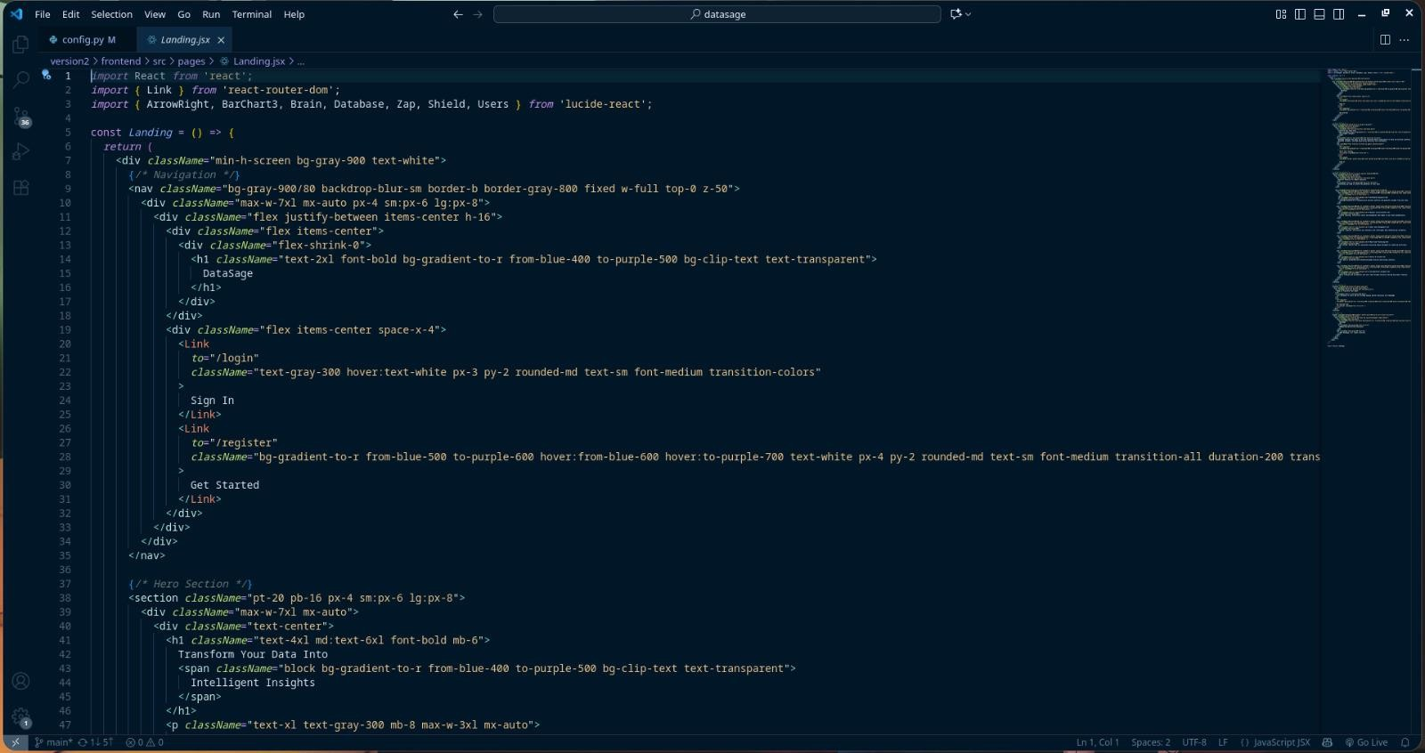
Figure 6.1: LandingPage Component
LoginPage.jsx
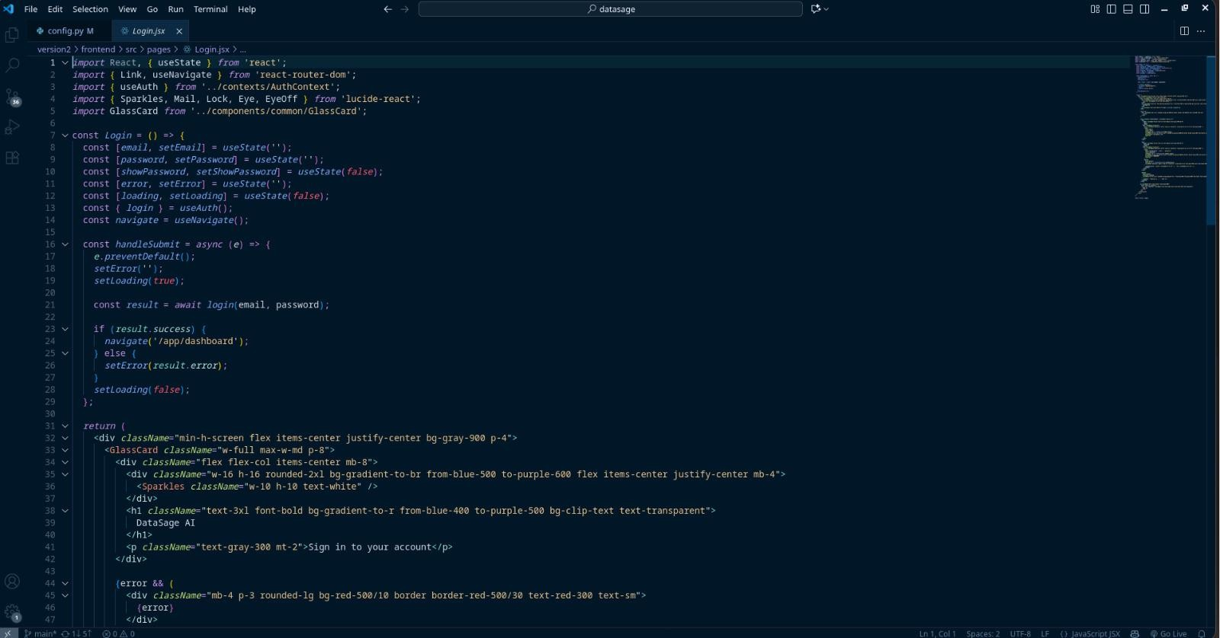
Figure 6.2: LoginPage Component
RegistrationPage.jsx
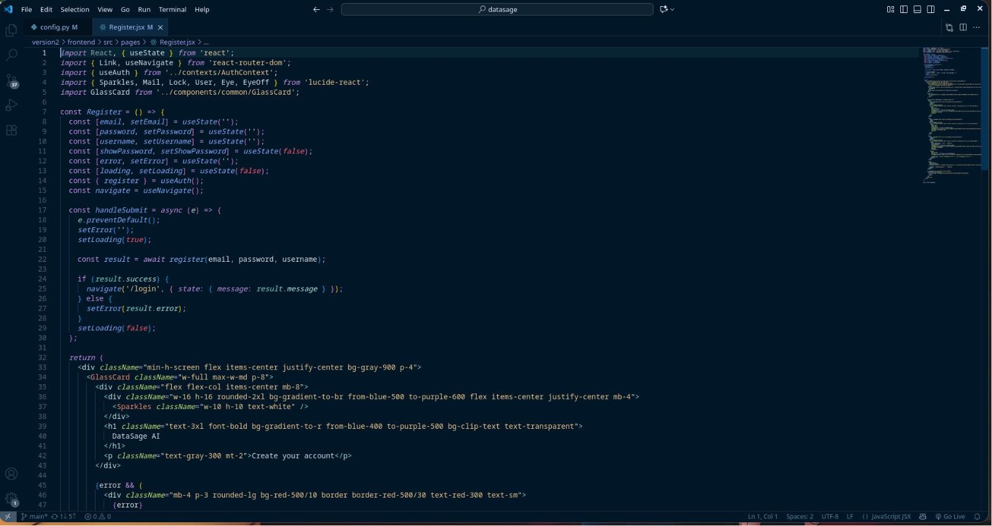
Figure 6.3: RegistrationPage Component
Dashboard.jsx
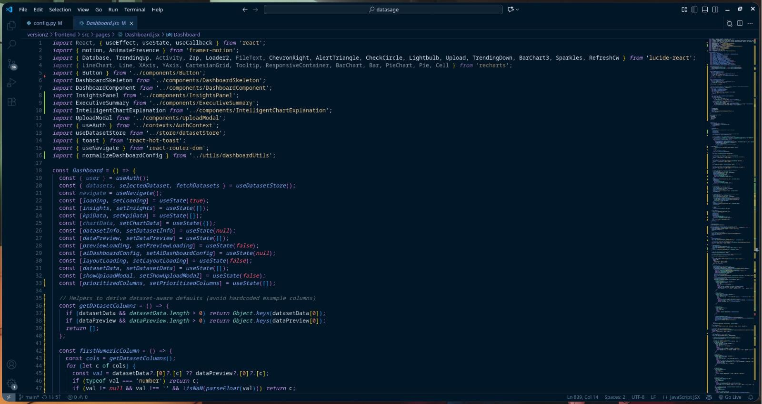
Figure 6.4: Dashboard Component
Charts.jsx
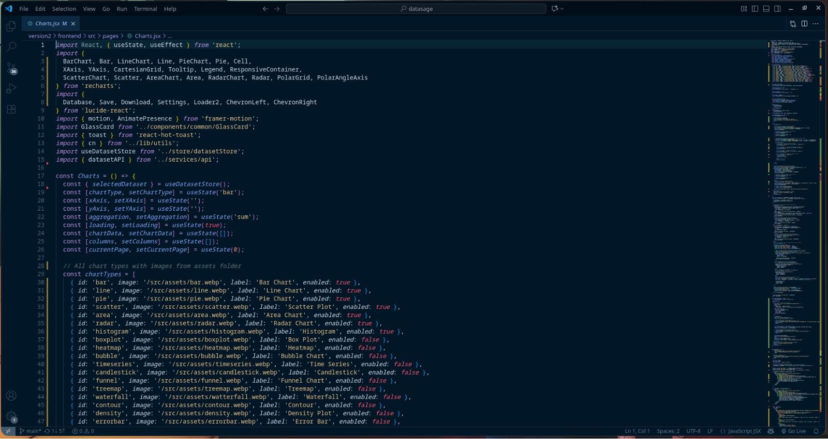
Figure 6.5: Charts Component
Datasets.jsx
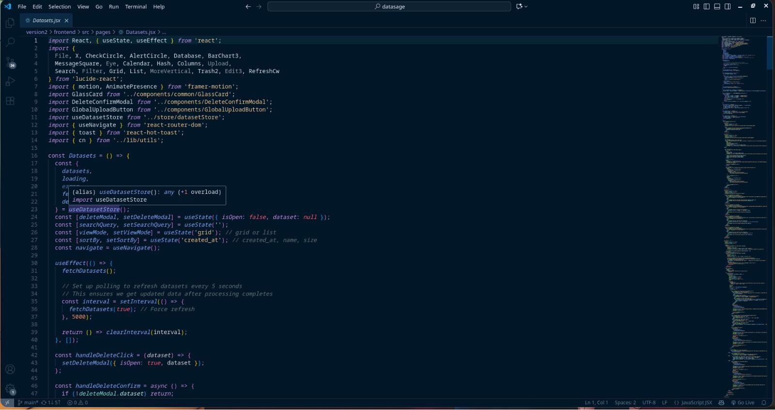
Figure 6.6: Datasets Component
App.jsx
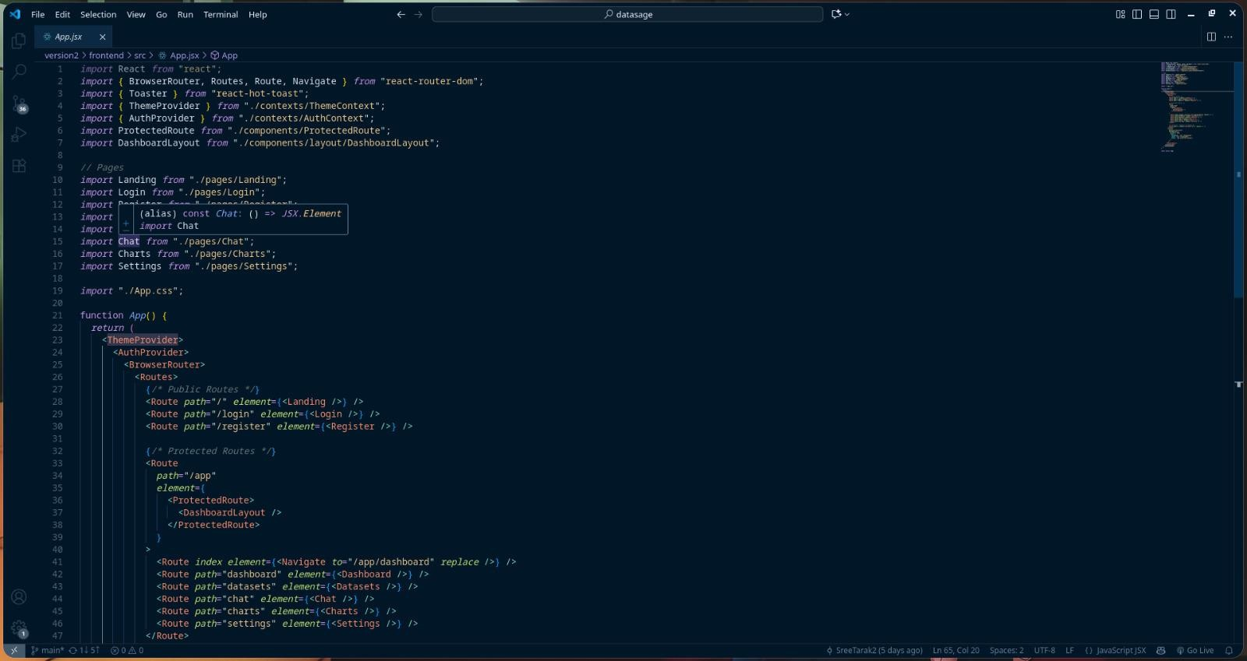
Figure 6.7: App Component
App.css
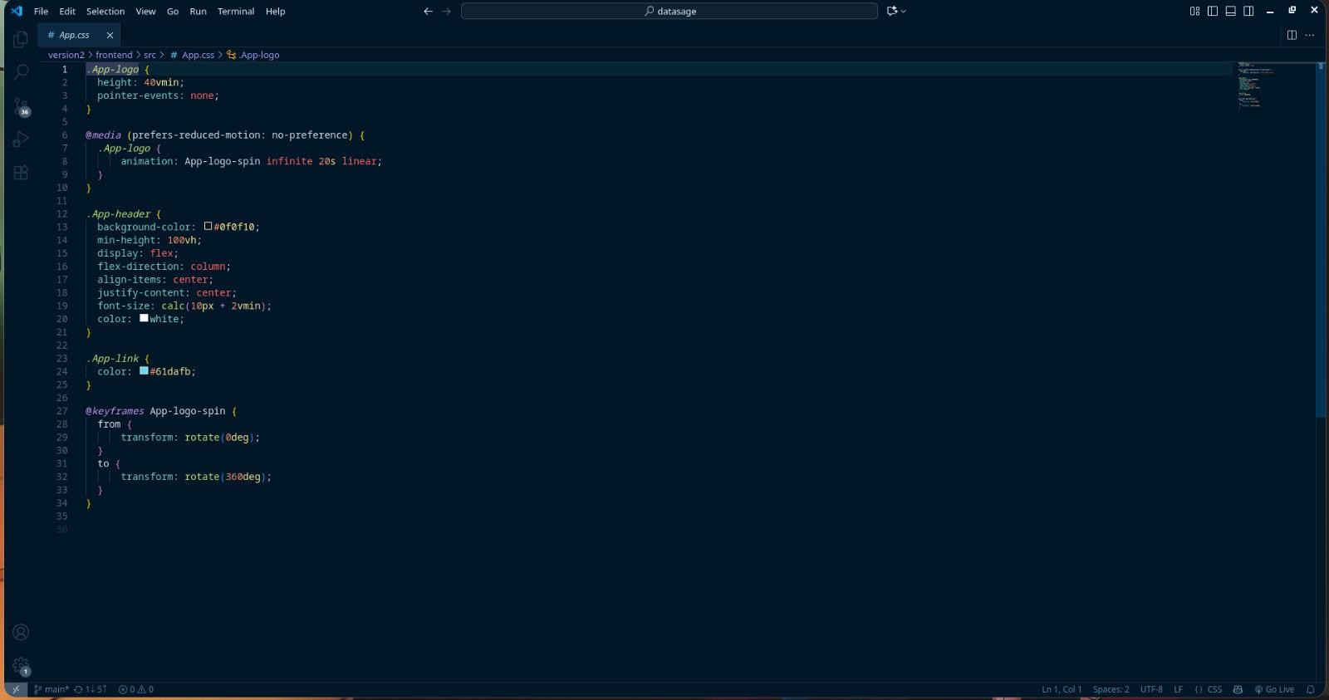
Figure 6.8: App Stylesheet
Terminal Execution
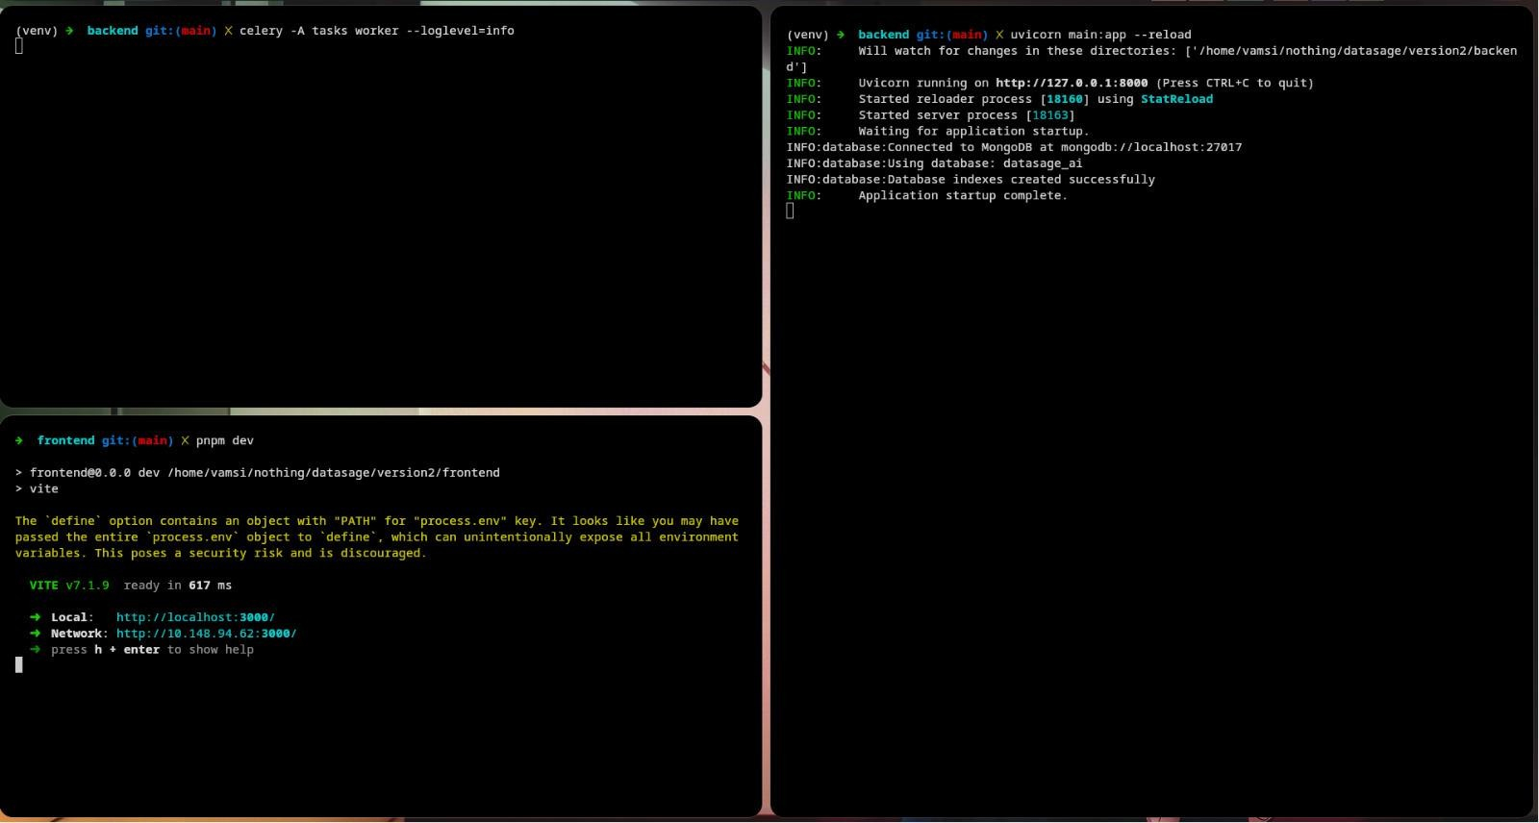
Figure 6.9: Terminal Execution

CHAPTER - 7
TESTING

7.1 Test Objectives
The testing phase aimed to validate the reliability, correctness, and performance of the DataSage AI platform across its full-stack architecture. The primary objectives were:
1. Verify that dataset uploads (CSV, Excel) are correctly ingested, validated, and processed through the Celery background pipeline.
2. Ensure the AI-powered dashboard generation produces valid, well-structured JSON blueprints with correct KPI values and chart configurations.
3. Validate that the AI Chat interface accurately interprets natural language queries and returns relevant data-driven responses and visualizations.
4. Test the server-side data hydration pipeline to confirm all Plotly chart data traces are correctly computed and rendered.
5. Verify user authentication flows (registration, login, session management) function correctly and securely.
6. Assess frontend responsiveness and cross-browser compatibility across desktop and mobile devices.

7.2 Types of Testing Performed
- Unit Testing: Individual backend services (AnalysisService, AIService, ChartRenderService) were tested in isolation to verify correct output for known inputs, edge cases, and error conditions.
- Integration Testing: End-to-end workflows were tested, including the full pipeline from dataset upload → Celery processing → AI dashboard generation → frontend rendering, to ensure all components interact correctly.
- API Testing: All FastAPI endpoints were validated using automated requests, checking correct HTTP status codes, response schemas, authentication enforcement, and error handling for invalid inputs.
- UI/UX Testing: The React frontend was tested for correct rendering of dynamic dashboard components, chart interactivity, responsive layout behavior, and smooth navigation across all pages (Landing, Login, Dashboard, Charts, Datasets, Chat).
- Performance Testing: The system was tested with datasets of varying sizes to evaluate response times for dashboard generation, chat queries, and data processing. Polars was benchmarked against baseline expectations for large dataset handling.
- Error Handling Testing: Graceful degradation was verified for scenarios including AI model failures, invalid file uploads, malformed user queries, network timeouts, and Celery worker unavailability.

CHAPTER - 8
OUTPUT & SCREENSHOTS

8.1 Interfaces
Landing Page
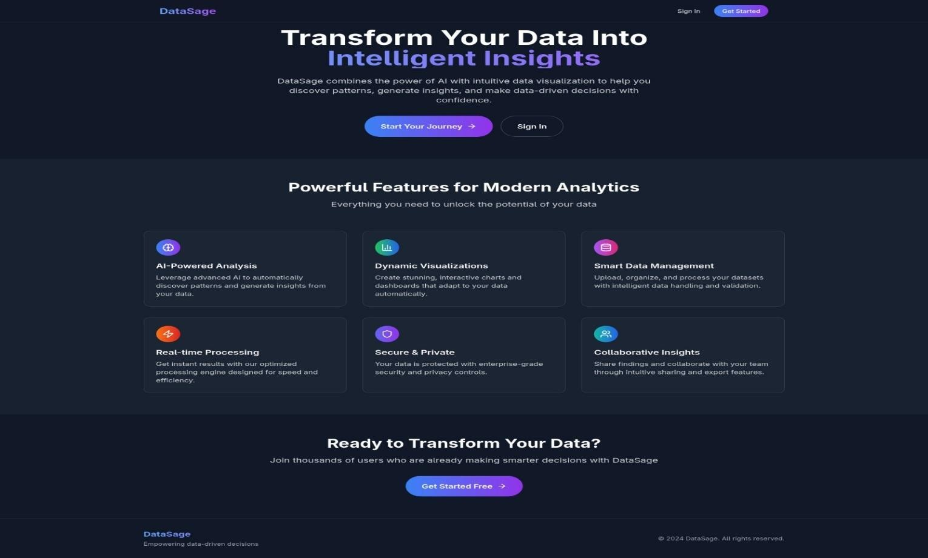
Figure 8.1: DataSage AI Landing Page
Login Page
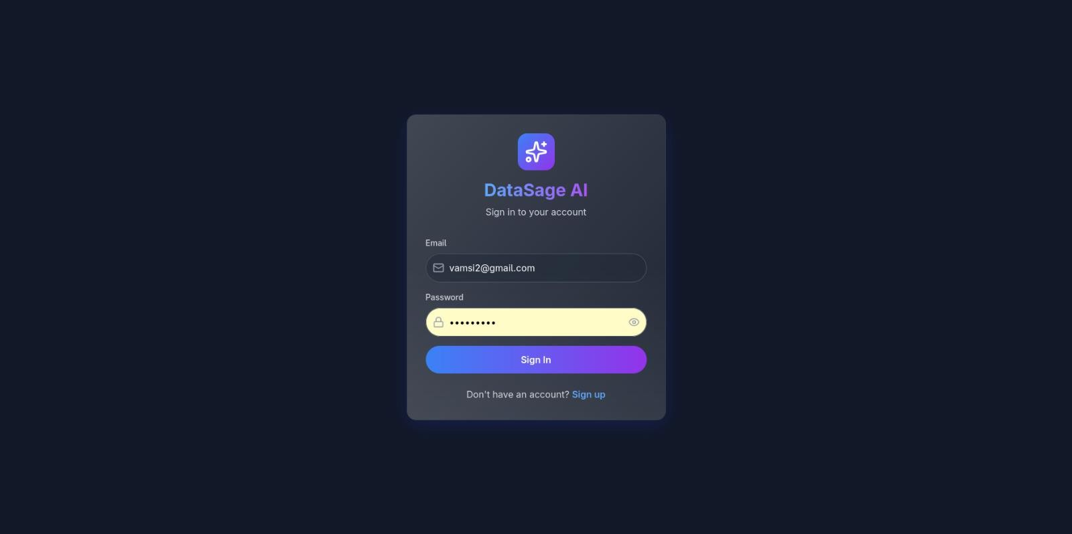
Figure 8.2: User Login Page
Charts Page
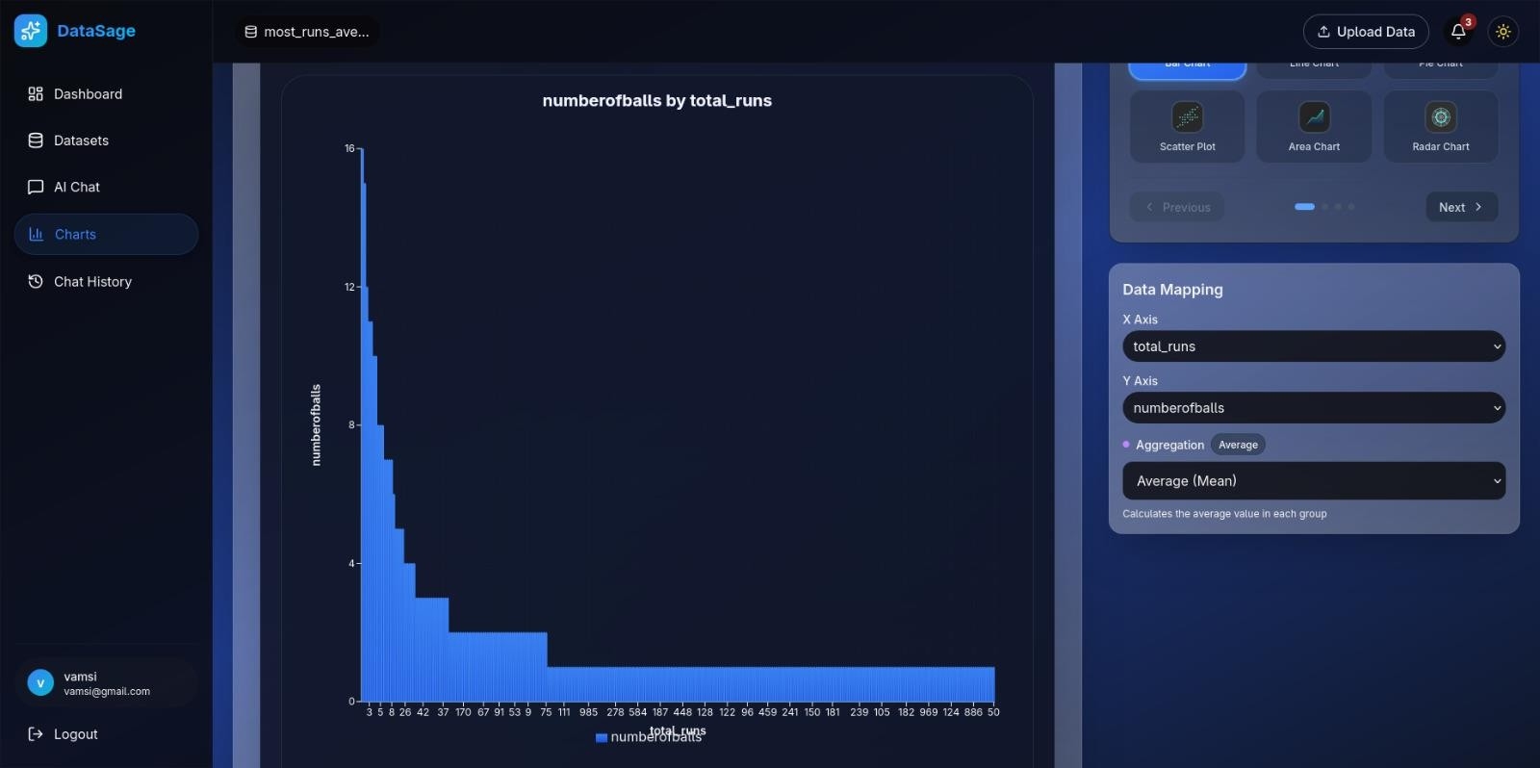
Figure 8.3: Interactive Charts Studio
Datasets Page
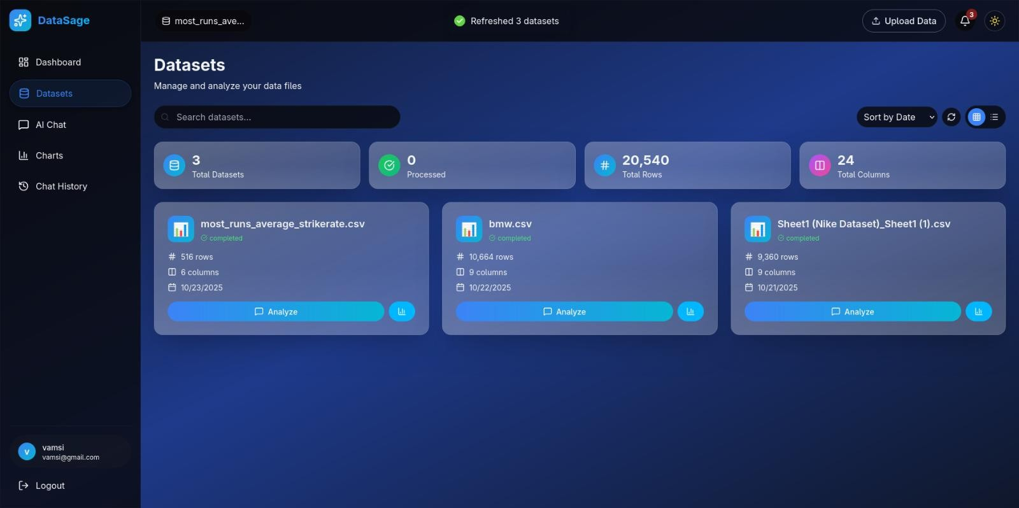
Figure 8.4: Dataset Management Page
Dashboard
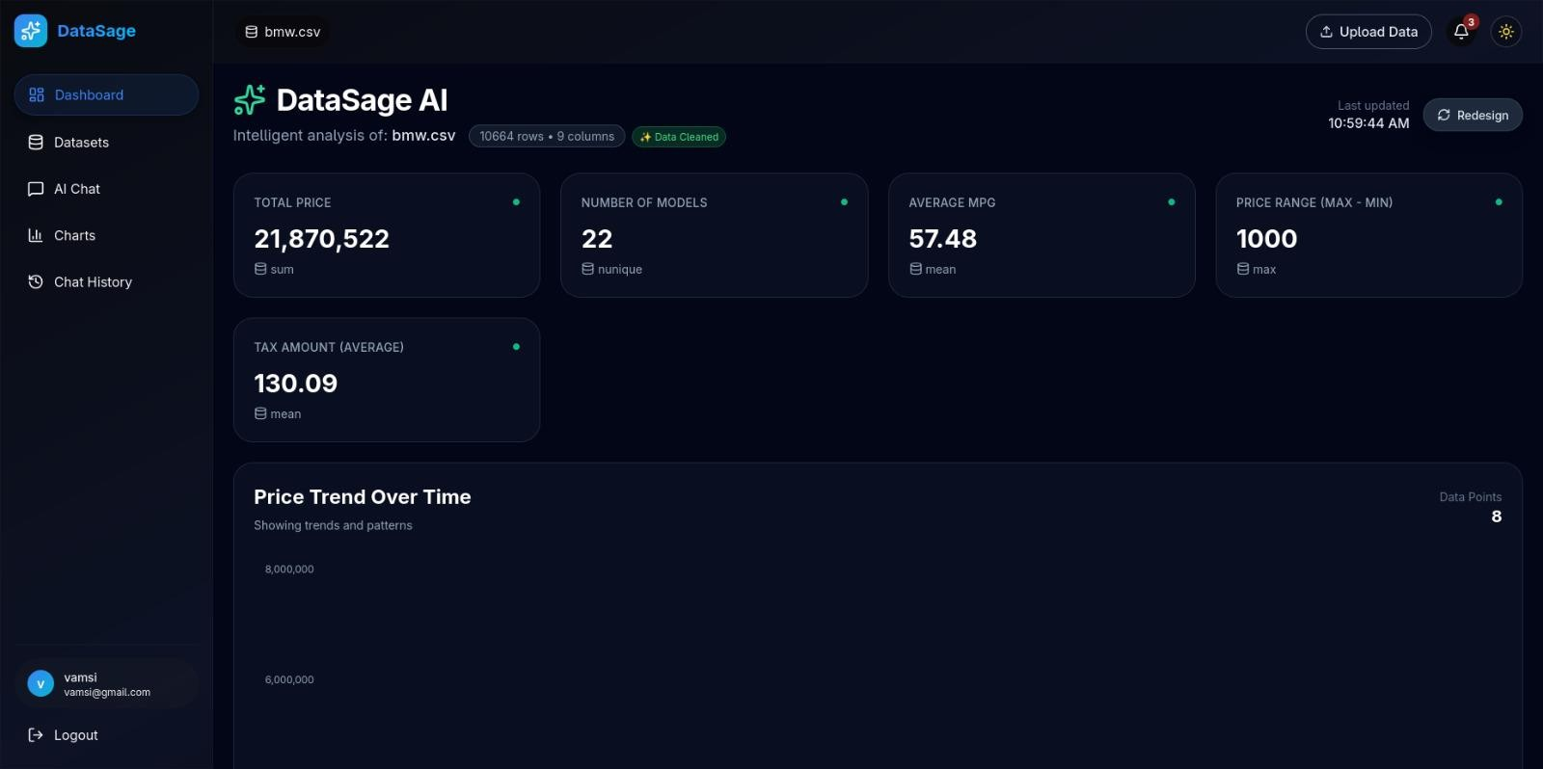
Figure 8.5: AI-Generated Dashboard
Dashboard (continued)
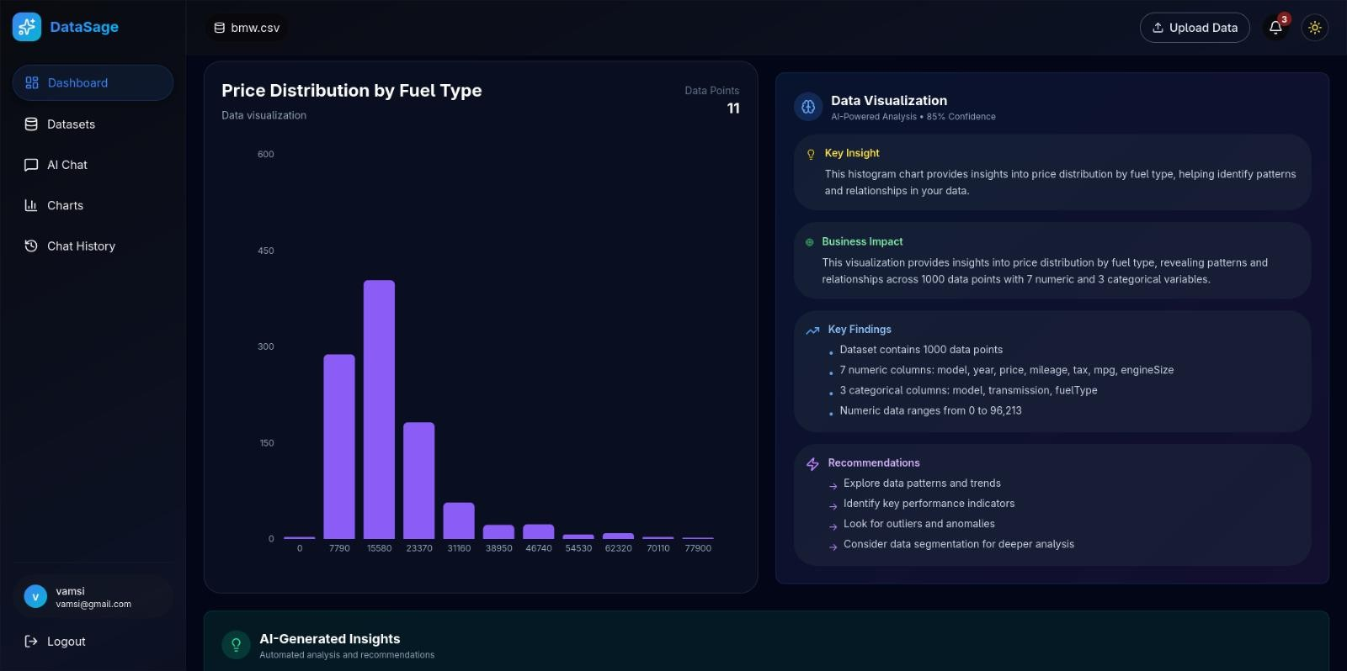
Figure 8.6: Dashboard Visualizations

CHAPTER - 9
CONCLUSION AND FUTURE WORK

9.1 Conclusion
This project successfully engineered DataSage AI, a fully dynamic, AI-driven analytics platform that empowers users to transform raw data into actionable intelligence. By integrating a sophisticated multi-model AI engine via the OpenRouter API with role-based routing and fallback chains, a high-performance FastAPI and Polars backend, and advanced features including a LangGraph-based agentic analysis system, a fully operational RAG pipeline, and a Mem0-inspired conversational memory system, the platform automates the entire analytical workflow—from generating context-aware KPIs and visualizations to surfacing complex data patterns through a real-time WebSocket-powered chat interface with Natural Language to SQL execution.
The architecture's core innovation is its server-side hydration model, where the AI acts as an expert analyst to design a complete dashboard, which is then fully rendered on the backend before being delivered to a lightweight React, Tailwind CSS, and Plotly.js frontend.
Ultimately, DataSage AI bridges the critical gap between complex data and clear, confident decision-making, proving the viability of using multiple LLMs with agentic reasoning, hybrid retrieval-augmented generation, and conversational memory to make sophisticated data analysis accessible and intuitive for everyone.

9.2 Future Enhancements
- Advanced RAG with Cross-Dataset Reasoning: Extend the existing RAG pipeline to support cross-dataset analysis, enabling users to ask questions that span multiple uploaded datasets. Implement intelligent context fusion that combines insights from different data sources, and add temporal RAG capabilities that can track how data patterns evolve over time across successive dataset uploads.
- Advanced Collaborative Analytics: Implement multi-user collaboration features where team members can share dashboards, annotate insights, and build on each other's analytical discoveries. Add role-based access control for datasets and a shared workspace where multiple users can simultaneously explore data through a collaborative chat interface.
- Automated Anomaly Detection: Implement a background service that periodically runs the Analysis Service on user datasets. If a significant new trend, outlier, or pattern is detected (e.g., a sudden spike in sales), the system will generate a proactive notification for the user.
- Time-Series Forecasting & Predictive Analytics: Add a Forecast mode to the AI Chat enabling users to request projections (e.g., "Project our sales for the next three months"). The backend would use statistical models (ARIMA, Prophet) or ML models to generate forecasts, visualized as line charts with confidence intervals on the Plotly.js frontend.
- Personalized Analytics Profiles: Build user-specific analytical profiles that learn from each user's querying patterns, preferred visualization types, and areas of interest. The system would proactively suggest relevant analyses and surface insights aligned with each user's analytical history and preferences.
- Enhanced User Customization & Collaboration: Allow users to save their AI-generated dashboard layouts as custom templates. This would extend the AI Designer Service by storing user-created templates in the MongoDB dashboard_templates collection, making them available for future use.
- Deeper & More Interactive Visualizations: Fully integrate the DynamicDrillDownService. When a user clicks on a segment of a chart (e.g., a bar in a "Sales by Region" chart), the dashboard would automatically filter and reload, showing a more granular view of that specific region.
- Scalability & Production-Readiness: As the platform grows, migrate from the local FAISS file-based storage to a scalable, cloud-based vector database like Pinecone, Weaviate, or Google Cloud's Vertex AI Vector Search. This would provide better performance, real-time indexing, and advanced filtering capabilities.

CHAPTER - 10
REFERENCES
[1] Mackinlay, J. (1986): "Automating the Design of Graphical Presentations of Relational Data." ACM Transactions on Graphics.
Established the foundational theory for automated visualization systems by linking data types (categorical, numeric, temporal) to appropriate chart forms—a principle reflected in DataSage AI's chart selection logic within ai_service.py and prompts.py.
[2] Satyanarayan, A., Moritz, D., Wongsuphasawat, K., & Heer, J. (2017): "Vega-Lite: A Grammar of Interactive Graphics." IEEE Transactions on Visualization and Computer Graphics.
Inspired DataSage AI's declarative JSON chart configuration system, where the ChartRenderService acts like Vega-Lite's compiler, transforming AI-generated "grammar of graphics" blueprints into visual outputs.
[3] Brown, T., et al. (2020): "Language Models are Few-Shot Learners." Advances in Neural Information Processing Systems (NeurIPS).
Provided the basis for few-shot prompting techniques used in the AIDesignerService, which leverages example-driven prompting for consistent and structured dashboard generation.
[4] Lewis, P., et al. (2020): "Retrieval-Augmented Generation for Knowledge-Intensive NLP Tasks." NeurIPS.
Introduced the concept of Retrieval-Augmented Generation (RAG), which supports DataSage AI's FAISSVectorService and informs the hybrid dense+sparse retrieval system for conversational and knowledge-grounded AI.
[5] Ramírez, S. (2018): "FastAPI Official Documentation." https://fastapi.tiangolo.com/.
The authoritative source for FastAPI, the asynchronous framework that powers DataSage AI's backend, ensuring high performance and modern API design.
[6] De Vries, R. (2021): "Polars: Blazingly Fast DataFrames in Rust and Python." pola.rs.
The foundation for DataSage AI's high-performance data handling in the AnalysisService, representing a shift toward faster and more scalable DataFrame technologies.
[7] Johnson, J., Douze, M., & Jégou, H. (2019): "Billion-scale Similarity Search with GPUs." IEEE Transactions on Big Data.
Introduced FAISS (Facebook AI Similarity Search), the technology powering DataSage AI's semantic search through the FAISSVectorService, enabling efficient large-scale vector similarity computation.

