Quantifying and attributing standardization reproducibility in cheminformatics pipelines
Draft manuscript. Target venue: Journal of Cheminformatics.
Every numeric value in the Results section is generated by learning/research-track-R5-benchmark/analyse_sample.py and stored in chembl_results.json; verify_numbers.py checks the manuscript text against that file. Every reference is PubMed-verified (see references.md).

Abstract
Molecular structure standardization — normalizing salts, charge states, tautomers, isotopes and stereochemistry to a canonical form — is a mandatory preprocessing step in essentially every cheminformatics pipeline, yet the protocols used to perform it vary across tools, databases and individual configurations. Disagreement between standardization pipelines is documented at production scale, but existing analyses compare one pipeline against one reference and cannot say which normalization decision produced a given disagreement. We present a measurement framework that treats standardization reproducibility as a quantifiable property of a dataset. Given an arbitrary set of protocols, the method determines whether they agree on each molecule's standardized identity — evaluated under two identity conventions, canonical SMILES and InChIKey, which we show are not interchangeable — and attributes each disagreement to a specific normalization operation by systematic ablation. Applied to a seeded random sample of 4,972 ChEMBL structures, three representative protocols (Minimal, ChEMBL-like, Aggressive) agreed on 54.1% of molecules under canonical-SMILES identity (95% CI 52.8–55.5%) and 57.7% under InChIKey identity (56.3–59.0%). Ablation attributed divergence predominantly to stereochemistry handling (66.6% of divergent molecules) and tautomer canonicalization (22.1%), with charge and fragment handling accounting for under 10% combined. We show that this spectrum is a joint property of dataset composition and protocol contrast rather than an intrinsic ranking of operations, and that a hand-assembled benchmark inverts it — an argument for auditing the dataset actually in use. The method and an open-source reference implementation are released as part of WaweKit.

1. Introduction
Structure standardization — the normalization of salts, charge states, tautomers, isotopic labels and stereochemistry to a canonical representation — is a mandatory preprocessing step in essentially every cheminformatics workflow. Similarity search, clustering, database deduplication and QSAR modelling all rest on the assumption that the same chemical entity is represented identically wherever it appears. Standardization is what makes that assumption hold.
In practice, standardization is performed by a protocol: an ordered composition of normalization operations, each encoding a modelling decision. Whether to strip counter-ions, whether to neutralize formal charges, whether to select a canonical tautomer, whether to discard stereochemistry — these are choices, and different databases, software packages and individual configurations resolve them differently. Public infrastructure reflects this: the ChEMBL curation pipeline [1] and the PubChem standardization service [3] are independently designed, independently reasonable, and not equivalent.
The consequence is that a molecule's standardized form — and therefore its identity within a dataset — can be pipeline-dependent. Two datasets curated under different standardization choices are not guaranteed to be directly comparable, and a result computed on one may not be reproducible from the other. That this matters downstream is established: automated curation of chemical structure and identity measurably changes QSAR model performance [5].
The scale of pipeline dependence is not hypothetical. PubChem reports that 44% of structures passing its standardization are modified in the process, and that 60% of its standardized structures are not identical to the structure obtained by round-tripping through InChI, attributed primarily to a different preferred tautomeric form [3]. Tautomerism in particular is a catalogued source of representational ambiguity, with thousands of experimentally annotated tautomeric tuples documented across the literature [4].
What existing work provides is standardization implementations, each encoding one set of choices, together with pairwise comparisons between a specific pipeline and a specific reference [3]. What is not available is a general method for asking, of an arbitrary set of protocols and an arbitrary dataset: how often do these protocols disagree, on which molecules, and — critically — because of which operation. Without per-operation attribution, a disagreement is an observation; with it, a disagreement becomes an actionable diagnostic pointing at the specific modelling decision responsible.
We therefore treat standardization reproducibility as a measurable, first-class property of a dataset rather than an implicit assumption, and contribute:
- A composable protocol model (§2.1) in which standardization is expressed
as a fixed-order sequence of independently toggleable operations, making two protocols directly comparable and any single operation's contribution isolable.
- A dual-identity divergence measure (§2.2), evaluating agreement
separately under canonical-SMILES and InChIKey identity, because the two conventions can disagree about whether a given molecule is reproducible — InChI's internal normalization [2] absorbs differences that canonical SMILES exposes.
- An ablation-based cause-attribution procedure (§2.3) identifying, for
each divergent molecule, which operation(s) are responsible.
- An open-source reference implementation with a reusable benchmark
harness, applied to a seeded random sample of ChEMBL (§3).

1.1 Relationship to prior work
The closest prior art is PubChem's own analysis of its standardization service [3], which quantifies disagreement between one production pipeline and InChI round-tripping at full database scale. That work establishes that standardization disagreement is real and substantial; it does not generalize to arbitrary protocol sets, and it does not attribute disagreement to individual normalization operations, because its comparison is between two monolithic pipelines rather than between compositions of separable operations. Our contribution is the generalization along both axes — arbitrary N protocols, and per-operation attribution — not the observation that standardization pipelines disagree, which is already documented.

2. Methods

2.1 Composable standardization protocols
A standardization protocol is defined as a named subset of eight operations, applied in a fixed, chemically motivated order. Six are provided by RDKit's rdMolStandardize module; the remaining two are elementary structural edits applied directly:
# | Operation | Implementation
1 | Metal disconnection | MetalDisconnector
2 | Functional-group normalization | Normalizer
3 | Reionization | Reionizer
4 | Parent-fragment selection (salt/solvent stripping) | LargestFragmentChooser
5 | Charge neutralization | Uncharger
6 | Isotope removal | clear all isotope labels
7 | Stereochemistry removal | Chem.RemoveStereochemistry
8 | Canonical tautomer selection | TautomerEnumerator.Canonicalize

The ordering is fixed across all protocols: disconnection and normalization precede fragment selection, which precedes charge handling, with tautomer canonicalization last. A protocol is therefore fully specified by which operations it enables. Fixing the order is a deliberate design constraint — it means two protocols differ only in their operation sets, which is what makes their outputs comparable and any single operation's effect isolable by ablation. Standardization is applied to a copy of each input molecule; input structures are never mutated.
Three representative protocols are used throughout:
- Minimal — normalization only (operation 2). A light-touch baseline
representing the least a pipeline might reasonably do.
- ChEMBL-like — operations 1–5, deliberately excluding tautomer
canonicalization, approximating the published ChEMBL curation pipeline [1].
- Aggressive — all eight operations.
These are not an exhaustive survey of deployed pipelines but three points spanning the range of reasonable practice, chosen so that the pairwise comparisons differ by controlled numbers of operations: ChEMBL-like versus Aggressive differ by three (isotope removal, stereochemistry removal, tautomer canonicalization), Minimal versus ChEMBL-like by four, and Minimal versus Aggressive by seven.

2.2 Identity conventions and divergence
For each standardized structure two identity representations are recorded:
- Canonical SMILES (RDKit MolToSmiles), sensitive to any structural
change, including tautomer choice.
- InChIKey (MolToInchiKey), which applies InChI's own normalization
layers — including tautomer normalization for a defined set of tautomer classes — independently of the protocol's operations [2].
For a molecule audited under a protocol set, agreement under an identity convention means all protocols produced an identical value. A molecule is labile if it disagrees under either convention. Both conventions are reported separately rather than one being selected as canonical, because they are not interchangeable proxies for chemical identity (§3.2).
A protocol may fail on a molecule if RDKit rejects an intermediate structure. Such failures are recorded and excluded from the agreement computation for that molecule: a failure is evidence of fragility, not of divergence, and conflating the two would let two failed protocols count as agreeing with each other. Agreement is computed over the protocols that produced a valid identity, with the count of affected molecules reported separately.

2.3 Ablation-based cause attribution
For each labile molecule, the most operation-rich protocol in the comparison set is selected. For each of its enabled operations, evaluated in reverse application order, the molecule is re-standardized with that single operation disabled and the resulting identity compared against the full protocol's output. An operation whose removal changes the identity is recorded as an implicated cause, ranked by whether it changes InChIKey (deeper identity) or only canonical SMILES.
Reverse application order reflects that later operations are more likely to be the proximate cause of a difference in the final structure. The procedure costs one additional standardization per enabled operation per labile molecule, bounded because at most eight operations exist.
Two limitations follow directly from the construction. First, attribution is only possible among the operations in the protocol — divergence originating outside this set (a different aromaticity model, a different tautomer scoring function, a non-RDKit standardizer) cannot be detected. Second, when two operations jointly determine an outcome such that neither alone changes it, single-operation ablation attributes no cause; these molecules are reported as unattributed rather than silently omitted, and their count is a direct measure of how often this occurs (§3.4).

2.4 Dataset-level metrics
From an audit over N molecules and P protocols we report:
- Reproducibility score, per identity convention — the fraction of
molecules on which all P protocols agree.
- Pairwise agreement — for each protocol pair, the fraction of molecules on
which that pair agrees, computed over molecules where both produced a valid identity.
- Cause spectrum — among labile molecules, the fraction implicating each
operation. This does not sum to 1: a molecule may implicate several operations.
Proportions are reported with 95% Wilson score intervals, which remain within [0, 1] near the boundaries and behave acceptably at the subgroup sizes involved in per-cause reporting, where the normal approximation does not. The intervals assume independent sampling; §3.1 quantifies the departure from that assumption introduced by the sampling design, and §4.3 discusses its consequence.

2.5 Benchmark dataset and sampling design
Structures were drawn from ChEMBL via its public REST API, which paginates by offset and provides no random-record endpoint. Drawing N independent single-record requests would require N round trips, so we used cluster sampling: 500 independent uniformly-random offsets into the molecule table (2,921,148 records at time of access), each returning a block of 10 consecutive records. The random seed and the drawn offsets are recorded, so the exact sample is regenerable.
This design trades statistical independence for practicality, and the trade must be disclosed: records adjacent in ChEMBL's ordering frequently originate from the same publication or assay series, so blocks may contain structurally related analogues. §3.1 reports the realised effect.

2.6 Implementation and availability
The measurement pipeline — protocol engine, divergence analysis, metrics, and a command-line benchmark harness — is implemented in Python 3.13.2 against RDKit 2026.03.4, with no dependency on any GUI layer, and is covered by 39 unit tests. An interactive front-end (WaweKit) additionally presents a protocol-agreement heatmap, a cause-spectrum chart and an inspectable list of labile molecules for exploratory curation; both interfaces call the identical underlying computation. The implementation, the sampling and analysis scripts, the drawn sample and the raw per-molecule results are released under the MIT license.

3. Results

3.1 Sample characteristics
All 4,972 fetched structures parsed successfully under RDKit (0 unparseable), and no protocol failed on any molecule (0 molecules with failures), so every figure below is computed over the full sample rather than a surviving subset.
Structural composition, which determines which operations can act at all:
Feature | Molecules | Fraction
Contains a stereocentre | 2366 | 47.6%
Formally charged atom | 313 | 6.3%
Multiple fragments (salt/solvate) | 192 | 3.9%
Metal or uncommon element | 66 | 1.3%
Isotopically labelled | 6 | 0.1%

The sampling design's realised clustering was measurable: mean pairwise Tanimoto similarity within blocks was 0.206 against 0.112 between blocks (22,284 pairs each), i.e. within-block pairs are approximately 1.8× as similar as between-block pairs. The effective sample size is therefore smaller than the nominal 4,972, and the confidence intervals below are correspondingly optimistic (§4.3).

3.2 The two identity conventions disagree about reproducibility
Canonical-SMILES identity and InChIKey identity do not agree on which molecules are reproducible. Across the sample, 54.1% of molecules were reproducible under canonical SMILES against 57.7% under InChIKey — InChI's internal normalization absorbs differences that canonical SMILES exposes, so the same dataset appears more reproducible when identity is defined by InChIKey.
The mechanism is visible in a single molecule. For 2-hydroxypyridine, enabling canonical-tautomer selection changes the canonical SMILES output (Oc1ccccn1 → O=c1cccc[nH]1) while leaving the InChIKey unchanged, because InChI's own normalization already collapses this tautomer pair [2]. A molecule can therefore be flagged as pipeline-dependent under one convention and fully reproducible under the other. Reporting a single reproducibility figure without naming the identity convention is consequently ambiguous, and a curation step that deduplicates by InChIKey is not equivalent to one that deduplicates by canonical SMILES.

3.3 Protocol agreement
Metric | Value | 95% CI
Molecules analysed | 4972 | —
Reproducible under canonical SMILES | 54.1% | 52.8–55.5%
Reproducible under InChIKey | 57.7% | 56.3–59.0%
Divergent (labile) molecules | 2280 (45.9%) | —
Molecules with a protocol failure | 0 | —

Pairwise agreement (Figure 1):
Protocol pair | Operations differing | InChIKey | Canonical SMILES
Minimal vs. ChEMBL-like | 4 | 96.1% | 96.1%
ChEMBL-like vs. Aggressive | 3 | 60.0% | 56.4%
Minimal vs. Aggressive | 7 | 57.7% | 54.1%

Agreement is not a simple function of how many operations two protocols differ by. Minimal and ChEMBL-like differ by four operations yet agree on 96.1% of molecules, while ChEMBL-like and Aggressive differ by only three yet agree on 60.0%. What matters is whether the differing operations are applicable to the data at hand: the four operations separating Minimal from ChEMBL-like — metal disconnection, reionization, fragment selection and charge neutralization — act on features present in only 3.9–6.3% of this sample (§3.1), whereas the three separating ChEMBL-like from Aggressive include stereochemistry removal, which applies to 47.6%.
The high Minimal/ChEMBL-like agreement also has a direct explanation in the provenance of the data, discussed in §4.2: these structures have already passed ChEMBL's own curation pipeline, so the operations approximating that pipeline have comparatively little left to change.

3.4 Divergence cause spectrum
Ablation attributed causes as follows (Figure 2; fractions of the 2280 divergent molecules, not summing to 1 because a molecule may implicate several operations):
Operation | Fraction of divergent molecules | n | 95% CI
Stereochemistry removal | 66.6% | 1518 | 64.6–68.5%
Canonical tautomer selection | 22.1% | 504 | 20.4–23.9%
Parent-fragment selection | 8.4% | 192 | 7.3–9.6%
Charge neutralization | 1.1% | 26 | 0.8–1.7%
Isotope removal | 0.3% | 6 | 0.1–0.6%
Functional-group normalization | 0.1% | 2 | 0.0–0.3%

278 divergent molecules (12.2% of divergent molecules) were unattributed — no single-operation ablation changed the outcome, indicating divergence determined jointly by two or more operations. This is the measured size of the single-operation ablation blind spot described in §2.3.
The spectrum reflects protocol contrast and dataset composition, not an intrinsic ranking of operations. Stereochemistry removal is implicated in 1518 molecules; the sample contains 1505 molecules with at least one assigned stereocentre. The near-identity of these counts shows the mechanism plainly: stereochemistry removal is enabled in Aggressive and in neither other protocol, so essentially every molecule with defined stereochemistry diverges, by construction. The same logic explains fragment selection's 8.4% against a 3.9% prevalence of multi-fragment structures, and isotope removal's 0.3% against 0.1% isotopically labelled.
The correct reading is therefore "given these three protocols and this dataset, stereochemistry handling accounts for two thirds of disagreement" — which is exactly the question a curator auditing their own pipeline needs answered — and not "stereochemistry handling is the most problematic standardization operation in general." The cause spectrum is a property of the comparison, and it is only interpretable alongside the composition table in §3.1.

3.5 Comparison with a hand-assembled benchmark
An earlier 40-molecule set, assembled deliberately to span structural classes hypothesized to be labile (salts, charged species, tautomer-ambiguous heterocycles, isotopes, stereocentres), produced a substantially different cause spectrum under the identical method: charge neutralization 41.7%, parent-fragment selection 33.3%, isotope removal and tautomer canonicalization 16.7% each. On the ChEMBL sample, charge neutralization falls to 1.1% and fragment selection to 8.4%, while stereochemistry removal — absent from the hand-assembled set's top causes — dominates at 66.6%.
The hand-assembled set reproduced the composition of its own construction rather than that of the underlying population. This is not a defect of the method, which was identical in both cases, but a demonstration that a standardization audit is only meaningful on the dataset actually in use. Generic benchmarks cannot substitute for auditing one's own data — which is the central practical argument for making such an audit cheap enough to run routinely.

4. Discussion

4.1 Practical implications
Three findings bear directly on curation practice.
First, identity convention must be reported. A dataset that is 57.7% reproducible under InChIKey is 54.1% reproducible under canonical SMILES; "we deduplicated by InChIKey" and "we standardized structures identically" are different claims, and the gap is concentrated exactly where tautomer ambiguity is common.
Second, protocol distance does not predict disagreement. Two protocols differing by four operations agreed on 96.1% of molecules while two differing by three agreed on 60.0%. What matters is the interaction between the differing operations and the composition of the dataset, which cannot be known in advance and must be measured on the data at hand.
Third, the dominant divergence cause is not the one the literature emphasises. Tautomer canonicalization is the most discussed standardization ambiguity [3, 4], and it is substantial here (22.1%), but stereochemistry handling accounts for three times as much divergence in this sample. That is a consequence of protocol contrast (§3.4) rather than a claim about chemistry — but it is precisely the kind of dataset-specific fact an audit surfaces and intuition does not.

4.2 The pre-curation confound
The sample is drawn from ChEMBL, whose structures have already passed ChEMBL's own curation pipeline [1]. The data is therefore pre-normalized with respect to exactly the class of operations under study: counter-ions largely stripped, charges largely resolved, valences already checked. Three consequences follow.
The measured divergence is a lower bound on what the same protocols would produce on raw vendor, patent or literature-extracted structures. The very low implication rates for charge neutralization (1.1%) and the low prevalence of multi-fragment structures (3.9%) are properties of curated data, not of chemistry — a raw supplier catalogue would contain far more salt forms. And the high Minimal/ChEMBL-like agreement (96.1%) is structurally favoured, because the ChEMBL-like protocol approximates the pipeline these structures already passed through; it should not be read as evidence that light and moderate standardization generally agree.
The corresponding experiment — running the identical audit on an uncurated source and comparing — would isolate how much of the reproducibility gap curation actually closes. We identify this as the most valuable single follow-up and have not performed it here.

4.3 Limitations
- Sampling design. Cluster sampling produced measurable within-block
structural correlation (0.206 vs 0.112 mean Tanimoto, §3.1). The effective sample size is below the nominal 4,972 and the reported Wilson intervals, which assume independent sampling, are optimistic. They should be read as lower bounds on the true interval width. A design-effect correction or a simple random sample obtained from a full database dump would remove this.
- Attribution scope. Causes can only be attributed among the eight
operations in the protocol model. Divergence arising from a different aromaticity perception model, a different tautomer scoring function, or a non-RDKit standardizer is invisible to the procedure.
- Joint causes. Single-operation ablation cannot attribute divergence
determined jointly by two or more operations; 12.2% of divergent molecules were unattributed for this reason (§3.4). A combinatorial ablation would resolve these at exponential cost.
- Single-toolkit study. All three protocols are RDKit-based. Cross-toolkit
divergence — plausibly where the largest real-world disagreement lives, as the PubChem/InChI comparison suggests [3] — is out of scope by construction.
- Pre-curated source (§4.2).
- No external validation of attribution correctness. The procedure has not
been validated against ground truth. The curated tautomer database of Dhaked et al. [4], which provides experimentally annotated tautomeric tuples, is a natural substrate for measuring attribution precision and recall; this remains future work.

4.4 Future work
The priorities, in order: run the identical audit on an uncurated structure source to quantify the pre-curation confound (§4.2); validate attribution accuracy against the annotated tautomer database [4]; extend the protocol model across toolkits so that cross-implementation divergence becomes measurable; and replace cluster sampling with a simple random sample from a database dump to remove the design effect.

5. Conclusion
Standardization reproducibility is measurable, attributable and — on a random sample of an already-curated public database — substantially less than complete: three reasonable protocols agreed on 54.1% of molecules under canonical-SMILES identity and 57.7% under InChIKey identity. Ablation attributed two thirds of the divergence to stereochemistry handling and a further fifth to tautomer canonicalization, while showing that this ranking is a property of the protocols compared and the data audited rather than an intrinsic ordering — demonstrated directly by a hand-assembled benchmark that inverts it. We release the method and its implementation openly so that a reproducibility audit can become a routine, reportable step in dataset curation rather than an unexamined assumption.

Figures
Figure 1. Pairwise protocol agreement under both identity conventions. Cells are annotated with their values so identity is never encoded by colour alone; the sequential single-hue ramp is perceptually uniform and remains legible in greyscale and under colour-vision deficiency.
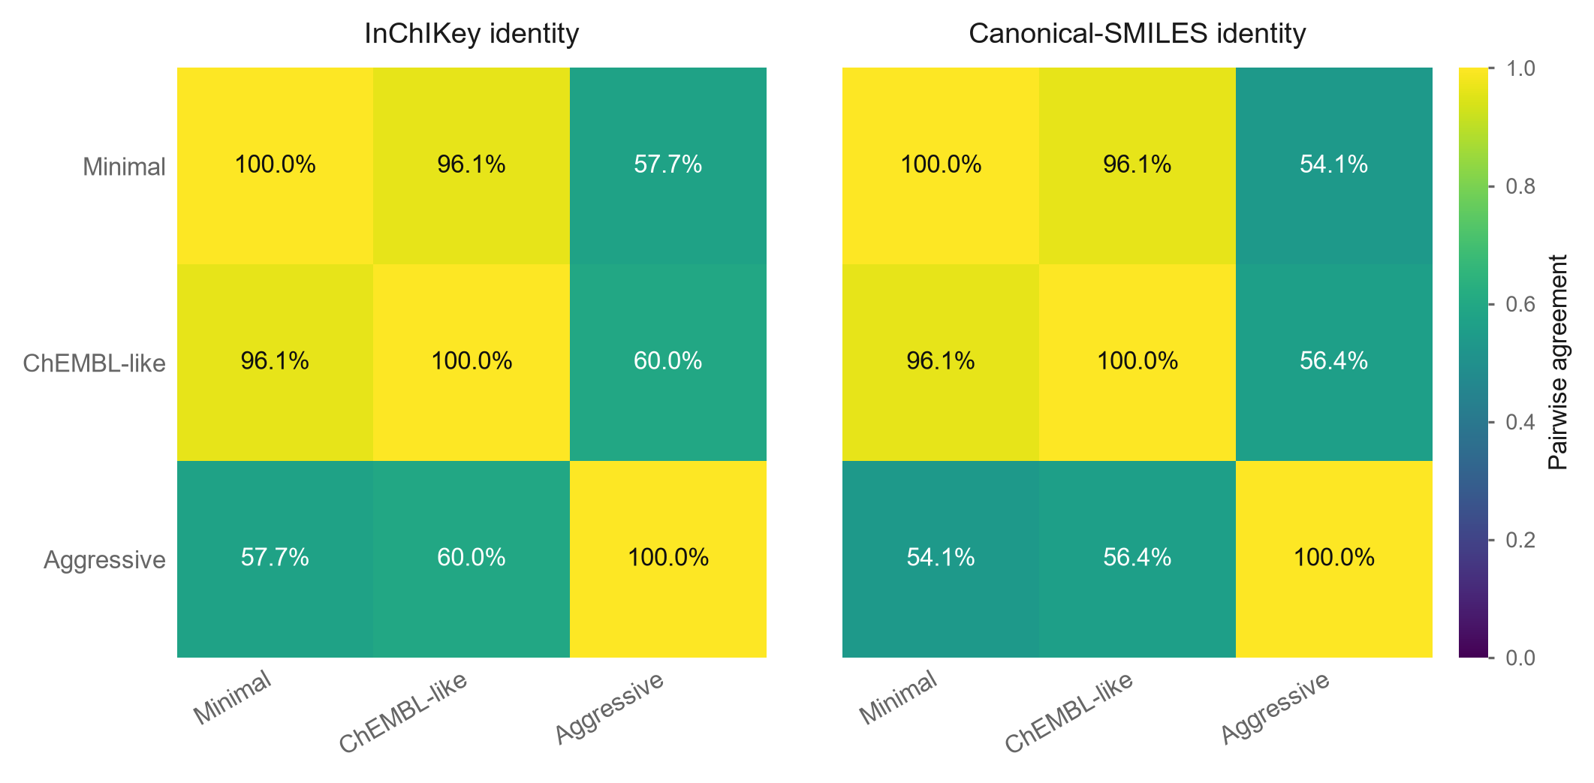
Figure 2. Divergence cause spectrum with 95% Wilson intervals. Fractions are of the 2280 divergent molecules and do not sum to 1, since one molecule may implicate several operations.
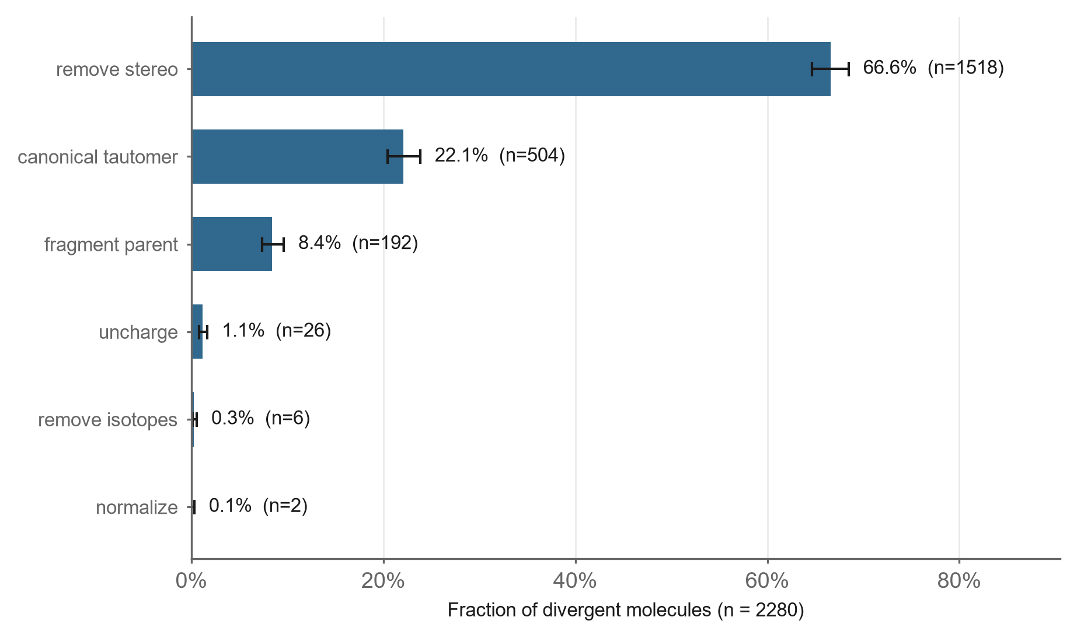
Figure 3. Headline reproducibility under each identity convention, with 95% Wilson intervals.
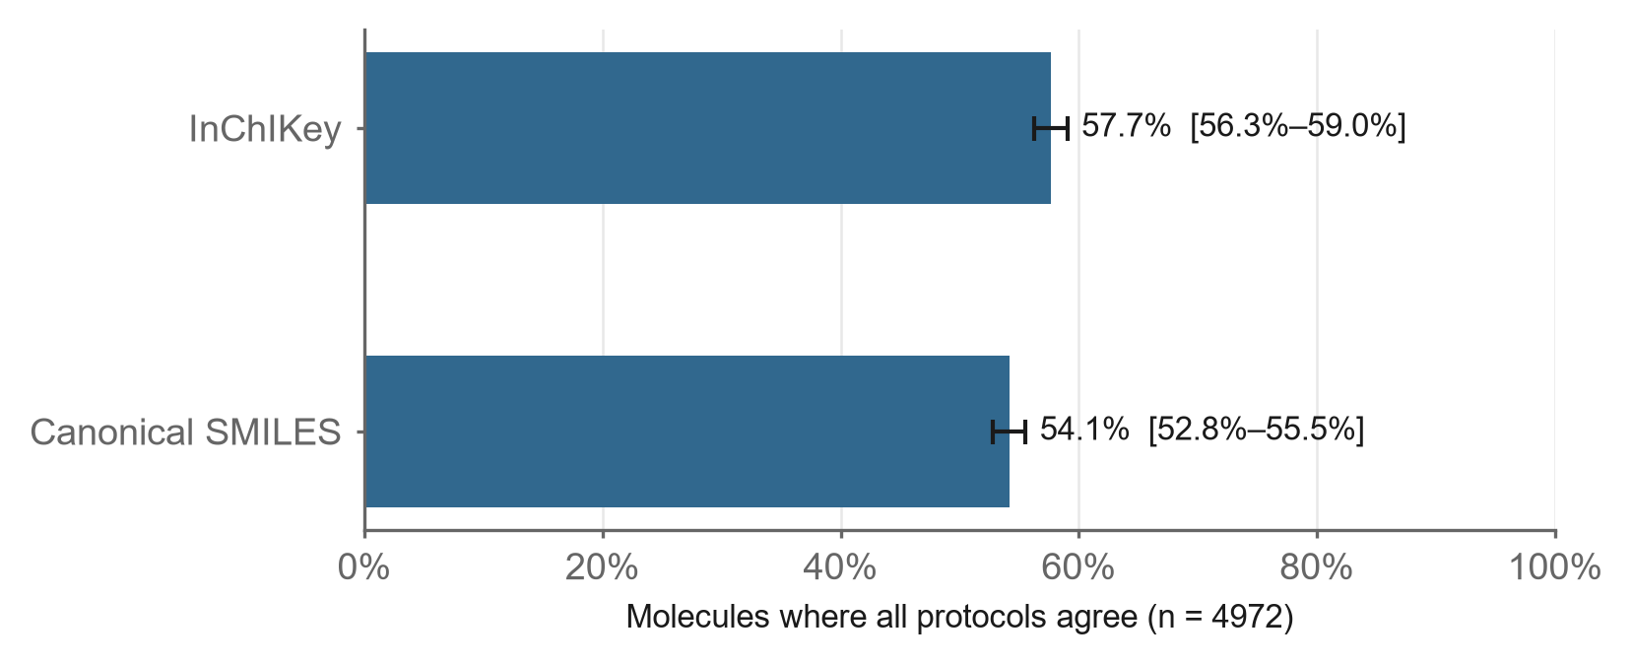

Data and code availability
The implementation, unit tests, sampling script, analysis script and figure generation code are available in the WaweKit repository under the MIT license (src/wawekit/services/reproducibility/, learning/research-track-R5-benchmark/, learning/research-track-R6-manuscript/). The drawn sample (chembl_sample.smi), the sampling offsets and seed (chembl_sample_offsets.json) and the complete audit output (chembl_results.json) are included, so every reported figure is regenerable from a single command.

Author contributions, funding, competing interests
To be completed by the author(s) before submission.

References
- Bento AP, Hersey A, Félix E, Landrum G, Gaulton A, Atkinson F, Bellis LJ,
De Veij M, Leach AR. An open source chemical structure curation pipeline using RDKit. J Cheminform. 2020;12(1):51. doi:10.1186/s13321-020-00456-1
- Heller SR, McNaught A, Pletnev I, Stein S, Tchekhovskoi D. InChI, the IUPAC
International Chemical Identifier. J Cheminform. 2015;7:23. doi:10.1186/s13321-015-0068-4
- Hähnke VD, Kim S, Bolton EE. PubChem chemical structure standardization.
J Cheminform. 2018;10(1):36. doi:10.1186/s13321-018-0293-8
- Dhaked DK, Guasch L, Nicklaus MC. Tautomer Database: A Comprehensive
Resource for Tautomerism Analyses. J Chem Inf Model. 2020;60(3):1090-1100. doi:10.1021/acs.jcim.9b01156
- Mansouri K, Grulke CM, Richard AM, Judson RS, Williams AJ. An automated
curation procedure for addressing chemical errors and inconsistencies in public datasets used in QSAR modelling. SAR QSAR Environ Res. 2016;27(11):939-965. doi:10.1080/1062936X.2016.1253611
Software: RDKit (2026.03.4) and the ChEMBL database release corresponding to 2,921,148 molecule records must additionally be cited per their own instructions; these are not PubMed-indexed and their citation form should be verified before submission.

