WaweKit: an offline desktop workbench for cheminformatics with built-in standardization auditing
Target venue: SoftwareX (Elsevier). Format follows the SoftwareX template: code metadata table, Motivation and significance, Software description, Illustrative examples, Impact, Conclusions.
Relationship to the companion research paper. This article describes the software. The scientific study that the reproducibility auditor enabled — divergence measurement across 4,972 ChEMBL structures and its downstream consequences on 27,152 bioactivity measurements — is reported separately and cites this article for the tool. This paper contains no results from that study beyond what is needed to demonstrate that the feature works.

Code metadata
Current code version | 0.1.0
Permanent link to code/repository | https://github.com/SreeVasthav-Upputoori/WaweKit
Permanent link to Reproducible Capsule | (Zenodo DOI — to be minted at submission)
Legal Code License | MIT
Code versioning system used | git
Software code languages, tools, services used | Python 3.12+, PySide6 (Qt 6), RDKit, scikit-learn, matplotlib, ReportLab, 3Dmol.js
Compilation requirements, operating environments | Python ≥ 3.12; Windows, macOS, Linux
Link to developer documentation | https://github.com/SreeVasthav-Upputoori/WaweKit/blob/main/docs/FEATURES.md
Support email for questions | (author contact — to be completed)

1. Motivation and significance
Cheminformatics analysis of small-molecule datasets — loading structures, standardizing them, computing descriptors and fingerprints, searching by similarity or substructure, clustering, and reporting — is routine work, but the software landscape for performing it interactively is polarised. On one side are programmatic toolkits, principally RDKit, which are powerful and free but require fluency in Python. On the other are graphical environments such as KNIME, Datagrok and DataWarrior, which remove the coding requirement but bring workflow-engine complexity, platform services, or licensing and deployment constraints that are not always compatible with teaching settings, air-gapped environments, or researchers whose primary training is synthetic or medicinal chemistry rather than programming.
WaweKit occupies the space between: a single-window desktop application that performs a complete analysis workflow locally, with no account, no server, no network access and no scripting, while remaining a plain Python package that can be imported and scripted when the user is ready for that.
The specific gap that motivated its development, however, is narrower and is what distinguishes WaweKit from the alternatives above. Structure standardization — normalising salts, charge states, tautomers, isotopes and stereochemistry — is a mandatory preprocessing step whose protocol varies between tools and configurations, and no existing interactive tool lets a user measure how much that choice affects their own dataset. Standardization implementations are widely available; the ChEMBL curation pipeline [1] and the PubChem standardization service [2] are prominent, independently designed, and not equivalent to one another. What is not available is a way to ask, of a specific dataset, which molecules would receive a different identity under a different protocol, and which normalization operation is responsible.
WaweKit provides that capability as a first-class, interactive feature alongside the conventional analysis toolset, and exposes the same computation as a Qt-free library and command-line tool so it can be embedded in non-interactive pipelines.

2. Software description

2.1 Software architecture
WaweKit is organised in four layers with dependencies pointing in one direction only:
gui → services → models → core
- core (5 modules, ~370 lines) — configuration, logging, cross-platform
paths, application constants. No chemistry.
- models (9 modules, ~1,200 lines) — RDKit-backed domain objects: the
molecule record and the typed results attached to it (descriptor sets, fingerprints, similarity scores, scaffolds, conformer ensembles, cluster assignments, substructure hits). Contains no Qt and no computation.
- services (29 modules, ~4,700 lines) — all chemistry and I/O:
standardization, descriptors, fingerprints, similarity, scaffolds, conformer generation, chemical-space projection, clustering, substructure search, structural alerts, format conversion, report generation, and the reproducibility auditor. Services may use Qt's core (signals, thread pool) but never its widgets.
- gui (32 modules, ~7,100 lines) — the PySide6 window, docked panels,
dialogs and delegates.
- plugins (3 modules) — third-party extension loading.
Two consequences of this arrangement matter for reuse. First, every analysis service imports without Qt, so the scientific functionality is usable headlessly; pip install wawekit installs the library and command-line tools without the GUI framework, and pip install wawekit[gui] adds the desktop application. Second, because the GUI holds no computation, the interactive and programmatic interfaces cannot diverge: the panel and the command-line tool call the same functions, and this equivalence is asserted by the test suite rather than by convention.
Long-running operations execute on a Qt thread pool and report progress through signals, so the interface remains responsive on datasets of thousands of structures. Every batch service follows the same contract — a progress callback, a result report carrying per-molecule failures, and the rule that one unprocessable structure never aborts a run.

2.2 Software functionalities
Data handling. Import of SDF, MOL and SMILES files by dialog or drag-and-drop, with per-record error reporting; a standalone format converter between CSV, SDF, MOL and SMILES; export to CSV and SDF with computed values attached as data fields.
Structure display. A sortable table with 2D depictions rendered per row, a detail panel with SVG/PNG export, and an interactive 3D viewer (3Dmol.js in an embedded browser view) that generates a conformation on demand for the selected molecule.
Standardization. Configurable cleanup — salt stripping, charge neutralisation, tautomer canonicalisation, deduplication — reporting every change made to every structure rather than applying them silently.
Analysis. Drug-likeness descriptors with Lipinski evaluation; Morgan, MACCS and RDKit fingerprints; Tanimoto/Dice/Cosine similarity ranking; Bemis–Murcko scaffold grouping with click-to-filter; conformer generation (ETKDG with MMFF94/UFF optimisation) with energy ranking and SDF export; chemical-space projection by PCA or t-SNE with linked selection between plot and table; Butina and k-means clustering; SMARTS/SMILES substructure search with matched-atom highlighting; and structural-alert screening against the combined PAINS, Brenk and NIH catalogues (765 substructure filters), flagging assay-interference and liability motifs with per-molecule detail.
Filtering. A query box accepting text and numeric comparisons (MW < 500, LogP >= 2), plus an interactive range-filter panel whose bounds are derived from the loaded dataset.
Standardization reproducibility auditing. The distinguishing capability. The user selects two or more standardization protocols — each a named subset of eight normalization operations applied in fixed order — and WaweKit reports how often they produce the same standardized identity, evaluated separately under canonical-SMILES and InChIKey identity, and attributes each disagreement to a specific operation by systematic ablation. Results are presented as a protocol-agreement heatmap, a cause-spectrum chart, and an inspectable list of the affected molecules.
Workflow and output. A batch dialog chaining standardization → descriptors → fingerprints → scaffolds → clustering → export as one cancellable operation; and self-contained HTML and paginated PDF reports with embedded depictions and summary statistics.
Extension and presentation. A plugin system discovering third-party packages through Python entry points, so installing a package adds menu items or dock panels with no modification to WaweKit; eight visual themes; and an illustrated in-application manual.

2.3 Quality assurance
The project has 346 automated tests covering the domain models, every chemistry and I/O service, the reproducibility auditor, GUI panels and dialogs (headless, via pytest-qt), the plugin loader, and the documentation itself — one test fails if the in-app manual references a missing image or omits a feature section. Continuous integration runs linting, formatting and the full suite on Ubuntu, Windows and macOS. A dedicated test asserts that the graphical, command-line and library interfaces return identical results for the same input, and a further test asserts that repeated audits of the same data produce identical output.

3. Illustrative examples

3.1 Interactive analysis
A user opens a SMILES or SDF file by drag-and-drop; structures appear as a sortable table with 2D depictions (Figure 1). Ctrl+D computes descriptors, adding columns for molecular weight, logP, TPSA, hydrogen-bond counts, rotatable bonds, ring count and Lipinski violations, and populating the property-filter panel with the ranges present in the loaded data. Typing MW < 350 in the filter box narrows the table; clicking a column header sorts by it. Selecting a row updates the structure panel, which also reports any structural alerts matched. Ctrl+Shift+P projects the dataset into two dimensions, and lassoing a cluster in the plot selects the corresponding table rows. Ctrl+R writes a shareable HTML report. No scripting is involved at any point, and no data leaves the machine.

3.2 Auditing standardization choices
With a dataset loaded, Research → Reproducibility Audit offers the three bundled protocols — Minimal (normalisation only), ChEMBL-like (approximating the published ChEMBL pipeline, notably without tautomer canonicalisation) and Aggressive (all eight operations).
Figure 2 shows the result for a 40-structure set spanning salts, charged species, tautomer-ambiguous heterocycles, isotopic labels and stereocentres. The panel reports that the three protocols agree on 70% of the set under canonical-SMILES identity and 75% under InChIKey identity, with twelve structures sensitive to protocol choice. The heatmap gives pairwise agreement: ChEMBL-like and Aggressive agree on 90% of structures, while Minimal and Aggressive agree on only 75%. The cause spectrum attributes those disagreements to specific operations — charge neutralisation and parent-fragment selection dominating this set — and the list beneath names the affected structures individually, so a curator can inspect exactly which compounds are pipeline-dependent and why. Two entries are marked unattributed, the honest report for a divergence that no single-operation ablation could isolate.

3.3 The same analysis without the interface
The identical computation is available as a library:
```python from rdkit import Chem from wawekit.services.reproducibility import analyze_divergence, compute_metrics from wawekit.services.reproducibility.protocol import DEFAULT_PROTOCOLS
records = [(name, Chem.MolFromSmiles(smi)) for name, smi in my_compounds] run = analyze_divergence(records, DEFAULT_PROTOCOLS) metrics = compute_metrics(run)
print(f"{metrics.inchikey_reproducibility:.1%} reproducible") for operation, fraction in metrics.cause_spectrum.items(): print(f" {operation}: {fraction:.1%} of divergent molecules") ```
and as a command-line tool for unattended use:
python -m wawekit.services.reproducibility.benchmark compounds.smi --out results.csv
Neither requires the GUI dependencies to be installed.

4. Impact
A capability not otherwise available interactively. To our knowledge no other graphical cheminformatics tool measures cross-protocol standardization divergence or attributes it to individual normalization operations. Because standardization determines which database records are treated as the same compound, this affects deduplication, dataset merging and any model trained on the result. The companion research paper uses WaweKit to show that protocol choice can remove several percent of a bioactivity dataset by merging and can fuse compounds differing thousandfold in potency into single training labels — consequences that conventional aggregate model metrics do not reveal. WaweKit makes detecting them a routine step rather than a bespoke study.
Accessibility. The application requires no programming, no account, no network connection and no license server, and is MIT licensed. This suits teaching environments, institutions without dedicated computational chemistry support, and settings where data cannot leave local infrastructure. The repository additionally contains a twenty-module development narrative documenting how each capability was built and why, which is usable as instructional material.
Reuse. The layered architecture means the chemistry services can be imported independently of the interface; the headless installation path makes this practical. The plugin system allows extension without forking. Published analyses can cite an exact version through the archived release.
Comparison with existing tools. WaweKit does not aim to replace established environments, and its position relative to them should be stated plainly.
 | WaweKit | DataWarrior | KNIME | RDKit (library)
Interactive desktop UI | yes | yes | yes | no
No coding required | yes | yes | yes | no
Fully offline, no account | yes | yes | yes | yes
Open source | MIT | BSD | GPL/commercial | BSD
Workflow automation | batch dialog only | limited | extensive | via scripting
Visualisation breadth | moderate | extensive | extensive | minimal
Ecosystem / user base | new | large | very large | very large
Scriptable as a library | yes | no | limited | yes
Standardization reproducibility auditing | yes | no | no | no

DataWarrior and KNIME are more mature, have far larger user communities, and offer broader visualisation and workflow automation than WaweKit does; for general-purpose exploratory analysis they remain the better-supported choices. WaweKit's contribution is the reproducibility auditing capability, delivered in an interface that requires no scripting, together with a codebase small and strictly layered enough to be reused programmatically or extended.
Limitations. The project is new and its user base correspondingly small. It does not provide workflow automation comparable to KNIME, and its visualisation is deliberately narrower than DataWarrior's. Standardization protocols are currently constructed from RDKit operations, so divergence between different toolkits' implementations cannot yet be measured — extending the protocol model across toolkits is the principal planned development.

Figures
Figure 1. The WaweKit main window after loading a structure file and computing descriptors. The central table carries 2D depictions and one column per computed value; the structure panel (right) shows the selected molecule with its matched structural alerts; the property-filter panel (left) derives its ranges from the loaded data. Docked panels are rearrangeable and each can be hidden.
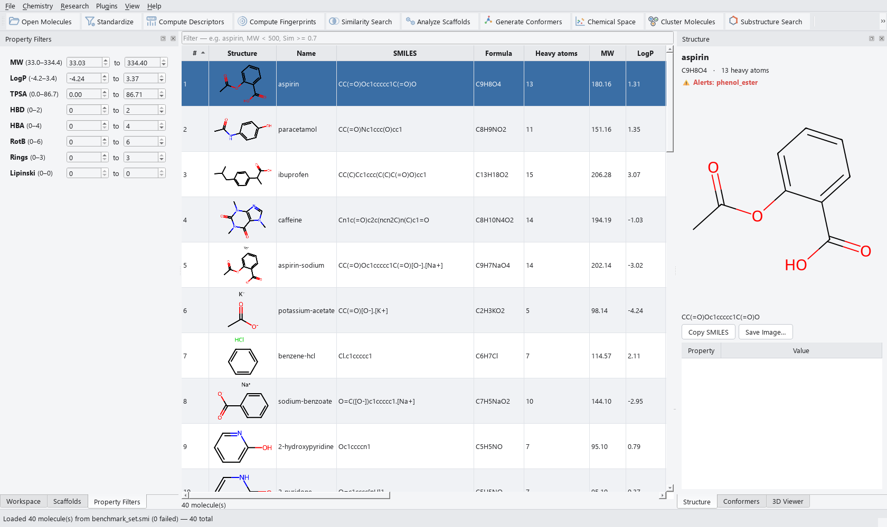
Figure 2. The reproducibility audit panel, showing a completed audit of 40 structures under three standardization protocols. Top left: pairwise protocol agreement under InChIKey identity, on a perceptually-uniform, colour-vision-safe scale with values printed so colour is never the sole encoding. Top right: the operations to which divergence was attributed by ablation. Bottom: the individual structures affected, each with its attributed cause, including entries marked unattributed where no single operation accounted for the difference.
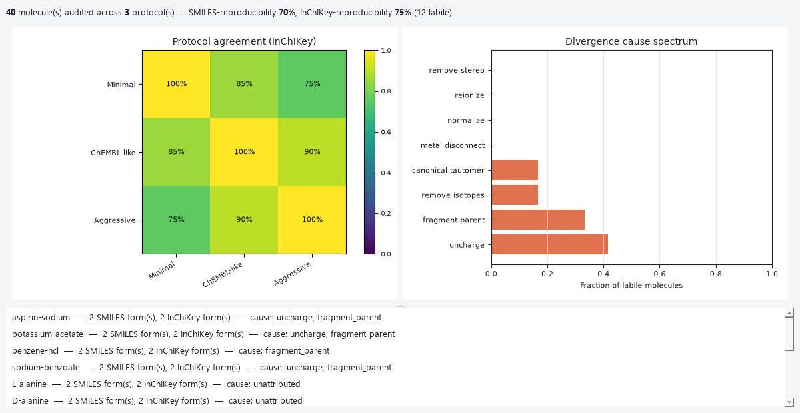

5. Conclusions
WaweKit is an open-source desktop workbench that performs the routine operations of small-molecule cheminformatics locally and without scripting, and adds a capability not otherwise available in an interactive tool: measuring how sensitive a dataset's molecular identities are to standardization protocol choice, and attributing that sensitivity to specific normalization operations. Its layered architecture keeps the scientific functionality importable without the interface, so the same computation serves interactive, scripted and unattended use, with equivalence between them enforced by the test suite.

Acknowledgements
(To be completed by the author(s).)

References
- Bento AP, Hersey A, Félix E, Landrum G, Gaulton A, Atkinson F, Bellis LJ,
De Veij M, Leach AR. An open source chemical structure curation pipeline using RDKit. J Cheminform. 2020;12(1):51. doi:10.1186/s13321-020-00456-1
- Hähnke VD, Kim S, Bolton EE. PubChem chemical structure standardization.
J Cheminform. 2018;10(1):36. doi:10.1186/s13321-018-0293-8
- Heller SR, McNaught A, Pletnev I, Stein S, Tchekhovskoi D. InChI, the IUPAC
International Chemical Identifier. J Cheminform. 2015;7:23. doi:10.1186/s13321-015-0068-4
Software cited in the text — RDKit, DataWarrior, KNIME, Datagrok, 3Dmol.js — must be cited per each project's own instructions; these were not verified through a bibliographic database and should be checked before submission.

