**Homework 2 – VBA Scripting Challenges**

Notes:

1. If I want to re-run the code, I would have to go back and delete all the columns before I run it again. Running the whole code multiple times results in multiple sections of the results data. During my testing, I frequently deleted the columns and results and often, I would save my code and completely exit out of Excel, before reopening it and running the code again.
2. After getting the screenshots for my dataset, I ran the code again and for some reason, I was unable to get values for the greatest % increase, decrease, and the greatest total volume for sheets 2015 and 2016. I think it was because I did not exit out and reload the file. But it ended up working for me a couple of times, which explains how I was able to capture some screenshots. Just a note for you if you encounter this problem as well.
3. This wasn’t specifically requested in the instructions, but I went ahead and made two columns for opening price and the closing price for the ticker, so that I could easily compute the yearly change and percent change.
4. I realized much later in the assignment that I forgot to save the code for the “easy” part of the assignment, so I am submitting just one file with code, as opposed to two, along with this report.

Screenshot before attempting the first challenge:

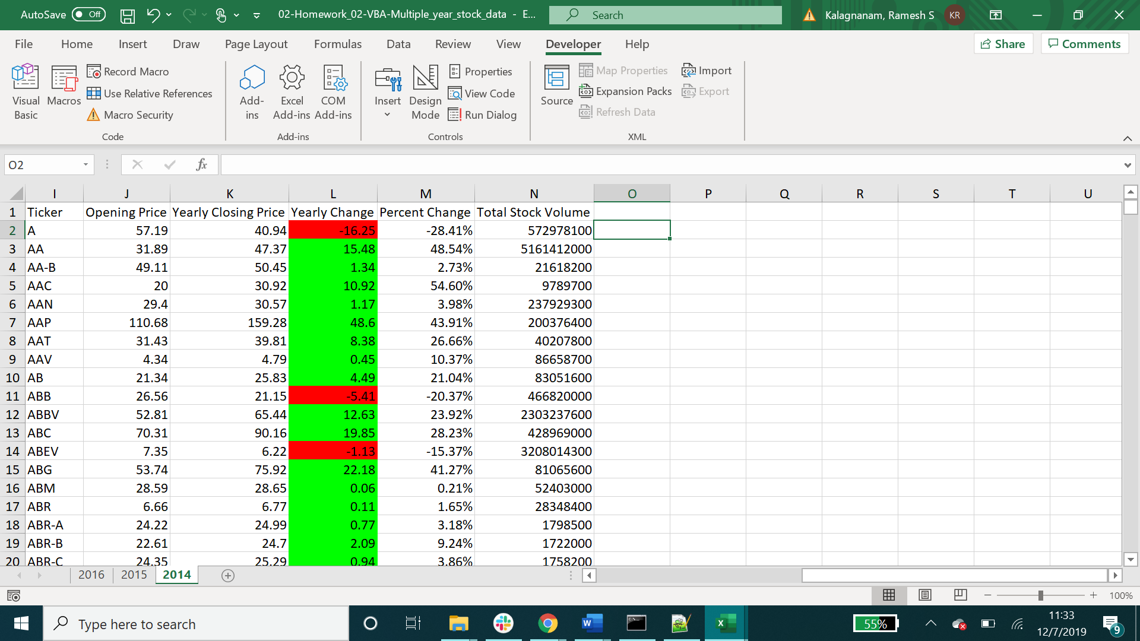

Screenshot of the 2014 tab:

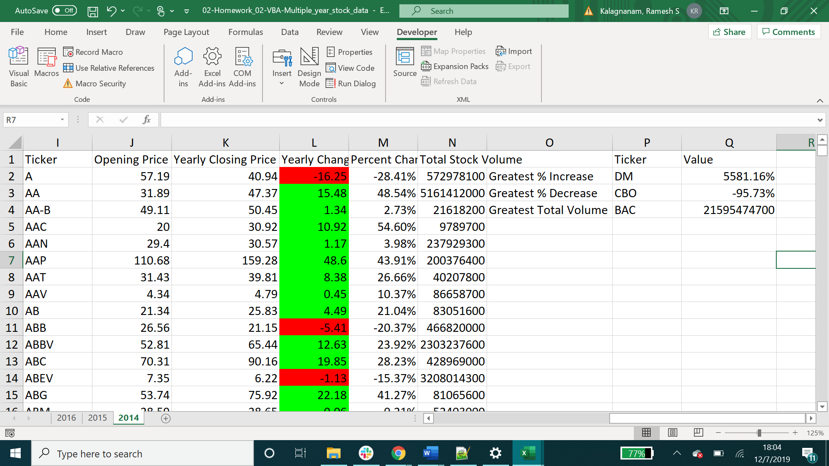

Screenshot of the 2015 tab:

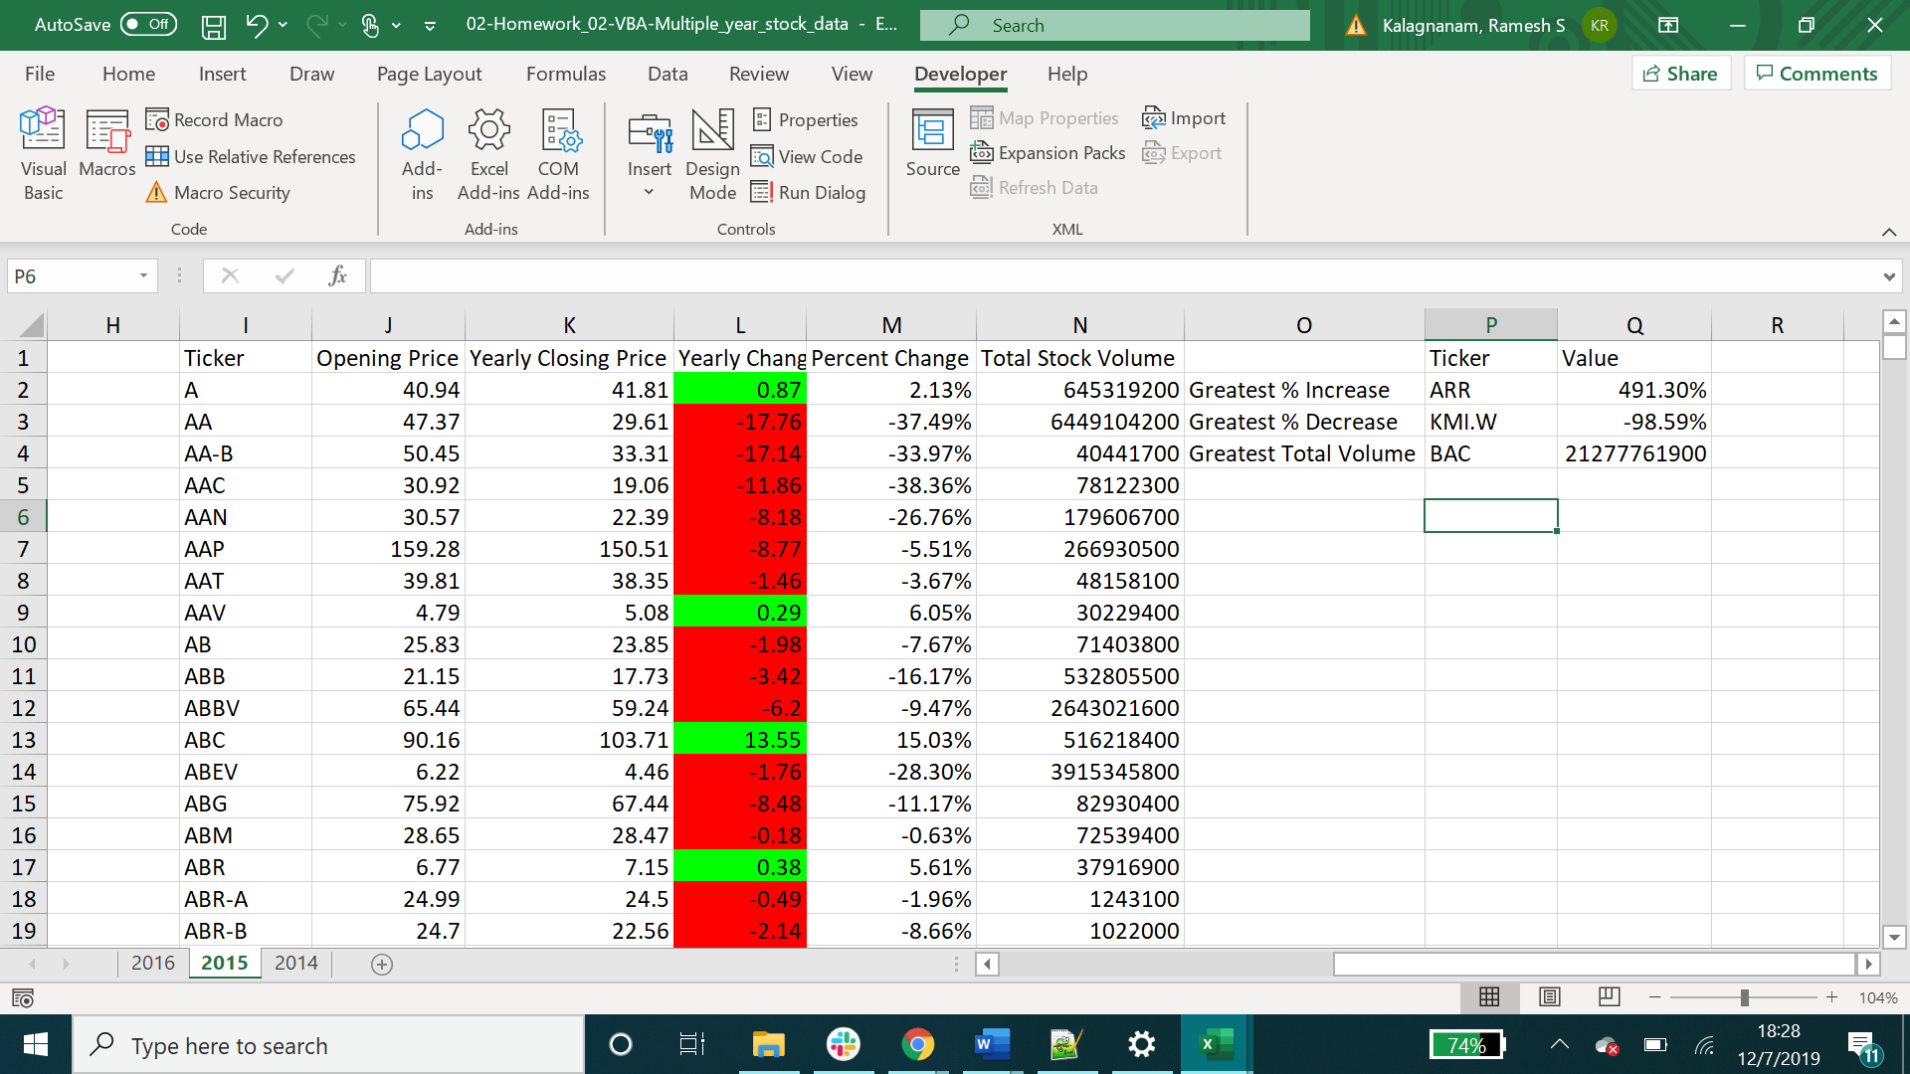

Screenshot of the 2016 tab:

