SenseMinds 360
Codebase Review
Complete codebase · Testing & validation · Deployment · 22 July 2026

For technical review of the complete codebase. A concise map of what exists, how it is structured, how it is tested, and what is deployed. Deeper detail lives in the companion documents linked at the end.
*22 July 2026 · 231 automated tests passing · deployed and live on GCP*

1. What it is
A predictive-maintenance platform for six utility machines at Laurus Labs. It turns raw sensor history into deterministic engineering facts, a knowledge graph, rule-based diagnoses, machine-learning hypotheses, escalation email, and a grounded LLM that explains everything with cited evidence.
Design rule the whole codebase obeys: deterministic facts are authoritative; machine learning is strictly additive and advisory. Remove the ML layer and nothing deterministic changes.

2. Architecture at a glance
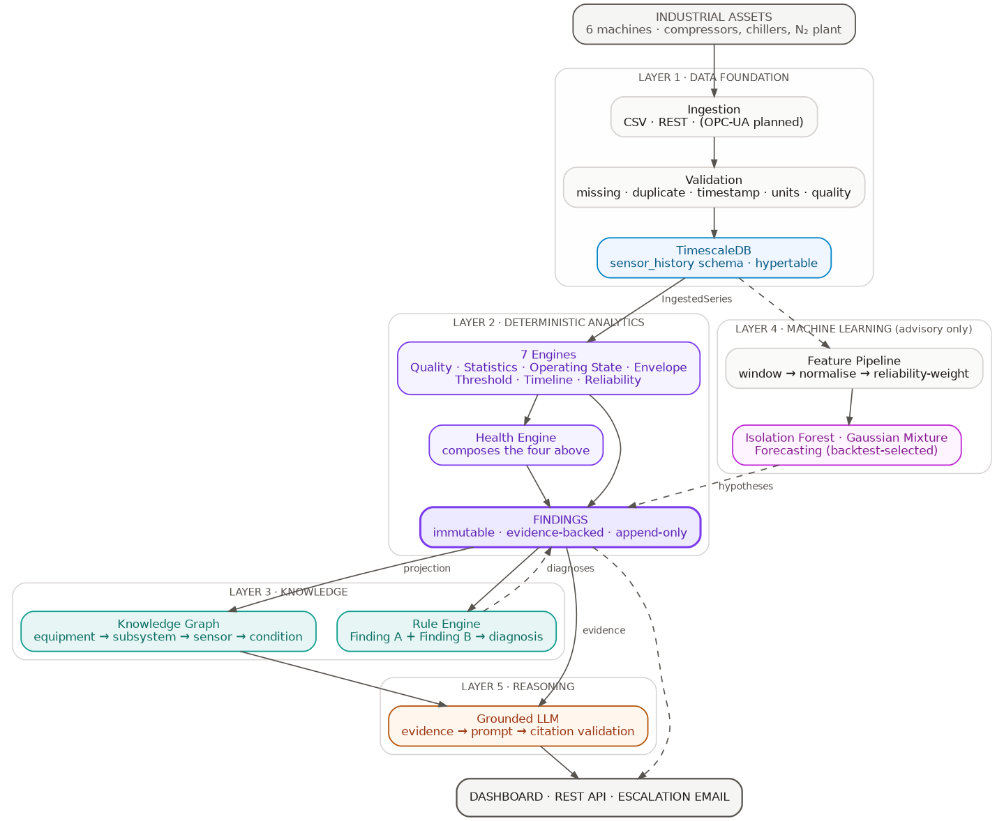
The five layers. Solid = facts; dashed = advisory hypotheses.
Data flows top to bottom: validated readings → deterministic engines → immutable
Findings → knowledge graph → rule diagnoses → ML enrichment → grounded LLM → API/dashboard. Full walkthrough with one reading traced end-to-end: TECHNICAL-WALKTHROUGH.md.

3. Codebase structure
One modular monolith, strict internal boundaries (senseminds/):
Package | Responsibility
domain/ | Immutable models, enums, value objects
ingestion/ | Validation, TimeSeriesSource, CSV/DB adapters, ReadingSink
engines/ | The 7 deterministic analytics engines
findings/ | Immutable Finding contract + assembler
rules/ | Rule definitions + forward-chaining evaluator (diagnoses)
knowledge_graph/ | Graph model, projector, feedback projector
pattern_learning/ | Unsupervised novelty / regimes + engineer feedback store
forecasting/ | Backtest-selected short-horizon forecasting
llm/ | Grounded communication: retrieval, prompt, citation validator
alerting/ | Escalation policy, SMTP mailer, outbox dispatcher
application/ | AnalysisUseCase — atomic orchestration
repositories/ | Aggregate-root ports + models
infrastructure/ | DB engine, migrations, Postgres repos, artifact store, logging
api/ | FastAPI app, routers, JWT auth
workers/ | Continuous analysis worker
frontend/ | React + Vite + Tailwind dashboard

Boundaries that make it reviewable and extensible: business logic depends on
*ports* (interfaces), not concretes — ArtifactStore, KnowledgeGraphRepository, TimeSeriesSource, LanguageModel. Each has an in-memory implementation for tests and a production one, so swapping storage or the graph engine later is one class, not a rewrite.

4. Testing & validation
231 automated tests pass (31 skipped only when a live database isn't present), plus live end-to-end suites and a tested disaster-recovery restore. Zero ruff lint findings.
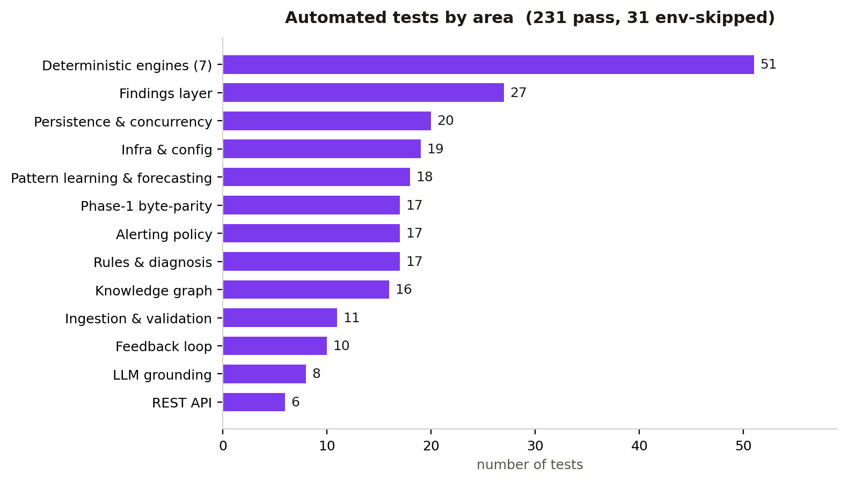
Automated tests by area.

4.1 Kinds of validation used
Kind | What it proves | Where
Unit tests | Each engine / component behaves per spec | 51 engine + per-module tests
Byte-parity tests | Refactored engines produce output byte-identical to the original Phase-1 analysis | 17 test_parity_*
Persistence parity | Data round-trips CSV → DB → reconstruction identically | test_db_parity, test_application_persistence
Idempotency & concurrency | Re-running an input is a no-op; 5 concurrent analyses produce one result | test_analysis_concurrency, test_kg_idempotency
Policy edge cases | Alerting lifecycle (17) and feedback loop (10) pinned against every corner case | test_alert_policy, test_feedback_loop
Live end-to-end | 28 real cases against the running API + Postgres (auth, validation, append-only triggers, KG survival) | feedback E2E suite
Tested restore | A backup actually restores into a throwaway DB with data + triggers intact | validate-restore.sh — PASSED
Live deployment checks | CORS, metrics, a real escalation email delivered from the server | verified on the VM

4.2 Notable things the tests caught (and now guard)
- Findings explosion — un-changed conditions were re-recorded every cycle (4,006 rows for 25 conditions). Fixed with a material-change filter; pinned by test_finding_delta.
- Verdict-erasure regression — engineer verdicts would have been silently wiped by the next ML re-projection. Fixed by storing them on their own graph node; pinned by test_validation_survives_a_pattern_reprojection.
- Backup that wouldn't restore — a floating Postgres image tag drifted the TimescaleDB version and broke logical restore. Caught only by *testing* the restore; fixed by pinning the image by digest.

4.3 Reproducibility discipline
- Python dependencies pinned in requirements.lock (the image builds from it, not open ranges) — protects byte-identical numerical output.
- The Postgres/TimescaleDB image pinned by digest.
- Every engine is a pure function; every finding carries provenance (engine, version, input hash, timestamp).

5. Deployment status
Live on GCP (Deployment Strategy v1, single plant):
Item | Status
Compute | GCE VM, Dockerised stack
State | Postgres + artifacts on a persistent disk (survives VM deletion)
Data | All 6 machines bootstrapped (~2.6M readings), analysed
API | http://35.254.19.129:8000 · docs at /docs · health at /ready
Backups | Nightly pg_dump + disk snapshots, tested restore
Escalation email | Verified — a real alert delivered from the server

Durability, backup, and recovery policy: DATA-GOVERNANCE.md. Deployment architecture and rationale: DEPLOYMENT-STRATEGY-V1.md.

6. Honest scope
Complete and running: all 7 engines, findings, knowledge graph, rules, pattern learning, forecasting, grounded LLM, alerting, the feedback loop, the dashboard, and the deployment.
Not built, by design:
- Phase C supervised failure prediction / RUL — blocked on labelled breakdown history the plant hasn't provided. The feedback loop is already capturing the labels that will unlock it.
- OPC-UA / Modbus ingestion — data currently arrives via CSV/REST.
- Auth hardening (rotating dev secrets, refresh tokens, user management) and HTTPS lock-down — deferred for v1, required before external exposure.

7. Companion documents
Document | Contents
TECHNICAL-WALKTHROUGH.md | Architecture, one reading traced end-to-end, six scenario dry runs, edge cases
API-REFERENCE.md | Every endpoint, for the frontend engineer
DEPLOYMENT-STRATEGY-V1.md | GCP deployment, single plant
DATA-GOVERNANCE.md | Durability, consistency, tested recovery
`docs/architecture/` | ADR-001 … ADR-019 — every decision and its rejected alternatives

