**SERVERLESS IOT DATA PROCESSING**

***Consider integrating machine learning models to enhance the automation and decisionmaking capabilities of the smart home***

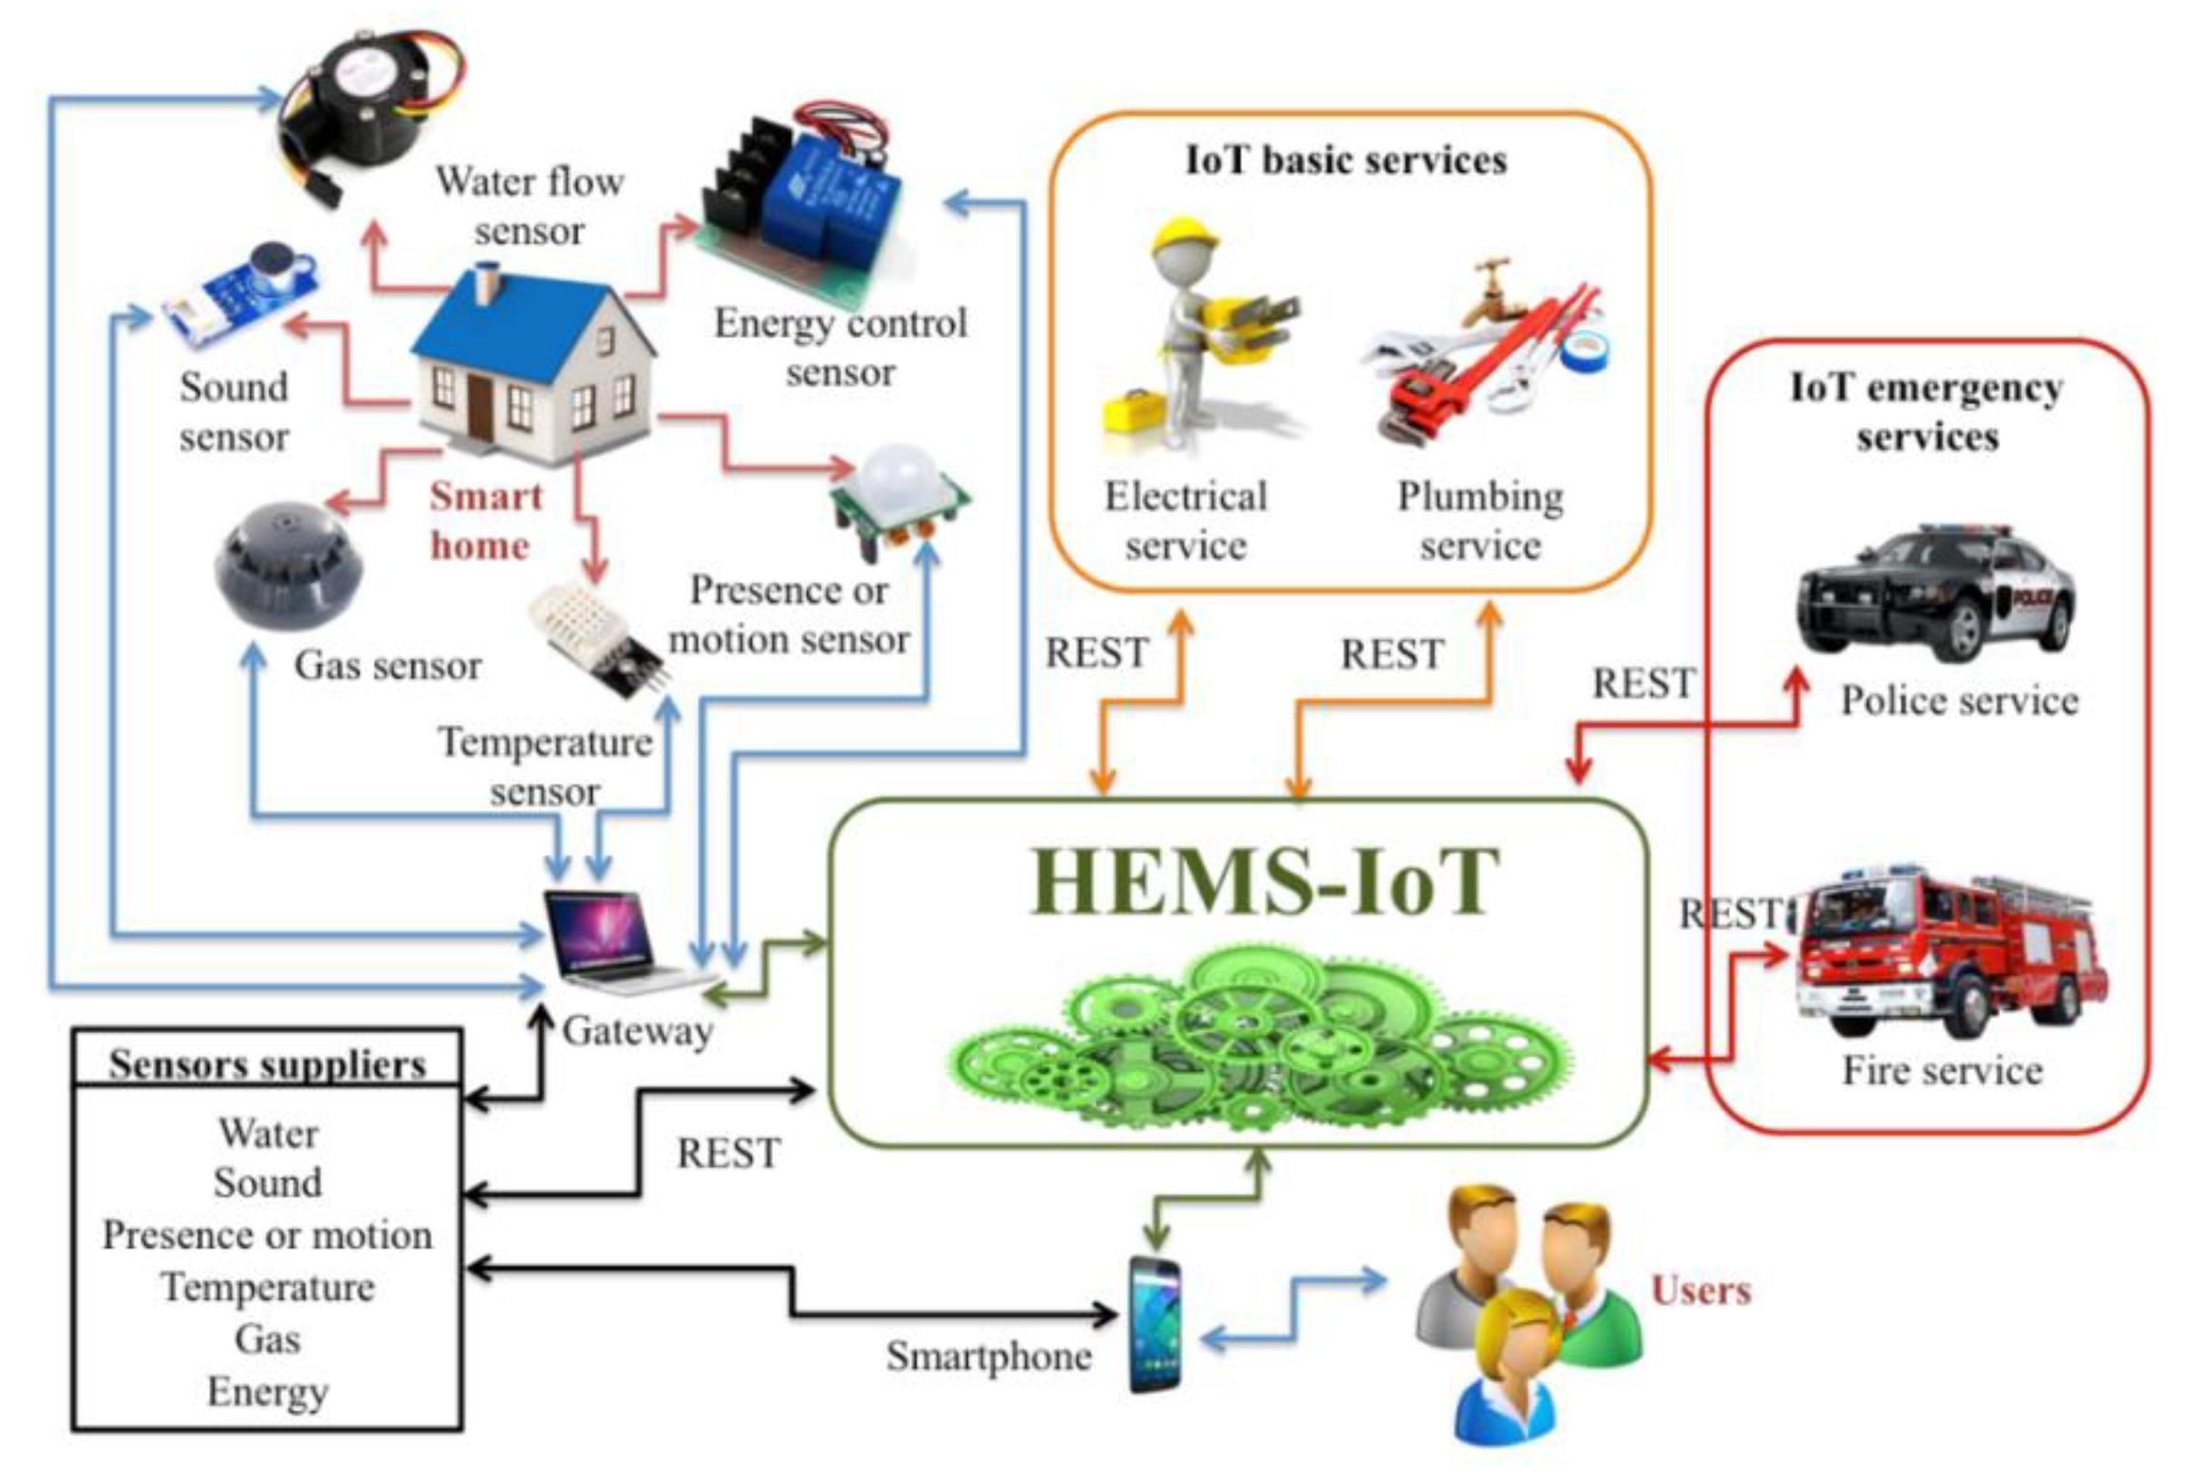

***Energy Management:***

*Predictive Analytics: Machine learning can analyze historical energy usage data to predict future consumption patterns and optimize heating, cooling, and lighting accordingly.*

*Demand Response: ML models can enable the smart home to participate in demand response programs by automatically adjusting energy-intensive devices during peak demand periods.*

***Program in python:***

*Import cv2*

*# Load a pre-trained object detection model*

*Net = cv2.dnn.readNet(“yolov3.weights”, “yolov3.cfg”)*

*# Load classes file*

*With open(“coco.names”, “r”) as f:*

*Classes = f.read().strip().split(“\n”)*

*# Load image from a security camera*

*Image = cv2.imread(“security_camera_image.jpg”)*

*Blob = cv2.dnn.blobFromImage(image, 1/255.0, (416, 416), swapRB=True, crop=False)*

*Net.setInput(blob)*

*Layer_names = net.getUnconnectedOutLayersNames()*

*Outs = net.forward(layer_names)*

*# Parse the output and draw bounding boxes*

*Conf_threshold = 0.5*

*For out in outs:*

*For detection in out:*

*Scores = detection[5:]*

*Class_id = scores.argmax()*

*Confidence = scores[class_id]*

*If confidence > conf_threshold:*

*# Draw bounding box and label*

*Center_x, center_y, width, height = (detection[0:4] * [image.shape[1], image.shape[0], image.shape[1], image.shape[0]]).astype(int)*

*X, y = int(center_x – width/2), int(center_y – height/2)*

*Cv2.rectangle(image, (x, y), (x + width, y + height), (0, 255, 0), 2)*

*Cv2.putText(image, classes[class_id], (x, y – 5), cv2.FONT_HERSHEY_SIMPLEX, 0.5, (0, 255, 0), 2)*

*# Display the image with detected objects*

*Cv2.imshow(“Security Camera Feed”, image)*

*Cv2.waitKey(0)*

*Cv2.destroyAllWindows()*

***Security and Surveillance:***

*Anomaly Detection: ML algorithms can detect unusual patterns of activity, helping to identify potential security threats or intrusions.*

*Facial Recognition: Smart cameras can use facial recognition to identify authorized residents and visitors, enhancing security.*

*Object Detection: ML can recognize and alert homeowners to specific objects or events, such as a package delivery or a pet wandering into restricted areas.*

***Personalized Comfort and Convenience:***

*Temperature Control: ML models can learn user preferences for heating and cooling, adjusting the temperature based on historical data and user feedback.*

*Lighting Control: Smart lighting can adapt to user preferences and habits, adjusting brightness and color temperature as needed.*

*Voice and Gesture Recognition: ML-powered systems can understand voice commands and gestures, making it easier for residents to control devices.*

***Predictive Maintenance:***

*Appliance Health Monitoring: Machine learning can monitor the performance of appliances and systems, predicting when maintenance or repairs are needed before they fail.*

*Water Leak Detection: ML can identify potential water leaks and shut off the water supply to prevent damage.*

***Health and Well-being:***

*Health Monitoring: Machine learning can analyze data from wearable devices and sensors to track the health and well-being of residents. For example, it can detect falls or irregular health patterns.*

*Medication Reminders: ML can provide reminders for medication schedules based on individual health conditions.*

***Contextual Automation:***

*ML models can consider various contextual factors like weather, time of day, occupancy, and personal preferences to automate actions. For instance, it can adjust blinds based on sunlight intensity or schedule the coffee maker to start brewing in the morning.*

***User Behavior Analysis:***

*ML can analyze user behavior and preferences over time to suggest optimizations or automate routine tasks. For example, it can recommend energy-saving settings or grocery shopping lists.*

***Security and Privacy:***

*It’s essential to ensure that any data collected by smart home devices and used by machine learning models is securely stored and privacy-compliant.*

*To implement these machine learning capabilities, a smart home would require a robust infrastructure with sensors, cameras, actuators, and a central controller capable of running machine learning models. Additionally, cloud-based solutions can provide scalability and remote access. Integration with IoT protocols like Zigbee, Z-Wave, or Wi-Fi is crucial to connect various devices.*

*Keep in mind that privacy and security should be paramount when integrating machine learning into a smart home. Data encryption, access control, and regular software updates are essential to protect user data and maintain system integrity.*