1. **Return a Fibonacci series of `num` length as a JSON**

|  |  |
| --- | --- |
| **Tool used for testing** | Postman |
| **Request Type** | GET |
| **URL** | http://localhost:50894/api/fibonacci/{num} |
| **Header Information** | **Key:** Content Type  **Value :** application/json |
| **Output format** | Json |
| **Json Format /Output format** | {  "fibonacciSequence": <fibonacciSequence> (List of Int)  "message": message (relevant messages)  } |

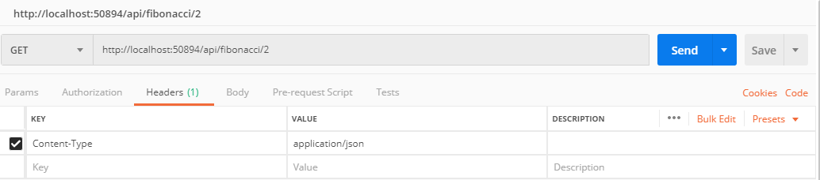

**Sample URL’s and Outputs**

|  |  |
| --- | --- |
| **URL** | **Actual Result** |
| http://localhost:50894/api/fibonacci/2 | {  "fibonacciSequence": [  0,  1  ],  "message": "Success"  } |
| http://localhost:50894/api/fibonacci/0 | {  "fibonacciSequence": null,  "message": "Please enter a numeric value greater than 0."  } |
| shttp://localhost:50894/api/fibonacci/-2 | {  "fibonacciSequence": null,  "message": "Please enter a numeric value greater than 0."  } |
| http://localhost:50894/api/fibonacci/4 | {  "fibonacciSequence": [  0,  1,  1,  2  ],  "message": "Success"  } |

1. **Compare 2 Lists and produce the below lists as output**

new: the list of keys – and their values --  that are in “current” but not in “initial”                                updated: a list of values that are both in “current” and “initial” but have a different value                                deleted: a list of keys – and their values – that are in “initial” but not in “current”

|  |  |
| --- | --- |
| **Tool used for testing** | Postman |
| **Request Type** | Post |
| **URL** | http://localhost:50894/api/common |
| **Header Information** | **Key:** Content Type  **Value :** application/json |
| **Body tab** | Select “raw” |
| **Output format** | Json |
|  | {  "newItems": [],  "updatedItems": [],  "deletedItems": [ ],  "message": ""  } |

**Header information**

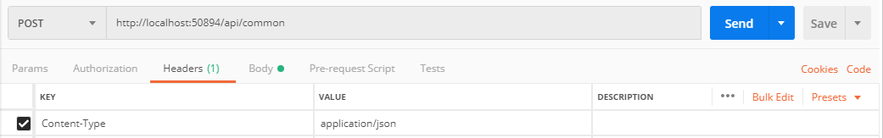

**Body content to be passed**

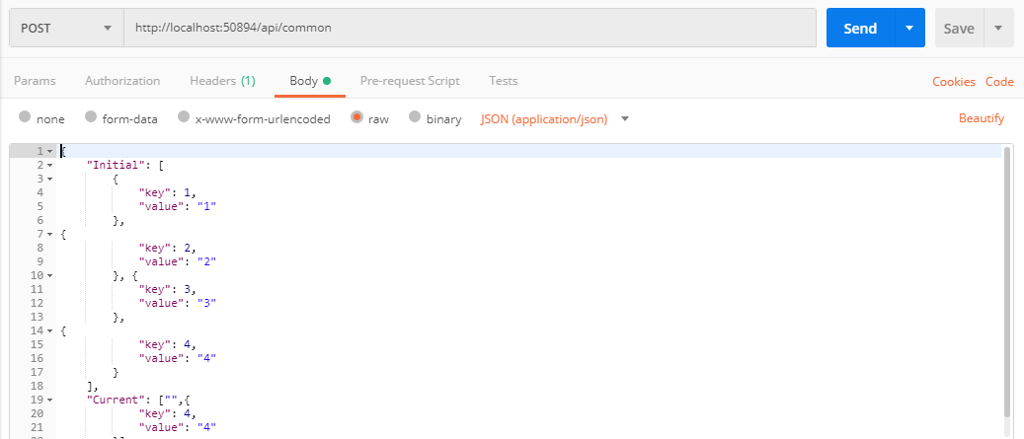

**Sample URL’s and Outputs**

|  |  |
| --- | --- |
| **URL**: http://localhost:50894/api/common | |
| **Input Json** | **OutPut** |
| {  **"Initial":** [  {  "key": 1,  "value": "1"  },  {  "key": 2,  "value": "2"  }, {  "key": 3,  "value": "3"  },  {  "key": 4,  "value": "4"  }  ],  **"Current":** ["",{  "key": 1,  "value": "1"  },  {  "key": 2,  "value": "2"  }, {  "key": 3,  "value": "3"  },  {  "key": 4,  "value": "4"  }]  } | {  "newItems": [],  "updatedItems": [],  "deletedItems": [],  "message": "Success"  } |
| {  "Initial": [  {  "key": 1,  "value": "1"  },  {  "key": 2,  "value": "2"  }, {  "key": 3,  "value": "3"  },  {  "key": 4,  "value": "4"  }  ],  "Current": ["",{  "key": 1,  "value": "1"  },  {  "key": 2,  "value": "2"  }, {  "key": 3,  "value": "3"  },  {  "key": 4,  "value": "6"  },  {  "key": 5,  "value": "5"  }]  } | {  "newItems": [  {  "key": 5,  "value": "5"  }  ],  "updatedItems": [  {  "key": 4,  "value": "6"  }  ],  "deletedItems": [],  "message": "Success"  } |
| {  "Initial": [  {  "key": 1,  "value": "1"  },  {  "key": 2,  "value": "2"  }, {  "key": 3,  "value": "3"  },  {  "key": 4,  "value": "4"  }  ],  "Current": [  {  "key": 2,  "value": "2"  }, {  "key": 3,  "value": "3"  },  {  "key": 4,  "value": "6"  },  {  "key": 5,  "value": "5"  }]  } | {  "newItems": [  {  "key": 5,  "value": "5"  }  ],  "updatedItems": [  {  "key": 4,  "value": "6"  }  ],  "deletedItems": [  {  "key": 1,  "value": "1"  }  ],  "message": "Success"  } |