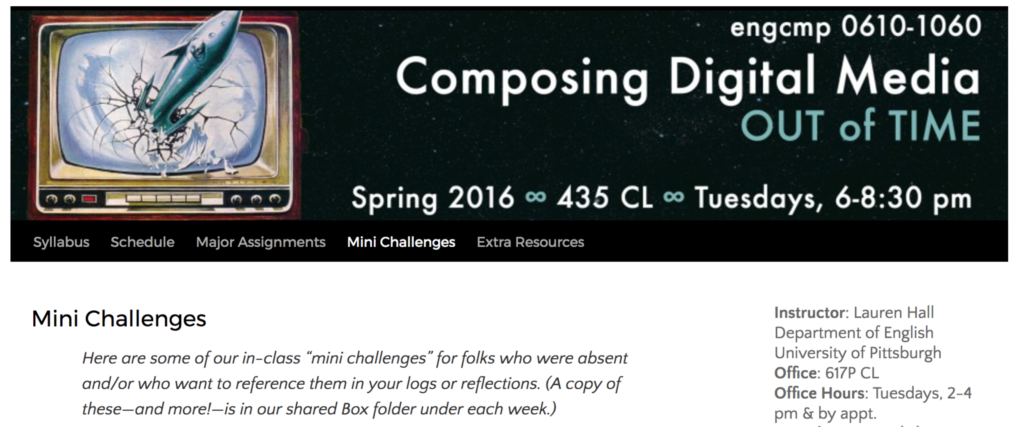

<https://composedm2016.wordpress.com/mini-challenges/>

**Capture a Feeling in Sound**(on Box under “Week 6”)

On Box (under Week 6 / Sample Audio), I provided a handful of audio files from the Public Domain. They’re pretty eclectic.

After our class intro tutorial on Audacity, I handed around the “Bag of Feelings” (my old D&D dice bag with thirty strips of paper, each with a feeling written on it). Everyone pulled out a “feeling” strip and had twenty minutes to compose one-minute of audio that captured or induced that feeling. (Example feelings: nervous, angry, nostalgic, excited . . .)

If you weren’t in class that day, watch the Lynda Audacity tutorial and try this out OR if you were there but are still at a loss for how to begin your cut-up, try something similar. Download some random audio files (within constraints of assignment) and see what you can put together.

At home, you can generate more (and even more complex) feelings here: <http://www.seventhsanctum.com/generate.php?Genname=charmood>

*I borrowed this assignment from Trisha Campbell & from Gabriel Peters-Lazaro’s contribution to the [HASTAC Pedagogy Project](https://www.hastac.org/blogs/gabepl/2014/02/13/14-60-second-feeling-day-one-exercise-learning-media).