CA-1

Question 1

package com.test.Ca1;

import org.openqa.selenium.By;

import org.openqa.selenium.WebDriver;

import org.openqa.selenium.chrome.ChromeDriver;

import org.openqa.selenium.chrome.ChromeOptions;

import io.github.bonigarcia.wdm.WebDriverManager;

public class CA1Q1S1 {

public static void main(String[] args) throws InterruptedException {

// **TODO** Auto-generated method stub

ChromeOptions co=new ChromeOptions();

co.addArguments ("--remote-allow-origins=*");

WebDriverManager.*chromedriver*().setup ();

WebDriver driver=new ChromeDriver(co);

driver.get ("https://www.amazon.in/Apple-MacBook-Chip-13-inch-256GB/dp/B08N5T6CZ6/ref=sr_1_1_sspa?keywords=macbook&sr=8-1-spons&sp_csd=d2lkZ2V0TmFtZT1zcF9hdGY&th=1");

driver.manage().window().maximize() ;

String currentTitle=driver.getTitle();

System.***out***.println(currentTitle);

String expectedTitle="Apple 2020 MacBook Air Laptop M1 chip, 13.3-inch/33.74 cm Retina Display, 8GB RAM, 256GB SSD Storage, Backlit Keyboard, FaceTime HD Camera, Touch ID. Works with iPhone/iPad; Silver : Amazon.in: Computers & Accessories";

if(currentTitle.equals(expectedTitle)) {

System.***out***.println("Title Matched");

}

else {

System.***out***.println("Title not Matched");

}

driver.findElement(By.*xpath*("//*[@id=\"add-to-cart-button\"]")).click();

Thread.*sleep*(5000);

driver.findElement(By.*xpath*("//*[@id=\"attach-sidesheet-view-cart-button\"]/span/input")).click();

Thread.*sleep*(3000);

driver.findElement(By.*xpath*("//*[@id=\"sc-buy-box-ptc-button\"]/span/input")).click();

}

}

OUTPUT:

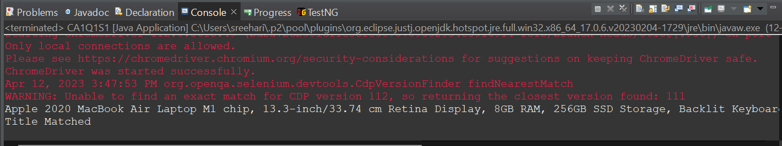

Question 2:

package com.test.Ca1;

import org.openqa.selenium.By;

import org.openqa.selenium.WebDriver;

import org.openqa.selenium.WebElement;

import org.openqa.selenium.chrome.ChromeDriver;

import org.openqa.selenium.chrome.ChromeOptions;

import io.github.bonigarcia.wdm.WebDriverManager;

public class CA1Q2 {

public static void main(String[] args) {

// **TODO** Auto-generated method stub

ChromeOptions co=new ChromeOptions();

co.addArguments ("--remote-allow-origins=*");

WebDriverManager.*chromedriver*().setup ();

WebDriver driver=new ChromeDriver(co);

driver.get ("https://www.amazon.in/");

driver.manage().window().maximize() ;

String currentTitle=driver.getTitle();

System.***out***.println(currentTitle);

String expectedTitle="Online Shopping site in India: Shop Online for Mobiles, Books, Watches, Shoes and More - Amazon.in";

if(currentTitle.equals(expectedTitle)) {

System.***out***.println("Title Matched");

}

else {

System.***out***.println("Title not Matched");

}

WebElement txtBoxl=driver.findElement(By.*xpath*("//*[@id=\"twotabsearchtextbox\"]"));

txtBoxl.sendKeys("Iphone 14");

driver.findElement(By.*xpath*("//*[@id=\"nav-search-submit-button\"]")).click();

//displaying 5 products

String txt1=driver.findElement(By.*xpath*("//*[@id=\"search\"]/div[1]/div[1]/div/span[1]/div[1]/div[3]/div/div/div/div/div/div/div/div[2]/div/div/div[1]/h2/a/span")).getText();

System.***out***.println(txt1);

String txt2=driver.findElement(By.*xpath*("//*[@id=\"search\"]/div[1]/div[1]/div/span[1]/div[1]/div[4]/div/div/div/div/div/div/div/div[2]/div/div/div[1]/h2/a/span")).getText();

System.***out***.println(txt2);

String txt3=driver.findElement(By.*xpath*("//*[@id=\"search\"]/div[1]/div[1]/div/span[1]/div[1]/div[5]/div/div/div/div/div/div[2]/div/div/div[1]/h2/a/span")).getText();

System.***out***.println(txt3);

String txt4=driver.findElement(By.*xpath*("//*[@id=\"search\"]/div[1]/div[1]/div/span[1]/div[1]/div[6]/div/div/div/div/div/div[2]/div/div/div[1]/h2/a/span")).getText();

System.***out***.println(txt4);

String txt5=driver.findElement(By.*xpath*("//*[@id=\"search\"]/div[1]/div[1]/div/span[1]/div[1]/div[7]/div/div/div/div/div/div[2]/div/div/div[1]/h2/a/span")).getText();

System.***out***.println(txt5);

//filter

driver.findElement(By.*xpath*("//*[@id=\"p_36/1318507031\"]/span/a/span")).click();

driver.findElement(By.*xpath*("//*[@id=\"p_n_feature_eight_browse-bin/14267636031\"]/span/a/div/label/i")).click();

}

}

Output:

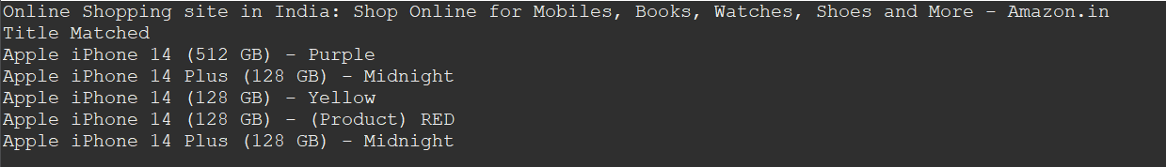

Question 4

package com.test.Ca1;

import org.openqa.selenium.By;

import org.openqa.selenium.WebDriver;

import org.openqa.selenium.WebElement;

import org.openqa.selenium.chrome.ChromeDriver;

import org.openqa.selenium.chrome.ChromeOptions;

import io.github.bonigarcia.wdm.WebDriverManager;

public class CA1Q3 {

public static void main(String[] args) {

ChromeOptions co=new ChromeOptions();

co.addArguments ("--remote-allow-origins=*");

WebDriverManager.*chromedriver*().setup ();

WebDriver driver=new ChromeDriver(co);

driver.get ("https://www.amazon.in/");

driver.manage().window().maximize() ;

String currentTitle=driver.getTitle();

System.***out***.println(currentTitle);

String expectedTitle="Online Shopping site in India: Shop Online for Mobiles, Books, Watches, Shoes and More - Amazon.in";

if(currentTitle.equals(expectedTitle)) {

System.***out***.println("Title Matched");

}

else {

System.***out***.println("Title not Matched");

}

driver.findElement(By.*xpath*("//*[@id=\"nav-link-accountList\"]")).click();

WebElement txtBoxl=driver.findElement(By.*xpath*("//*[@id=\"ap_email\"]"));

txtBoxl.sendKeys("7530053266");

driver.findElement(By.*xpath*("//*[@id=\"continue\"]")).click();

WebElement txtBox2=driver.findElement(By.*xpath*("//*[@id=\"ap_password\"]"));

txtBox2.sendKeys("C0llin_H00v3r");

driver.findElement(By.*xpath*("//*[@id=\"signInSubmit\"]")).click();

driver.findElement(By.*xpath*("//*[@id=\"nav-link-accountList\"]")).click();

driver.findElement(By.*xpath*("//*[@id=\"a-page\"]/div[2]/div/div[2]/div[1]/a/div/div")).click();

driver.findElement(By.*xpath*("//*[@id=\"a-autoid-2-announce\"]")).click();

driver.findElement(By.*xpath*("//*[@id=\"ordersInPackage-container\"]/div/div/a[1]")).click();

}

}

OUTPUT: