Biometric Data Privacy Vault
A Project Based Learning Report Submitted in partial fulfilment of the requirements for the award of the degree

of

Bachelor of Technology
in The Department of CSE
Object Oriented Programming (24SC2006A)
Submitted by
2410030076 – Kodali Naga Sreeja
2410030228 – Bijju Adithi Yadav
2410030229 – Likitha Thumma
2410030232 – Esha Manogna
2410030430 – Malreddy Manogna
Under the guidance of
Dr. Pavan Kumar Pagadala
Assistant Professor


Department of Electronics and Communication Engineering
Koneru Lakshmaiah Education Foundation, Aziz Nagar
Aziz Nagar – 500075
FEB - 2025.
INTRODUCTION

Background and Motivation
With the rising use of biometric technologies in various applications like authentication and access control, protecting biometric data privacy has become critically important. Biometric data, such as fingerprints or facial features, are unique and cannot be changed once compromised. This project aims to develop a secure biometric data privacy vault that encrypts and safely stores biometric information, preventing unauthorized access and ensuring user privacy.
Problem Statement
Biometric data needs strong protection to prevent misuse. Existing systems often lack secure storage and encryption. This project aims to create a secure vault in Java to protect biometric data.
Objectives of the Project
- To create a biometric data vault application to securely store biometric information.
- To implement strong encryption techniques to ensure data privacy.
- To facilitate user authentication based on biometric data with secure data handling.
- To design the system using Java and adhere to object-oriented programming concepts.
- To develop a simple user interface for registration and authentication.
Scope and Limitations
The project focuses on designing a biometric data privacy vault for one type of biometric data (such as fingerprint), implemented entirely in Java. It provides encrypted storage and secure authentication but does not cover the biometric data capture hardware or detailed biometric feature extraction algorithms. The system is designed for educational and prototype purposes, so scalability and integration with real biometric sensors is beyond its current scope.

METHODOLOGY

- Requirement Analysis & Planning
  - Study the importance of biometric data protection and review existing systems.
  - Define functional requirements: secure storage, encryption, registration, and authentication.
  - Define non-functional requirements: system should be reliable, easy to use, and implemented in Java with OOP concepts.
  - Select biometric type to work with (e.g., fingerprint image or face image in grayscale format).
- System Architecture Design
  - Design a layered architecture:
    - Presentation Layer – User interface for registration and login.
    - Business Logic Layer – Encryption, decryption, and authentication logic.
    - Data Layer – Secure vault (encrypted storage files or database).
  - Use UML diagrams (class diagram, sequence diagram) to plan module interactions.
  - Decide storage format (encrypted file system or lightweight DB like SQLite).
- Biometric Data Pre-processing
  - Convert biometric input (e.g., fingerprint image) into a consistent format.
  - For images, use grayscale conversion to reduce complexity and storage size.
  - Generate a digital representation (template) for storage.
- Encryption and Security Module
  - Implement strong cryptographic algorithms such as AES-256 for data encryption.
  - Use a secure key generation mechanism (Java Security libraries or KeyStore).
  - Ensure encrypted data is stored instead of raw biometric features.
  - Add integrity check mechanisms (hash functions like SHA-256) to prevent tampering.
- Vault Implementation
  - Develop the Biometric Privacy Vault module.
  - Ensure only authorized processes can access or update the vault.
  - Enforce secure read/write operations.
- User Registration Process
  - User provides biometric data (e.g., fingerprint/face image).
  - Pre-process data (resize, grayscale conversion, or template extraction).
  - Encrypt biometric template using the encryption module.
  - Store encrypted biometric data securely in the vault.
- User Authentication Process
  - During login, the user provides biometric input again.
  - System pre-processes and encrypts the input.
  - Encrypted data is compared with the stored encrypted template.
  - If both match → grant access, else → deny access.
- User Interface Development
  - Provide two main functions: Register (new users) and Login (authentication).
  - Show success/failure messages in a user-friendly manner.
  - Ensure no raw biometric data is ever displayed or stored.
- Testing & Validation
  - Test with multiple users and different biometric samples.
  - Validate that unauthorized users cannot access the vault.
  - Check encryption by verifying that stored biometric data is unreadable without the key.
  - Perform edge-case testing (wrong input, corrupted data, repeated attempts).
- Performance & Security Evaluation
- Measure encryption/decryption time to ensure efficiency.
- Evaluate storage overhead due to encryption.
- Test against possible threats like brute force, replay attacks, and direct vault access.
- Documentation & Reporting
- Prepare detailed documentation covering design, implementation, and test cases.
- Highlight limitations (e.g., prototype use, no real biometric hardware integration).
- Suggest future enhancements like multi-biometric support, cloud integration, or real-time hardware interfacing.

DESIGN

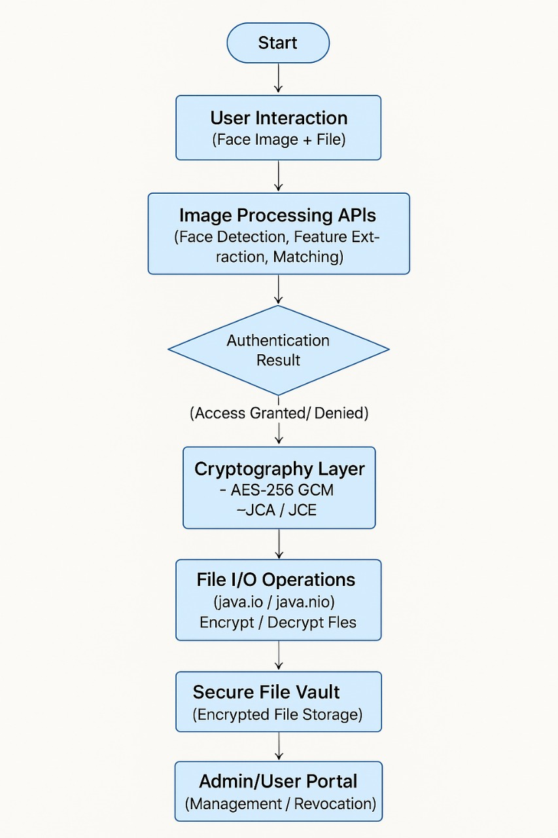

STEP 1:


STEP 2:

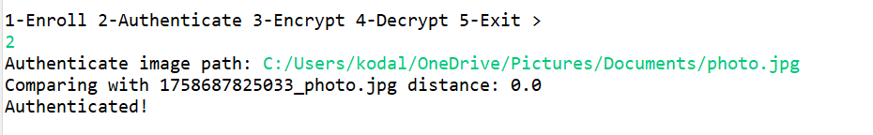
STEP 3:
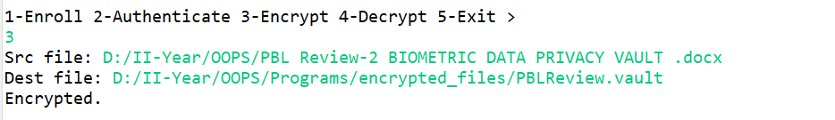
STEP 4:
