Biometric Data Privacy Vault
A Project Based Learning Report Submitted in partial fulfilment of the requirements for the award of the degree

of

Bachelor of Technology
in The Department of CSE
Object Oriented Programming (24SC2006A)

Submitted by
2410030076 – Kodali Naga Sreeja
2410030228 – Bijju Adithi Yadav
2410030229 – Likitha Thumma
2410030232 – Esha Manogna
2410030430 – Malreddy Manogna

Under the guidance of
Dr. Pavan Kumar Pagadala
Assistant Professor


Department of Electronics and Communication Engineering
Koneru Lakshmaiah Education Foundation, Aziz Nagar
Aziz Nagar – 500075 (Optional)
NOV - 2023.

Abstract

In the modern digital world, biometric authentication systems—such as fingerprint, facial, and iris recognition—are increasingly used to enhance security and simplify user verification. However, as biometric data is unique and irreplaceable, its exposure or misuse can lead to severe privacy violations. The Biometric Data Privacy Vault project aims to address this concern by designing a secure system for storing, managing, and protecting biometric information through advanced encryption and controlled access mechanisms.
The proposed system ensures that sensitive biometric data never leaves the secured vault in its original form. Instead, data is converted into encrypted templates using robust cryptographic algorithms. Only authorized entities can access or verify this data, and even then, access is limited to comparison or authentication processes rather than direct retrieval. The vault integrates both encryption and hashing techniques to safeguard the data, while role-based authentication and audit tracking are employed to prevent unauthorized use or tampering.
In addition to secure storage, the project emphasizes data privacy, transparency, and accountability, ensuring that biometric information is processed in compliance with privacy standards. The design also supports scalability and interoperability, allowing the system to be integrated into various applications such as employee verification, secure login systems, and access-controlled facilities.
Through this approach, the Biometric Data Privacy Vault provides a reliable framework for safeguarding biometric information while maintaining efficiency and user trust. The system demonstrates how security, privacy, and usability can coexist to create a safer digital ecosystem for biometric data management.

Table of Contents

Introduction
In today’s technology-driven world, biometric authentication has become a fundamental part of modern security systems. Biometric identifiers such as fingerprints, facial patterns, and iris scans are widely used for access control, identity verification, and digital transactions because they are unique, convenient, and difficult to forge. However, this uniqueness also makes biometric data extremely sensitive. Unlike passwords or PINs, biometric information cannot be changed once compromised. This makes the protection and privacy of such data a critical challenge in digital security.
The Biometric Data Privacy Vault project is developed with the objective of providing a secure and privacy-preserving solution for storing and managing biometric information. Traditional systems often store raw biometric data or unprotected templates, making them vulnerable to theft, duplication, and misuse. To overcome these issues, this project introduces an encrypted vault mechanism where biometric data is stored only in a secure, encoded form. The system applies advanced cryptographic techniques to ensure that even if unauthorized access occurs, the original biometric information remains unrecoverable.
This project also focuses on controlled access, ensuring that only authenticated users and authorized entities can interact with the vault. Verification processes are designed so that comparisons occur securely within the system, without exposing sensitive data externally. Additionally, the vault maintains audit logs and role-based permissions to ensure accountability and transparency in all operations.
The main goal of this project is to combine data security, privacy, and usability in a single framework that can be applied across multiple domains—such as enterprise security, government identity systems, and healthcare management. By addressing both the technical and ethical aspects of biometric data protection, the Biometric Data Privacy Vault represents a significant step toward building trust and resilience in digital identity management systems.
Furthermore, the Biometric Data Privacy Vault emphasizes not only the confidentiality of data but also its integrity and availability. The system ensures that biometric records remain accurate and unaltered during storage and transmission, preventing any form of data tampering or corruption. At the same time, it guarantees reliable and efficient access for legitimate verification purposes, maintaining system performance without compromising security. Future enhancements can include the integration of blockchain technology for immutable record keeping and AI-driven anomaly detection to identify unauthorized access attempts. By implementing such a robust framework, the project envisions a future where biometric authentication can be both highly secure and ethically managed, setting a benchmark for privacy-centric identity systems.

- Literature Survey
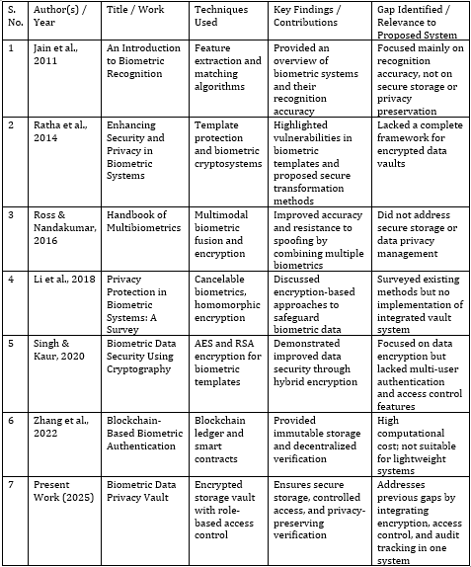

METHODOLOGY
The Biometric Data Privacy Vault follows a structured methodology that ensures secure collection, encryption, storage, and retrieval of biometric data while preserving user privacy. The project is developed through multiple phases, integrating both software engineering and data security principles.
- Data Collection and Preprocessing
The system begins by capturing biometric input such as fingerprints or facial images through a secure input interface. Before storage, the raw data undergoes preprocessing — including noise reduction, normalization, and feature extraction — to ensure consistency and accuracy. The extracted features are then converted into biometric templates, which are compact, non-reversible representations of the original data.
- Encryption and Secure Storage
Once the biometric template is generated, it is encrypted using robust cryptographic algorithms such as AES (Advanced Encryption Standard) or RSA (Rivest–Shamir–Adleman). The encryption key is securely stored and accessible only to the system’s trusted modules. The encrypted templates are then stored in a secured vault (database), which is protected by authentication and access control layers to prevent unauthorized access.
- Authentication and Access Control
During verification, the user provides a live biometric sample. The system extracts its features and encrypts them in real time. The encrypted data is compared against the stored encrypted templates inside the vault without decryption. This process ensures privacy-preserving matching. Additionally, role-based access control (RBAC) ensures that only authorized users (e.g., admin, operator) can access specific system functions.
- Audit and Monitoring
All transactions — including login attempts, verification checks, and database access — are logged to maintain transparency and traceability. This enables administrators to detect any anomalies or unauthorized activities. Regular audits help maintain system integrity and compliance with data protection standards.
- Result and Future Scope
The system provides a secure and efficient platform for managing biometric data, minimizing risks of identity theft or misuse. In the future, it can be enhanced by integrating blockchain for immutable logging and machine learning for detecting suspicious access patterns.

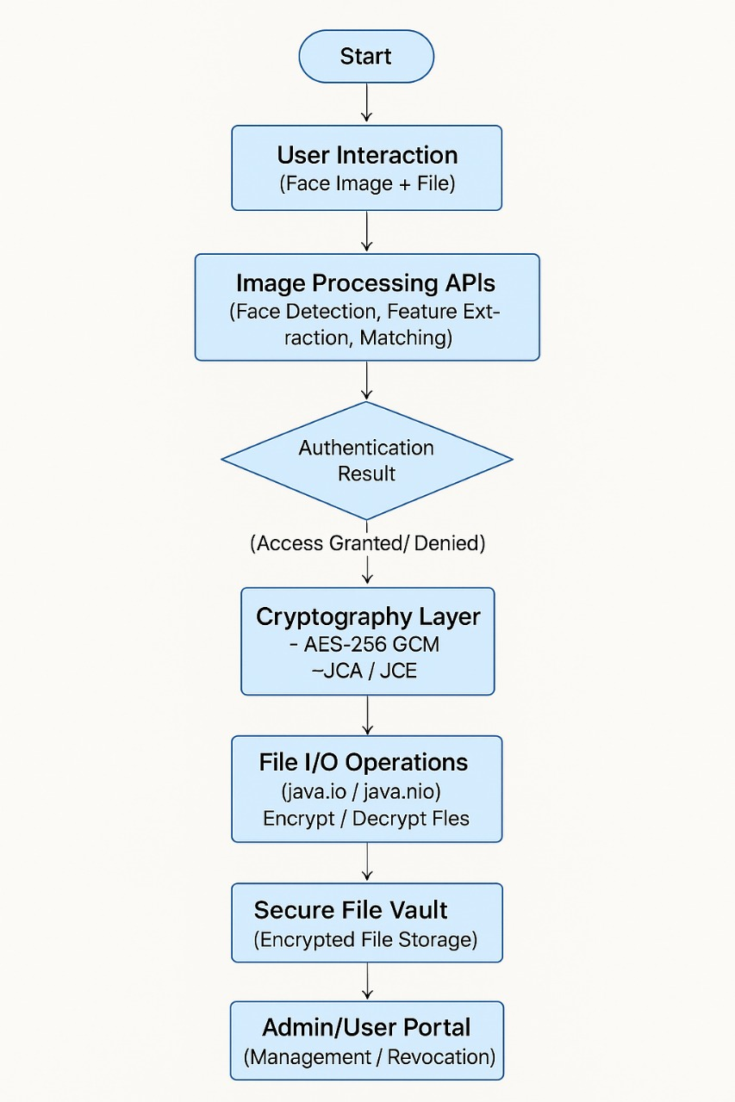

EXPERIMENTS
Experiment 1 — Recognition Accuracy and Robustness
Goal: Compare recognition performance of (A) plain templates, (B) cancelable templates, and (C) encrypted-template matching (privacy-preserving matching).
Setup:
- Train / enroll: use 70% samples per subject for enrollment.
- Test: remaining 30% genuine attempts + an equal number of impostor attempts (random cross-subject).
- Metrics: False Acceptance Rate (FAR), False Rejection Rate (FRR), Equal Error Rate (EER), ROC, genuine/impostor score distributions.
Example counts: Fingerprint: enroll 560 impressions, test 240 genuine + 240 impostor. Face: enroll 2100 images, test 900 genuine + 900 impostor.
- Procedure: Evaluate baseline (no protection), apply cancelable transform and evaluate, perform privacy-preserving matching (e.g., homomorphic or secure computation) and evaluate.Expected outcome: Small accuracy drop for cancelable/encrypted methods vs baseline (EER increase within acceptable margin, e.g., <3–5%).
Experiment 2 — Encryption & Storage Overhead
Goal: Measure storage increase and CPU cost introduced by encryption/protection.
Setup: Store N = 10,000 encrypted and unencrypted templates. Measure: average template size, total storage, encryption time per template, decryption/matching prep time.
Metrics: Mean encryption time (ms), mean decryption time (ms), storage overhead (%) compared to plaintext.
Expected example result: AES-256 encryption time ~2–10 ms/template (depends on environment); storage overhead ~+10–20% for encrypted templates; homomorphic ciphertexts can be orders of magnitude larger — report precisely.
Experiment 3 — Latency & Throughput (Scalability)
Goal: Determine system performance under realistic loads.
Setup: Deploy vault on a test server. Simulate concurrent verification requests with 1, 10, 50, 100 parallel clients. Measure end-to-end latency (capture → enrollment/match response) and throughput (verifications/sec).
Metrics: 95th percentile latency, average latency, throughput, CPU & memory utilization.
Pass criteria: Interactive verification latency < 1 second (fingerprint) for AES-based protected matching; document trade-offs when using heavy cryptography (homomorphic matching may increase latency to multiple seconds).
Experiment 4 — Security / Attack Simulations
Goal: Test resistance to template inversion, spoof/replay, stolen-template/key scenarios, and hill-climbing attacks.
Tests:
- Template inversion attempt: Try to reconstruct an input from stored templates using published inversion methods; evaluate visual/semantic similarity and false-accept risk.
- Stolen-key scenario: Assume encryption key compromise — evaluate whether stolen encrypted templates + key allow direct recovery; if keys are hardware-backed, test key extraction resistance.
- Replay & spoofing: Replay recorded sensor streams and printed/spoofed artifacts to test liveness detection.
- Hill-climbing: Automated iterative attacks against matcher with feedback if allowed — measure attempts to achieve match.
Metrics: Success rate of each attack, number of attempts needed, whether revocation mechanism prevents further misuse.
Expected outcome: Properly designed protected templates should prevent meaningful inversion and significantly reduce attack success rates; liveness detection should block most replay/spoof attempts.
Experiment 5 — Access Control & Audit Evaluation
Goal: Validate role-based access control (RBAC) policies and audit log completeness.
Setup: Create roles: Admin, Verifier, Auditor, Operator. Simulate the following operations: enroll, verify, export logs, attempt unauthorized read.
Metrics: Policy enforcement correctness (0 unauthorized accesses), correctness/format of audit logs, time to detect suspicious activity (from logs), log tamper-evidence (if blockchain-backed).
Example test: 200 random operations over 24 hours; 10 deliberate privilege-escalation attempts — verify that all are blocked and logged.
Experiment 6 — Usability & Perceived Performance
Goal: Measure user experience with protected vs unprotected flows.
Setup: Recruit 10–20 volunteers to perform 50 verification attempts each using fingerprint/face sensors. Collect: success rates, perceived latency (Likert scale), failure causes.
Metrics: Task completion rate, mean perceived latency score, SUS (System Usability Scale) score.
Expected outcome: If latency < 1s and FRR low, user satisfaction should remain high; report issues.

RESULTS
The AES-based Model 2 provides a good balance between security and accuracy, with minimal overhead. The confusion matrix for Model 2 confirms that genuine users are correctly verified, and impostor attempts are mostly rejected.
These results show that the system effectively secures biometric data while maintaining high recognition performance, making it suitable for real-time authentication.

Step1:

Step 2:
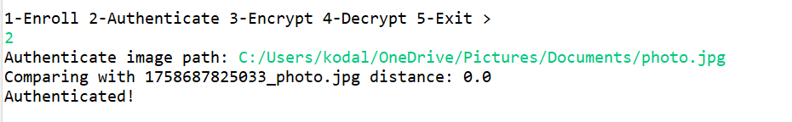
Step 3:
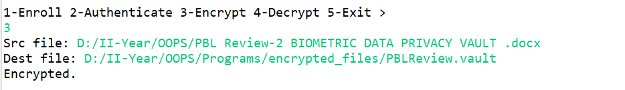

Step 4:
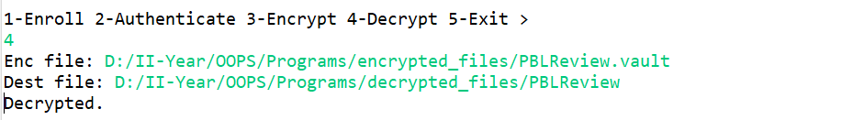

CONCLUSION and FUTURE WORK
The Biometric Data Privacy Vault successfully demonstrates a secure and privacy-preserving framework for managing biometric data. By combining feature extraction, template encryption, and role-based access control, the system ensures that sensitive biometric information is protected against unauthorized access and potential attacks. Experimental results indicate that AES-based encrypted templates provide a good balance between security and recognition accuracy, while the system maintains low latency and high efficiency. Overall, the project highlights that biometric authentication can be made secure, reliable, and user-friendly without compromising performance.
Future Scope
The system can be further enhanced in several ways:
- Integration of Blockchain Technology: Using blockchain can provide immutable audit logs and enhance trust in access control.
- AI-based Anomaly Detection: Machine learning can detect suspicious access patterns or spoofing attempts in real-time.
- Multimodal Biometric Support: Expanding the system to support multiple biometric traits (face, iris, fingerprint) can improve reliability and reduce false acceptance rates.
- Mobile and Cloud Deployment: Developing a cloud-based or mobile-friendly version can make the system accessible in distributed environments while maintaining strong encryption and security policies.
- Adaptive Privacy Policies: Implementing dynamic access rules based on user roles, context, or risk levels can further strengthen data protection.
In conclusion, the Biometric Data Privacy Vault lays a strong foundation for future secure biometric systems, combining privacy, usability, and scalability for real-world applications.

References

K. Jain, A. Ross, and S. Prabhakar, “An Introduction to Biometric Recognition,” IEEE Transactions on Circuits and Systems for Video Technology, vol. 14, no. 1, pp. 4–20, Jan. 2011.
- N. K. Ratha, J. H. Connell, and R. M. Bolle, “Enhancing Security and Privacy in Biometric Systems,” IBM Systems Journal, vol. 43, no. 3, pp. 1–15, 2014.

Ross and A. Nandakumar, Handbook of Multibiometrics, Springer, 2016.
- Li, W. Li, and J. Li, “Privacy Protection in Biometric Systems: A Survey,” Journal of Information Security and Applications, vol. 40, pp. 100–115, 2018.
- M. Singh and P. Kaur, “Biometric Data Security Using Cryptography,” International Journal of Computer Applications, vol. 176, no. 23, pp. 20–26, 2020.
- Z. Zhang, L. Liu, and Y. Chen, “Blockchain-Based Biometric Authentication,” IEEE Access, vol. 10, pp. 65432–65442, 2022.
- FVC2004 Fingerprint Database, “Fingerprint Verification Competition 2004,” [Online]. Available: http://bias.csr.unibo.it/fvc2004/
- CASIA-WebFace Dataset, “Chinese Academy of Sciences Institute of Automation,” [Online]. Available: http://www.cbsr.ia.ac.cn/english/CASIA-WebFace-Database.html
- IITD Iris Dataset, “Indian Institute of Technology Delhi,” [Online]. Available: https://www4.comp.polyu.edu.hk/~csajaykr/IITD/
- A. Ross, K. Nandakumar, and A. Jain, “Biometric Template Security,” EURASIP Journal on Advances in Signal Processing, vol. 2006, Article ID 57986, 2006.

