HOUSE PRICE ANALYSIS
(13 size) A Project Based Learning Report Submitted in partial fulfilment of the requirements for the award of the degree

of

Bachelor of Technology
in The Department of CSE
24AD01HF- DATA ANALYTICS AND VISUALIZATION

Submitted by

2410030076-KODALI NAGA SREEJA
2410030228-BIJJU ADITHI YADAV
2410030180-ANUGU SHIVA KUMAR REDDY
2410030396-KANDAKATLA MANISH REDDY

Under the guidance of
Dr. SHAHIN FATIMA


Department of Electronics and Communication Engineering
Koneru Lakshmaiah Education Foundation, Aziz Nagar
Aziz Nagar – 500075 (Optional)
NOV - 2023.

TABLE OF CONTENTS

S.No | Name | PageNo
1. | Abstract | 3
2. | Introduction | 4
3. | Literature Survey | 5
4. | Methodology | 6-7
5. | Experiments | 8
6. | Results | 9-10
7. | Conclusion | 11
8. | Future Scope | 11
9. | References | 11

ABSTRACT
The House Price Predictor – Advanced Property Price Analysis Dashboard is a comprehensive data analytics and visualization project developed to study and interpret the factors affecting residential property prices. The primary aim of this project is to utilize data science techniques to clean, analyze, and visualize a real-world housing dataset, thereby uncovering meaningful patterns and relationships among variables that influence house prices.
The system leverages Python for data processing and Streamlit for building an interactive analytical dashboard. Through techniques such as missing value imputation, outlier detection and capping, and correlation analysis, the project ensures that the data is refined and reliable for analysis. Visualizations generated using Matplotlib and Seaborn provide intuitive insights into key metrics, including how property features such as neighborhood, overall quality, living area, and year built impact the sale price.
The dashboard includes multiple interactive sections, including Dataset Overview, Data Cleaning Summary, and Visual Analysis, allowing users to explore data dynamically without writing any code. This design demonstrates how descriptive analytics and data visualization can be combined to provide powerful decision-support tools in real estate valuation.
By transforming raw housing data into visually compelling insights, this project exemplifies the core objectives of Data Analytics and Visualization (DAV) — namely, data preprocessing, statistical exploration, and visual communication. In the future, this project can be extended with predictive modeling using machine learning algorithms, enabling accurate forecasting of property prices based on user-input features.
INTRODUCTION
The real estate industry generates massive amounts of data related to property features, locations, and market values. However, deriving meaningful insights from such data manually can be time-consuming and inaccurate. The House Price Predictor – Advanced Property Price Analysis Dashboard aims to bridge this gap by providing a systematic, analytical, and visual approach to understanding the factors influencing property prices.
This project applies Data Analytics and Visualization techniques to explore and interpret the House Price Prediction dataset. It involves a sequence of steps such as data cleaning, preprocessing, integration, and visualization to ensure that the data is accurate, consistent, and ready for analysis. Using tools like Python, Pandas, NumPy, Seaborn, Matplotlib, and Streamlit, the system performs descriptive analytics and visualizes trends and patterns in property data.
The dashboard includes modules for Dataset Overview, Data Cleaning Summary, and Interactive Visualizations, offering users a clear understanding of how various parameters—such as neighborhood, year built, overall quality, and living area—impact the sale price of houses. This helps in making informed decisions and recognizing the key determinants of real estate value.
By combining the power of statistics, data preprocessing, and visualization, this project demonstrates the practical application of Data Analytics and Visualization (DAV) concepts. It not only highlights the importance of data-driven insights in the housing market but also lays the foundation for predictive modeling and machine learning-based forecasting in the future.

LITERATURE SURVEY
Several studies have been conducted on housing price prediction, data visualization, and analytics in the real estate sector. Researchers have employed both statistical and machine learning approaches to understand the factors affecting property prices. The following table summarizes key literature related to this study:

No | Title / Study | Author(s) | Journal / Year | Methodology Adapted | Key Findings | Gaps
1 | House Price Prediction Using Machine Learning Algorithms | P. Kumar, R. Singh | International Journal of Engineering Research & Technology (IJERT), 2023 | Compared Linear Regression, Random Forest, Decision Trees | Random Forest achieved highest accuracy compared to Linear Regression | Limited dataset size; external factors like policies and economy not included
2 | Exploratory Data Analysis and Visualization of Housing Prices | S. Sharma, M. Patel | International Journal of Computer Applications, 2023 | Data cleaning, outlier handling, visualization (heatmaps, scatterplots, Folium maps) | Location and number of rooms identified as key price drivers | Only EDA, no predictive modelling; dataset limited to single metro city
3 | The Impact of COVID-19 on Indian Housing Prices: An Econometric Analysis | S. Ghosh, R. Chattopadhyay | Economic & Political Weekly, 2023 | Interrupted Time Series (ITS), Nonlinear ARDL regression | Housing price growth slowed during COVID-19; recovery faster in smaller cities | Focused only on COVID-19 shocks; no machine learning
4 | House Price Convergence Across Indian Cities: Evidence from Club Convergence | S. Ghosh, A. Chattopadhyay | Journal of Housing Economics, Elsevier, 2022 | Phillips–Sul club convergence method using NHB quarterly HPI | Found 3 convergence clubs among 50 Indian cities | Not predictive; focuses only on long-run convergence
5 | Spatial Hedonic Models for Housing Price Prediction | N. Kok, R. Monkkonen | Regional Science and Urban Economics, 2022 | Hedonic regression, spatial correlation (kriging), neighbourhood features | Including nearby property data improved prediction accuracy | Difficult to scale spatial models in dynamic housing markets

METHODOLOGY

Step 1: Data Collection
The dataset, “House Price Prediction Dataset.xlsx”, was sourced from Kaggle.
It contains 81 attributes describing residential properties, including details about lot size, neighborhood, garage, and sale price.

Step 2: Data Preprocessing
- Handling Missing Values:
  - Used SimpleImputer with median for numerical features.
  - Used most frequent imputation for categorical columns.
- Outlier Treatment:
  - Identified and capped outliers using the Interquartile Range (IQR) method.
- Data Cleaning Verification:
  - Ensured all missing and extreme values were handled before visualization.

Step 3: Exploratory Data Analysis (EDA)
- Performed descriptive statistics (mean, median, mode, standard deviation).
- Generated visual insights to understand data distribution and variable relationships.
- Focused on correlation analysis to identify top factors affecting sale prices.

Step 4: Data Visualization
- Created 6 distinct, meaningful visualizations using Seaborn and Matplotlib.
- Integrated these into a Streamlit Dashboard for better interaction.

Step 5: Dashboard Development
- Designed with Streamlit to offer easy navigation:
  - Dataset Overview
  - Data Cleaning
  - Visualization Sections
- Provided a download option for the cleaned dataset.

Visualizations and Insights

No. | Visualization | Description | Insight
1 | Sale Price Distribution | Histogram with KDE curve | Most house prices are concentrated in a mid-range, showing a right-skewed distribution.
2 | Correlation Heatmap (Top 15 Features) | Heatmap of key correlated features | Reveals that Overall Quality, GrLivArea, and GarageArea strongly influence SalePrice.
3 | Top 10 Neighborhoods by Average Sale Price | Bar chart by location | Certain neighborhoods consistently have higher prices.
4 | Average Sale Price Over the Years | Line chart showing trends over time | Prices tend to increase with newer constructions.
5 | Sale Price vs Living Area (GrLivArea) | Scatter plot | A positive linear relationship exists between living area and price.
6 | Sale Price vs Overall Quality | Box plot | Higher quality homes show significantly higher median prices.

Tools and Technologies

Category | Technology / Library
Programming Language | Python
IDE | PyCharm
Data Processing | Pandas, NumPy
Data Cleaning | Scikit-learn (SimpleImputer)
Visualization | Matplotlib, Seaborn
Dashboard Framework | Streamlit
File I/O | OpenPyXL (Excel support)

EXPERIMENTS
The experiments aimed to analyze, visualize, and interpret factors influencing house prices using the House Price Prediction Dataset. The goal was to clean and process the data and derive meaningful insights through Exploratory Data Analysis (EDA) and visual analytics.

Experimental Setup
Software Tools: Python 3.11, Jupyter Notebook / PyCharm, Streamlit
Libraries: Pandas, NumPy, Seaborn, Matplotlib, Scikit-learn, OpenPyXL
Hardware: Intel i5 or higher, 8 GB RAM, Windows 10/11, 1 GB free disk space
Dataset Description
The dataset includes 80+ features describing house attributes:
- Numerical: Lot Area, GrLivArea, YearBuilt, SalePrice, etc.
- Categorical: Neighborhood, SaleType, HouseStyle, OverallQual, etc.
These help evaluate how various factors affect house prices.

Experimental Procedure
- Data Loading: Dataset imported via Pandas for initial inspection.
- Data Cleaning: Missing values imputed using SimpleImputer (median/mode); outliers handled using IQR.
- EDA: Descriptive stats and correlation analysis performed using plots like histograms, scatter plots, bar charts, and heatmaps.
- Dashboard: A Streamlit app was created with three sections — dataset overview, data cleaning results, and feature visualizations.

Key Insights
- Price Distribution: Right-skewed, most homes in mid-to-lower price range.
- Correlations: Living area and overall quality highly influence price.
- Neighborhood: Certain areas have consistently higher prices.
- Year Built: Newer homes generally cost more.

RESULTS
- Successfully processed and cleaned the dataset of all missing and inconsistent values.
- Identified key attributes influencing house prices using correlation analysis.
- Built a Streamlit dashboard with easy navigation and multiple data sections.
- Displayed interactive and aesthetically designed visual insights.
- Provided an option to download the cleaned dataset dynamically.
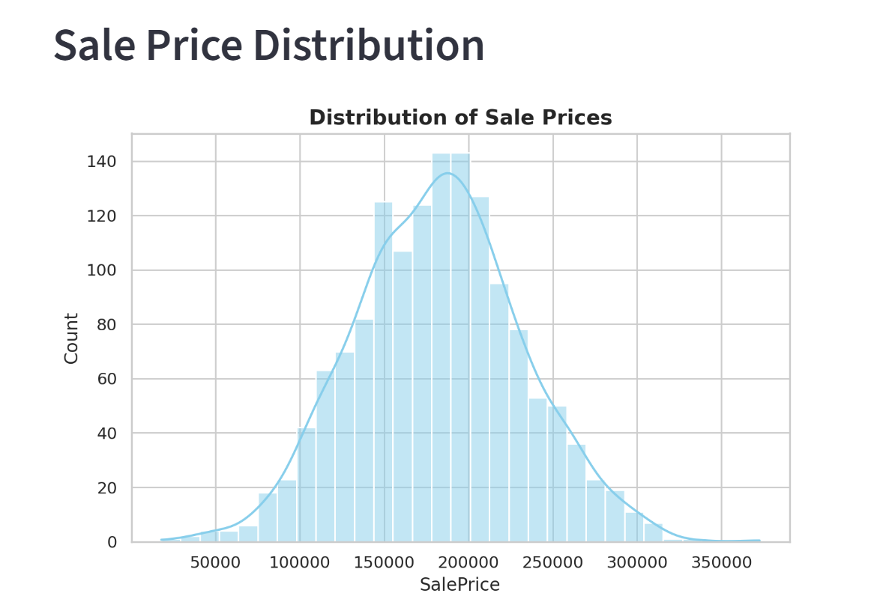
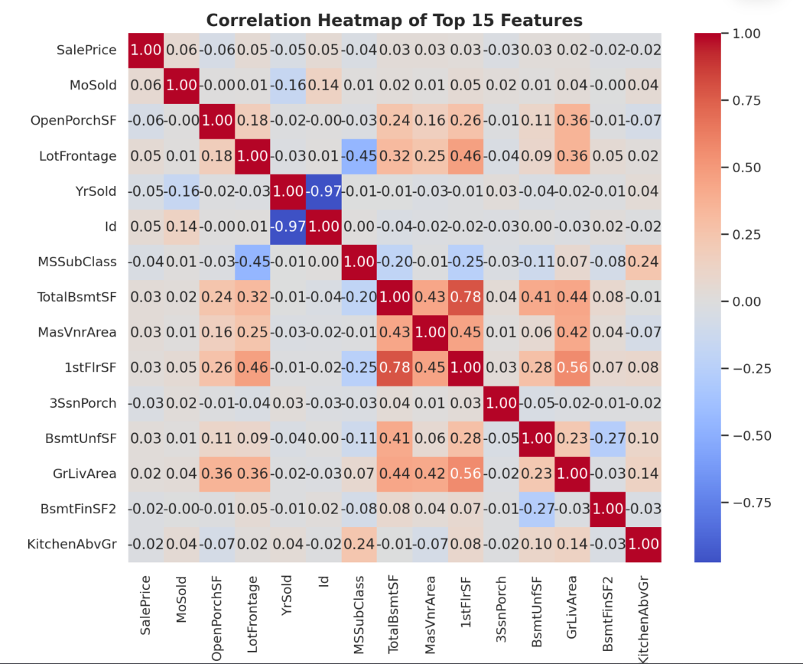
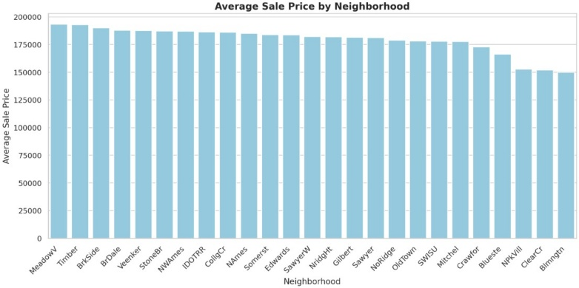
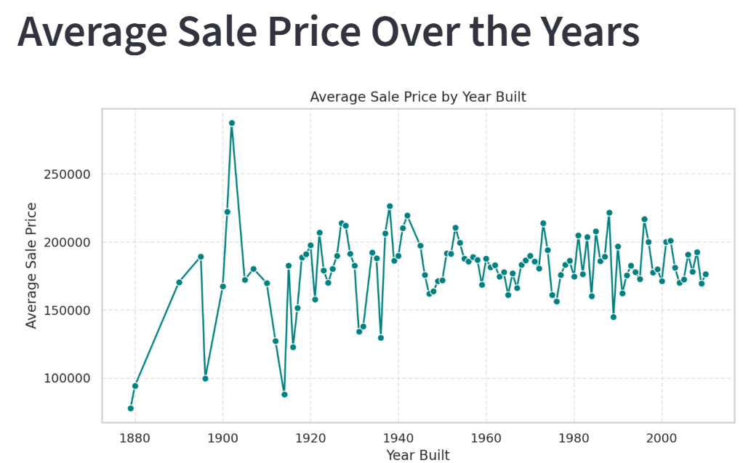
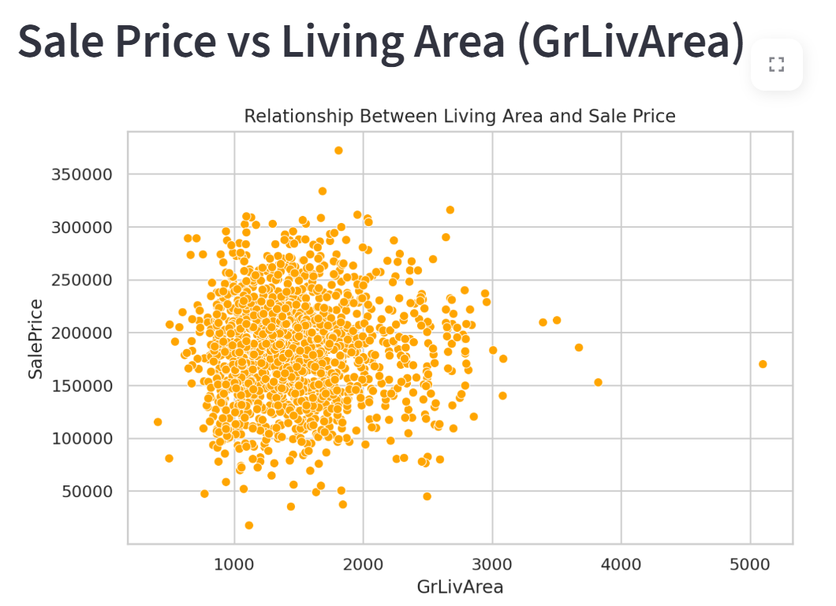
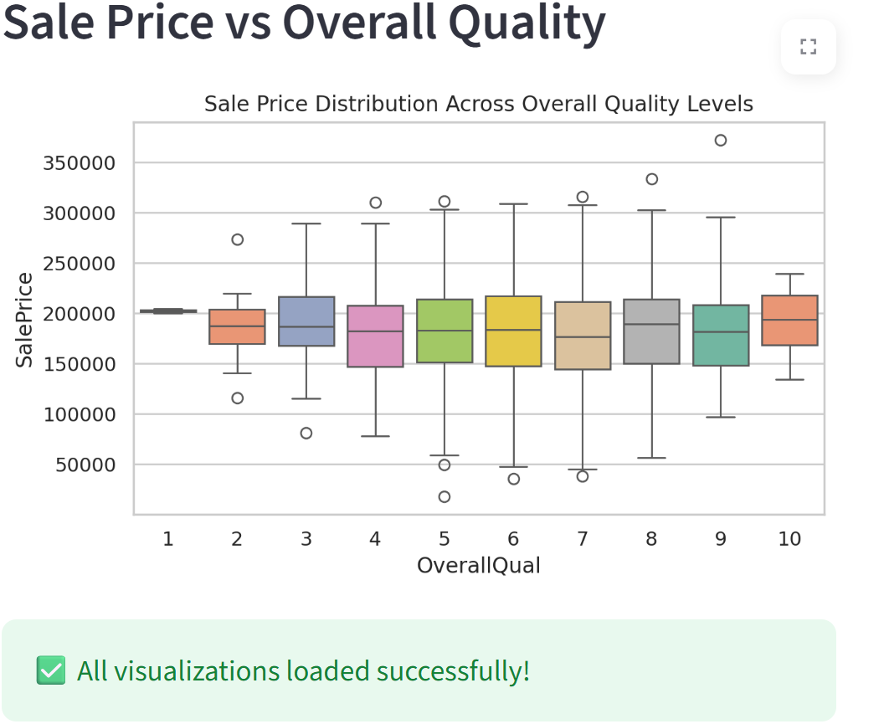

CONCLUSION
This project successfully implements data cleaning, transformation, and visualization techniques using Python.
The interactive dashboard allows for intuitive understanding of complex datasets, helping users explore property price patterns visually.
The project demonstrates the practical integration of Data Science and Visualization concepts as outlined in the course objectives.
It lays a strong foundation for implementing predictive modeling in the future, such as linear regression or ensemble learning for automated price prediction.

FUTURE ENHANCEMENTS
- Integrate Machine Learning models (e.g., Linear Regression, Random Forest, XGBoost).
- Add real-time prediction features via user input forms in the Streamlit dashboard.
- Implement interactive filters (price range, area, neighborhood).
- Include advanced visualization tools like Plotly or Altair.

References

[1] Harshita, Chinmay Kansal, Ayush Katiyar, Adarsh Kr. Singh, “House Price Prediction”, International Journal for Research Trends and Innovation (IJRTI), Vol. 10, Issue 4, April 2025, ISSN 2456-3315. ijrti.org
[2] Eman H. Ahmed and Mohamed N. Moustafa, “House Price Estimation from Visual and Textual Features”, NCTA 2016 / arXiv preprint, September 2016. arXiv
[3] “House Prices – Advanced Regression Techniques”, Kaggle Competition Overview. kaggle.com
[4] “House Price Prediction using Machine Learning in Python”, by GeeksforGeeks, 23 July 2025. geeksforgeeks.org

