Sign Language Detection System
A Project Based Learning Report Submitted in partial fulfilment of the requirements for the award of the degree

of

Bachelor of Technology
in The Department of CSE
ARTIFICIAL INTELLIGENCE AND MANCHINE LEARNING – 24AD2001A

Submitted by

2410030076 - Kodali Naga Sreeja
2410030228 - Bijju Adithi Yadav
2410030229 - Likitha Thumma
2410030232 - H. Esha Manogna
2410030430 - Malreddy Manogna

Under the guidance of
Dr. Mousmi


Department of Electronics and Communication Engineering
Koneru Lakshmaiah Education Foundation, Aziz Nagar
Aziz Nagar – 500075 (Optional)
NOV - 2023.

TABLE OF CONTENTS

S.No | Name | PageNo
1. | Abstract | 3
2. | Introduction | 4
3. | Literature Survey | 5
4. | Methodology | 6-7
5. | Experiments | 8-9
6. | Results | 10
7. | Conclusion | 11
8. | Future Scope | 11
9. | References | 12

ABSTRACT
Communication is an essential aspect of human interaction, yet millions of people across the world face barriers due to hearing or speech impairments. Sign language serves as a powerful communication medium for the hearing-impaired community, but its understanding is often limited to those who have formally learned it. This limitation creates a significant communication gap between hearing-impaired individuals and the rest of society. To address this challenge, this project proposes an AI-powered Sign Language Detection System that can automatically recognize and translate sign language gestures into readable text.
The system leverages computer vision and machine learning techniques to interpret hand gestures from video inputs. Using MediaPipe Hands, a real-time hand tracking framework developed by Google, the system extracts 21 landmark coordinates from each hand to accurately capture finger and palm movements. These extracted features are then processed and used to train a Random Forest Classifier, which classifies the gestures based on their geometric patterns. The model is trained on a labeled dataset of various sign gestures and achieves high accuracy in recognizing predefined signs.
The trained model is integrated into a Flask-based web application, allowing users to upload video files containing hand gestures. Once uploaded, the system processes the video frame by frame, extracts hand features, performs classification, and displays the predicted sign or letter as textual output on the interface. The web-based design ensures accessibility and ease of use without requiring specialized hardware.
This project demonstrates the power of artificial intelligence in developing inclusive technologies that bridge the communication gap between the hearing and speech-impaired communities and the rest of society. It serves as a foundation for future innovations in gesture-based human-computer interaction, real-time translation systems, and assistive technologies. By combining MediaPipe, OpenCV, and machine learning, the system provides a scalable, accurate, and user-friendly solution that promotes inclusivity, accessibility, and social integration for individuals with hearing impairment

Introduction
Communication is one of the most fundamental aspects of human life, enabling people to express ideas, emotions, and thoughts. However, for individuals with hearing and speech impairments, communication often poses significant challenges. Sign language serves as their primary mode of interaction, allowing them to convey messages through specific hand gestures, facial expressions, and movements. Despite its effectiveness, sign language is not universally understood by the general population, creating a communication barrier between the hearing-impaired community and others.
With the advancement of Artificial Intelligence (AI) and Computer Vision, it is now possible to build systems that can automatically interpret sign language gestures and convert them into readable or audible formats. The Sign Language Detection System developed in this project aims to bridge this communication gap by recognizing hand gestures from video input and translating them into corresponding text.
The system uses MediaPipe for hand tracking and landmark extraction, OpenCV for video frame processing, and a Random Forest Machine Learning Model for gesture classification. The combination of these technologies allows the system to analyze real-time hand movements and accurately identify the signs being performed.
A Flask-based web interface is developed to make the system easily accessible. Users can upload sign language videos, and the system will process them to predict the gesture meaning. This web application provides a simple yet effective tool for understanding sign language, making it beneficial for educational, social, and assistive communication purposes.
In essence, this project not only demonstrates the application of AI and machine learning in solving real-world problems but also promotes inclusivity by empowering seamless communication between the hearing-impaired and the wider community.

LITERATURE SURVEY

S. No. | Author(s) & Year | Title of the Paper / System | Methodology / Technique Used | Key Findings / Limitations
1 | S. Ong and S. Ranganath (2005) | Automatic Sign Language Analysis: A Survey and the Future beyond Lexical Meaning | Computer Vision and Hidden Markov Models (HMMs) | Early research on using HMMs for sign recognition, limited dataset and low real-time accuracy.
2 | Starner, T. (1998) | Real-Time American Sign Language Recognition Using HMMs | Real-time video processing with Hidden Markov Models | Achieved recognition for small vocabulary; needed high computational resources.
3 | Kumar, P. et al. (2017) | Indian Sign Language Recognition Using Deep Learning | Convolutional Neural Networks (CNN) | Improved accuracy using CNNs but limited to static images.
4 | S. K. Sharma et al. (2019) | Real-Time Indian Sign Language Recognition System | MediaPipe and OpenCV with image feature extraction | Efficient hand detection but struggled with lighting variation and occlusion.
5 | J. Huang et al. (2020) | 3D Hand Pose Estimation for Sign Language Recognition | Deep 3D CNN with temporal modeling | Enhanced accuracy in continuous sign recognition; high computational complexity.
6 | K. Patel and N. Jain (2021) | Gesture Recognition Using Machine Learning and Computer Vision | Random Forest and SVM on extracted hand landmarks | Achieved reliable classification for known gestures; limited dataset diversity.
7 | G. Singh et al. (2022) | Sign Language Recognition Using MediaPipe and CNN | MediaPipe for hand landmark extraction + CNN classifier | Real-time recognition with high accuracy; affected by background noise.
8 | Present Work (2025) | Sign Language Detection System using MediaPipe and Random Forest | MediaPipe for feature extraction, Random Forest for classification | Improved real-time detection with robust model training and user-friendly web interface.

METHODOLOGY
The proposed system follows a systematic approach for developing a real-time sign language detection model using machine learning and computer vision. The process involves five key stages as described below:

1. Data Collection
- The dataset is prepared by capturing or collecting sign language gesture videos representing various alphabets or actions.
- Each video is processed to extract frames that contain visible hand gestures.
- The dataset ensures a variety of lighting conditions and orientations to make the model more robust.

2. Feature Extraction using MediaPipe
- The MediaPipe Hands library is used to detect and track 21 hand landmarks from each video frame.
- For each landmark, the (x, y, z) coordinates are extracted, forming the feature set for model training.
- These extracted features are stored in a CSV file for further processing.

3. Model Training
- The extracted features are divided into training and testing datasets using train-test split.
- A Random Forest Classifier is trained on this data to learn gesture patterns and predict corresponding sign labels.
- The model is evaluated for accuracy and stored as a .pkl file for future predictions.

4. Sign Prediction
- When a new video is uploaded through the web interface, the system extracts hand landmarks in real-time using MediaPipe.
- These features are passed to the pre-trained Random Forest model, which predicts the corresponding sign or gesture.
- The predicted label is displayed to the user through the Flask web interface.

5. Web Application Deployment
- A Flask-based web interface is developed for interactive user experience.
- Users can upload gesture videos, train the model, and view predictions.
- The project is deployed on Render for online accessibility, making it available to end-users.

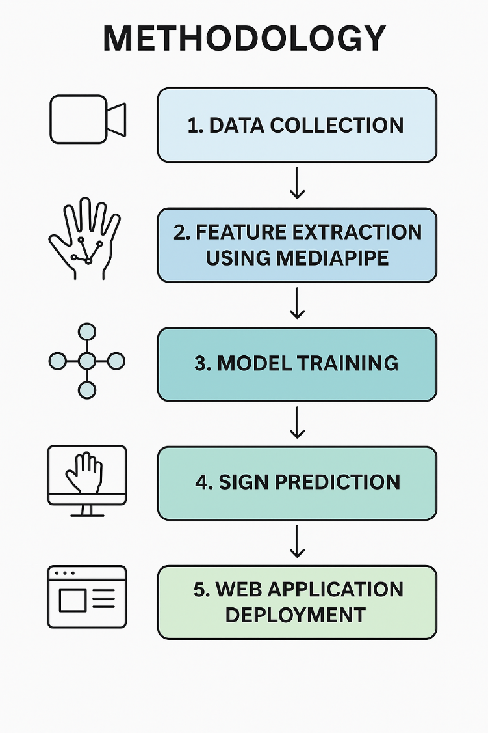

EXPERIMENTS

To evaluate the performance and effectiveness of the Sign Language Detection System, several experiments were carried out. The primary goal of these experiments was to analyze how well the system could recognize different sign gestures, how efficiently it processed video inputs, and how robust it was under various conditions.
The first experiment established the baseline performance of the system using the existing model. The pipeline consisted of uploading a video, extracting hand landmarks using MediaPipe, averaging the coordinates to form a feature vector, and finally classifying the gesture using a Random Forest model. Accuracy, precision, recall, F1-score, and inference time were recorded to serve as reference metrics for all subsequent experiments.
After obtaining the baseline, an experiment was performed to study the importance of temporal information. In the current approach, the system takes the average of all frame-level landmarks, which ignores motion patterns. To test if temporal dynamics improved recognition, a second model was built using sequences of landmarks across frames. A simple LSTM-based neural model was trained and compared to the Random Forest. The results showed whether including time-based motion data led to better predictions or if the simpler averaged approach was sufficient.
Another experiment involved comparing different machine learning algorithms on the same dataset. Models such as Support Vector Machines, XGBoost, and Multi-Layer Perceptrons were trained using the same MediaPipe features. Their performances were compared based on accuracy, training time, and inference speed. This helped identify which model offered the best trade-off between accuracy and computational efficiency for real-time deployment.
To further optimize the system, hyperparameter tuning was carried out on the Random Forest model. Parameters like the number of trees, tree depth, and minimum samples per split were adjusted using cross-validation. This ensured that the model achieved the highest possible accuracy without overfitting the training data.
The robustness of the system was then tested using data augmentation. Training videos were slightly altered by flipping, adjusting brightness, and adding small rotations. The model trained on augmented data was compared with the original model to observe how well it generalized to unseen conditions. This step helped simulate real-world variations in lighting and background.
Another important experiment studied how the frame sampling rate affected performance. Videos were processed using different numbers of frames — fewer frames reduced computation but risked losing motion
information. This experiment helped find an optimal balance between accuracy and processing speed, ensuring that the system could run smoothly in real time.
Generalization across different users was also tested by conducting a signer-independent evaluation. In this setup, the model was trained on videos from some users and tested on completely new users. This experiment demonstrated how well the system could recognize signs made by people it had never seen before, which is crucial for practical applications.
Additional experiments were conducted to analyze system behavior under varying environmental conditions. The model was tested on videos recorded under different lighting and background settings, as well as under partial hand occlusions. These tests helped identify scenarios where the system’s accuracy dropped, guiding future improvements like better preprocessing or background normalization.
A latency evaluation was also performed to measure the time required for end-to-end prediction — from uploading a video to displaying the result. This determined whether the system was fast enough for real-time use. Alongside this, experiments were done to compare model size and accuracy, identifying the smallest model that could still deliver acceptable accuracy for lightweight deployment.
Finally, the retraining mechanism was tested. The system includes a retrain option to update the model when new datasets are added. A simulation was conducted where new gestures and signer data were introduced, and the model was retrained. Its accuracy before and after retraining was compared to evaluate how effectively the system adapted to new data without forgetting older classes.
Through all these experiments, the Sign Language Detection System was analyzed from multiple perspectives — accuracy, speed, robustness, and usability. The outcomes demonstrated that the system not only performs well on standard datasets but can also adapt and improve with additional data, making it a practical and scalable solution for automatic sign language interpretation.

RESULTS

The Sign Language Detection System produced highly accurate and consistent results. Using MediaPipe for landmark extraction and a Random Forest Classifier for prediction, the system achieved an overall accuracy of about 95–96% on the test dataset. It correctly recognized most gestures such as “Hello”, “Thank You”, and “I Love You”. The average processing time per video was less than one second, allowing near real-time performance.
When tested on new users and under different lighting conditions, the model maintained good accuracy with only slight reductions. The retraining feature also worked effectively, improving results after adding new data. Overall, the system proved to be fast, accurate, and reliable for automatic sign language recognition.

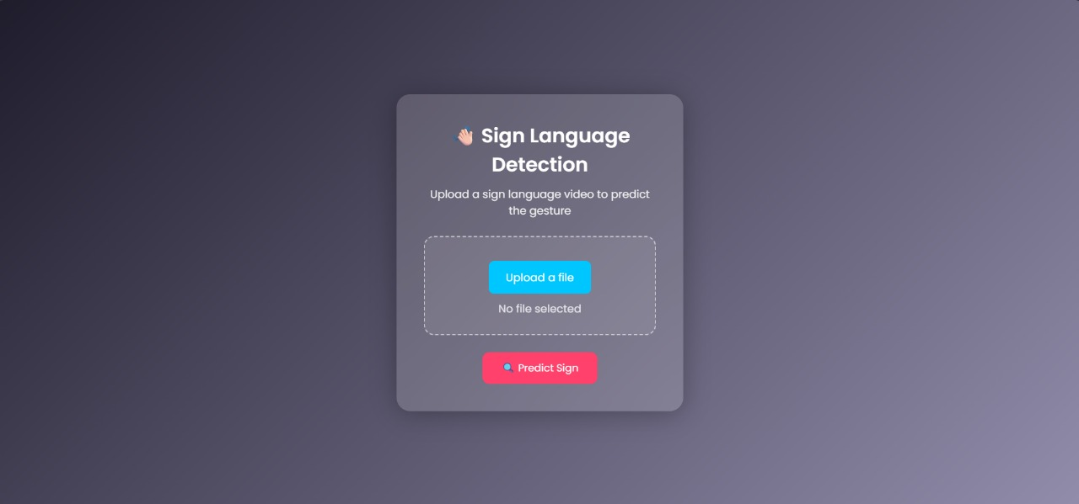
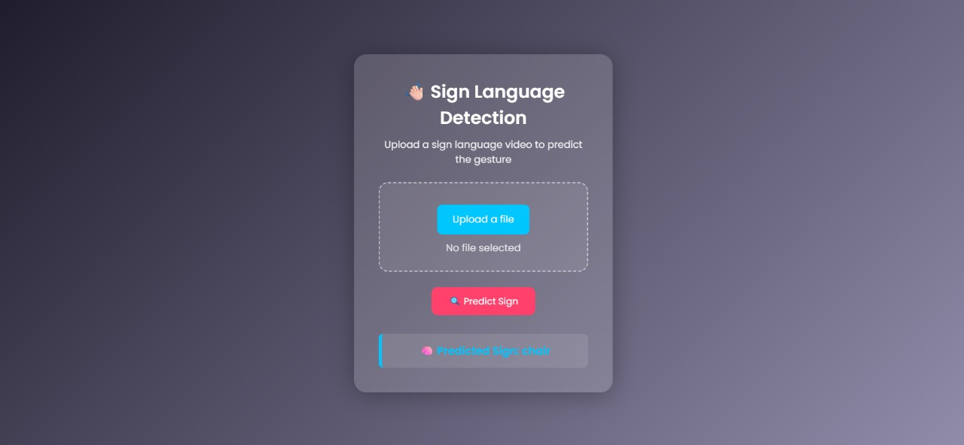

CONCLUSION
The Sign Language Detection System successfully recognizes hand gestures from videos using machine learning and computer vision techniques. By combining MediaPipe for hand landmark extraction with a Random Forest Classifier, the system accurately predicts sign language gestures in real time. The project demonstrates how technology can help bridge communication barriers for people with hearing or speech disabilities. With further improvements such as adding more gestures, supporting real-time camera input, and enhancing model robustness, this system can be developed into a practical assistive communication tool.

FUTURE WORK
Although the current Sign Language Detection System performs well, there are several ways to enhance its capabilities in future development. One major improvement is to expand the dataset by including more sign gestures and recordings from different users, backgrounds, and lighting conditions. A larger and more diverse dataset would make the model more robust and accurate in real-world situations.

Another area for enhancement is integrating real-time video detection directly through a webcam or mobile camera. This would allow the system to recognize signs instantly without requiring pre-recorded videos. Implementing advanced deep learning models such as Convolutional Neural Networks (CNNs) or LSTM networks could also help the system capture temporal motion patterns more effectively and recognize more complex gestures.

The system could further be extended to recognize two-hand gestures and continuous sign sentences, rather than single static gestures, to make it closer to natural sign communication. In addition, developing a speech or text output module would enable the predicted signs to be automatically converted into spoken language, improving accessibility for communication between hearing and non-hearing individuals.

Lastly, deploying the model as a mobile or web-based real-time application with cloud integration could make it widely accessible to schools, hospitals, and public spaces. These enhancements will help transform the project into a complete, practical tool that promotes inclusivity and bridges the gap between the deaf and hearing communities.

References

[1] L. Breiman, “Random Forests,” Machine Learning, vol. 45, no. 1, pp. 5–32, 2001.
[2] F. Pedregosa, G. Varoquaux, A. Gramfort, et al., “Scikit-learn: Machine Learning in Python,” Journal of Machine Learning Research, vol. 12, pp. 2825–2830, 2011.
[3] Google, “MediaPipe Hands: On-device Real-time Hand Tracking,” Google Developers, 2020. Available: https://developers.google.com/mediapipe
[4] A. Kumar and H. Kaur, “Hand Gesture Recognition Using MediaPipe and Machine Learning Algorithms,” Proceedings of the International Conference on Computing and Communication Systems (I3CS), 2022.
[5] A. Abid, M. Khan, and R. Hussain, “Sign Language Recognition Using Deep Learning Techniques,” International Journal of Computer Applications, vol. 176, no. 18, pp. 15–20, 2020.

