Project Report
On
DNS ANALYSIS TOOL
Submitted in partial fulfilment of the requirements for the award of
BACHELOR OF TECHNOLOGY
in
COMPUTER SCIENCE & ENGINEERING
(Artificial Intelligence & Machine Learning)
by
Ms. I SIVANI (22WH1A6613)
Ms. DIVYA SAAHITHYA N (22WH1A6616)
Ms. D SAI LASYA (22WH1A6617)
Ms.K SREEJA(22WH1A6657)
Under the esteemed guidance of
Ms. P Anusha
Assistant Professor, CSE(AI&ML)

Department of Computer Science & Engineering
(Artificial Intelligence & Machine Learning)
BVRIT HYDERABAD COLLEGE OF ENGINEERING FOR WOMEN
(AUTONOMOUS)
(Approved by AICTE, New Delhi and Affiliated to JNTUH, Hyderabad)
Accredited by NBA and NAAC with A Grade
Bachupally, Hyderabad – 500090
2024-25
ABSTRACT

The Domain Name System (DNS) is a fundamental component of the internet, serving as the "phonebook" that translates user-friendly domain names like www.example.com into their corresponding IP addresses, which computers use to communicate. Despite its importance, many students and beginners in the field of computer networks find DNS operations complex and difficult to understand due to the lack of practical, hands-on tools. This project aims to bridge this gap by creating a simple yet effective C-based program to demonstrate DNS functionality.The project showcases the basic operation of DNS queries by resolving domain names into their corresponding IPv4 addresses. Users can input any domain name, and the program will return the associated IP address using the getaddrinfo() function. This process mimics real-world DNS resolution and provides an educational tool for understanding how domain names are translated into IP addresses.

PROBLEM STATEMENT

The Domain Name System (DNS) is a critical component of modern internet infrastructure, acting as a decentralized directory that translates human-readable domain names into machine-readable IP addresses . This process is fundamental to how the internet functions, enabling seamless communication between users and online services. Despite its significance, the intricacies of DNS operations often remain opaque to students and beginners in the field of computer networks, making it difficult to grasp the practical workings and troubleshooting processes of DNS.
To address this gap, this project aims to develop an interactive and user-friendly tool that simulates DNS queries and demonstrates the resolution of domain names to their corresponding IP addresses. The tool will serve as an educational resource, providing insights into the underlying mechanisms of DNS, including query types ,recursion, caching, and authoritative responses. By offering real-time visualization and feedback, the tool will not only enhance understanding but also aid in diagnosing and resolving common DNS-related network issues.

FUNCTIONAL REQUIREMENTS

1. User Input for Domain Names: The application should accept domain names as input from the user.
2. DNS Query Execution: Perform a DNS lookup to retrieve the IPv4 address corresponding to the entered domain name.
3. IPv4 Address Display: Display the resolved IPv4 address of the domain name on the console.
4. Error Handling: Inform the user of any errors encountered during the DNS query process, such as invalid domain names or query failures.
5. Memory Management: Efficiently handle and free dynamically allocated memory to avoid memory leaks.

NON-FUNCTIONAL REQUIREMENTS

1. Performance: Ensure that DNS queries are executed and responses are displayed in a timely manner.
2. Scalability: The application should handle multiple domain queries sequentially without performance degradation.
3. User Experience: Provide clear and concise output for both successful queries and error messages.
4. Portability: The application should run on standard Linux-based systems with minimal dependencies.
5. Reliability: Ensure that the application accurately retrieves and displays IP addresses for valid domain names.

SOURCE CODE

#include <stdio.h>
#include <stdlib.h>
#include <string.h>
#include <netdb.h>
#include <arpa/inet.h>

void dns_query(const char *domain_name) {
struct addrinfo hints, *res;
int status;

// Prepare the hints structure to specify the type of query (IPv4)
memset(&hints, 0, sizeof(hints));
hints.ai_family = AF_INET; // IPv4 addresses
hints.ai_socktype = SOCK_STREAM;

// Perform the DNS query
status = getaddrinfo(domain_name, NULL, &hints, &res);
if (status != 0) {
fprintf(stderr, "DNS query failed: %s\n", gai_strerror(status));
return;
}
// Print the IP address
struct sockaddr_in *ipv4 = (struct sockaddr_in *)res->ai_addr;
char ip_str[INET_ADDRSTRLEN];
inet_ntop(AF_INET, &(ipv4->sin_addr), ip_str, sizeof(ip_str));

printf("IP Address for %s: %s\n", domain_name, ip_str);

// Free the memory allocated by getaddrinfo
freeaddrinfo(res);
}

int main() {
char domain_name[256]; // Buffer to store the user input

printf("Enter a domain name to lookup: ");
scanf("%255s", domain_name); // Read user input safely

printf("DNS Lookup for: %s\n", domain_name);
dns_query(domain_name);

return 0;
}

OUTPUT

The domain name to lookup is geeksforgeeks.com and the ip address for it is 199.59.243.227
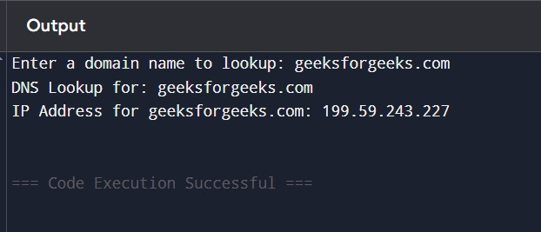

The domain name to lookup is amazon.com and the ip address for it is 54.239.28.85
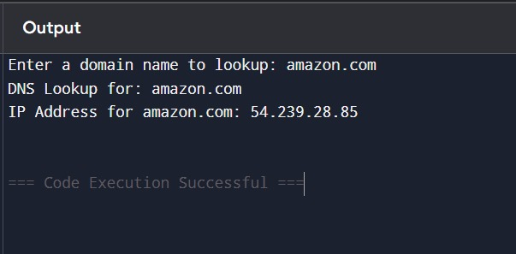

The domain name to lookup is mentorpick.com and the ip address for it is 172.67.217.151
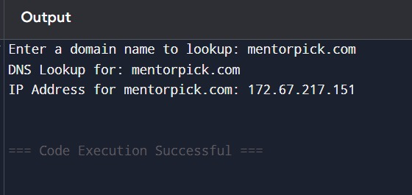

The domain name to lookup is google.com and the ip address for it is 173.194.193.102

